Main Improvements of RSM-VAT 2.6
Prepared by SCUT, 2021-01-20
List of Improvements:

- Under the Visualization & Analysis module:
- Add the “BenMAP Emission-Cut output” function in the “right-click” menu under the “MAP” submodule.
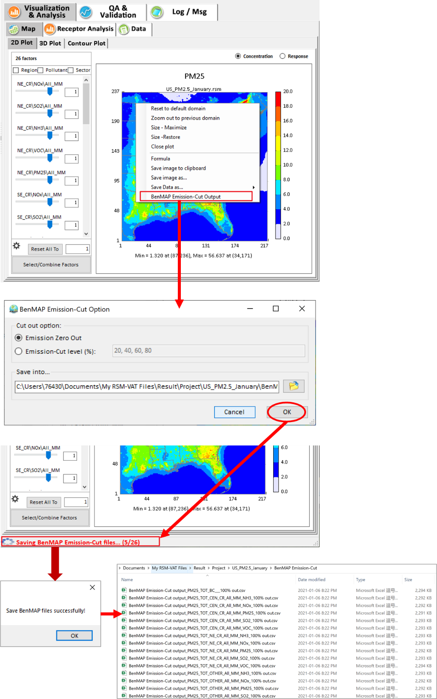
- Re-order the control factors.
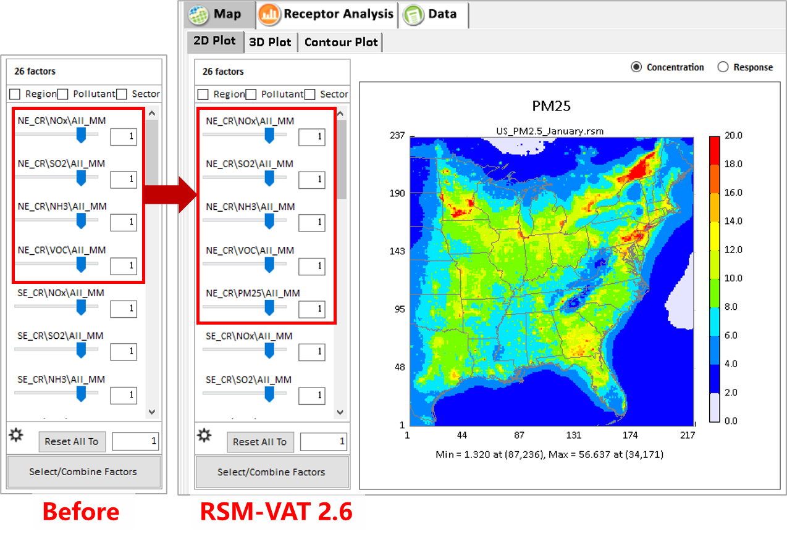

- Under the QA &Validation module, include a “Output Validation Scenarios” function in the “right-click” menu under the “Comparison Plot” submodule.
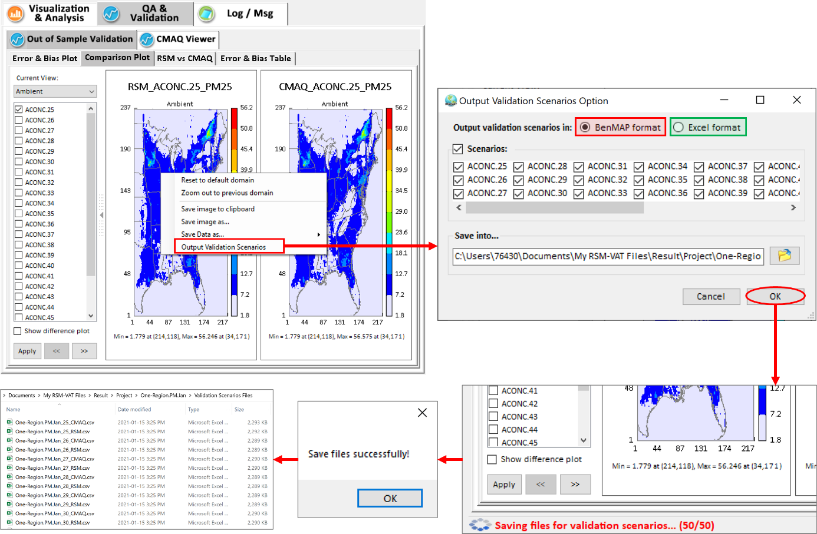
This function supports to generate the RSM-created OOS results (RSM & CMAQ) for all/selected scenarios in “BenMAP format” or “Excel format”. The “BenMAP format” option will create an “RSM” BenMAP format file and a “CMAQ” BenMAP format file for each selected scenario, while the “Excel format” option will create only one file with both “CMAQ” and “RSM” data for each selected scenario.
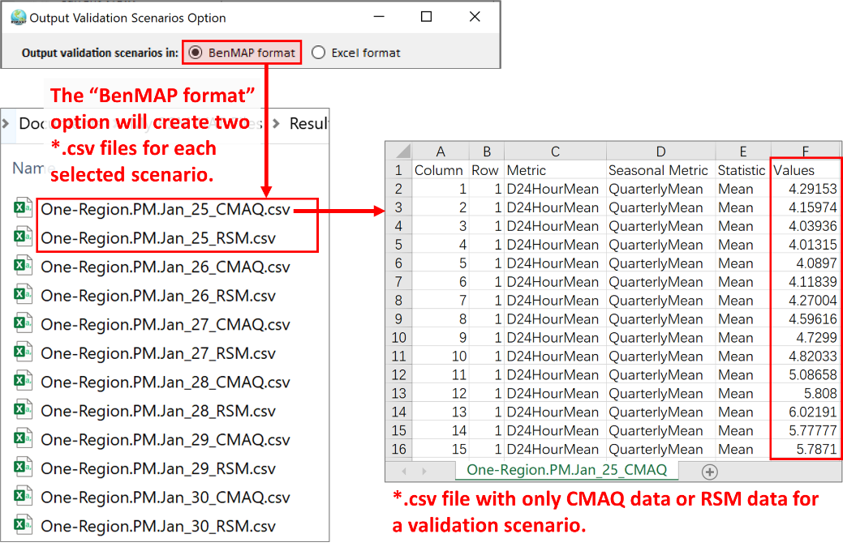
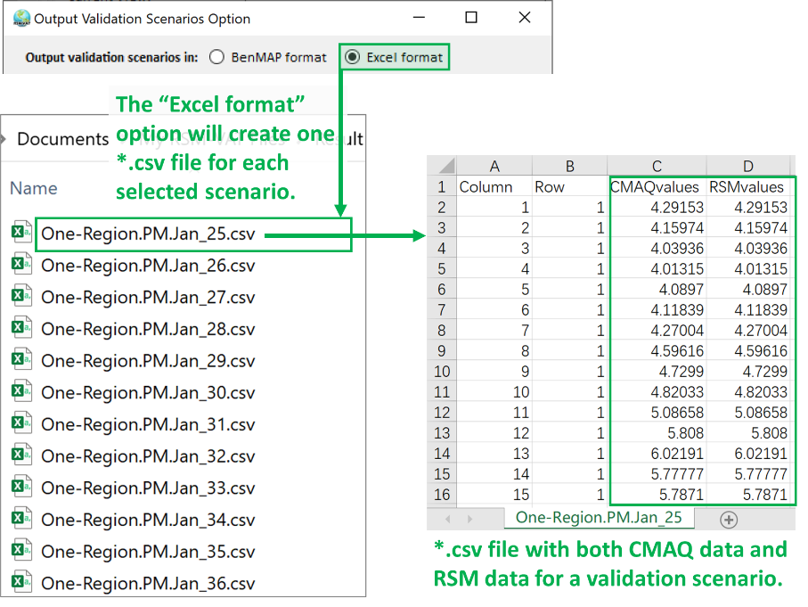

- Support to output RSM predictions and CMAQ simulations for out-of-sample cases as a batch job. User can do this batch job by the following steps:
- Prepare an RSM-VAT script file (*.ctlx) with the directory of project files (*.rsmproj), the format of output files, and the output directory. Below is an example script file for “US_RSM - OneRegion”.
VALIDATIONSCENARIOS ##The keyword of the “Output Validation Scenarios” function.
-projfolder C:\Users\Devin\Documents\My RSM-VAT Files\Result\Project ## the directory of *.rsmproj files (the program will identify all *rsmproj files to output under this directory).
-fileformat BENMAP #Support “BENMAP” or “EXCEL” format
-outputfolder C:\Users\Devin\Documents\My RSM-VAT Files\Result\Project\ValidationScenariosFiles ##The the directory for output files.
- Prepare a batch script file (*.bat) for calling the RSM-VAT script file. Here’s an example batch file “batRSM.bat” under the “\Documents\My RSM-VAT Files\Data\BatchExample”.Note that “%~dp0” means current directory. User can use the full path of the RSM-VAT script file (*.ctlx) instead.
@echo Please check the directory of CTLX file(*.ctlx) used in batch job!
start /wait "" "C:\Program Files (x86)\RSM-VAT\RSM-VAT.exe" %~dp0\"US_RSM - OneRegion_RSMscript_ValidationScenarios.ctlx"
- Double click “batRSM.bat” and wait until the work complete.

- In the “RSM-VAT 2.6 Data.exe”, include 500 BenMAP files for all the One-region OOS scenarios under the “\Documents\My RSM-VAT Files\Result\Output\ValidationScenariosFiles”.
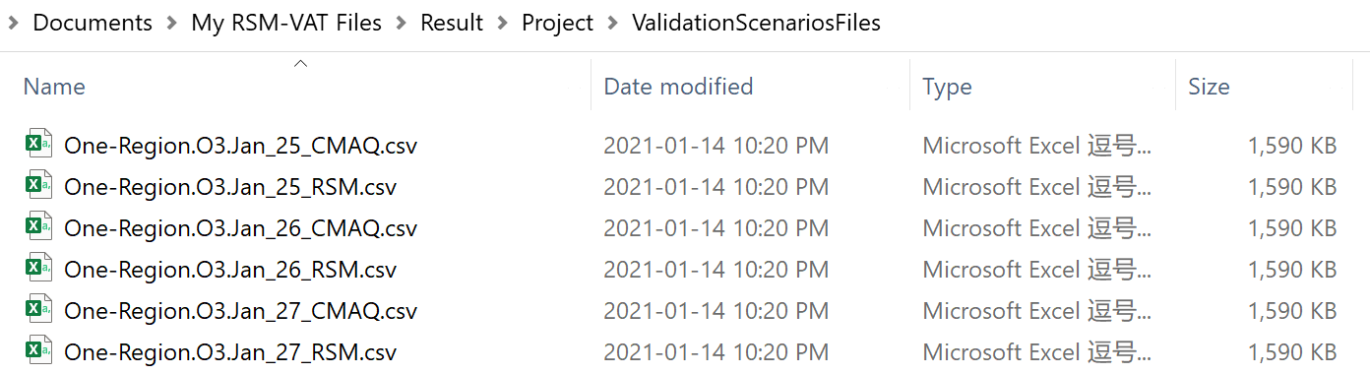

- Change the “Low-degree pf-ERSM” option to the “Optimized pf-ERSM” option.
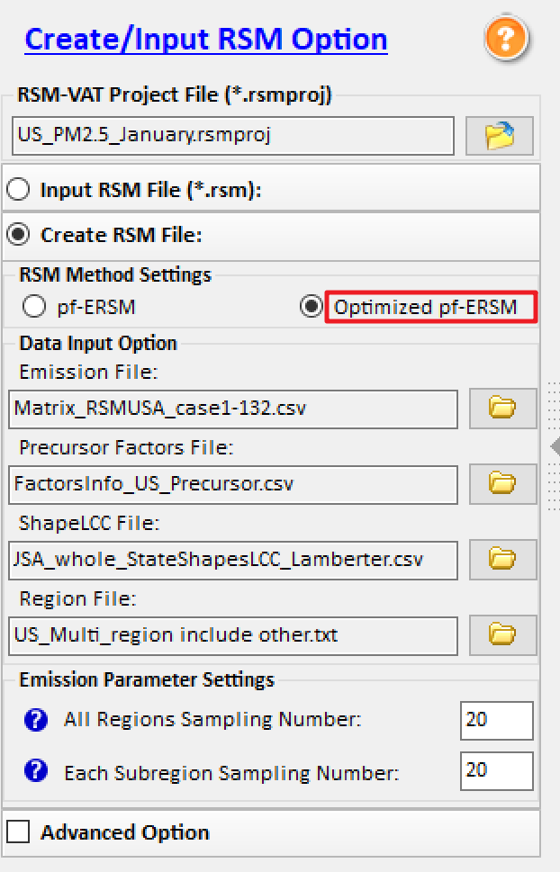

- Update the user manuals for RSM-VAT.

To do list:
- Support to set up values for the x-axis and y-axis of scatter plot in the “RSM vs CMAQ” module.

