RSM-VAT 2.9:
DeepRSM Quick Tutorial

Install RSM-VAT
- RSM-VAT setup package installation
- Uninstall all previous versions of RSM-VAT.
- Install RSM-VAT 2.9 by double-clicking the RSM-VAT 2.9 Setup.exe. Follow the instructions to install the program to the default location on your computer.
- US DeepRSM Data package installation
- Like installing RSM-VAT 2.9, double-clicking the RSM-VAT 2.9 Data.exe. Follow the instructions to install the data to the default location on your computer.

Load a previous RSM project
Click Open Project (*.rsmproj) on the RSM-VAT main page to launch a Windows Explorer window. Use this window to navigate to the directory where RSM project (*.rsmproj) files located to load a previous project. As shown in Fig. 2-1, it includes 4 example RSM projects in this version, “Whole_US_O3_July_Avg.rsmproj” and “Whole_US_PM25_July_Avg.rsmproj” are the July case of whole US (1 region) for O₃ and PM_{2.5}, while “US_Climate_Region_O3_July_Avg.rsmproj” and “US_Climate_Region_PM25_July_Avg.rsmproj” are the July case of US climate region (10 regions) for O₃ and PM_{2.5}, respectively.

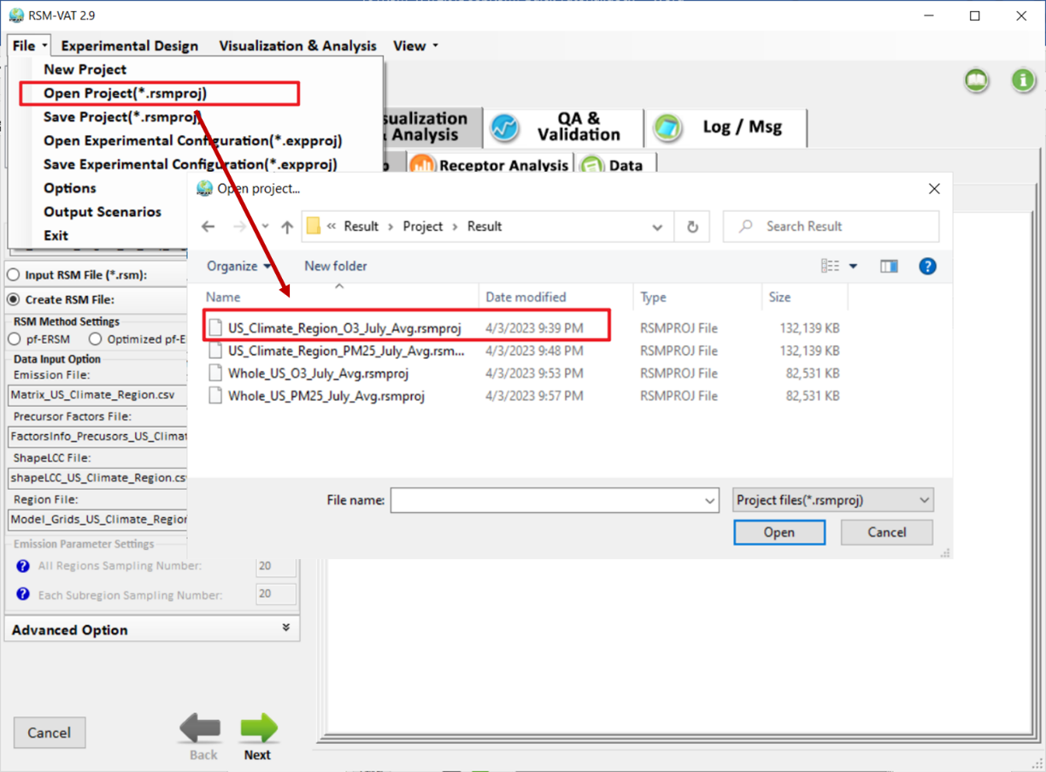
Fig. 2-1 Load a previous RSM project

Create RSM project for DeepRSM option
The steps below describe how to use RSM-VAT 2.9 to create a RSM project with DeepRSM algorithm. Here we use the data named whole_US_DeepRSM as an example and it will take 4 steps.
Step1: Create/Input RSM Option. Choose RSM algorithm and corresponding configuration file, including RSM Method Settings and Data input option. In RSM Method Settings, there are 3 methods can be selected, here DeepRSM option is checked. Besides, Emission File, Precursor Factors File, ShapeLCC File and Region File will be selected in turn.
- As shown in Fig. 3-1, click button to select corresponding file. Except for the Emission files, the rest of the files are similar to that of previous versions. For DeepRSM option, 1 baseline and 1 clean condition (fully controlled scenario) for each region are used to create the RSM. In other words, the number of cases determined by the regions of interest. Fig. 3-2 shows the DeepRSM emission matrix for the whole US region, while Fig. 3-3 is the DeepRSM emission matrix for 10 US climate regions.
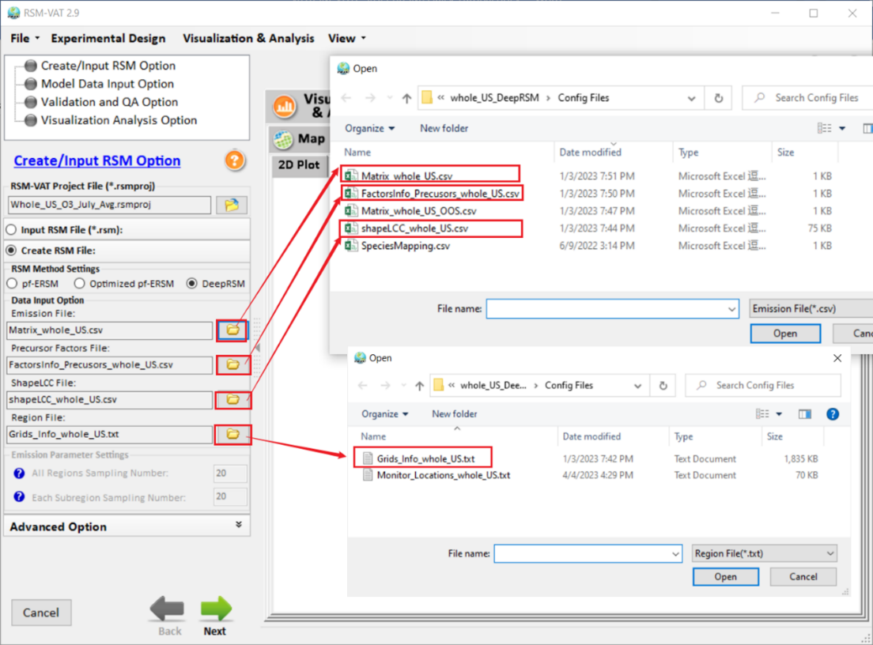
Fig. 3-1 Data Input Option
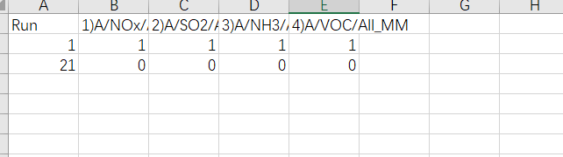
Fig. 3-2 Emission File for whole US (Matrix_whole_US.csv)
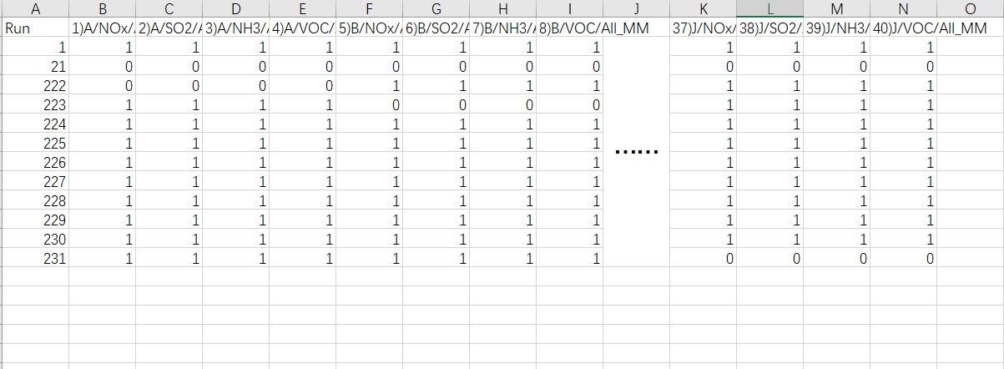
clean conditions per region
base case
clean conditions for whole region
Fig. 3-3 Emission File for 10 US climate regions (Matrix_US_Climate_Region.csv)
Step2: Model Data Input Option and DeepRSM Input. In this step, the parameters for DeepRSM option will be set, including Base Case CMAQ File and training model, etc.
- Base Case CMAQ File (ACONC). As shown in the Fig. 3-4, click to select baseline CMAQ file.
Note that:
- All the cases listed in the Emission file from the previous step should be put together with the CMAQ baseline file;
- the Days button 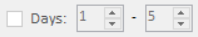 will be disabled if CMAQ baseline file selected only contains the monthly average data.
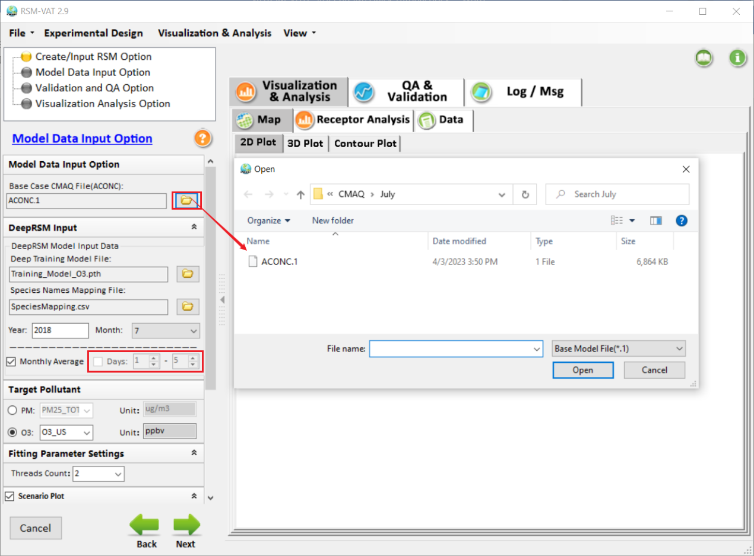
Fig. 3-4 Base case CMAQ File
- Deep Training Model File: Set the deep learning model file based on target pollutants (Fig. 3-5). Here select a O₃ training model file as example.
- Species Names Mapping File: This is a *.csv file that records mapping information for species, which ensures that species names in the CMAQ baseline model file match those in the deep learning model file, as shown in Fig. 3-6. Note that the species names in the deep learning model file is built-in and users just need to update the species name in the column “ Species Name In Model File ” according to the selected baseline model file.
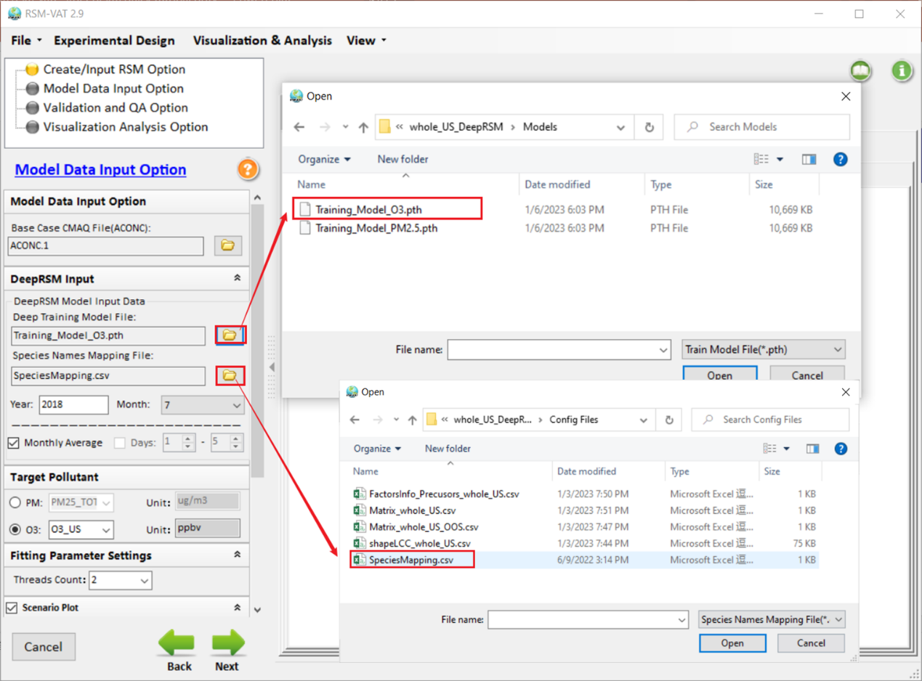
Fig. 3-5 Deep Training Model File and Species Names Mapping File
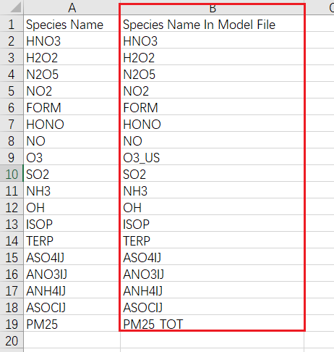
Fig. 3-6 Species Names Mapping File
- Year: Model run year. It will be filled automatically when the baseline model file (Base Case Model File) is selected.
- Month: Model run month. It also can be filled automatically according to the baseline file.
- Monthly Average \ Days: User can choose to calculate monthly average data or daily average data according to their interests. Both of them can be chosen at the same time, but it depends on the type (e.g., daily, monthly, etc.) of the CMAQ file selected in “Base Case CMAQ File”. The Days button only enables for daily model file.
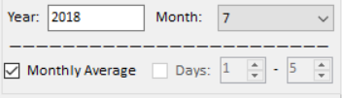
Fig. 3-7 Time parameter setting
- Target Pollutant: Select the target pollutant to create the RSM. Note: This pollutant should be consistent with the deep learning model file.
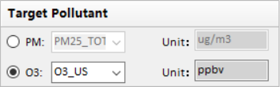
Fig. 3-8 Target Pollutant
Step3: Validation and QA Option. In Validation and QA Option, DeepRSM option is the same as pf-ERSM or Optimized pf-ERSM option. User can do the validation and QA as needed.
- In DeepRSM, Out of Sample option is used to validate. As shown in Fig. 3-9, Matrix_whole_US_OOS.csv is chosen to validate the performance of DeepRSM.

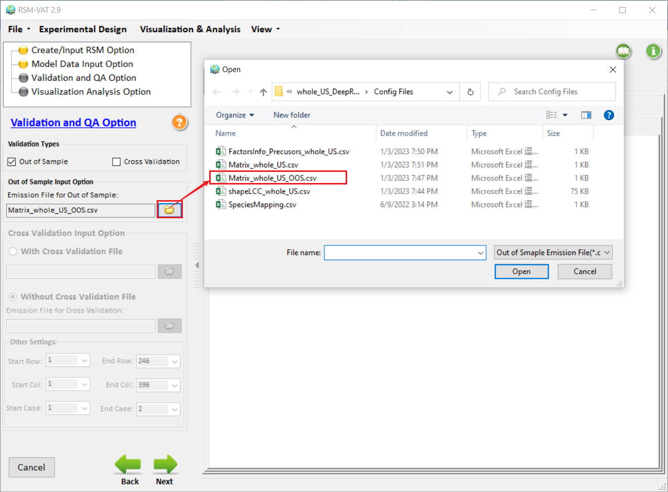
Fig. 3-9 Validation and QA Option
Step4: Visualization Analysis Option. Click to choose Receptor Region File. This file generally records the grid cell information where monitoring sites located. As shown in Fig. 3-10, Monitor_Locations_whole_US.txt is used as an example.
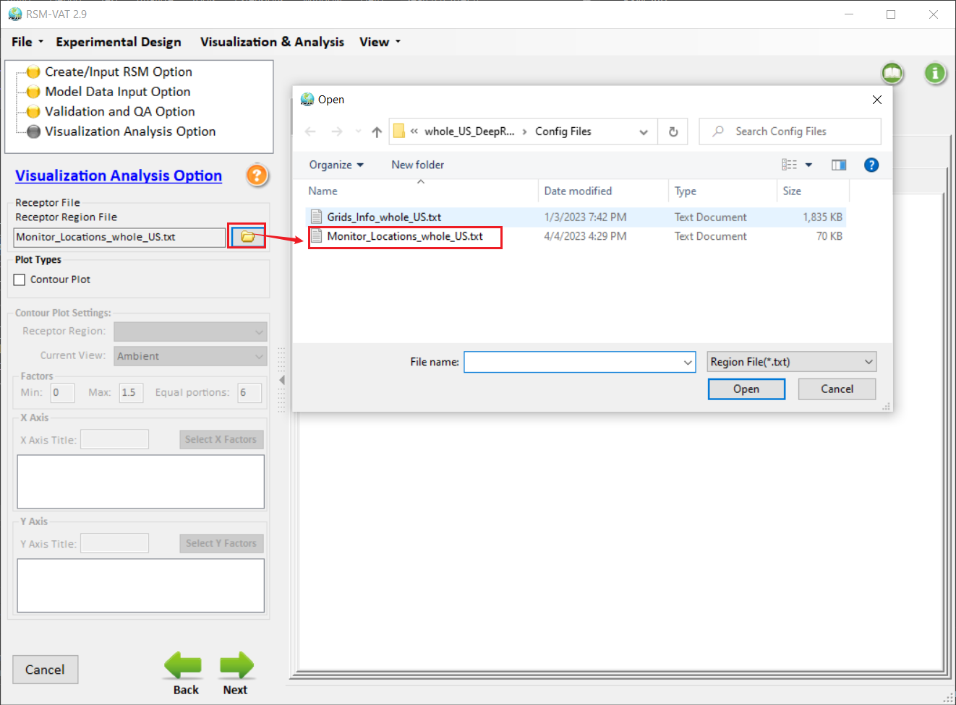
Fig. 3-10 Visualization Analysis Option

QA and Visualization Analysis

QA & Validation Visualization
This module is mainly used to examine and validate the DeepRSM model performance. The QA & Validation module shows the QA results according to the settings in Validation and QA Option. As shown in Fig. 4-1, Out of Sample Validation and CMAQ Viewer for this example case are available. Among them, Out of Sample Validation is conducted to evaluate the performance of DeepRSM, which compares the predicted values derived from RSM with the CMAQ simulations of a set of model runs that are not used in creating RSM. CMAQ Viewer is a tool for displaying a CMAQ simulations.
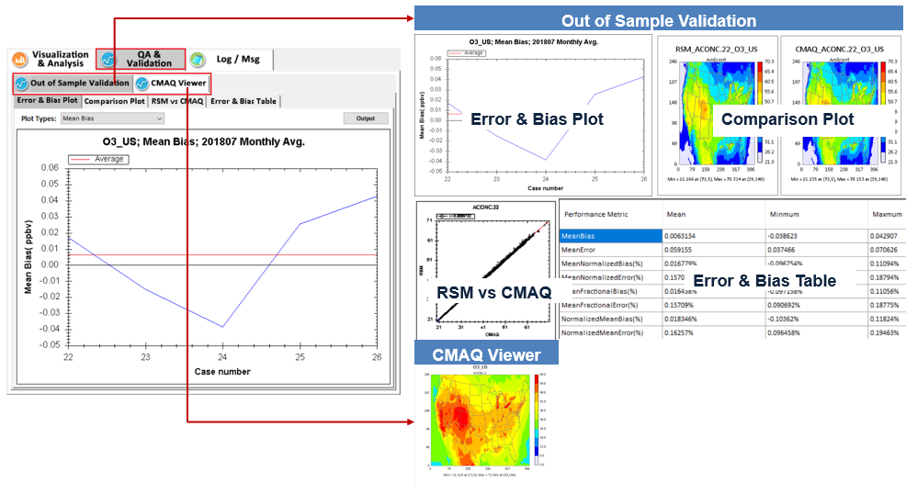
Fig. 4-1 QA & Validation

Visualization Analysis for DeepRSM project
Here we use Whole_US_O3_July_Avg.rsmproj as an example.
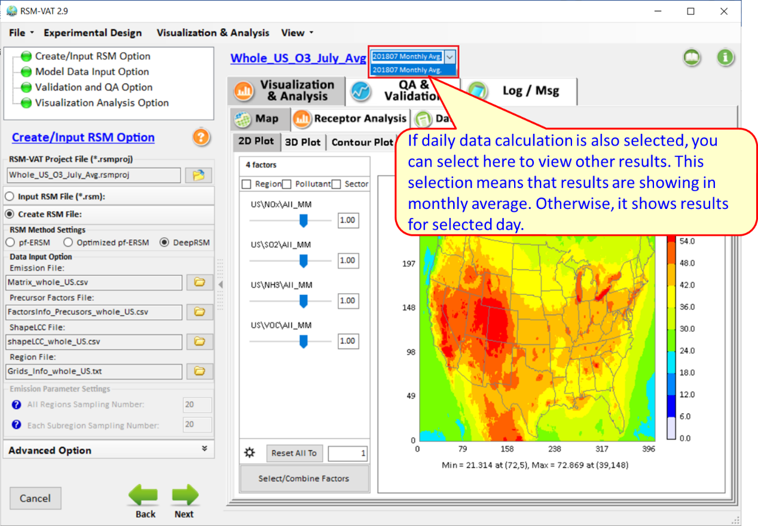
Fig. 4-2 Whole_US_O3_July_Avg.rsmproj
- Map
- 2D Plot. User can click the 2D Plot tab to view the 2D spatial concentration distribution in real-time.
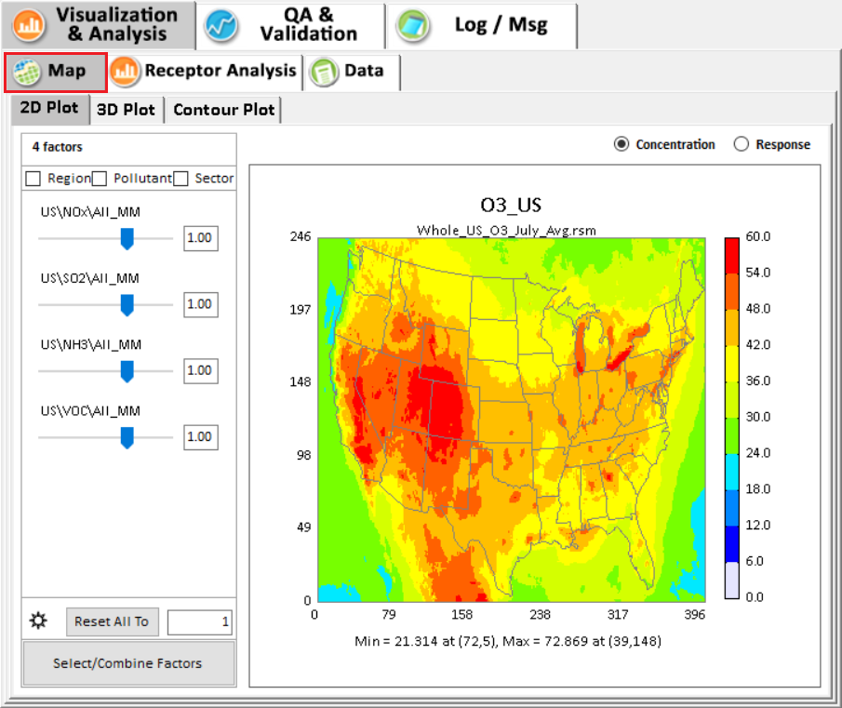
Fig. 4-3 2D-Plot
- 3D Plot. User can click the 3D Plot tab to view the 3D distribution of pollutant concentration in real-time.
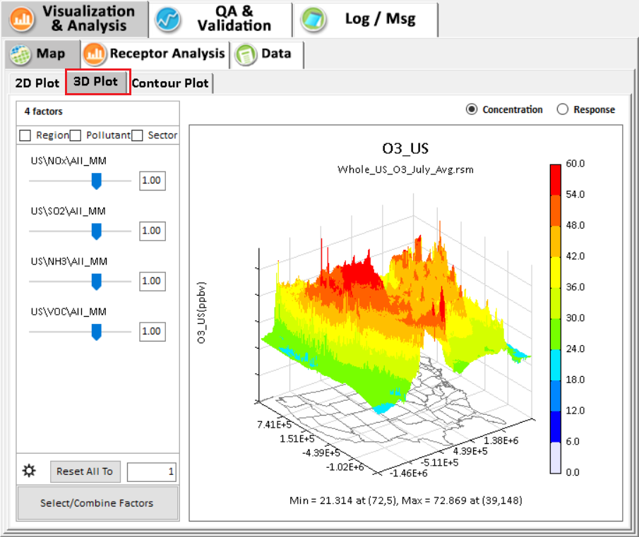
Fig. 4-4 3D-Plot
- Contour Plot. User can click the Contour Plot tab to view the 2D contour plot of pollutant concentration. This module can help users study the sensitivity among different precursors, e.g., O3 response of NOx and VOCs emissions control.
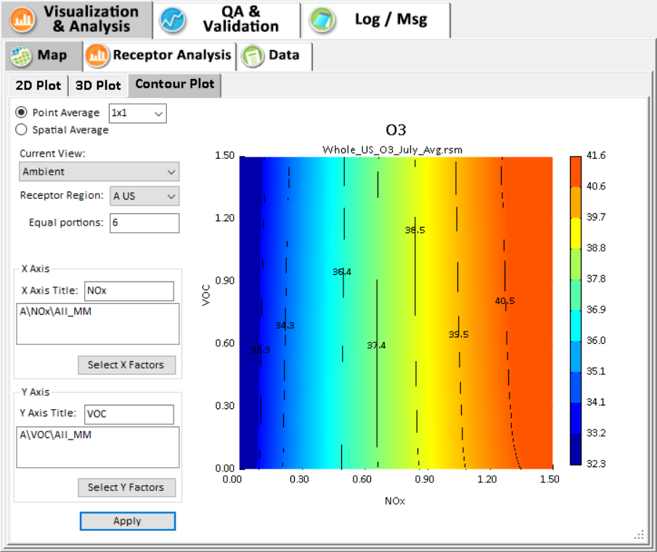
Fig. 4-5 Contour Plot
- Receptor Analysis
- Under Chart module, it provides 4 kinds of charts for users to analysis the response to different emission controls. There are (1) Source Contribution 1, (2) Source Contribution 2, (3) Emission Control 1 and (4) Emission Control 2. Note: If the DeepRSM options is selected, the results of different days can be selected through the drop-down box, as shown in Fig. 4-2)
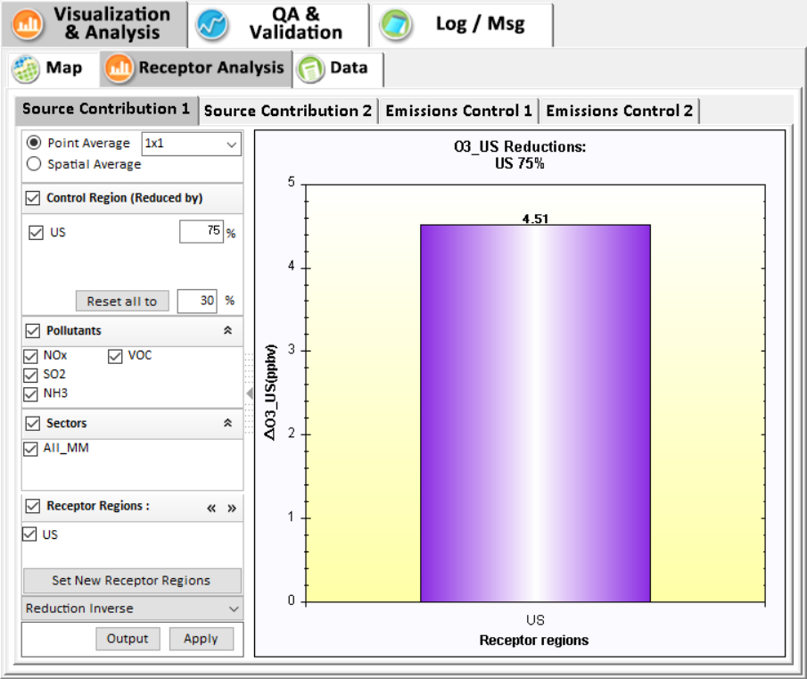
Fig. 4-6 Source Contribution 1
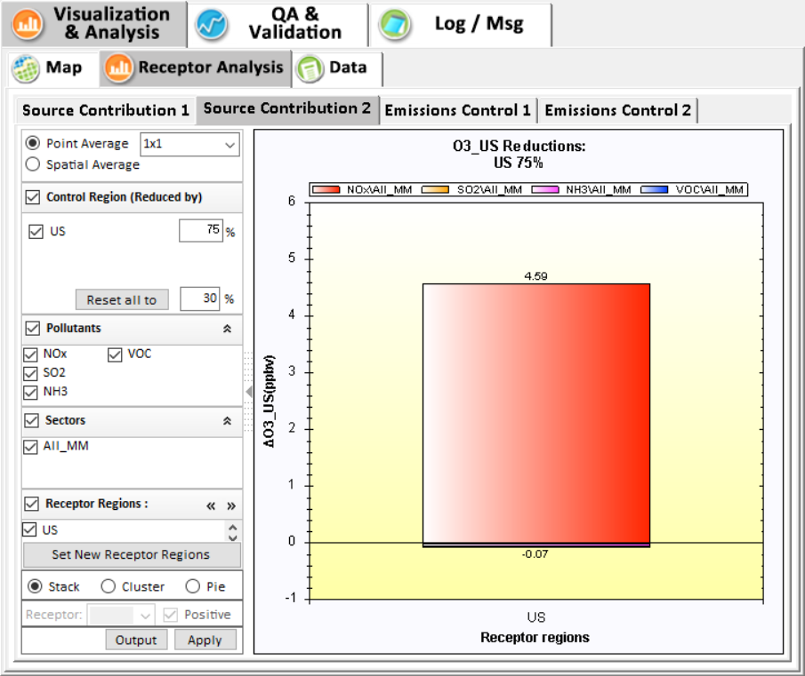
Fig. 4-7 Source Contribution 1

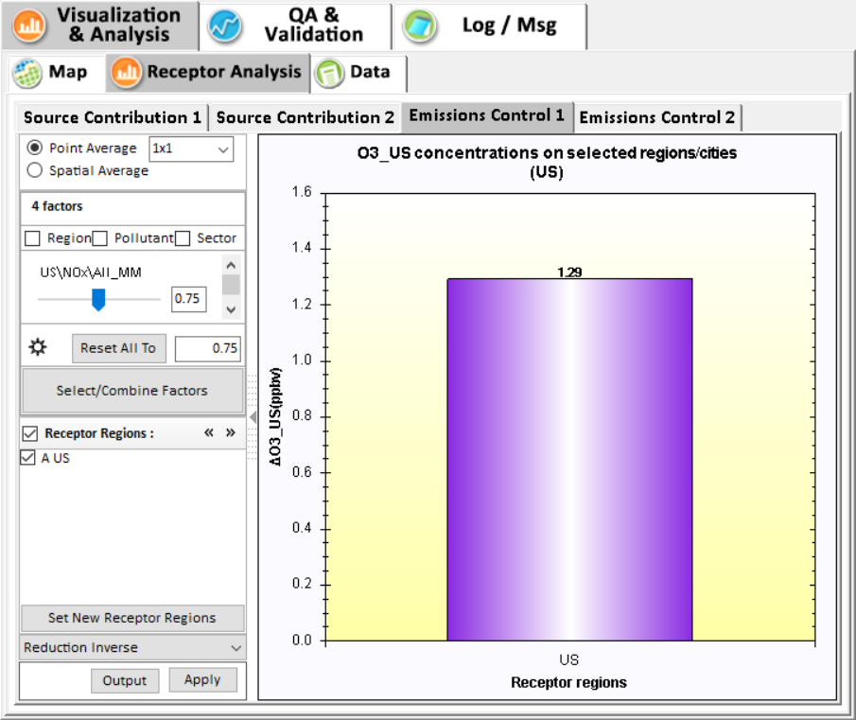
Fig. 4-8 Emission Control 1
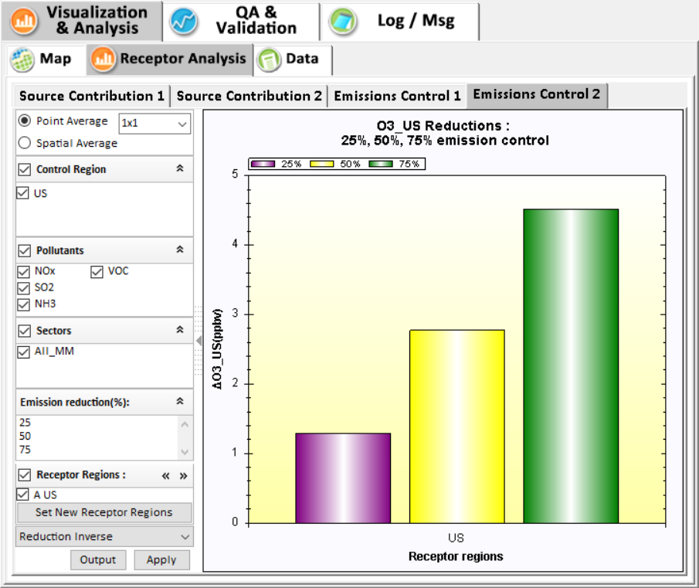
Fig. 4-9 Emission Control 2
- Data
- The Data module provides detailed information (e.g., Latitude, Longitude, ambient concentration) of all grid cells in the model domain.
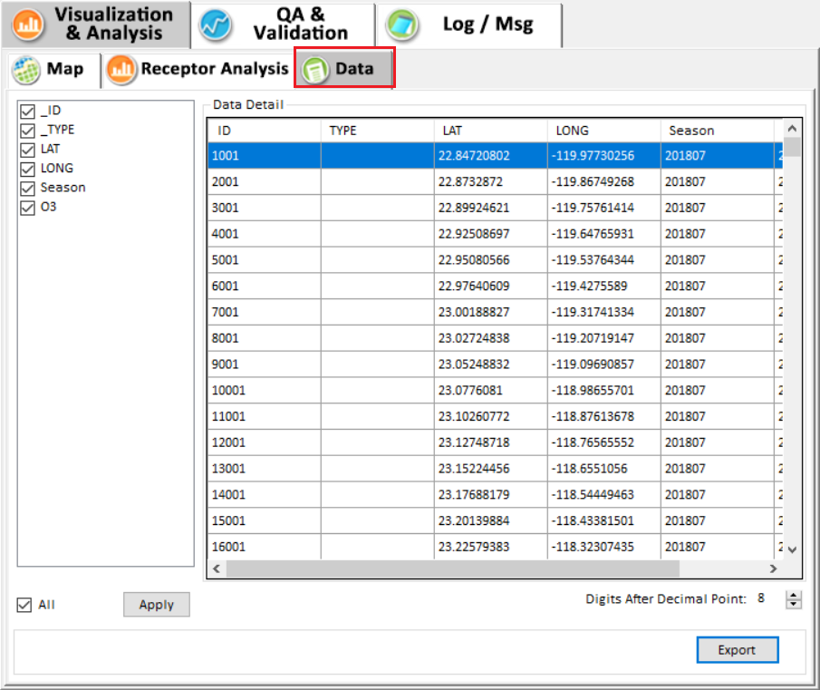
Fig. 4-10 Data Detail Results and Configuration

