Main Improvements of NEXUS 1.0
By SCUT, 2020-07-18

Main Improvements for Data Viewer
  - Change the name of the default project to “NEXUS_2014”.
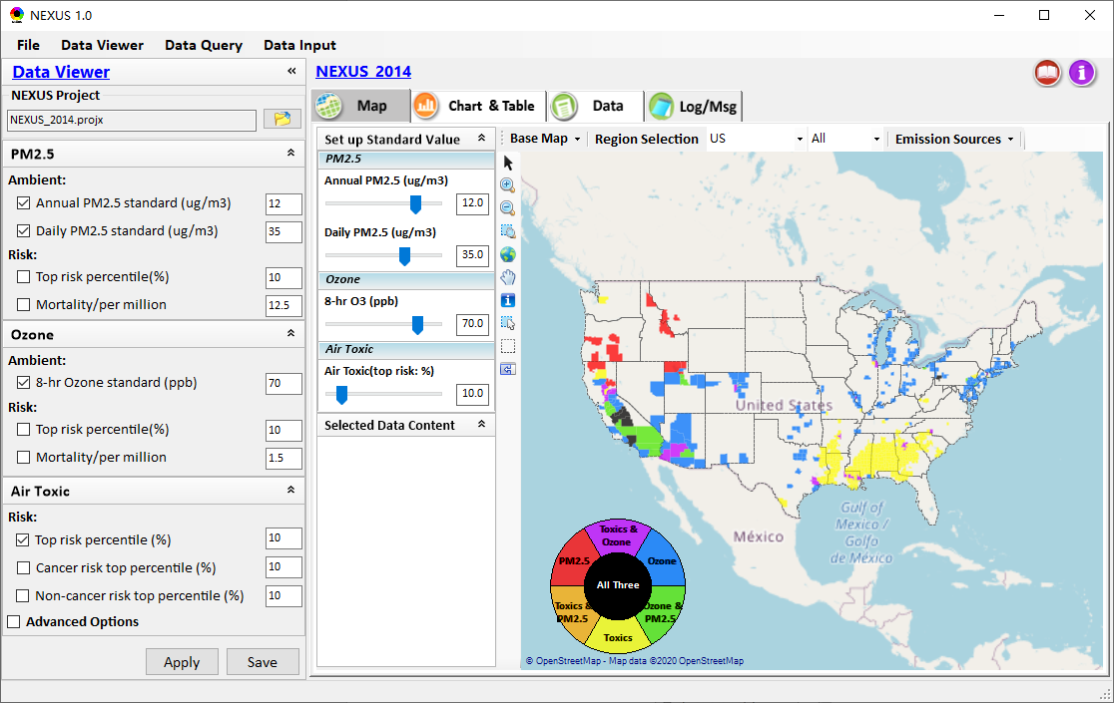
  - Adjust the title of “NEXUS_2014”, “Data Viewer” and the slide bar titles (e.g., “Annual PM2.5”, “Daily PM2.5”, etc.) under “Set up Standard Value” panel more prominent and user-friendly by changing the font size.
  - Set the default value of 8-hr O3 (ppb) to 70, max value to 85;
  - The max value of “Heavy-metal HAPs Ambient” is set to 0.1. The step value is set to 0.01.
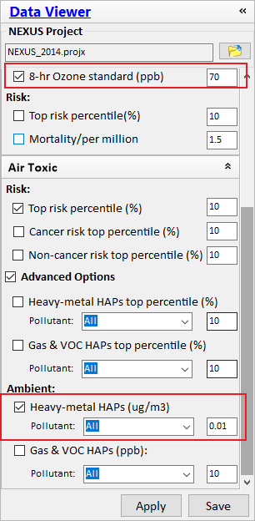
  - Move the menu buttons of “Boundary Lines” under “Base Map” (use line to separate with map providers). Remove the “Metro SA”, “Micro SA” boundary line functions.
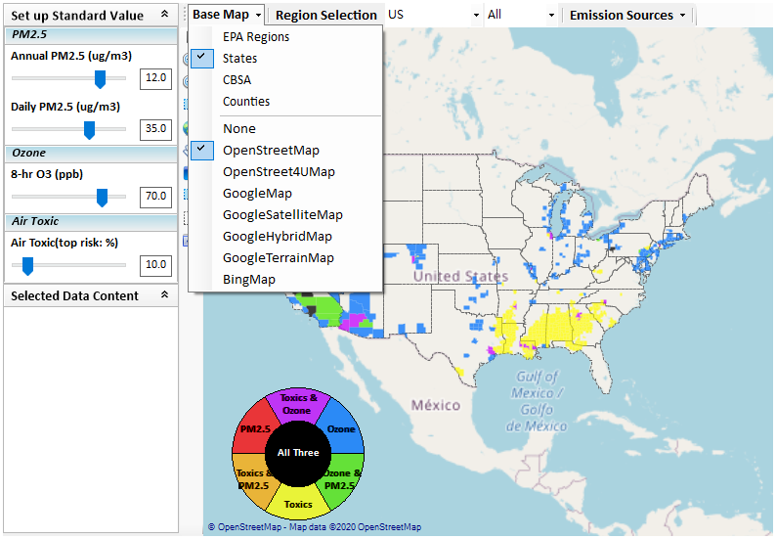
  - Use single-click (instead of double-click) on the “circle color bar” to configure the “color bar” properties. Set the default transparency to 75.
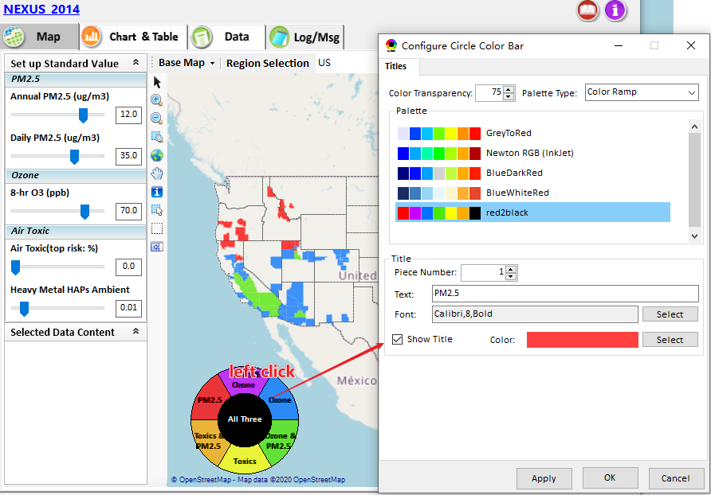

  - Under “Region Selection”: (1) replace the full state name with short name; (2) replace the full name of EPA Region with numbers (“EPA Region 1” => “01”); (3) remove those “Metro SA”, “Micro SA” from the drop-down box of CBSA and adjust the width to fully show the long CBSA names.
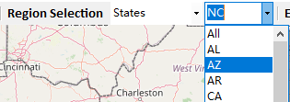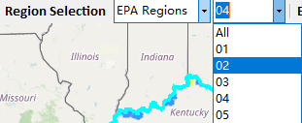
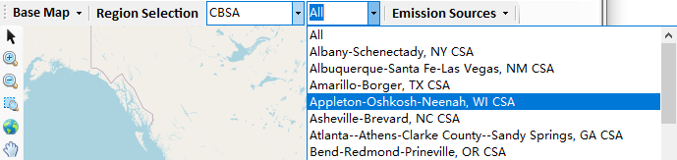
  - Under “Major Emission Sources”:
    - Use pollutants “NOx”,”SO2”,”PM2.5”,”Heavy metal HAPs” and “GAS& VOC HAPs” as default.
    - Keep the “Map” change automatically when region is changed under this module.
    - Make circles of the emission points bigger and more obvious.
    - Make the pollutant titles more prominent user-friendly by using bigger font.
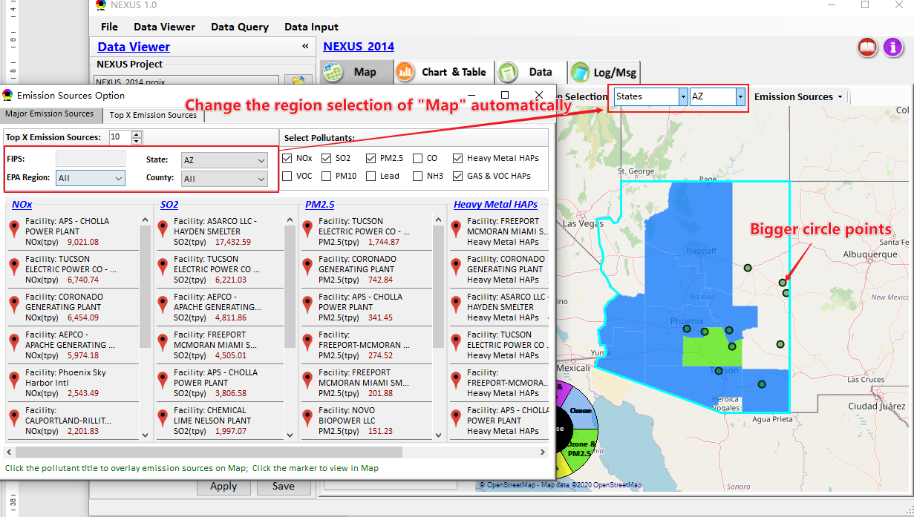
    - Fix a bug for failing to load “Durham” county under the “County” drop-down menu

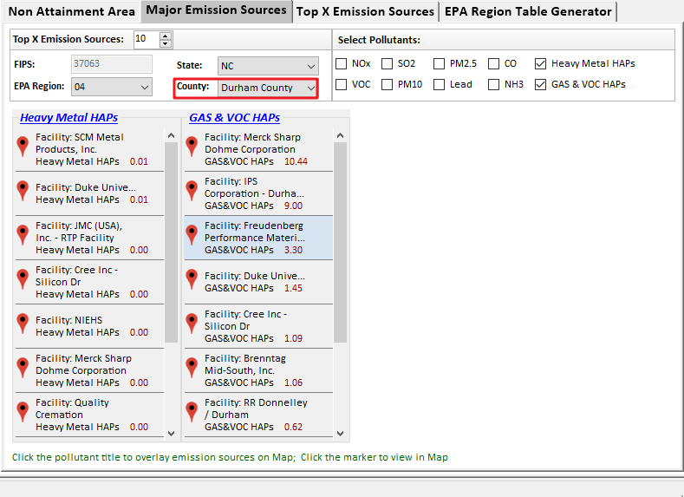
  - Under “Top X Emission Sources”, add alternative data option of “HAPs_CAPs”
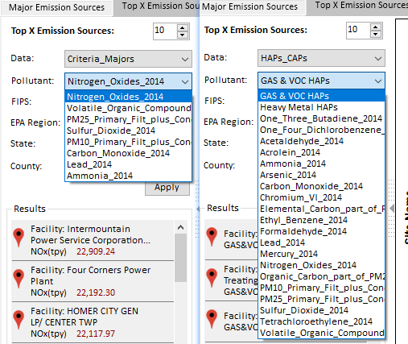
  - Add a “Region Selection” function for the “Non-Attainment Area” Chart
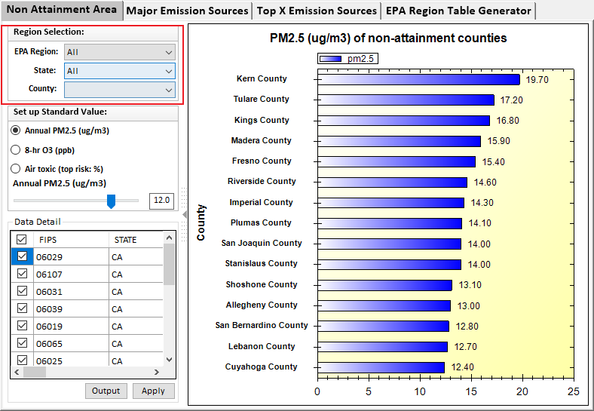

  - Under the “Data tabpage” &“Data Preview tabpage”: (1) add new functions of using filter to select and query data; (2) include a page-turning function;(3) include a function to output all records or current page records to *.csv.
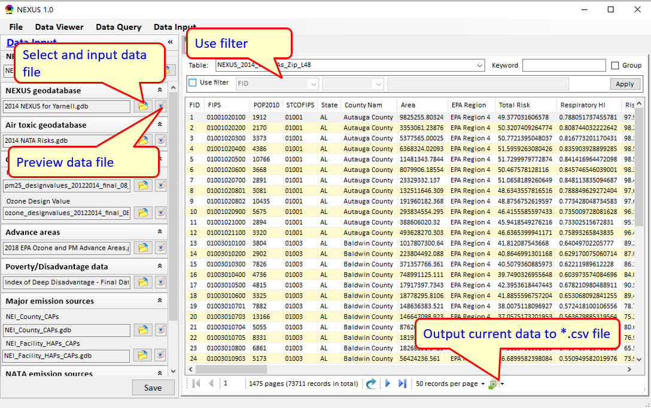
  - Under “Data Input” module:
      - Support to navigate to the directory that the file exists when clicking the browser button .
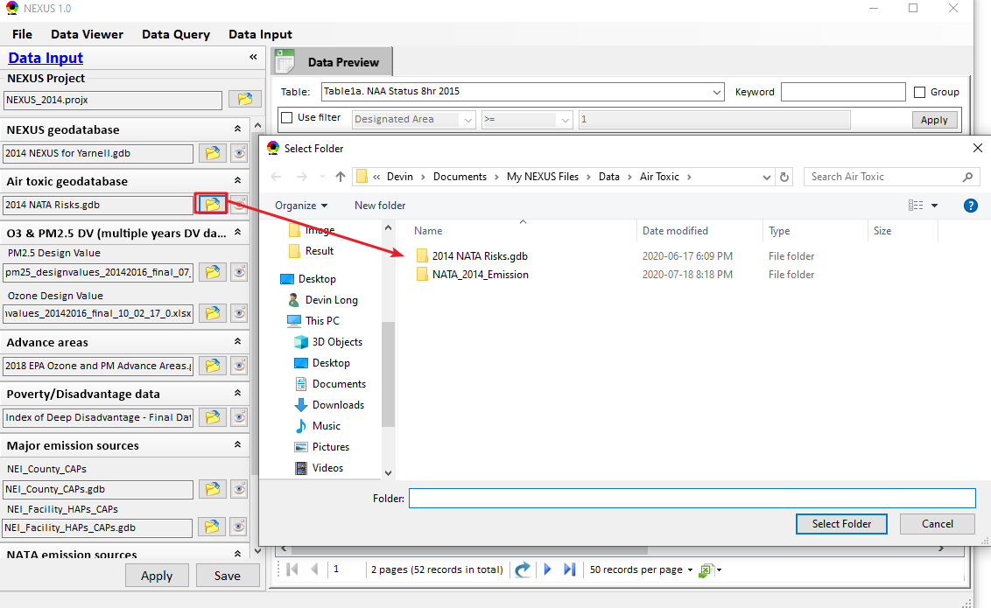
      - Fix a bug in selecting O₃ & PM_{2.5} DV files, and support to use the 2017 DV files to save and run the NEXUS project.
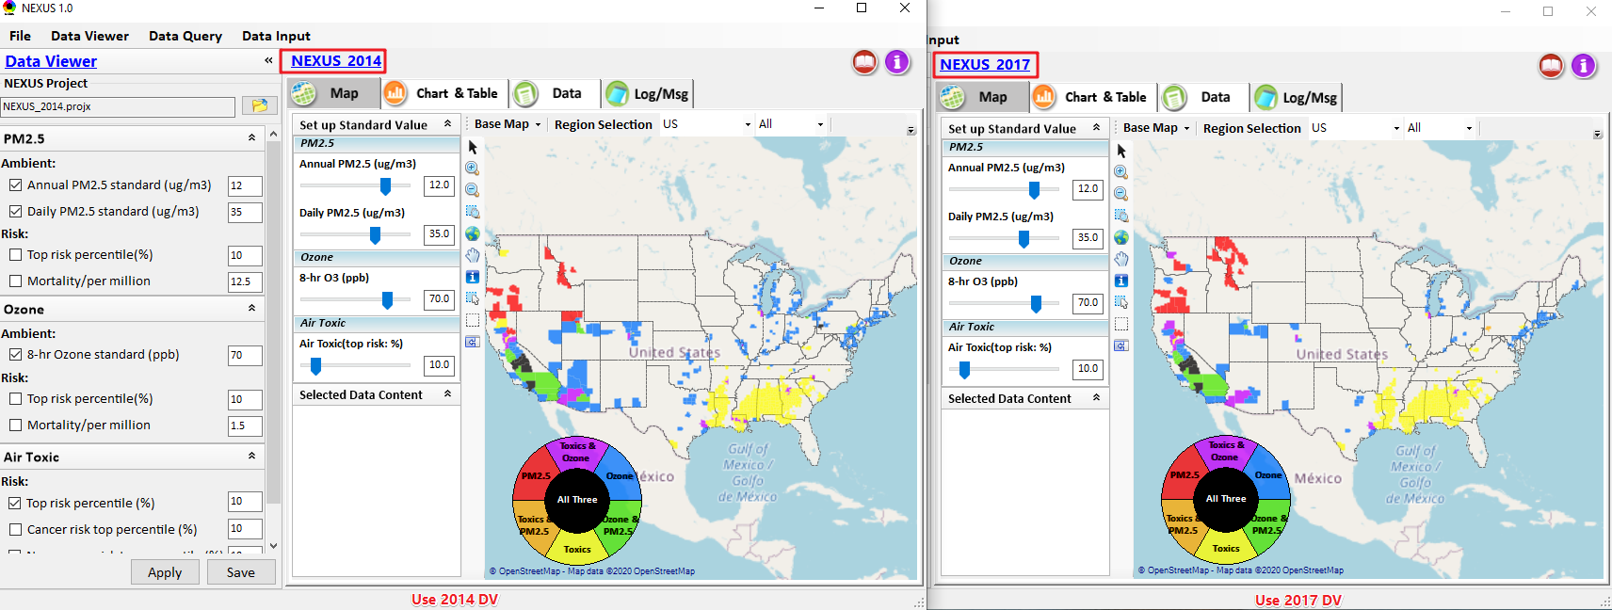

Data Query Development
- Use bold font for “Apply to Map” and “Configure Data Query”. Remove the “daily pm2.5 risk” option under the “Filter Configuration”.
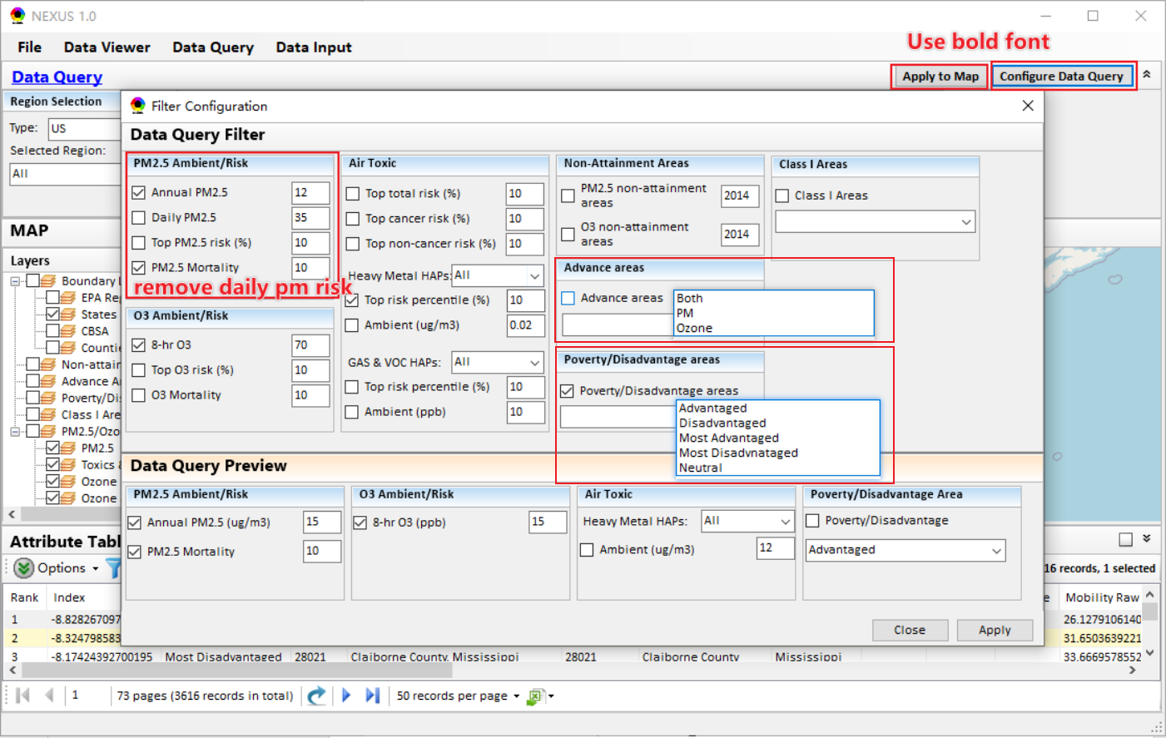
- Support to take out the “Attribute Table” window to maximize.
      - Click the button on the right top of “Attribute Table” title, this “Attribute Table” window will pop up as a floating “Attribute Table” window;
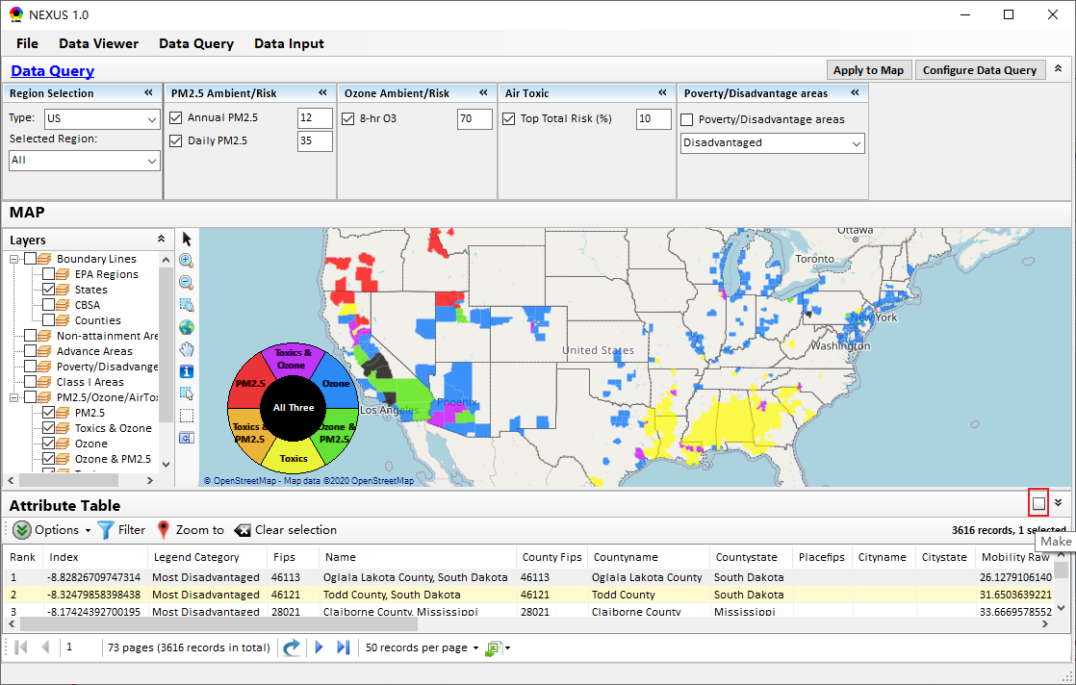
      - Under the floating “Attribute Table” window:
(a)Click the button on the top to maximize this window; (b)Click the button on the top to come back to the “Data Query” window; (c)Click “Filter” button, show the filter panel and allow users to set up filter to query data.
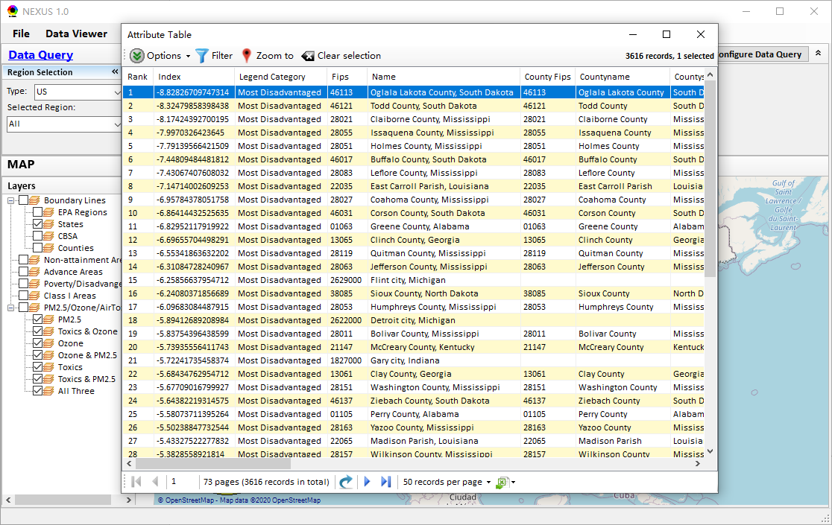
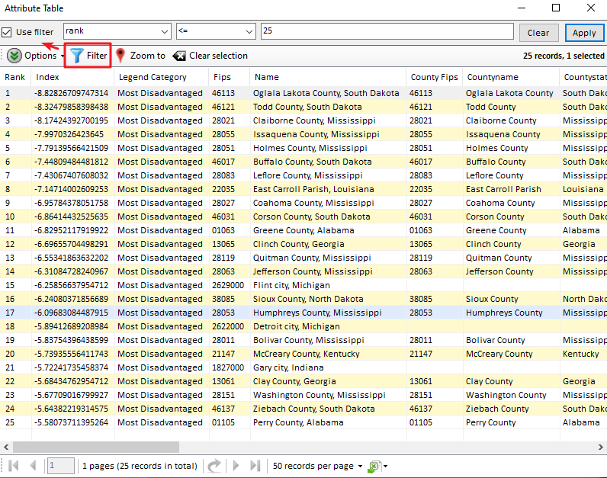

To do list:
  - Support to multi-select regions to combine the data (e.g., emission, mortality) to conduct multi-pollutant “Region Analysis”.
  - Under the Data module, provide a “Summary Table” that includes all kinds of data from “Data Input” module, e.g., join in the current data with Poverty/Disadvantage data.
  - Develop similar function like “EPA Regions” & “States” for “CBSA” under “Region Selection”
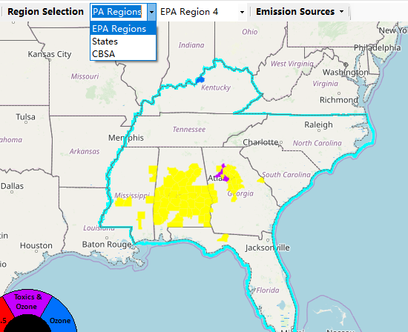
  - Continue to develop the Data Query module
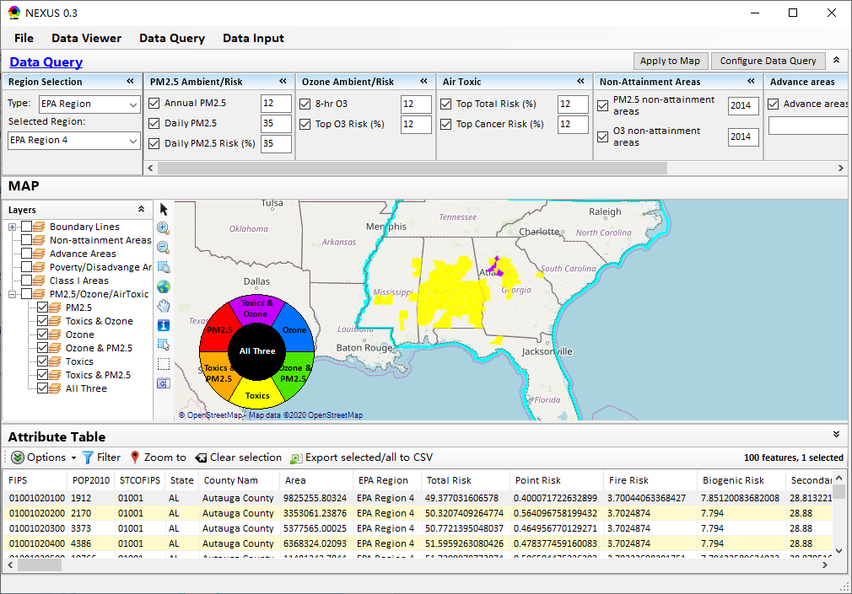
  - Develop the Table Generator module
