Script for NEXUS 3.0 Demo on 5/10/22

- Beth – Carey, I’m putting on my national program manager hat and I’d like to use the NEXUS tool to conduct a national screening analysis.

  - Carey – Great, let’s open up NEXUS! This is NEXUS’s launching page with a national GIS county-level map <opens up NEXUS 3.0 as Beth is talking>

- Beth – From looking at the legend on this national map, I can see the counties that meet all three default criteria selected for PM2.5, Ozone and Air Toxics are colored in black. It looks like areas that only meet the selected criteria for Ozone are colored blue, toxics are colored yellow, and PM2.5 are colored red. Then the overlap of categories is colored green, orange and purple as appropriate. Do I have that right?

  - Carey – Yes, that is correct. You can also click a county to see more detailed information about this county <hovers over color legend, then click a county w/ black color>

- Beth – Great, I’m interested in seeing a map of locations that are above the NAAQS for O3 or PM2.5 or have high air toxics risk estimates. The default settings in NEXUS appear to be the NAAQS levels for annual PM2.5 of 12 ug/m3 and daily PM2.5 of 35 ug/m3, and 70 ppb for O3; however, the air toxics metric seems to be different in this case?

  - Carey – Yes, since there is no ambient standard for air toxics, we use the cancer risk estimate for air toxics, and the default setting is cancer risk value greater than 40 in 1 million per year, which is close to the 90 %tile risk value. <hover over air toxic and values>

- Beth – I also see that both the annual and the daily PM2.5 standard are selected as the default setting in NEXUS. I assume this means that an area on the map will be colored red if either of those criteria are being met, and if I’m only interested in one, I can deselect the other and the map will update?

  - Carey – Yes, that is correct. For example, you can de-select daily PM2.5 and keep only the annual PM2.5 standard <hover over to show where the both the annual and daily PM2.5 standards are selected. De-select daily PM2.5 standard and “Apply”>

- Beth – Oh wow, okay that is really helpful. I’ve heard that EPA is considering lowering the standards for PM2.5 and O3. Can you show us what that would look like if this were to happen Carey?”

  - Carey – Yes, you can use the slider bar to adjust the threshold and the map should update instantly <slide PM2.5 bar down to 10 or 8 ug/m3 & slide O3 to 65 ppb on the left-hand side for O3>

- Beth – Wow, I see there would be a lot of new areas of concern if the standards are lowered. These areas that are popping onto the map should consider joining EPA’s Advance program! The Advance program promotes local actions in attainment areas to reduce ozone and/or PM2.5 to help them continue to maintain the NAAQS. Can you show us how the cancer risk is measured Carey?

  - Carey – Sure, let us take a look at the control panel <hovers over cancer risk to show floating text>. The NEXUS tool uses the “max census tract-level in a county” as suggested by Air Toxic team. So, for a county to meet the criteria for toxics, at least one census tract must have a cancer risk estimate greater than 40 in 1 million <hovers over cancer risk>

- Beth – If I don’t want to look at risk value, can you select a top risk percentile, such as 90%, for air toxics risk?

  - Carey – Yes, just click the %tile box and then click “Apply” <select top cancer risk percentile of 90% for toxics and “Apply”>

- Beth – Carey, I’m hoping I have the same flexibility of selecting different criteria for PM2.5 and O3. It looks like you can select the mortality rate or mortality number and select your cutoff based on risk value or top risk percentile. If I am interested in looking at risk for PM2.5 and Ozone rather than ambient concentrations, can you switch to a risk percentile for mortality rate or mortality number for PM2.5 and ozone?

  - Carey – Yes, NEXUS can provide the “health risk estimate” for PM2.5 and O3 based on BenMAP results < de-select “ambient” for PM2.5 and ozone, then click risk percentile for PM2.5 and ozone, then “Apply”>,

- Beth – Thanks Carey. Now I see more areas showing up in the East. Can you show us what would happen if we lowered all criteria from the 90th %tile to the 80th?

  - Carey – Yes, you just need to move the bar from 90%tile to 80%tile <slide selection bars down from 90th %tile to 80th %tile>

- Beth – Now I see a lot of new areas showing up on the map. I also thought I saw some advanced options for Air Toxics. Can you click on those?

  - Carey – Sure, let us check the “Advance Options” box under Air Toxics. <click on advanced options>

- Beth – Oh interesting. We know that there are mainly two kinds of HAPS, heavy metal HAPs and Gas & VOC HAPs and I see they are both listed here. Since Heavy Metal HAPs are also part of PM2.5, they can be co-existing pollutants. So, if you select the heavy metal HAPs risk and PM2.5 risk and find counties that are colored orange, does that indicate potential co-pollutant issues?

  - Carey – Yes, that’s right and let us try it out. <select heavy metal HAPs risk and PM2.5 risk, then “Apply”>

- Beth – Ok I can see a lot of orange color on the map where we have heavy metal HAPs and PM2.5 concerns. That’s really helpful. Since Gas/VOC HAPs can be precursors for O3, I assume you could select those and anything colored green on the map would indicate potential co-pollutant issues?

  - Carey – That’s right!

- Beth –I’m also very interested in environmental justice concerns in these communities that have multi-pollutant risk. Does NEXUS have a way to overlay any demographic information?

  - Carey – Yes, the EJ/Demographic information is included in NEXUS and the data come directly from EJSCREEN. You can select EJ/Demographic indicator of your interest to display demographic information < Hover over “EJ/Demographic”>

- Beth – Can you switch the map back to show locations with top risk percentile greater than 90% for PM2.5, O3 and cancer risk and add in the demographic index?

  - Carey – Sure <click “Reset” and “set all to risk-based default %tile” to switch to top risk %tile greater than 90% for PM2.5, O3, cancer risk & top demographic index>

- Beth – I see that green dashes showed up in locations where the demographic index is greater than the 90th %tile. So, locations that are colored black and have green dashes likely have multi-pollutant and environmental justice concerns?

  - Carey – Yes, that’s correct.

- Beth – It looks like there is a drop down so you can select other EJ indicators in addition to demographic index. Are these the same EJ/demographic indicators as provided in EJSCREEN?

  - Carey – Yes, they are the same 7 EJ indicator in EJSCREEN <Scroll down to bottom to show other EJ indicators>

- Beth – I also just noticed the “map layers” button. Can you show us which layers can be toggled on and off?

  - Carey – Yes, in addition to the metrics we already selected, you can overlay PM2.5 and O3 nonattainment areas, advance areas, class 1 areas, tribal areas, and boundary lines. <click on “Map Layers”, diminish control panel, and toggle on/off several of the metrics>

- Beth – This information is really helpful Carey, but I’m still struggling with determining where to focus my efforts. Is there any way to apply rankings to prioritize locations so we know where to dig in further?

  - Carey – Yes, this function is provided under the “MP Risk Ranking” tab <click on “MP Risk Ranking” and “CBSA Risk Ranking”, then maximize the table to show all columns>
------------------------------------------------------------------------------------------------------------------------------------------
New Orleans Example

- Beth – Oh interesting, I see locations like LA, New York, Fresno, New Orleans, and Dallas on the list. This is really helpful for getting a handle on the multi-pollutant and potential environmental justice concerns across the country. But let me put on my regional coordinator hat, can you show me areas with MP risk in the 90th percentile across O3, PM2.5, and air toxics with potential EJ concerns in Region 6?

  - Carey – Sure, you can click on “Region selection” and select EPA Region 6 <select “Regional Selection” dropdown, “EPA Region” and “06”>

- Beth – OK great, I also saw that we can drill down to the state level. I’m aware there are air toxics concerns in the state of Louisiana, especially along the 85-mile stretch of land along the Mississippi River between Baton Rouge and New Orleans that is nicknamed “cancer alley”. Is there any chance we can use NEXUS to see the major emission sources in Louisiana?

  - Carey – Yes, you can click on “Region Selection” and Select “State” and type “L” to find “LA” easily. And then right-click to select “Display emission sources” <select “Regional Selection” dropdown, “State”, and “LA”. Right click on map and select “display major emission sources”, and then “minimize” control panel to allow more map space>

- Beth – It looks like there is a line of sources along the Mississippi River, but I can’t quite tell. Is it possible to change the transparency on the map and switch to something we are more familiar with, like google maps?

  - Carey – Yes, you can easily change the transparency by clicking the color wheel and change the base map to other mapping system you are more familiar with, for example, the “Google Map”. <Click on the color wheel and lower the transparency, change the base map to google map & zoom in to display stretch of river b/w Baton Rouge & New Orleans>

- Beth – Okay thanks, now we can more clearly see the sources along the Mississippi River. I also noticed that a table pops up where you can select which pollutants you would like displayed. If you click on the pollutant titles, will the map update which emission sources are shown?

  - Carey – Yes, it will update what is displayed as you click, for example, click “NOx”, “SO2”, etc. <click different pollutant titles to show how map changes>

- Beth – Thanks Carey. I can see from the legend on the bottom right that the different colored dots for the facilities correlate to emission amounts, right?

  - Carey – Yes, the larger emissions are a warm color, like red, and the smaller emissions are a cool color, like blue <click on “Entergy” as a red source... hover over a blue source>

- Beth – In the table I saw that Entergy Louisiana LLC – Ninemile Point is the top emitter for NOx in the state and I saw the marker on the map when you clicked on it. It’s hard to tell if Entergy Louisiana LLC – Ninemile Point is in the parish that is colored orange or in the parish that is colored black. Can we zoom in to the New Orleans CBSA to figure that out?

  - Carey –Yes, you can quickly select a CBSA and display the emission sources on the map <Under “Emissions & Sources table”, select dropdown, “CBSA”, and “New Orleans”>. You can also click on the counties or parishes and facilities to learn more in the “Data Content” table <click Orleans Parish, Jefferson Parish, and Entergy LLC & hover over “Data Content”

- Beth – Okay great, can we add CO2 equivalent and PM2.5 to the major emissions sources table?

  - Carey – Sure, you just need to click CO2e and PM2.5 <click CO2e and PM2.5 to add to table; uncheck Gas/VOC HAPs & H/M HAPs>

- Beth – It looks like the Entergy Louisiana LLC – Ninemile Point is a top emitter in the CBSA for several pollutants. Is there a way to easily identify potential co-benefits of controlling sources?

  - Carey – Yes, you can click on the source in the table it will highlight all the categories that it shows up in as a top emitter, and at the same time locate the source with a target sign in the map. <click on Entergy Louisiana LLC>

- Beth – Thanks Carey. I’m interested in looking more closely at New Orleans because it has multipollutant and possible EJ concerns, but it would be helpful to see things at the community level rather than county level. Is that possible?

  - Carey – Yes, we have just recently developed a more refined community-level analysis capability called “Proximity Analysis” module <right-click and select “display proximity analysis”> <minimize “Radius of analysis” circle first> You may find the new window has the same area but provides a more refined resolution at the census-tract level, particularly over the urban areas such as New Orleans.

- Beth – Great, so it looks like we can setup our threshold at the top left for PM2.5, O3, air toxics, and EJ/demographics, but now the data is displayed down to the census tract level, correct?

  - Carey – Yes, and you can adjust the slider bars or type in numbers and the map will update accordingly <move slider bars down to show how map updates, then reset>

- Beth – I see you can also select whether to display PM2.5, O3 or air toxic risk surfaces, morbidity risk surfaces, fused PM2.5 or O3 concentration surfaces, and the various EJ indicators. Can you show us how to update these surfaces and toggle them on and off?

  - Carey – Sure, you can select different air quality mortality or morbidity risk, concentration, and EJ indicators and select apply. Then under the legend section, you can toggle on and off the surfaces to provide spatial analysis for PM2.5 risk, ER visit-respiratory, fused PM2.5 and EJ/demographic indicator < zoom in closer to New Orleans, check/uncheck boxes to toggle on and off metrics>. You can also select different metrics, < hover over O3 risk, fused O3 and individuals over the age of 64, >

- Beth – This functionality is really helpful for conducting spatial analysis. But I see that there is an adjustable “radius of analysis” circle on the map and that you can select a location for proximity analyses. When you were toggling on and off layers just now, I noticed a census tract that has air toxics and PM2.5 concerns and is in the 90th percentile for PM2.5 risk and demographic index. Can you show us what proximity analysis looks like in that community?

  - Carey – Sure, you just need to double-click and choose a census tract of interest as the centroid < click the census tract to select its centroid”, select census tract 22071007501, reduce radius of analysis to 1km>, Then you can click “summary plot” to see bar charts of your results. <click “summary plot”>
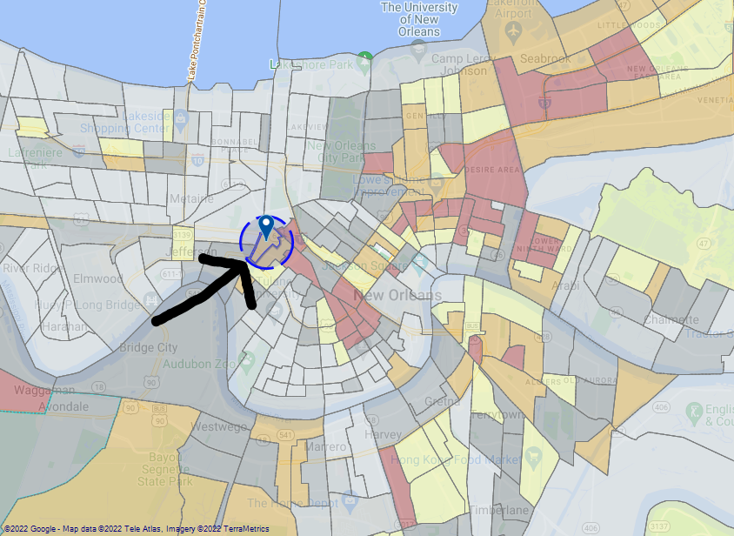

- Beth – Wow this is really helpful to visually see the information for this census tract. So, if I’m interpreting this correctly, the national average air toxics risk (which is the yellow bar) is 55%tile, the region 6 average is 72%tile, and the average for Louisiana, the CBSA, the County and within 1km of the census tract centroid we selected are all above the 90%tile - and PM2.5 & demographic index are also higher than national and regional averages, is that correct?

  - Carey – Yes that’s correct

- Beth – And what if I was interested in looking at this data in a table rather than a plot?

  - Carey – You can click on summary table to see the raw data <click “summary table”> and you can also download the data from “Output” icon here to create your own charts and graphs <click “output”>

- Beth – Carey, I am interested in seeing the MP risks and EJ analysis for a facility with high source emissions, but can we switch to explore the Baton Rouge CBSA?

  - Carey – Sure we can change to the Baton Rouge CBSA <select CBSA from “region selection” dropdown and select Baton Rouge> and right click to display major emission sources <right click and select “display major emission sources”>

- Beth – OK thanks, and in the major emissions table, I see that the Exxon Mobil Chemical Plant in Baton Rouge is a top emitter for NOx and Gas & VOC HAPS. Can you add PM2.5 and VOCs to the table and see if it is a top emitter for those as well?

  - Carey – Yes <click to add PM2.5 and VOC to table, unclick SO2 & H.M. HAPs>, and we can confirm that it is a top emitter.

- Beth – So it looks like there are air toxics and possible EJ concerns near the Exxon facility, and there are also several other top emitting sources nearby. Can we do a proximity analysis within 5 kilometers of the Exxon facility and look at the summary plot?

  - Carey – Sure, we just need to double-click the Exxon facility and then adjust radius to 5-km. <double click on Exxon Facility, increase radius of interest to 5km, and select “summary plot”>

- Beth – Thanks, so it looks like the air toxics risk is 99th %ile within 5km of the facility, PM2.5 risk is 59th %tile and the demographic index is 95th %ile. Is there a way to see if there are any monitoring sites nearby?

  - Carey – Sure, you can right-click on the map and select “display monitoring sites/data” <right click the map and select “display monitoring sites/data”>

- Beth – Ok great, and I assume this table is similar to the emissions table so we can select the different pollutants and it will update the map to show where the monitoring sites are located. I see PM2.5 monitoring sites on the map currently. Can we see monitoring site locations for the other pollutants?

  - Carey – Yes, you can click through the pollutants and see where the monitors are located <click through pollutants and let map update, stop at “O3” monitoring site>

- Beth – So I see some monitoring sites for O3, PM2.5 and Gas & VOC HAPs near the facility, but none for heavy metal HAPs. This tool could be really useful as we work to identify gaps in the monitoring networks, particularly as it relates to potential environmental justice areas that have multi-pollutant concerns. Is there a way to see the PM2.5, O3 and Gas & VOC HAPs data from sites near the facility?

  - Carey – Yes, you just click on the pollutant you want to display <click on “PM2.5” in the table> and click on the site nearby the area of interest to see the trend <click on West Baton Rouge Parish Site to show PM2.5 trend, click on East Baton Rouge Parish Site to show O3 and click on East Baton Rouge Parish Site to show Gas & VOC HAPS>

- Beth – It looks like their PM2.5 and Gas & VOC HAPs levels have come down significantly with time which is encouraging. Their ozone levels have also come down but are still rather close to the standard. I can see how NEXUS could be very beneficial as the new wave of monitoring funding is rolled out to help select locations for new monitors. I see there are some census tracts to the southeast that have multipollutant and possible EJ concerns, but no monitors. Can you show us the summary plot for one of those census tracts at a 2-km radius to see if it is a good location for monitoring?

  - Carey – Sure, I can just double-click on one of the centroids here and show the summary plot <click on centroid 22033001102, adjust radius of analysis to 2-km, and click “summary plot”>

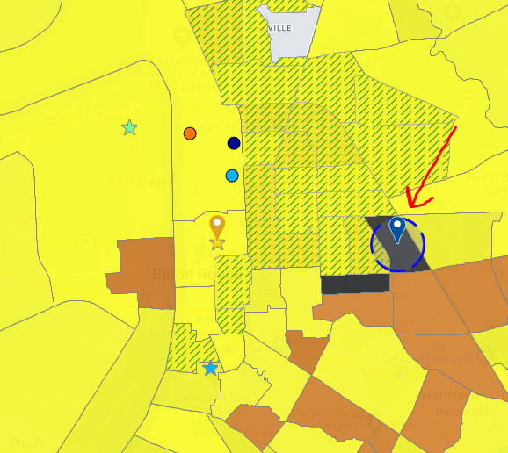

- Beth – Oh wow, they are 99th %tile for air toxics risk, 82nd %tile for demographic index, and 92nd %tile for PM2.5 risk, so this is a location that could be considered for additional monitoring.

- Carey – Yes that’s right.

- Beth – What if I am interested in proximity analysis for multiple locations, monitoring sites, or facilities. Is there a way for NEXUS to provide that information?

- Carey – Yes, we have developed a new “Select Sites” function to give users that ability. <Hover “Select Sites” tab>.

- Beth – Oh great! Can you show us an example of how it works for the state of Louisiana?

- Carey – Sure, we can go back to “Region selection” to select the State of Louisiana <click on “Region Selection” to select State/LA>. Then let us click the new “select sites” tab, and then a window will pop up to allow you to select one or a group of monitoring sites, facilities, or locations <Click “Select Sites” tab>.

- Beth – Can you show us how to select PM2.5 and/or O3 monitoring sites?

- Carey – Sure, you can select “PM2.5 monitor site” group or “O3 monitor site” group or both <Select/toggle “PM2.5” & “O3” check boxes>. Here you can also select any PM2.5 sites or all PM2.5 sites in LA and click “Apply” <Select/toggle several or all PM2.5 sites and “Apply”>.

- Beth – Wow, and if we click the “summary plot” or “summary table” will we see the grouped proximity analysis results?

- Carey – Yes! <Click “Summary Plot & Table” tabs>

- Beth – Great! This seems to be quite useful and really powerful, but what if I am interested in the proximity analysis results for individual sites?

  - Carey – You can click “Create Individual Sites Table” to show the individual sites’ reporting table <Click “Create Individual Sites Table”>. This table include all 14 PM2.5 monitor sites reporting PM2.5 data in LA since 2017.

- Beth – Thanks Carey. Is it possible to adjust the radius of analysis or the scale for highlighting numbers of interest in the table?

  - Carey – Yes, you can easily make those adjustments <Click “Radius” and then “highlighted number scale”>. You can also output the table to an Excel Spreadsheet by clicking the “Output” tab <Click “Output” tab>.

- Beth – Wow! This is really great Carey, but now I’m wondering if this would be possible to create a table for the entire nation?

  - Carey – Yes again, you can click “Create National Sites Table” to show all national PM2.5 monitor sites’ results over CONUS <Click “Create National Sites Table”>. However, this will take a few minutes, so for the sake of time, let me show you the proximity analysis results I created earlier for all national PM2.5 monitor sites <Open “Excel file” for “National PM2.5 site table”> to support the new national monitor siting project initiative.

- Beth – This is great. I also see options for selecting sources and facilities. So, I assume we can do something similar as what we just did with the monitoring sites. Can you show me an example with EGUs and petroleum refining?

  - Carey – Sure, you can select one or a group sources/facilities in the same sector group, such as EGUs <Click “Select one or a group of sources/facilities”, then “Select all” & “Apply”>. And then you can switch to different emissions sector group, like the “Petroleum refining” sector group in LA that you mentioned <Click “Clear” first, then select “Petroleum refining” sector, then “Select all” & “Apply”, and then click “Create Individual Sites Table”>.

- Beth – OK thanks. I really appreciate that it gives you an estimated time for how long it will take to create the table. And can you create a national table like we did with the monitoring sites?

  - Carey – Yes, you can create national tables <Click “Create National Sites Table”> for all emissions sources under this selected sector group over the entire nation (e.g., EGUs, Petroleum refining, etc.) <Open “Excel file” for “National EGUs site table”>

- Beth – Thanks Carey! And what if I was interested in selecting specific census tracts rather than monitoring sites, sources, or facilities?

  - Carey – No problem, you have the choice of selecting multiple census tracts by clicking the location to add census tracts <Click map to select several census tracts, then “Select all” & “Apply” & “Create Individual Sites Table”> or enter “latitude/longitude” <Click “Latitude/Longitude”, then “Select all” & “Apply” & “Create Individual Sites Table”>.

- Beth – Wow, thanks so much Carey. I can see how NEXUS could be incredibly beneficial to national, state, and local officials who are trying to identify and solve multi-pollutant air quality issues while also considering environmental justice. It’s great that the tool provides so much useful information in one place. Thanks so much for walking us through its functionality!

  - Carey – You are very welcome! If you have any questions or suggestions, please feel free to let us know!

