NEXUS 1.8.6 – Beta Testing Comments and Questions
Rich Damberg - 7/1/2021
Overall, this tool has a lot of great data and functionality that could be useful for many programs. Some of my comments get at improving the design from a user perspective. I would be happy to discuss these comments in more detail…
Genearal Response: Thank you very much for your valuable comments and taking time to put together this impressive list of comments and questions for the updated NEXUS 1.8.6! Below are my initial responses, and in our 7/20 (Tue) meeting, we may discuss and go thru this list in further details if it is OK with you.
In addition, we are interested in knowing what AQPD would like from NEXUS for Advance/NAA areas analysis so we can consider and incorporate those enhancements as part of engaging with Regional APMs. Also, for the preparation of upcoming “Regional Packets”, we are also interested in your opinion as what is the preferred method to rank areas and then what information is desirable to provide for EPA Regions in addition to a tool demo illustrating how one can access these data/generate summaries themselves.
One caveat is that we have to be somewhat resource-minded due to the resource limitation toward the NEXUS tool development, so we typically prioritize the list of NEXUS ugrades/improvements as follows:
- Bugs/errors/easy fixes-list: will do
- To-do-list: will do as much as we can in priority order
- Wish-list: will consider when resource is available and time is allowed

DATA VIEWER-MAP
- When system loads, header says “Nexus 2014” and file is Nexus_2014.projx. Assume this is because toxics data is 2014 vintage? And this will change to “Nexus 2017” shortly when 2017 Nata is loaded?
  - Response: Yes, “Nexus_2014.projx” was built based on current set of available 2014 (default) input data files under “Model Input” module. When updated data are available, users can replace any of these input data files and re-run the NEXUS by selecting “run & save project” tab to create a new “project” file; for example, when 2017 risk data are available, we will run “NEXUS 2017” to create a “Nexus_2017.projx” file (take several minutes to run). Note that under “NEXUS 2014”, only the risk data is based on 2014 data due to its availability, the other data are being updated up to 2018~2020 (e.g., NAA, DVs, Advance areas, etc.).
- The entry screen includes selections for “top risk percentile” for ozone and PM2.5. Could it say “top mortality risk percentile”? What is the logic if the user enters a search criteria for PM2.5 annual = 10 and “top risk percentile”=90? Is the logic AND or OR? Is it the top 10% PM2.5 risk areas across the country PLUS all areas with annual PM2.5 over 10, or is it the top 10% risk areas WITHIN the annual PM2.5 areas over 10? Also: Note that in NAAQS implementation world, after the standard has been set, there is little reference to top risk percentiles for ozone and PM2.5. It may be useful to add a tool tip here if it is possible.
  - Response: (1) the column width is somewhat limited so it is difficult to add “mortality” to “Top risk percentile”. However, when “Top risk percentile” is checked/selected, “mortality” is clearly shown below so mortality risk should be obvious to users, (2) The logic is “Or”. This will be clarified by adding “or” in the screen in the next version. In addition, users can find all the AQ and risk data under the “Selected data content” tab when clicking a county of interest in the NEXUS map.
- Entered the following criteria as an example: PM2.5 annual = 10, 24-hr PM2.5 = 25, ozone = 65, Cancer risk: top risk = 90%. EJ demographics: top percentile, demographic index = 90%. Hit apply and generated map.
- Comment: The main entry point to the system is Data Viewer. My initial reaction here is: once the user has entered unique search criteria, they may want to add additional layers…. Such as to identify what tribes or nonattainment/Advance area counties also have high toxics risk, for example. But these boundaries are not available from Data Viewer. When you go to the Data Query tab, all of this functionality is available PLUS the boundaries. Yet the Data Viewer-Map tab is the first thing the user sees upon entering the system. Is there a reason to have different map interfaces in Data Viewer and Data Query?
  - Response: The main principle of NEXUS prototype design is user-friendly and has a simple, clean, and easy-to-use GUI. The philosophy is that >80% are common users and they may use <20% of the functions. In order to make NEXUS user-friendly for most common users, we initially developed the “Data Viewer” module to be more straightforward and easy-to-use in the launching page, while we later developed “Data Query” module for more advanced and exploratory users when we started to received more data and information (from initially only 2 input data files to currently 11 data files and growing). We keep this function design concept since there was no objection in the prototype design stage. At this point, it would be a major design change if we try to consolidate these two modules; however, this is still possible if management team has agreed with this change and is willing to find fund and support this change.
- Zooming in and out: On the Data Viewer and Data Query maps, if you click the zoom+ button, it zooms in VERY deep initially. Can it be changed to be more gradual? It seems to be more gradual when you click zoom- (zoom out button).
  - Response: I had a similar suggestion to the development team previously as well, but found that it takes longer effort to “zoom-in” to refined level or community of interest (e.g., “zoom-in” to Louisville’s “Rubber town” community). My suggestion is to use the “Mouse” to “move” or “zoom-in”/“zoom-out” (I hardly use the GIS map icons/functions on the left)
- DATA VIEWER - Chart and Table. Left tab = EPA Region Table Generator. Allows user to pick just one region, and then check boxes for tables for ozone, 24hr PM, and annual PM.
- Comment: it provides tables for current ozone and PM2.5 nonattainment and maintenance areas … but if the user had just entered unique criteria to generate a map in Data Viewer-Map, they may expect the next tab – Chart & Table-table generator - to provide a list of counties that meet their unique criteria. (e.g. ozone =65, annual PM2.5=10, 24-hr PM2.5= 25 in example above). Can the tables change dynamically with the user’s search criteria?
  - Response: This may need to go to “to-do list” and we can discuss the priority
- A. Chart&Table-EPA Region Table Generator: Regarding air quality data in these tables: it currently provides data for 2015-17 and 2016-18 in the tables. For public release, I really think it needs to include the most recent data available for everything. For ozone and PM, that would mean 2018-2020.
  - Response: Yes, it will be updated to “2016-2018, 2017-2019, 2018-2020” once I receive the most recent 2018-2020 monitoring DVs data from AQAD/AQAG (very likely in the next version).
- Units for the data: My preference would be to present ozone data as integers (in ppb). Ozone is presented in ppb in other areas of the system. For the population data, please use 2020 data, and add commas. For the risk data, is there any reason to include 5 significant digits after the decimal? I would recommend rounding to the nearest integer. All of these comments are to make the data more quickly understandable, especially for the “less technical” user.
  - Response: The ozone unit (ppm) follows the example table received from Beth. We will change to ppb if Beth agrees as well. “2010 population” will also be updated to most recent data and “comma” will be added. The cancer risk data will be rounded to near integer as well (example table has 3 decimal points).
- To generate the tables, the two buttons are Preview and Output, which the user may not fully understand. How about changing to Generate and Excel File, or something like that?
  - Response: Will do, but how about “Generate” and “Output”?
- Can the “select desired tables” include 2 additional categories for Advance areas and Tribes?
  - Response: “Advance area” can certainly be added, but “Tribal area” seems to contain a lot of information (can be a long text) and we need to test it first.
- Chart and table- Nonattainment area. Top box allows user to pick epa region, state, county.
- Next box says “Set up standard value” and has a slider at the bottom. This may be confusing to users. And it allows user to pick only one of annual PM2.5, ozone, or air toxics. This could be confusing because the main tab is for Nonattainment Areas, and air toxics is not nonattainment related. The other confusing aspect is that the user previously selected search criteria that could include areas that meet criteria for PM2.5, ozone, AND air toxics, yet this box limits the user to only one of the three, and only to nonattainment areas. Can this be used to search all counties/areas by the values in the sliders?
  - Response: “Chart and table- Nonattainment area” is part of initial prototype legacy that I personally don’t find it very useful. I plan to ask the development team to remove this function in the next version. We can discuss this if you feel that there may be some value to keep this function/tab.
- When moving the slider to different values, the data detail table below seems to change dynamically. But the bar chart does not always match the slider. For example, move annual PM2.5 to 10, the bar chart only includes counties down to 12.4. One other comment: the PM2.5 values in the bar chart should have just 1 digit after the decimal. The ozone values should not have any digits after the decimal.
  - Response: see above
- The bottom box is the “Data Detail” table with FIPs county codes and much detail for each county, including cancer risk for various metrics each for PM2.5, ozone, and air toxics. The risk numbers have 6 or more significant digits…. Can they be rounded to the integer? Also: the column headers are not intuitive to the average user, so there needs to be some explanation easily available. Also: the headers for columns on PM, ozone and toxics data should indicate the year of the data.
  - Response: see above
- The big chart on the far right shows the relevant PM2.5/ozone/air toxics values. For ozone and PM2.5, it should not be just for nonattainment counties if the search criteria included lower levels than that.
  - Response: see above
- If the air toxics box is checked, the big chart header says Top x% of Air Toxic. The largest numbers are in the hundreds, but there is no indicator of the units – the units should be added for all.
  - Response: see above
- Data Viewer-Data Tab. Can the table have a scroll bar on the right side?
  - Response: The “scroll bar” is displayed on the left when you select >50 “records per page”. The default is “20” “records per page”. This is somewhat confusing and I will ask the development to change the default to “50”
- Is the Poverty/Disadvantaged column going to be replaced with a different EJscreen metric?
  - Response: Will do in the next version
- It would be helpful for the column headers to indicate the vintage of the data (e.g. Annual PM2.5 (2018-2020).
  - Response: This is a “2014” project and dataset. The AQ and risk data are all selected for the year of 2014 under this project so they can be consistent. When updated to the “NEXUS 2017” project, they will be all updated together. However, “Data Query module” will allow users to select different years for O3 and PM2.5 DVs (currently up to 2018, and will be up to 2020 in the next version).
- Many of the columns are in terms of percentage, but in the form 0.1234. Can they simply be expressed as rounded integers, such as 12%?
  - Response: Good suggestion and will do in the next version!
- Several other columns are in the form of percentile, with 2 or 4 digits after the decimal. Can they just be rounded integers as well?
  - Response: Good suggestion and will do in the next version!
DATA QUERY
- Criteria entry screen at top. Again, same question about the logic when for ozone or PM2.5 the user checks BOTH an air quality level AND a risk percent level. Is the logic AND or OR? It would be helpful for the user to know. Also: Nonattainment Areas section on far right appears to have nonattainment areas only as recent as 2018. We should talk more about whether users will have the need to select nonattainment areas as of certain years. I might recommend removing the year selection boxes for PM2.5 and ozone. And then keep these lists updated based on the same data AQAG uses to keep their datasets current. I believe they have a way to regularly “poll” the database supporting the Green Book online. It updates every month or so, I believe. I think Brett Gantt or Ben Wells could assist.
  - Response: The logic is “Or” and will be clarify in the next version.
  - We may need to have a discussion about the NAA year selection. My suggestion is to keep the year selection. We may need to maintain some consistency between “Data Viewer” module and “Data Query” module, depending on the default AQ and risk data used (2014 or 2017?). When we update both AQ and risk data to 2017, they will be all updated together. In my opinion, “Data Query module” should provide some flexibility to allow users to select different years for O3 and PM2.5 DVs (currently up to 2018, and will be up to 2020 in the next version).

- Configure data query button (upper right). This brings up a form with Data Query Filter on top and Data Query Preview on bottom. Each section appears to have many of the same fields. This is confusing, and there is no explanatory text anywhere. Why are both sections needed?
  - Response: One is “Data Query Filter” (Selecting fields) and the other one is “Data Query Preview” (Displaying selected fields). I will ask the development team to add some clarification here so users will not be confused. Only the selected (box checked) data fields in “DQF” will be showing up in “DFP” window (you can try to check or un-check the boxes to see the effect easily).
- Map - Source/sector emissions tab: this tab appears to provide the same data as the 2 tabs under Data Viewer-Chart and Table: Major emission sources, and Top X emission sources.
  - Response: Yes, they provide some functions in both modules.
- Selecting Major Emission sources brings up a table similar to the one in Data Viewer, however there are 2 issues: a) there is no box in upper right to close out the table; and b) if you click on the column header (e.g. Nox, SO2, etc), it does not bring up the map with circles for the top X largest sources.
  - Response: (a) I do see a box in the upper right to close out the table (see below), (b) I do see the map circle with top x emitting facilities when selected as well (also see below) (Question: Have you installed the NEXUS 1.8.6 or 1.8.5?)
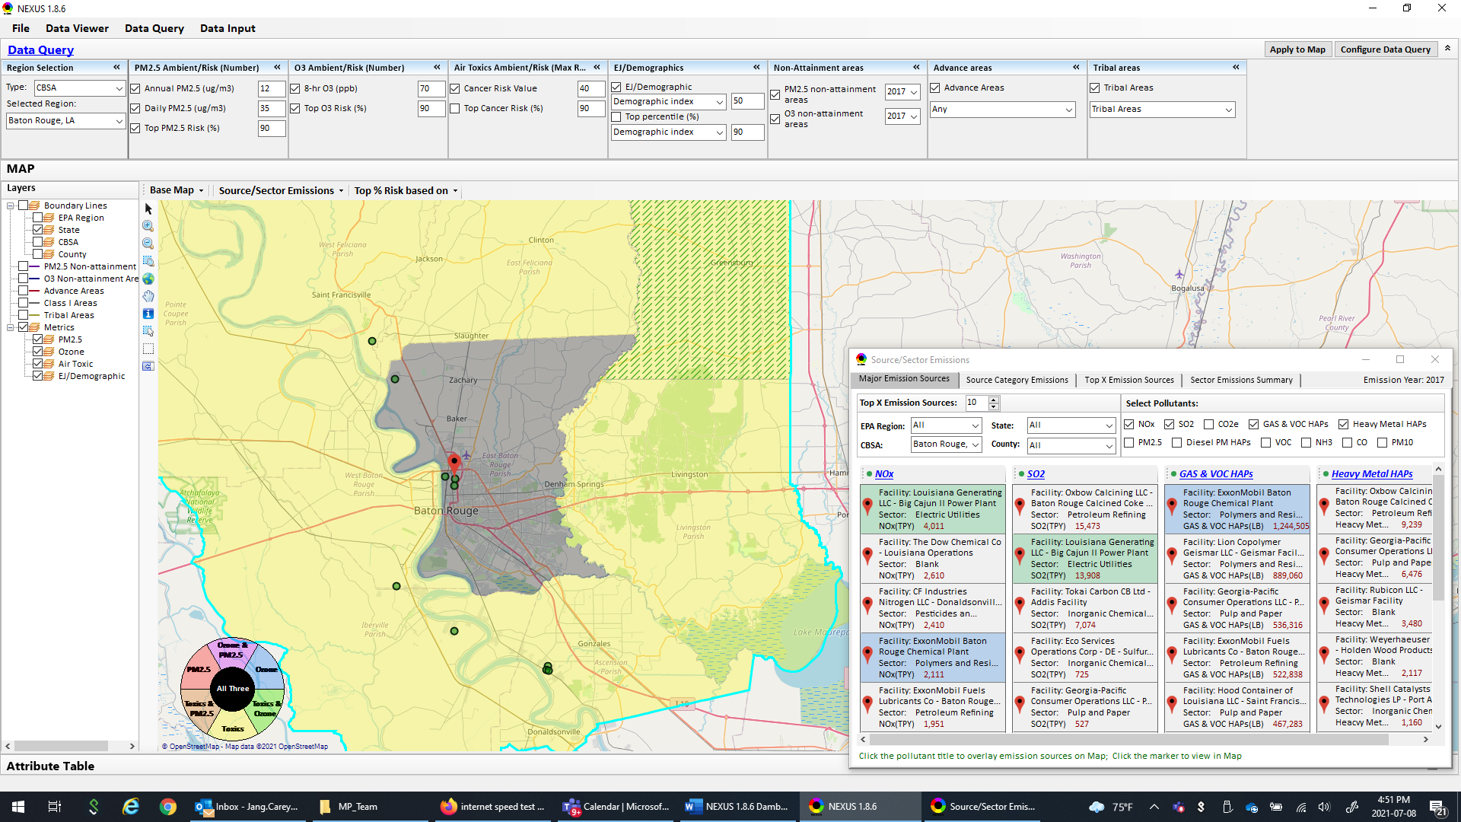
- Source category emissions tab: the categories displayed for each pollutant are nonpoint, road, point, nonroad, and event. It is not clear what “event” covers… wildfire perhaps? It may be more familiar to change road to onroad. Did you consider using the 14 tier 1 categories? Also, same as above, there is no way to close out this window.
  - Response: We will change “Road” to “On-Road” in the next version. “Events” are referred to “wildfires and prescribed burning emissions” based on AQAD/EIAG website (emission inventory group, ).
- Top X emission sources tab: Note that if you don’t choose a geographic area, the title of the chart says Top 10 Nox emissions in All,All. Need to change the All,All. The Y axis title is Site Name. Recommend changing to Facility Name. The x axis title is (10^3). Recommend changing to Emissions (1000 tons per year). Also, same as above, there is no way to close out this window. On the County tab, the top Nox source is Federal Waters, DM. I assume this is related to marine vessels? It is not clear what the DM stands for.
  - Response: This submodule/function is currently under some upgrades/improvements and your suggestions are noted. The scale is flexibly set depending on the scale of emissions (TPY), and “10^3” is not default. Based on the “2017 National Emissions Inventory: January 2021 Updated Release TSD”, “Federal Waters, DM” seems to be related to marine vessels emissions nationwide as you suggested.
- Sector emission summary tab: I checked the box for 2 CBSAs and it generated 2 excel files, one with largest facilities by pollutant, and the other with Total “Sector group” emissions combined for all selected CBSAs (based on Top X facility emissions in each CBSA). It would be useful to be able to generate the total sector emissions in the CBSA regardless of how many sources there are. Could an “All” selection be added? In looking over the list of sectors, I did not see Nonroad, and I did not see Residential heating. Do you know if data is listed for these sectors and I missed it?
  - Response: “Sector” of each facility is defined by a recent work of spreadsheet provided by EIAG (Marc Houyou) and his SPPD counterpart to support OAQPS’s “Sector prioritization” project. This input file will be included as part of “Data Input” module. These tables and their formats are suggested by the project team. This improvement may need to go to the “wish list” for now (unless management team decides to continue to pursue this project effort)
  - In the “sector definition” file I received, it seems that only “Point” sources (facilities) are included. “Non-Point” and other source categories may not be included yet.
- Also: The number of digits after the decimal varies greatly throughout the table. From a visual standpoint, it would be easier to read these tables if all the values were rounded to the closest integer, and you add commas. Lastly: this pop-up table DOES have an X in the upper right to be able to close it out.
  - Response: Since this is an Excel spreadsheet, users should be able to re-format the output data to their desirable format. I do see a “X” to close the table though in my NEXUS 1.8.6.
- Top % Risk Based On tab: This allows the user to base the risk percentiles on national values or on “region.” This functionality seems useful but is not available with the Data Viewer section, correct? Is there a reason for this?
  - Response: This new function is available in both modules.
DATA INPUT SECTION
- The Advance areas dataset appears to be from 4/29/20. Is that correct? I believe you should have a more current dataset from Doug Solomon from around March 2021, when our most recent map was created. Can you please double check this?
  - Response: Yes, the “Advance area” will be updated in the next version to most recent “3/03/2021” mpk file I received recently.

