HEID Air Toxics Products: NEXUS and SaRA
February 7, 2022

Purpose
To provide information on two air toxics data products currently in development 1) NEXUS and 2) the Source and Receptor Analysis (SaRA) tool.
NEXUS
- Goal: Multi-pollutant analysis tool to identify and assess areas with high ambient levels and/or health risks associated with PM_{2.5}, O₃, and air toxics
- Air Toxics risk data: max-tract cancer risk and/or the max respiratory HI in each county based on 2017 AirToxScreen
  - Risks and HIs are for all emission source sectors (e.g., point, mobile, biogenic, fires, etc.)
  - Values provided as both absolute and percentiles for all HAP (total) and for individual HAP
- Monitoring data: AQ monitoring data and trends (2002-2020) for 1) PM2.5, (2) O3, (3) gas and VOC HAPs, and 4) heavy metal HAPs
- Emissions data: tons per year from major emitters of 1) gas and VOC HAPs and 2) heavy metal HAPs
- Demographics: county-level; includes: demographic index, low-income, minority, less than high school education, linguistic isolation, under the age of 5, over the age of 64
- Examples uses:
  - Quickly screen areas across the nation that have combination of high air quality and/or risk levels for O₃, PM_{2.5}, and air toxics as well as areas with possible EJ concerns
  - Ability to ‘dial-into’ specific areas to determine extent to which common emissions sources are causing the MP issues

SaRA
- Goal: Provide actionable air toxics risk information for one or more facilities in a community, including communities with EJ concerns, at a refined scale
- Air Toxics data: block-level cancer risks and 14 different target organ HIs based on the 2017 AirToxScreen (point sources only)
- Emissions data: Source and pollutant-specific risks and HIs available for all facilities (~48,000)
- Demographics: census block group level; includes: population, minority, white, black, Hispanic, Asian, American Indiana, Hawaiian-Pacific, other races, two or more races, under the age of 18, over the age of 64, low income, income 50% below poverty level, income 50 to 99% poverty level, college educated, less than high school education, linguistic isolation, Hispanic, and non-Hispanic
- Example uses:
  - Identify combined air toxics risk for communities impacted by multiple sources
  - Support upcoming RTRs (i.e., HON) by quickly providing screening-level MIRs for all facilities, the risk drivers, and specific sources contributing to the risk
  - Identify census blocks with high risks and populations of specific demographic groups
  - Generate risks and other air toxics data products for annual air toxics data updates

Appendix - NeXus
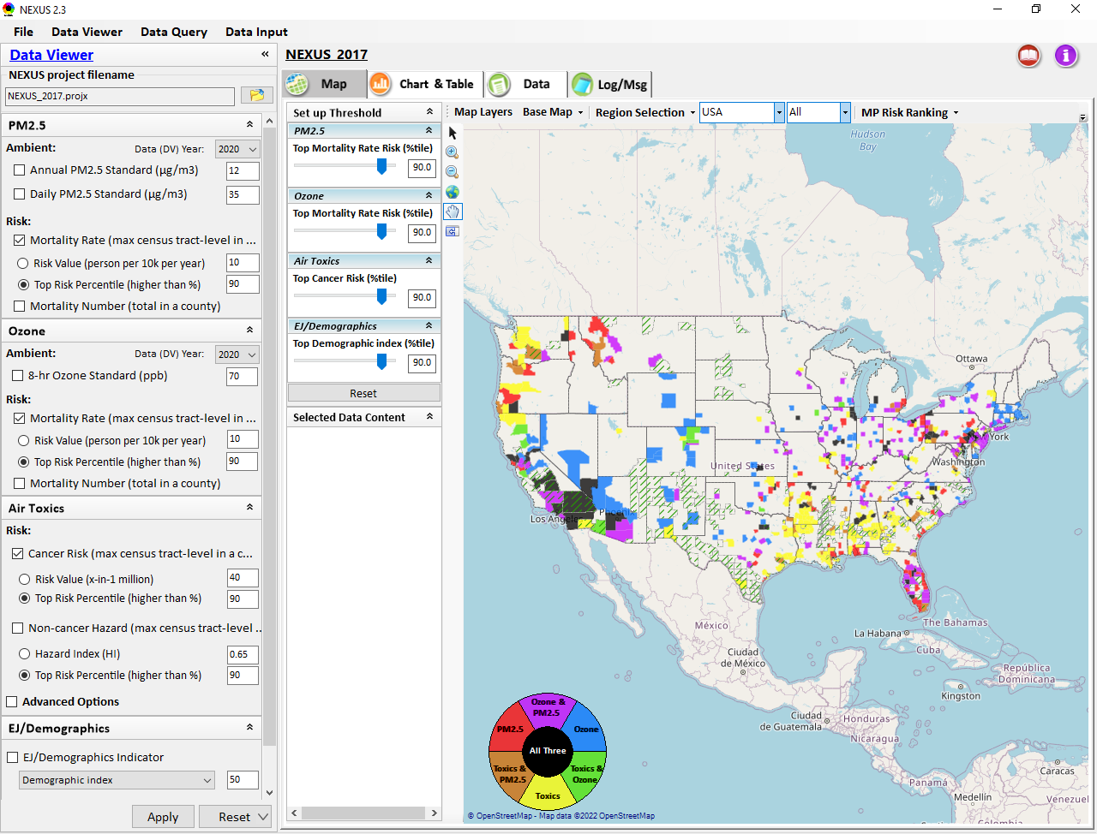
NeXus “Data Viewer” at a national scale. Colors on the map indicate counties meeting specific O₃, PM_{2.5}, air toxics, combinations of the three, and/or EJ/demogrpahic thresholds.
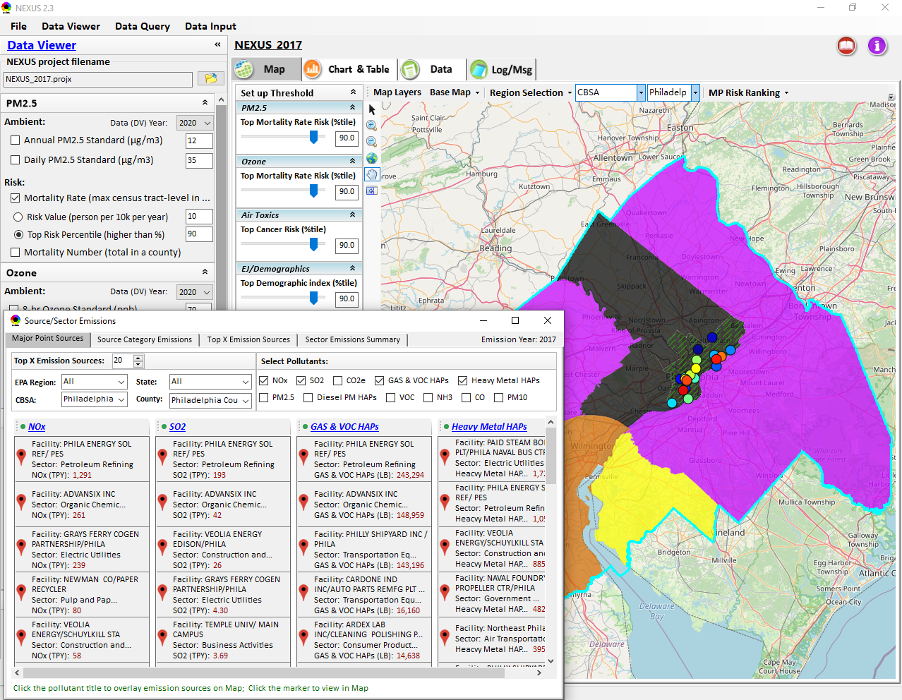
NEXUS “Data Viewer” at a county scale. Color on the map indicate counties meeting specific O₃, PM_{2.5}, air toxics, or combinations of the three. Also shown are major emission sources in the county.

Appendix - SaRA

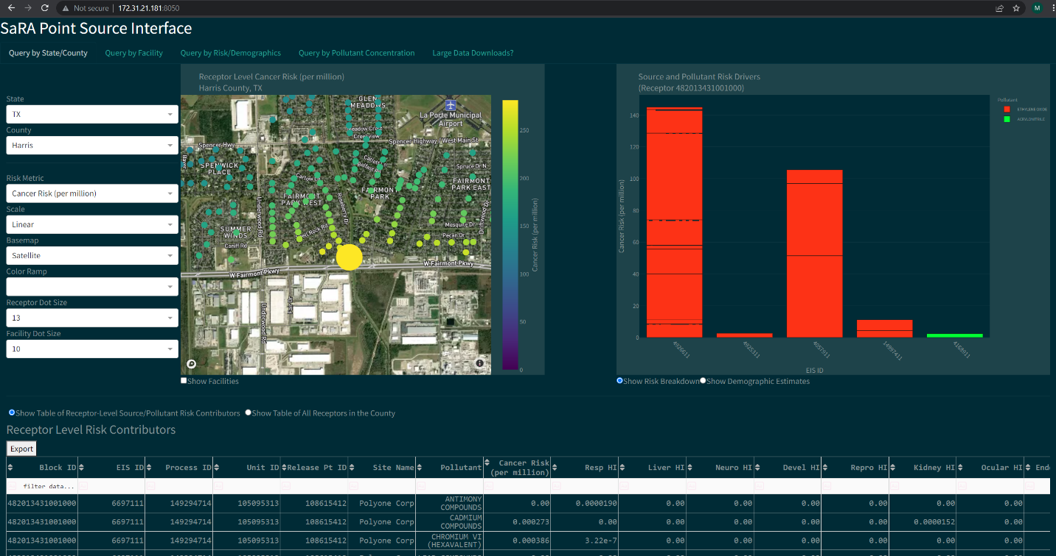Example visualization of SaRA data. Left: Cancer risks at census blocks in Houston, TX. Right: Facilities, pollutants, and sources contributing to the cancer risks at the selected census block.
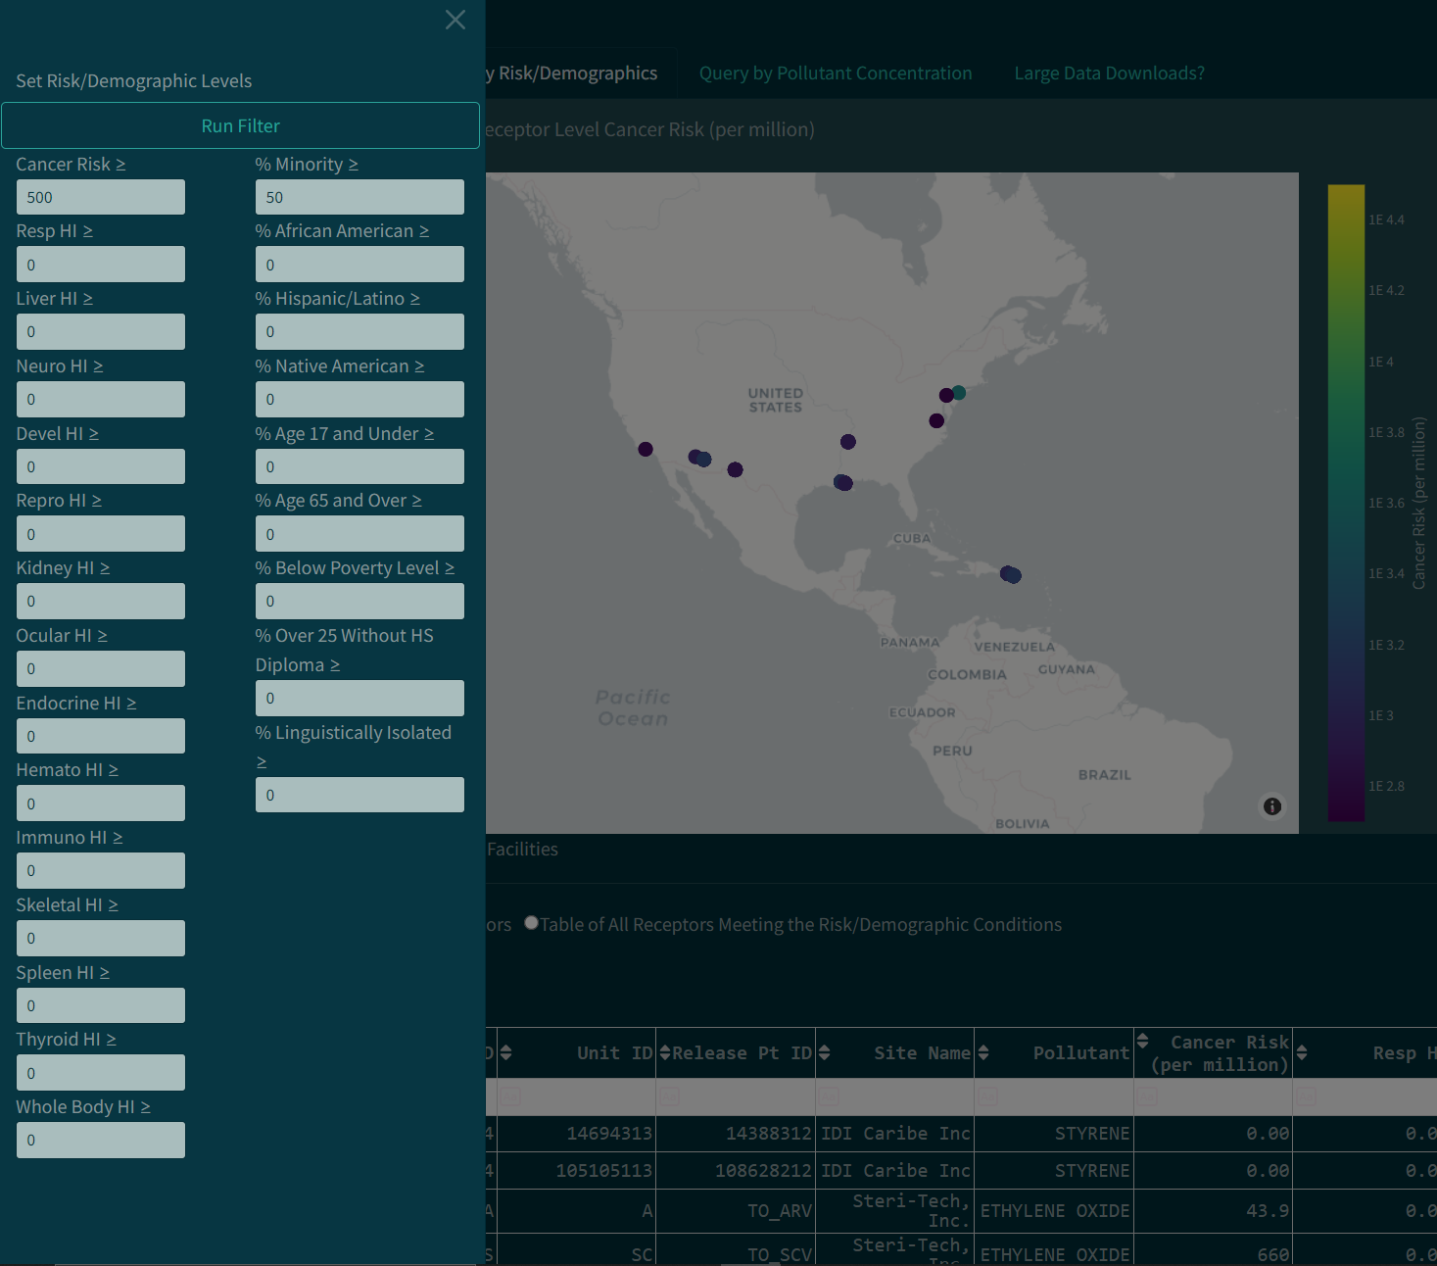 Example search capabilities of SaRA data to find areas of the country where census block risks or demographics meet specific criteria.

Ambient concentrations for O₃ and PM_{2.5} only
Other emission source sectors are in the process of being incorporated into SaRA and would be available to provide context

