Main Improvements of NEXUS 2.5
By SCUT, 2021-4-18

Main Improvements:
- Left-justified the “State/CBSA” column and “Name” column under “individual sites table” module;
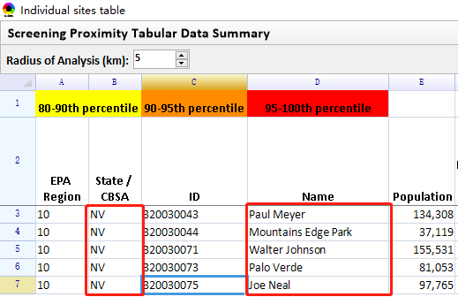
Fig. 1 Left-justified the “State/CBSA” column and “Name” column
- Remove “AK, HI, PR, VI” CBSA under “individual sites table” module;
- Use integer and one decimal point for all “%title” and “numbers” respectively in “Summary table” and “individual sites table” under “Proximity analysis” module, and keep the data format of the output Excel file consistent with that in NEXUS.
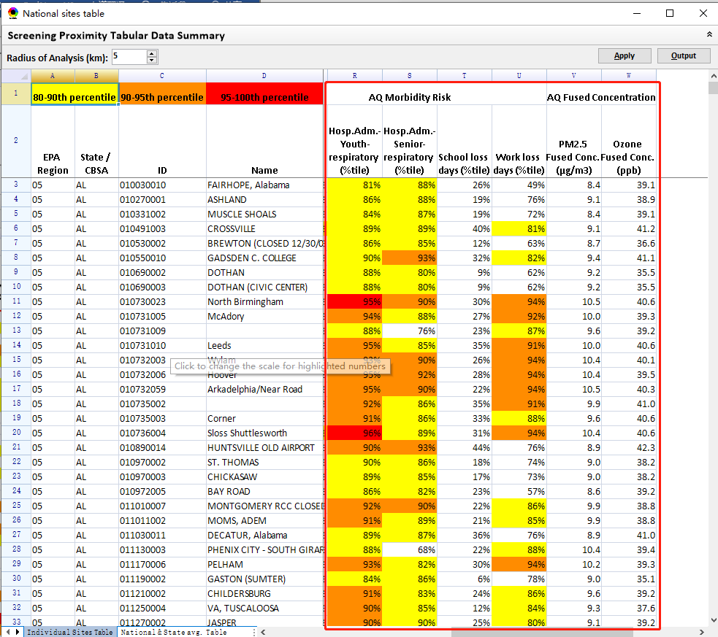
Fig. 2 Use integer or one decimal value for all “%title” and “numbers” respectively
- Fix the bug that there are many “0” numbers for “fused O₃” under “individual sites table” module;
- Develop a “National & State avg. Table” module under “National Sites Table” module;
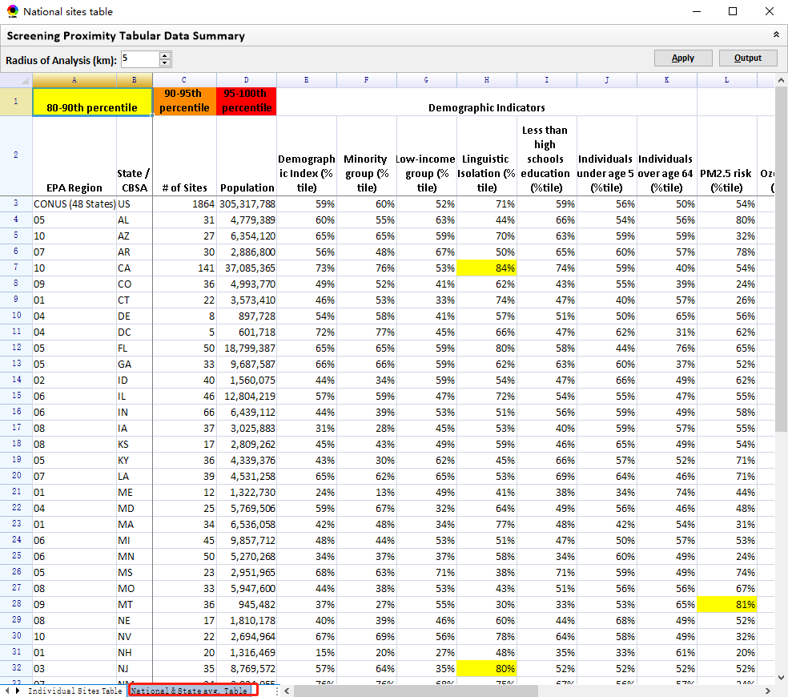
Fig. 3 The “National & State avg. Table”
- Show a tip for setting the scale for highlighted numbers when mouse moving over "A1:D1" cells; Freeze the title cells at the top and the first 4 columns.
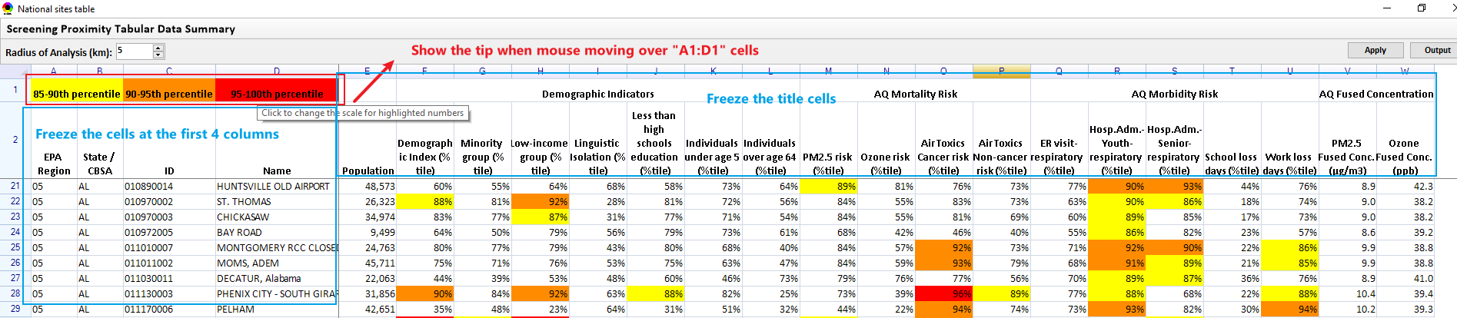
Fig. 4 Updated for sites table

- Update the function of “Reset” button to support to reset the “Attribute Table” to the default.
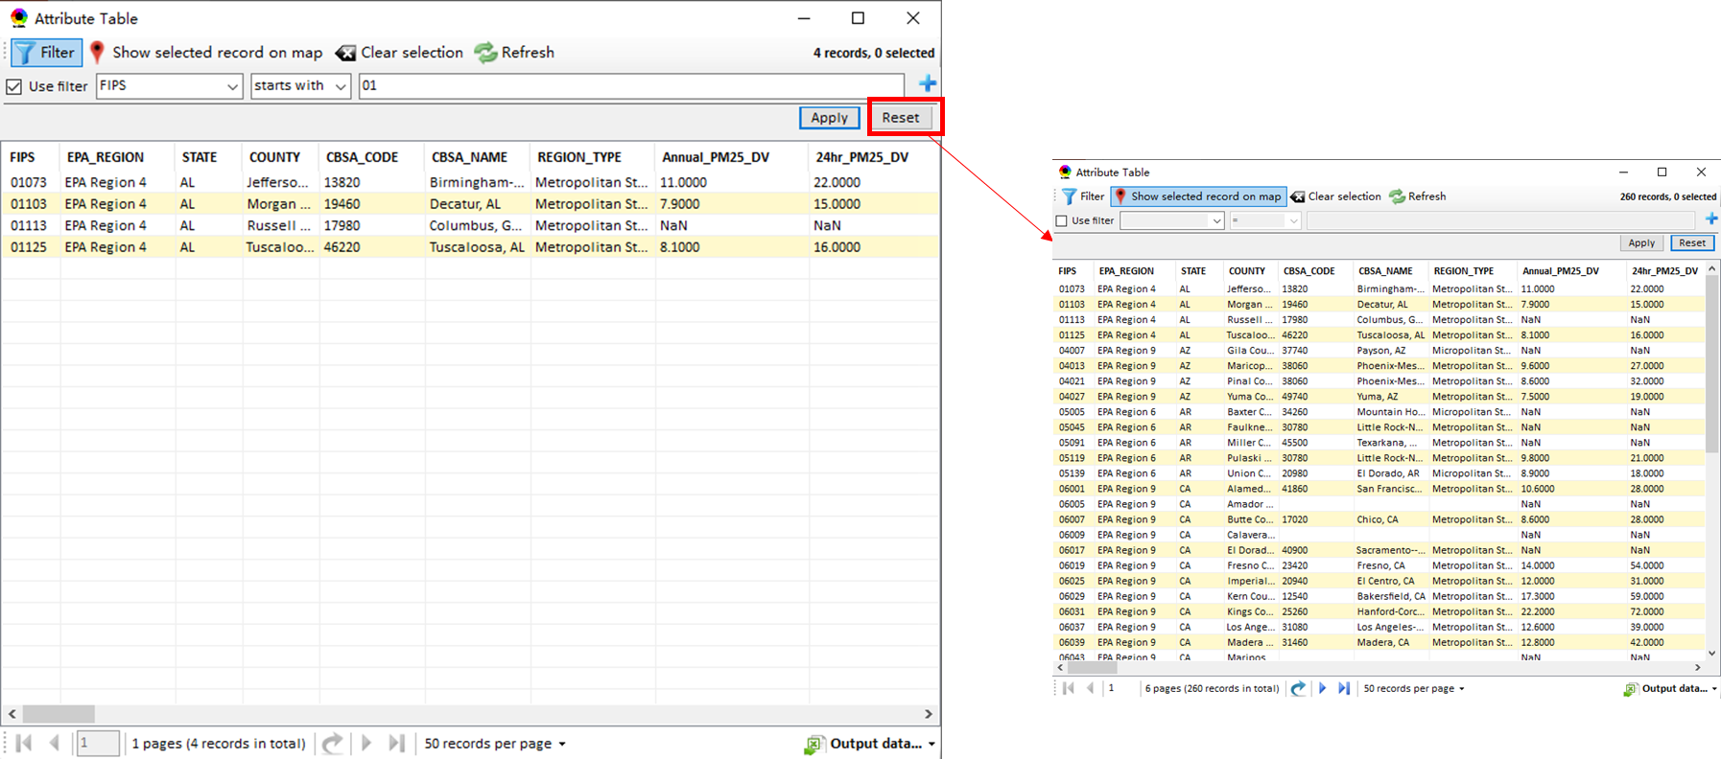
Fig. 5 Update the function of “Reset” button

To Do List:
- Include “morbidity risk” data into “summary table” & and “summary plot” under the “proximity analysis” module.
- Include top risk drivers into the “summary table” under the “proximity analysis” module and list the top 3 air toxic species of cancer risk.
- Add Air toxic concentration data in the “Data Input” module (currently blank and grayed).
- Need to speed up when loading a new project.
- Under Data Viewer → “Data Menu” Table: (1) Adjust all these columns (and the rest) to a narrower “reasonable” size (too wide for numbers) and list headers (titles) to two rows if needed;(2) If %tile is used, change all “%” to “%tile” ;(3) For number under “%tile” or “%”, add “%” to the numbers (e.g., “75.77” to “75.77%”);
- Gray out the HAPs species that have no data available when selecting “GAS & VOC HAPs” (15 species) or “Heavy mental HAPs” (7 species);
- Add “Sector Emissions Summary” under “Chart & Table”.
- Provide a clear base map for Proximity analysis.
- Provide a format validation for input files under Data Input module.
- Add “Tribal” options under Major Emission Source module for support to zoom-in to tribal areas (All & individual) and provide a Tribal Analysis module as given in the PPT sent previously;
- Include “Climate risk” layer data.
- Fix the bug for the “filter” function under Data Input module (see below figure).
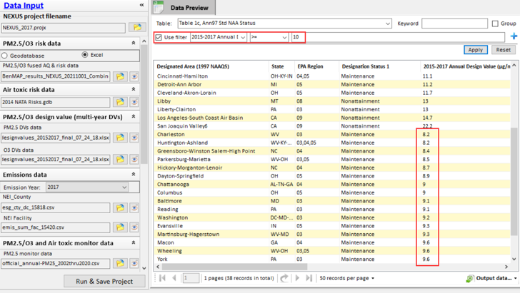
Fig. 6 Fix the bug for the “filter” function under Data Input module

