Air Quality Modeling Assessment Tools (AQMAT) Development
User’s Manual for Flexible Air quality Scenario Tool-Community Edition (FAST-CE) 3.2

Contract No: 68HERD21A0002
Task Order No: 68HERH21F0334
Version: 01

Prepared for: Carey Jang
Task Order Contracting Officer’s Representative
U.S. EPA/OAR/OAQPS/AQAD/AQMG
(Mail Code: C439-01)
109 T.W. Alexander Drive
Research Triangle Park, NC 27711

Prepared by: Yun Zhu, Shicheng Long
College of Environment & Energy
South China University of Technology
Guangzhou, 510006, Guangdong, China

Sarav Arunachalam
Institute for the Environment
The University of North Carolina at Chapel Hill

Date: December 31, 2022
Acknowledgements
In cooperation with the U.S. EPA, the Institute for the Environment at the University of North Carolina at Chapel Hill (UNC-IE) along with the South China University of Technology (SCUT) developed the FAST-CE software. This project was funded by the U.S. EPA under contract 68HERH21F0334 to UNC-IE.

Table of Contents
1 Introduction 2
1.1 Evaluation Principle 2
1.2 Computer Requirements 4
1.3 Installing/Uninstalling FAST-CE 4
1.3.1 Installing FAST-CE 4
1.3.2 Installing FAST-CE Data Installer 7
1.3.3 Uninstalling FAST-CE 8
1.4 Contacts for Comments and Questions 9
2 Terminology and File Types 9
2.1 Common Terms 9
2.2 File Types 10
2.2.1 File Types for OSAT/PSAT/APCA/ISAM method 10
2.2.2 File Types for RSM method 12
3 Quick Start 13
3.1 Load a Previous Project 13
3.2 PM Analysis Quick Start 13
3.3 Ozone Analysis Quick Start 16
4 Main Interface 18
4.1 Meta Data Function 21
5 Run FAST-CE 22
5.1 Source Contribution Input Option 22
5.1.1 Input option for OSAT/PSAT/APCA/ISAM method 23
5.1.2 Input option for RSM method 24
5.2 Emission & Spatial Field Input Option 24
5.2.1 Emission & Spatial Field Input option for OSAT/PSAT/APCA/ISAM method 25
5.2.2 Emission & Spatial Field Input option for RSM method 26
5.3 QA/Validation Input Option 27
5.4 Input File Validation Option 29
6 Operation Results 31
6.1 Map 33
6.1.1 Select 2D/3D plot 34
6.1.2 Configure color legend 36
6.1.3 Show concentration or response value of base/control cases 37
6.1.4 Customize control factors 39
6.1.5 Customize Model Domain 43
6.1.6 Monitor Point/DVs & Projection module 43
6.1.7 Display PM Species value 46
6.1.8 EJ/Demographics Data module 46
6.2 Receptor Analysis 48
6.2.1 Emission Control 1 49
6.2.2 Emission Control 2 49
6.2.3 Source Contribution 1 50
6.2.4 Source Contribution 2 51
6.2.5 Customize receptor regions 52
6.3 QA/Validation 53
6.4 Data 54
6.5 GCAM Scenario Builder 55
7 Case Study 56
7.1 Ozone MDA8 Analysis – OSAT. 56
7.1.1 Create a new project 56
7.1.2 Set up input parameters 57
7.1.3 View results 63
8 Reference 67

List of Tables
Table 1. The headers of Baseline Spatial Field File for O₃ analysis 10
Table 2. The headers of Baseline Spatial Field File for PM_{2.5} analysis 10
Table 3. The headers of Baseline Species Spatial Field File 11
Table 4. File types used by FAST-CE 12

List of Figures
Figure 1. The conceptual framework of FAST-CE 3
Figure 2. Setup Window 4
Figure 3. Choose Install Path 5
Figure 4. Ready to Install 5
Figure 5. Installation Process 6
Figure 6. Complete Installation 6
Figure 7. Choose Install Path 7
Figure 8. Installation Process 8
Figure 9. Uninstallation Process 8
Figure 10. Load a previous project 13
Figure 11. Main Interface of FAST-CE 20
Figure 12. Show Metadata/Model data 21
Figure 13. Add New Rows and Information 21
Figure 14. Delete Rows 22
Figure 15. Source Contribution Input Option 22
Figure 16. Input option for OSAT/PSAT/APCA/ISAM method 23
Figure 17. Input option for RSM method 24
Figure 18. Emission & Spatial Field Input Option 25
Figure 19. Baseline AQ Surface & Emissions Input Option for OSAT/PSAT/APCA/ISAM Method 26
Figure 20. Baseline AQ Surface & Emissions Input Option for RSM Method 27
Figure 21. QA/Validation Input Option 28
Figure 22. Running FAST-CE 29
Figure 23. Data Invalid Warnings 30
Figure 24. Data Unreasonable Warnings 30
Figure 25. Acceptable data tips 31
Figure 26. Data Viewer of the FAST-CE results 33
Figure 27. Map view of FAST-CE results 34
Figure 28. 2D plot 35
Figure 29. 3D plot 36
Figure 30. Configure color legend 36
Figure 31. Show concentration value of base/control cases 37
Figure 32. Show response value of base/control cases 38
Figure 33. Show multiple plots 38
Figure 34. Customize control factors and displaying results 39
Figure 35. Set the Max Slider Bar Value. 40
Figure 36. Group/combine specific factors 40
Figure 37. Pre-defined control filter 41
Figure 38. User-defined control method 42
Figure 39. Edit the Model Domain 43
Figure 40. Configure Color and Size of Monitor Points 44
Figure 41. Compare the Selected Scenarios 44
Figure 42. Display VNA Results 45
Figure 43. Output contribution table 45
Figure 44. Output summary table of contributions to all O₃ monitors 46
Figure 45. Display the PM Species Value 46
Figure 46. Enable EJ/Demographics Data Module 47
Figure 47. "EJ/Demographics Data" Option in Right-click Menu 47
Figure 48. EJ/Demographics Setting Plot 48
Figure 49. Emission Control 1 49
Figure 50. Emission Control 2 50
Figure 51. Source Contribution 1 51
Figure 52. Source Contribution 2 52
Figure 53. Select receptor regions of interest 53
Figure 54. Add new receptor regions 53
Figure 55. QA/Validate module 54
Figure 56. Detailed data results and configuration 54
Figure 57. Steps for GCAM Scenario Builder 55
Figure 58. Emissions output from GCAM 56
Figure 59. Create a new O3 project 57
Figure 60. Source Contribution Method Option for O₃-MDA8 analysis 58
Figure 61. Receptor Region File 59
Figure 62. Mapping File 59
Figure 63. Emission & Spatial Field Input Option for O₃-MDA8 analysis 60
Figure 64. Baseline Spatial File 61
Figure 65. Cases & Emission Files 61
Figure 66. An example of “Emission File” 62
Figure 67. QA/Validation Input Option for O₃-MDA8 analysis 62
Figure 68. Validation Configuration File 62
Figure 69. An example of “QA File” 63
Figure 70. Map results 64
Figure 71. Results of “Emission Control 1” 64
Figure 72. Results of QA/Validation 65
Figure 73. Data results 66

Acronyms
SA Source apportionment
RSM Response surface modeling technique
OSAT Ozone source apportionment technology
PSAT Particle source apportionment technology
CAMx Comprehensive Air Quality Model with Extensions
ISAM Integrated Source Apportionment Method
CMAQ Community Multiscale Air Quality Model
NAAQS National Ambient Air Quality Standards
DDM Decoupled Direct Method
ICET International Control Cost Estimate Tool
SMAT-CE Software of Model Attainment Test - Community Edition
BenMAP-CE Environmental Benefits Mapping and Analysis Program - Community Edition
CMAS Community Modeling and Analysis System
VNA Vector network analyzer
GCAM Global Change Assessment Model
APCA Anthropogenic Precursor Culpability Assessment
ACE Affordable Clean Energy
QA Quality assurance
GUI Graphical User Interface
AQ Air quality
DV Design value
EJ Environmental justice

Introduction
To conduct a comprehensive evaluation of the performance of different source apportionment approaches, a new standalone reduced-complexity tool named FAST-CE was developed to provide greater flexibility and transparency in the estimation of monetized benefits for O₃ and PM_{2.5} reductions. This tool provides fast turnaround times for benefits estimation, which can be an alternative to the more time-intensive application of specific control strategies modeled with a photochemical transport model. With this tool, users can integrate source-receptor relationships generated by photochemical transport models and provide analysis for meeting requirements of regulatory demonstration that range in complexity. The flexible framework allows users to integrate more complex air quality surfaces generated by photochemical models applied with instrumented techniques, including source apportionment (SA) modeling technique (CAMx/OSAT & PSAT, etc.), source/receptor sensitivity modeling technique (DDM) (Dunker, Yarwood et al. 2002, Li, An et al. 2016), and response surface modeling technique (RSM).

Evaluation Principle
Various methods have been applied to characterize and quantify the relationship between emission sources and pollutant concentrations. For example, model source apportionment approaches like Ozone source apportionment technology (OSAT) and Particle source apportionment technology (PSAT) in Comprehensive Air Quality Model with Extensions (CAMx), or the Integrated Source Apportionment Method (ISAM) in the Community Multiscale Air Quality (CMAQ), augment the model by adopting a system of tracer species to track the sources of ozone or PM_{2.5} and its precursor species for selected groupings of emissions categories and geographical regions (Li, An et al. 2016, Mojtaba, L. et al. 2018). The DDM integrates the sensitivity equations decoupled from the model equations and then calculates the sensitivity coefficients of the response of O₃ and PM_{2.5} concentrations to changes in model inputs (e.g., initial concentrations, boundary conditions, emission rates, etc.) using mathematical technology, while RSM uses advanced mathematical statistical techniques to characterize the relationship between model outputs and input parameters in a highly economical manner.

Accordingly, based on the above principles and the gridded photochemical model source apportionment surfaces or photochemical model DDM sensitivity coefficients generated by them, FAST-CE can modulate those surfaces to generate a new air quality surface, visualize the change in the air quality surface, and conduct a comprehensive comparison among OSAT/PSAT & ISAM, RSM, and DDM. The conceptual framework of FAST-CE is shown in Figure 1.
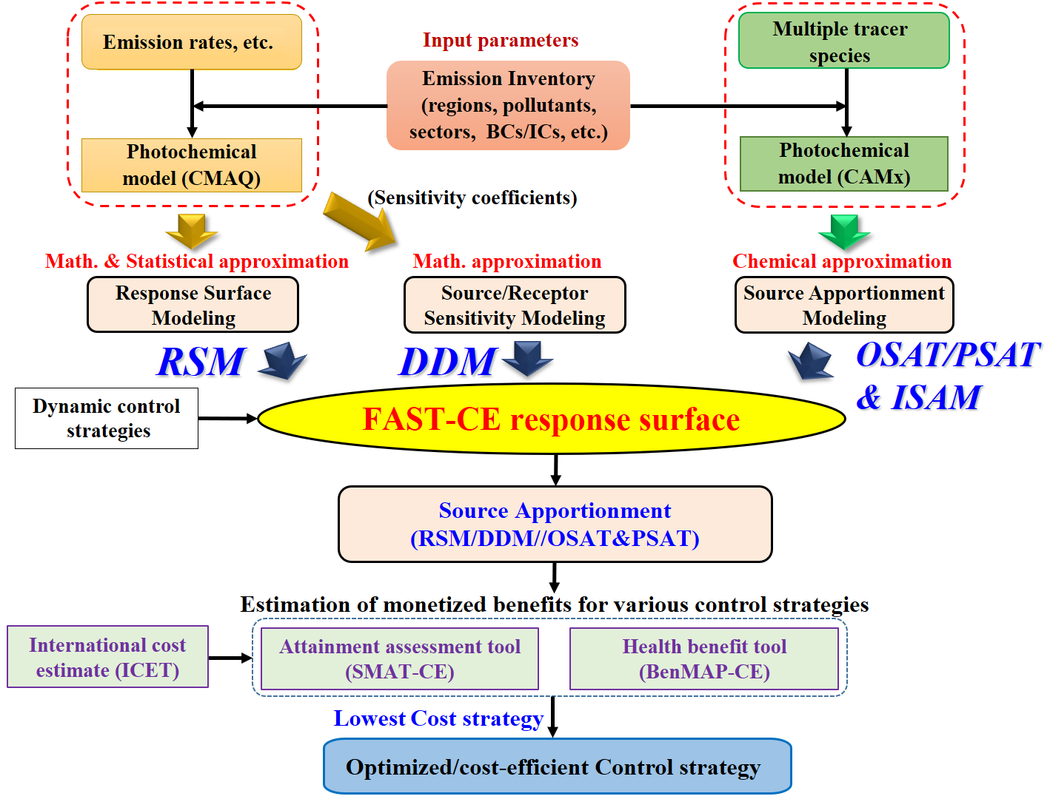
Figure 1. The conceptual framework of FAST-CE

The methodology and processes of FAST-CE are listed as:
- The source contribution method (e.g., OSAT/PSAT&ISAM, RSM and DDM method) and corresponding data are selected based on the research needs.
- Combined with the source apportionment data generated by OSAT/PSAT&ISAM, RSM or DDM, the program will create scenarios contribution fields for each tag, and then sum up all scaled contribution tag fields, and finally create scenarios spatial field for SMAT-CE or BenMAP-CE;
- The performance of FAST-CE is validated through scatter plots (e.g., normal scatter plots and color density scatter plots) which compare the user-generated FAST-CE results with the EPA validation data.

Computer Requirements
FAST-CE requires a computer with:
- Net Framework Version 4.6 or higher.
- 32-bit or 64-bit Windows 7/Windows 8/Windows 10.
- 4GB RAM or greater.
- 10 GB free disk space or greater.

Installing/Uninstalling FAST-CE

Installing FAST-CE
Download FAST-CE Software Package and corresponding example data (including FAST-CE EJ&GCAM Data.exe) from the ABaCAS website:
- ABaCAS EPA tools download page: http://abacas.see.scut.edu.cn/tools/
- Double click the package (e.g., FAST-CE.exe) to install the program (Figure 2).
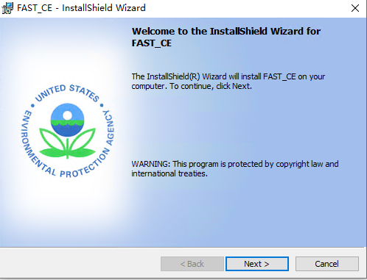
Figure 2. Setup Window
- Click the “Next” button, select the “Change” button if necessary, to specify a path rather than the default install path, as shown in Figure 3.
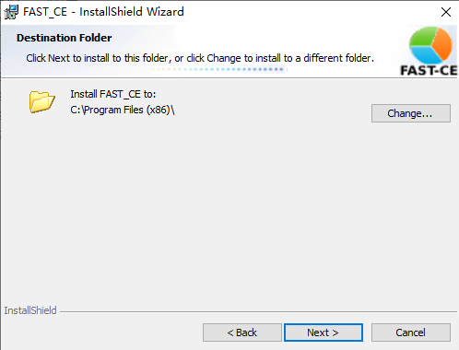
Figure 3. Choose Install Path
- Click the “Next” button, the “Ready to Install” window will display as shown in Figure 4.
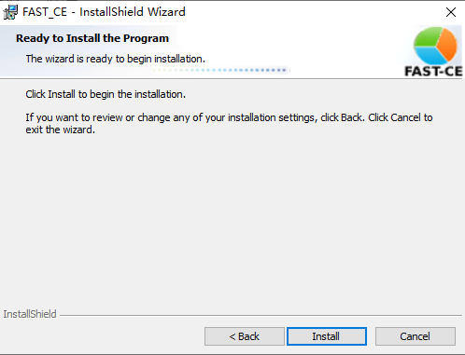
Figure 4. Ready to Install
- Click the “Install” button and FAST-CE will be installed.
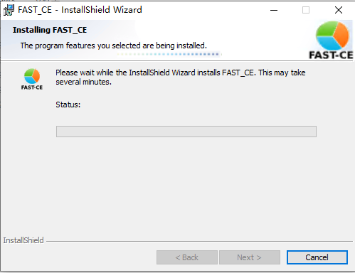
Figure 5. Installation Process
- Click the “Finish” button and complete the installation process.

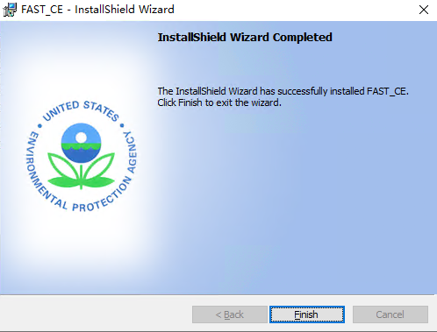
Figure 6. Complete Installation

Installing FAST-CE Data Installer
- After finishing the installation, please install the corresponding FAST-CE example data executable file (e.g., FAST-CE Data.exe) to User Documents directory under “\Documents\My FAST-CE Files\Data\*” to replace the old Data folder.
- Double click the example data executable file to install the program (Figure 7). It is recommended not to change the default install path because it is the path where FAST-CE reads the example data.

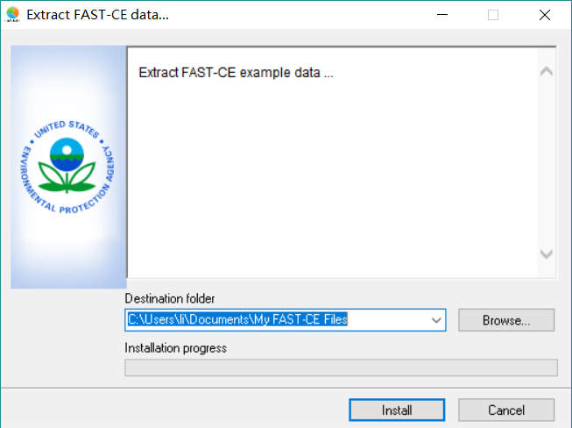
Figure 7. Choose Install Path
- Click the “Install” button and the FAST-CE Data will be extracted.
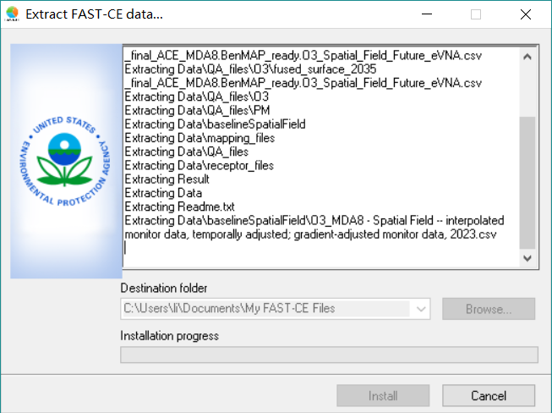
Figure 8. Installation Process

- When the data extraction is completed, the installation window will be closed automatically.

Uninstalling FAST-CE
- Go to Control Panel.
- Select FAST-CE and click Change/Remove, the pop-up window below will appear.

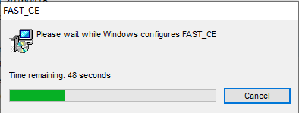
Figure 9. Uninstallation Process

- After a few seconds, uninstallation will finish.

Contacts for Comments and Questions
For comments and questions, please contact the following：
- The Center for Community Modeling and Analysis System (CMAS) at the University of North Carolina at Chapel Hill via email at cmas@unc.edu.

Terminology and File Types
The first section of this chapter explains the common terms used in this user’s manual and users can refer to other sections in this manual to find more detailed information about them if necessary. Section 2.2 describes the necessary format for externally generated model and monitor data files that can be read into FAST-CE in detail.

Common Terms
- OSAT/PSAT: Ozone source apportionment technology (OSAT) and Particle source apportionment technology (PSAT) are source apportionment modeling approaches in Comprehensive Air Quality Model with Extensions (CAMx), which augment the model by adopting a system of tracer species to track the sources of ozone or PM_{2.5} and its precursor species for selected groupings of emissions categories and geographical regions.
- RSM: RSM is a “reduced form” model of a complex air quality model (e.g. CMAQ) - “meta-model”, based on a systematically selected set of model runs, statistical techniques can be used to represent the relationship between model inputs and outputs (e.g. emissions control and concentrations of PM & ozone). Once the “response surface” has been generated, it can be used to simulate the change in secondary air pollutant concentrations due to a range of changes in emissions without re-running the computationally expensive photochemical air quality model. It can be also used to derive analytical representations of model sensitivities to changes in model inputs.
- CMAQ (Community Multi-Scale Air Quality): A state-of-the-art air quality model able to model ambient particulate levels, as well as other pollutants, including ozone. The grid-size of CMAQ is approximately 36 kilometers by 36 kilometers.

File Types

File Types for OSAT/PSAT/APCA/ISAM method
- CAMx Model data input for OSAT/PSAT: A netCDF formatted file for each tracer that contains tag information.
- Receptor Region File: A *.csv file which defines the grids of the analyzed receptors and is used to aggregate the grid concentration values to the level of those specified receptor regions. The columns in this file indicate in turn: region ID, grid column, grid row, grid region ratio, region code, and region name. The region ID, region code, and region name can be customized by users. Information such as grid columns, rows, and region ratios need to be calculated and obtained by ArcGIS.
- Mapping File: A *.csv file, which is used to link the tagged variables of CAMx model data with control factors (Region, Pollutant, Source) for FAST-CE. The columns in this file indicate in turn: tagged variables of CAMx model data, names used to identify different items, region, source, and pollutant. The names used to identify different items can be customized by users, and the control factors (Region, Pollutant, Source) were derived from the emission file.
- Baseline Spatial Field File: A *.csv file contains the baseline spatial field information, which is generally created by SMAT-CE. For O₃ analysis, it contains 14 headers (Table 1), while for PM_{2.5} analysis, it contains 32 headers (Table 2). The meaning of each header can refer to User’s Manual for SMAT-CE.
Table 1. The headers of Baseline Spatial Field File for O₃ analysis
No. | Header name | No. | Header name
1 | _id | 8 | i_f_o3(eVNA)
2 | _type | 9 | b_o3_model
3 | lat | 10 | f_o3_model
4 | long | 11 | ppb
5 | date | 12 | days
6 | ga_conc | 13 | referencecell
7 | i_b_o3(eVNA) | 14 | rrf
Table 2. The headers of Baseline Spatial Field File for PM_{2.5} analysis
No. | Header name | No. | Header name
1 | _id | 17 | f_crustal_mass_q_ga
2 | gridcell_lat | 18 | f_EC_mass_q_ga
3 | gridcell_long | 19 | f_NH4_mass_q_ga
4 | quarter | 20 | f_Ocmb_mass_q_ga
5 | b_pm25_ann_q_DV_ga | 21 | f_SO4_mass_q_ga
6 | f_pm25_ann_q_DV_ga | 22 | f_NO3_mass_q_ga
7 | b_blank_mass_q_ga | 23 | f_water_mass_q_ga
8 | b_crustal_mass_q_ga | 24 | f_salt_mass_q_ga
9 | b_EC_mass_q_ga | 25 | rrf_crustal_q_ga
10 | b_NH4_mass_q_ga | 26 | rrf_ec_q_ga
11 | b_Ocmb_mass_q_ga | 27 | rrf_nh4_q_ga
12 | b_SO4_mass_q_ga | 28 | rrf_oc_q_ga
13 | b_NO3_mass_q_ga | 29 | rrf_so4_q_ga
14 | b_water_mass_q_ga | 30 | rrf_no3_q_ga
15 | b_salt_mass_q_ga | 31 | rrf_salt_q_ga
16 | f_blank_mass_q_ga | 32 | rrf_water_q_ga

Baseline Species Spatial Field File: This option is only for PM analysis, which allows the user to set up PM species spatial field data. This data file is also created by SMAT-CE. It contains 24 headers (Table 3) and the meaning of each header can refer to the User’s Manual for SMAT-CE.
Table 3. The headers of Baseline Species Spatial Field File
No. | Header name | No. | Header name
1 | _id | 13 | fsalt_ga
2 | gridcell_lat | 14 | blank_mass_ga
3 | gridcell_long | 15 | don_ga
4 | quarter | 16 | i_so4_ga
5 | pm25_mass_frac_ga | 17 | i_no3r_ga
6 | fcr_ga | 18 | i_ocb_ga
7 | fec_ga | 19 | i_ec_ga
8 | fnh4_ga | 20 | i_crustal_ga
9 | focm_ga | 21 | i_don_ga
10 | fso4_ga | 22 | i_nh4_ga
11 | fno3_ga | 23 | i_no3_ga
12 | fwater_ga | 24 | i_salt_ga

- Cases & Emission File: A *.csv formatted file describes information of base & control cases and corresponding emission data. It contains three headers: “Case Name”, “Pollutant” and “Emission Path”. The “Emission Path” is used to link to the emission file which defines the total emissions by tag for all the baseline and policy scenarios (e.g., ACE 2025, 2030, 2035).
- Validation Configuration File: A *.csv formatted file that describes the configuration for FAST-CE cases and QA cases contains three headers: “FAST-CE Case”, “QA Case”, and “QA File”. The “FAST-CE Case” is the case name of FAST-CE analysis, which is consistent with the control case of “Cases & Emission File”. The “QA Case” is the user-defined name to each QA analysis and “QA File” is the origin EPA ACE results file.

File Types for RSM method
- RSM Input File: A pre-run RSM file, created by RSM-VAT.
- Receptor Region File: A separate *.txt file that defines the grids of the analyzed receptors. The meaning of each column is the same as the “Receptor Region File” of the OSAT/PSAT/APCA/ISAM method.
- Emission Matrix File: A *.csv file used to set up RSM base & control cases contains two headers: “Case Name” and “Emission Path”. The case name can be defined by the user and the “Emission Path” is the path of corresponding “FactorsInfo” file which describes the information of emission factor, including the attribute, size, and source of each factor.
Table 4 presents the type, name, extension, and data source of the files.
Table 4. File types used by FAST-CE
Filename | File Extension | Source
CAMx Model data input | netcdf | CAMx
Receptor Region File | *.csv or *.txt | RSM-VAT
Mapping File | *.csv | User-defined
Baseline Spatial Field File | *.csv | SMAT-CE
Baseline Species Spatial Field File | *.csv | SMAT-CE
Cases & Emission File | *.csv | User-defined
Validation Configuration File | *.csv | User-defined
RSM Input File | *.rsm | RSM-VAT
Emission Matrix File | *.csv | User-defined

Quick Start
This chapter provides the steps required to run FAST-CE for various analyses. The Quick Start will use EPA’s Affordable Clean Energy (ACE) data set to demonstrate how to run each of the FAST-CE analysis modules. These steps will use the default settings and do not describe the configuration settings for each analysis. For details of the configuration settings for the individual FAST-CE modules, refer to the User’s Guide chapter for each module.

Load a Previous Project
Click File→Open Project on the FAST-CE Home Page to launch a Windows Explorer window. Use this window to navigate to the directory where FAST-CE project (*. proj) files are saved to load a previous project.
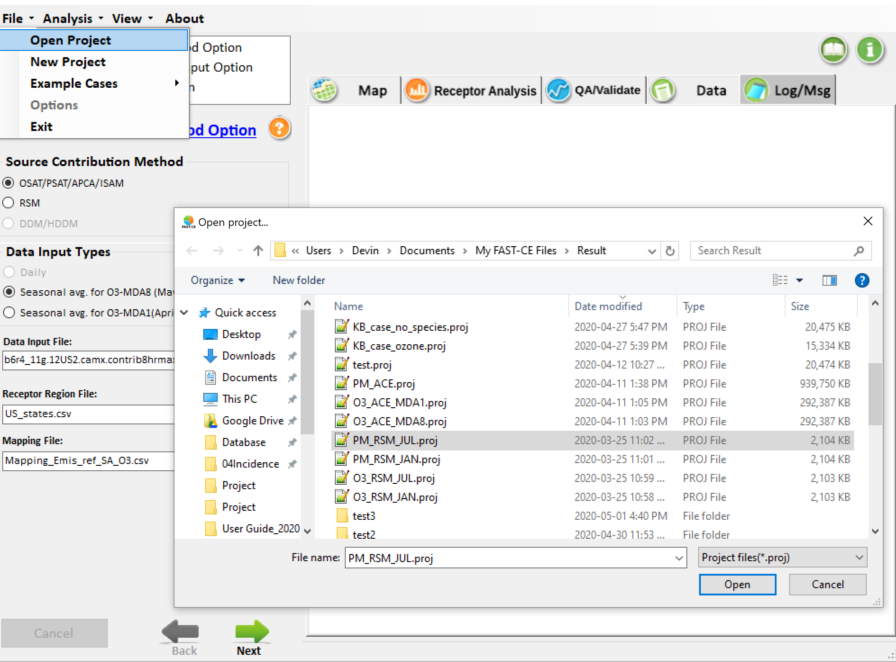
Figure 10. Load a previous project

PM Analysis Quick Start
The steps below describe how to use FAST-CE to conduct source contributions and create SMAT-CE air quality surface flexibly and in real-time for PM_{2.5}.

Step 1. Click Analysis→PM menu on the top of FAST-CE Home Page to launch the PM Analysis module window.

Step 2. The Source Contribution Method Option window display first. This window sets the source contribution method (e.g., OSAT/PSAT/APCA/ISAM), data input types (e.g., monthly), input files of selected source contribution method, receptor region file and mapping file for PM_{2.5} analysis. FAST-CE calculates fraction contribution for each tag in each grid-cell based on the input files.

Use the default settings in the Source Contribution Method Option window.

- Click on the Source Contribution Method Option hyperlink to display an electronic version of the User’s Manual for this window.
Source Contribution Method. Sets the source contribution method. There are three sets of source contribution methods for users to select. The default selected is OSAT/PSAT/APCA/ISAM.

Data Input Types: Sets the data type of input files. It provides three options: Daily, Monthly and Annual.

Data Input File: For OSAT/PSAT/APCA/ISAM option, sets the SA tags IOAPI files (e.g., inputs 12 monthly PM_{2.5} Source Appointment (SA) tag files for Monthly option specified in Data Input Types). For RSM option, sets the rsm file (*.rsm) that contains the response parameters between emission and air quality.

Receptor Region File: Sets the information of grid cells that located in those regions of interest.

Mapping File: Only for OSAT/PSAT/APCA/ISAM option. Sets a mapping between the variables in Source Appointment (SA) tag files and the variables in emission file.
- Click the Next arrow at the bottom right of the Source Contribution Method Option window to proceed to the next step.
Step 3. The Emission & Spatial Field Input Option window sets the baseline spatial field files and emission files. FAST-CE multiplies the baseline spatial field data by fractional contribution for each tag that calculated in last step, and then multiplies the appropriate emission ratio from emission files to create a scaled contribution tag fields, then finally sums up all scaled contribution tag fields to output future scenario spatial field data (including quarterly& annual for PM).

Use the default settings in the Source Contribution Method Option window.
- Click on the Emission & Spatial Field Input Option hyperlink to display an electronic version of the User’s Manual for this window.
- Include PM Species. Inputs the baseline quarterly PM_{2.5} spatial field that created by SMAT-CE (e.g., xxx Quarterly PM25 Spatial Field (eVNA).csv, “xxx” represents the project name of SMAT-CE) when this option is checked. Or sets the baseline air quality surface by users when this option is not checked.
- SMAT-CE adjustment. Only for Include PM Species option, sets the baseline quarterly species fraction spatial field that created by SMAT-CE (e.g., xxx Quarterly Avg Spec Frac Spatial Field (eVNA).csv, “xxx” represents the project name of SMAT-CE).
- Input Cases & Emissions Files. Inputs the emissions configuration file that set up one or more control cases and provide corresponding emissions data files.
- Click the Next arrow at the bottom right of the Emission & Spatial Field Input Option window to proceed to the next step.
Step 4. The QA/Validation Input Option window sets the validation configuration file. This step is optional, and the default is checked. For OSAT/PSAT/APCA/ISAM option specified in the Step 2, this option validates the FAST-CE results with SMAT-CE results. For RSM option specified in the Step 2, this option verifies RSM predictions with those CMAQ simulations that not included in RSM creation.

Use the default settings in the QA/Validation Input Option window.
- Click on the QA/Validation Input Option hyperlink to display an electronic version of the User’s Manual for this window.
- Click the Next arrow at the bottom right of the QA/Validation Input Option window to complete the PM Analysis configuration and run the FAST-CE project.
- Click OK in the pop-up window to input a project name and create a project (*. proj) file for this tutorial exercise.
The PM Analysis will complete after a few minutes and the results of this analysis will be presented in MAP, Receptor Analysis, QA/Validate and Data module on the right of current window. See Chapter 6 for details on how to analyze the results.

Ozone Analysis Quick Start
The steps below describe how to use FAST-CE to conduct source contributions and create SMAT-CE air quality surface flexibly and in real-time for O₃.

Step 1. Click Ozone Analysis on the SMAT-CE Start Page to launch the Ozone Analysis module window. Click Analysis→Ozone menu on the top of FAST-CE Home Page to launch the Ozone Analysis module window.

Step 2. The Source Contribution Method Option window display first. This window sets the source contribution method (e.g., OSAT/PSAT/APCA/ISAM), data input types (e.g., daily), input files of selected source contribution method, receptor region file and mapping file for Ozone analysis. FAST-CE calculates fraction contribution for each tag in each grid-cell based on the input files.

Use the default settings in the Source Contribution Method Option window.
- Click on the Source Contribution Method Option hyperlink to display an electronic version of the User’s Manual for this window.
- Source Contribution Method. Sets the source contribution method. There are three sets of source contribution methods for users to select. The default selected is OSAT/PSAT/APCA/ISAM.
- Data Input Types: Sets the data type of input files. It provides three options: Daily, Seasonal avg. for O₃-MDA8 (May-Sept) and Seasonal avg. for O₃-MDA1 (April-OCT).
- Data Input File: For OSAT/PSAT/APCA/ISAM option, sets the SA tags IOAPI files. For RSM option, sets the rsm file (*.rsm) that contains the response parameters between emission and air quality.
- Receptor Region File: Sets the information of grid cells that located in those regions of interest.
- Mapping File: Only for OSAT/PSAT/APCA/ISAM option. Sets a mapping between the variables in SA tag files and the variables in emission file.
- Click the Next arrow at the bottom right of the Source Contribution Method Option window to proceed to the next step.
Step 3. The Emission & Spatial Field Input Option window sets the baseline spatial field files and emission files. Note that the baseline spatial field file (e.g., xxx - Spatial Field -- interpolated monitor data, temporally adjusted; gradient-adjusted monitor data, 2023.csv, “xxx” stands for the project name of SMAT-CE) could be created by SMAT-CE. FAST-CE multiplies the baseline spatial field data by fractional contribution for each tag that calculated in last step, and then multiplies the appropriate emission ratio from emission files to create a scaled contribution tag fields, then finally sums up all scaled contribution tag fields to output future scenario spatial field data (including MDA1&MDA8 for Ozone).

Use the default settings in the Source Contribution Method Option window.
- Click on the Emission & Spatial Field Input Option hyperlink to display an electronic version of the User’s Manual for this window.
- Click the Next arrow at the bottom right of the Emission & Spatial Field Input Option window to proceed to the next step.
Step 4. The QA/Validation Input Option window sets the validation configuration file. This step is optional, and the default is checked for ACE cases. This default option is determined by the default configuration file set in Startup Option. For OSAT/PSAT/APCA/ISAM option specified in the Step 2, this option validates the FAST-CE results with SMAT-CE results. For RSM option specified in the Step 2, this option verifies RSM predictions with those CMAQ simulations that not included in RSM creation.

Use the default settings in the QA/Validation Input Option window.
- Click on the QA/Validation Input Option hyperlink to display an electronic version of the User’s Manual for this window.
- Click the Next arrow at the bottom right of the QA/Validation Input Option window to complete the Ozone Analysis configuration and run the FAST-CE project.
- Click OK in the pop-up window to input a project name and create a project (*. proj) file for this tutorial exercise.
The Ozone Analysis will complete after a few minutes and the results of this analysis will be presented in MAP, Receptor Analysis, QA/Validate and Data module on the right of current window. See Chapter 6 for details on how to analyze the results.

Main Interface
The top menu toolbar contains four menus: File, Analysis, View and About
- Click the File button on the toolbar of the main interface, there are seven options that users can choose.
- Go to File, click Open Project (*.proj) button, locate the *.proj file and open it.
- Click the New Project button to create a new project.
- Click the Load Configuration (*.xml) button to load a configuration file (*.xml) for project input files.
- Click the Save Configuration (*.xml) button to save a configuration file (*.xml) for project input files.
- Click the Example Cases button to load the default configuration for “ACE O3 case” or “ACE PM case”.
- Click the Startup Option button to set a default configuration file (*.xml). After settings, the default inputs in FAST-CE will be loaded from this default configuration file, even the program is opened next time. User can also decide whether to enable the EJ function here. Note that the EJ function only enables when the EJ data package is installed successfully after checking the EJ function in Startup Option.
- Click the Exit button to exit the program.
- Click the View button on the toolbar of the main interface, there are two options that users can choose.
- Click the Setting Viewer button to view the setting interface.
- Click the Data Viewer button to view the visual analysis interface.
- Click the Analysis button to select the target pollutant (e.g., PM, Ozone) to be analyzed.
- Click the About button to see the version and copyright information of FAST-CE.
- To complete a FAST-CE case, users should configure three streamline options to input data and configure the calculation parameters step by step. The three options are called Source Contribution Input Option, Emission & Spatial Field Input Option, and QA/Validation Input Option.

The main interface of FAST-CE is shown in Figure 11.

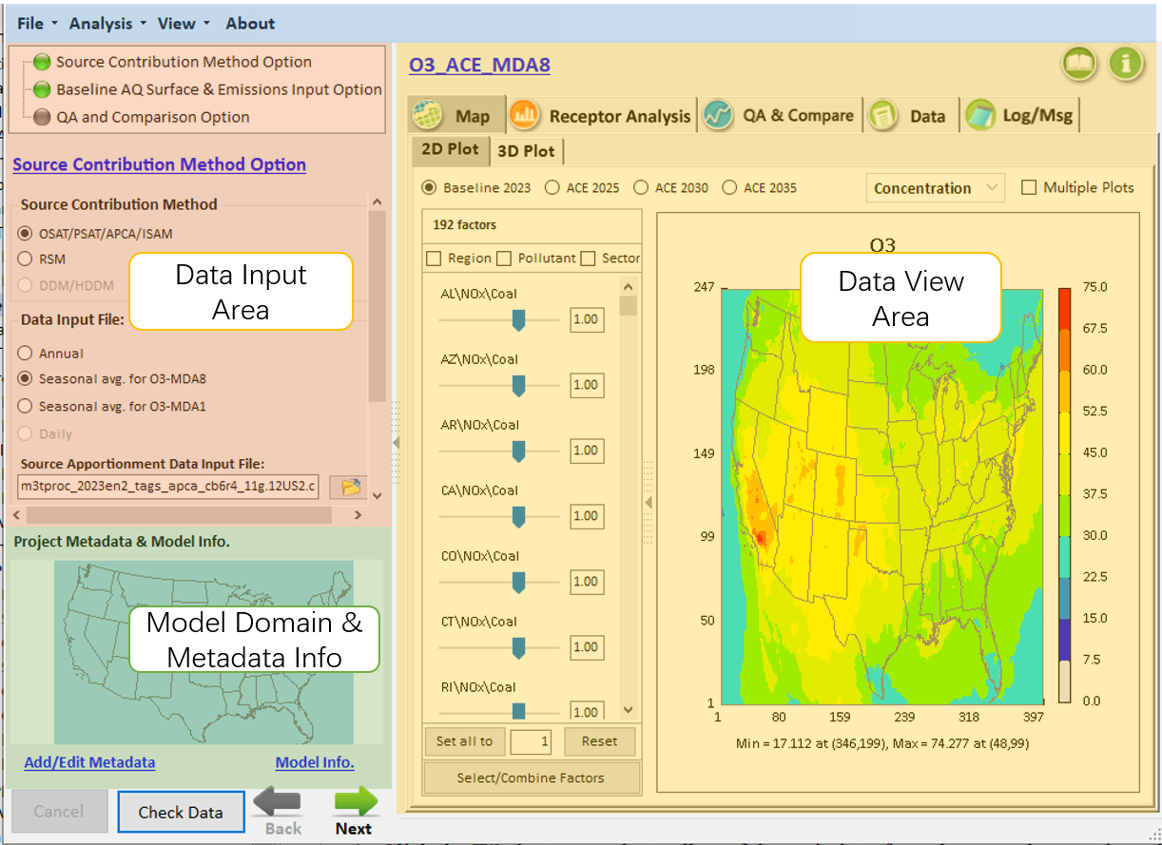
Figure 11. Main Interface of FAST-CE
- Data Input Area
This part is for user to set up the configuration and input data files of different analysis.
To complete a FAST-CE case, users should configure three streamline options to input data and configure the calculation parameters step by step. The three options are called Source Contribution Input Option, Baseline AQ Surface & Emissions Input Option, and QA and Comparison Option.

- Data View Area
When a FAST-CE analysis is completed, all the results will be displayed under the Data View Area. The system provides four kinds of ways to display the source contribution analysis results, including Map, Receptor Analysis, QA/Validate, and Data

- Model Domain & Metadata Area
This area is to show the model domain and the meta-data information of a FAST-CE project.

Meta Data Function
Click the "Add/Edit" Metadata" and "Modelinfo", to activate "Metadata Information" and "Model Data" windows as shown in Figure 12. Users are allowed to identify the FAST-CE cases & dataset.
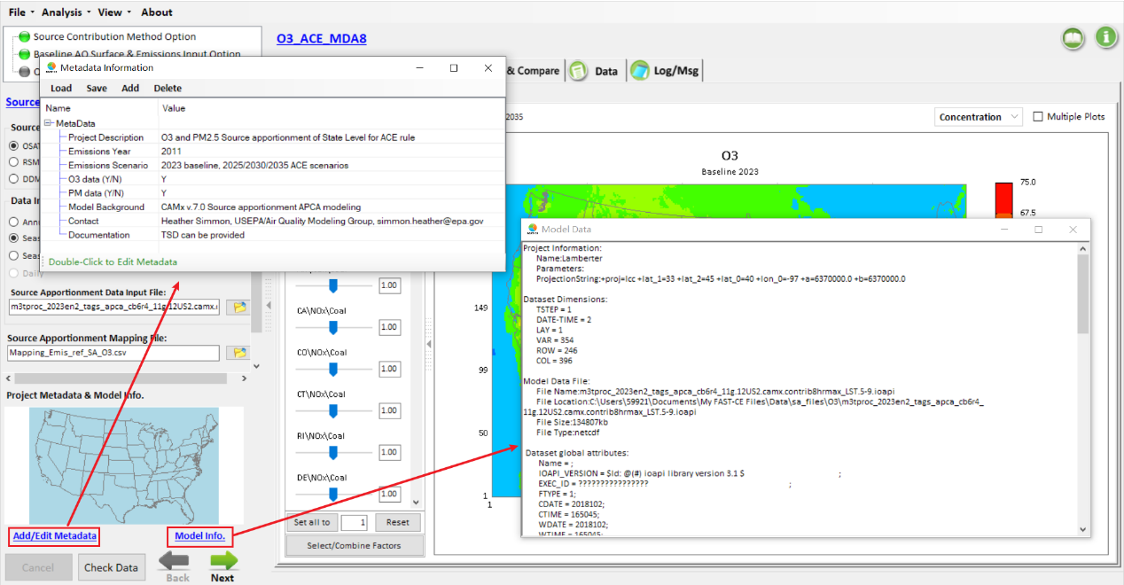
Figure 12. Show Metadata/Model data
In “Add/Edit Metadata”, users are allowed to add new rows and add information if needed.
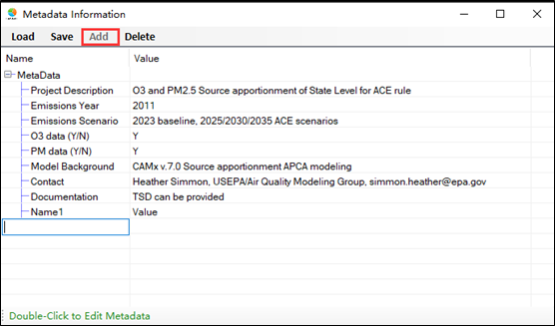
Figure 13. Add New Rows and Information
Click the "Delete", the selected row is deleted.
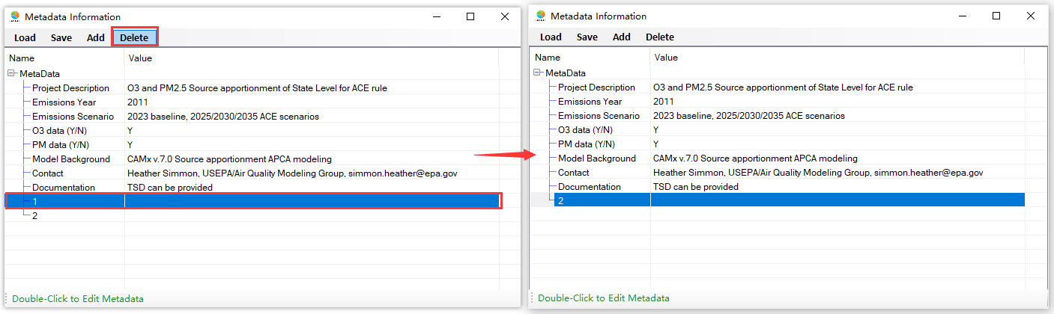
Figure 14. Delete Rows

Run FAST-CE

Source Contribution Input Option
This option allows the user to select different source contribution methods and set up the input data and parameter configurations. FAST-CE 3.1 includes two kinds of source contribution methods: OSAT/PSAT/APCA/ISAM and RSM method. The GUI and input data are different for different methods.
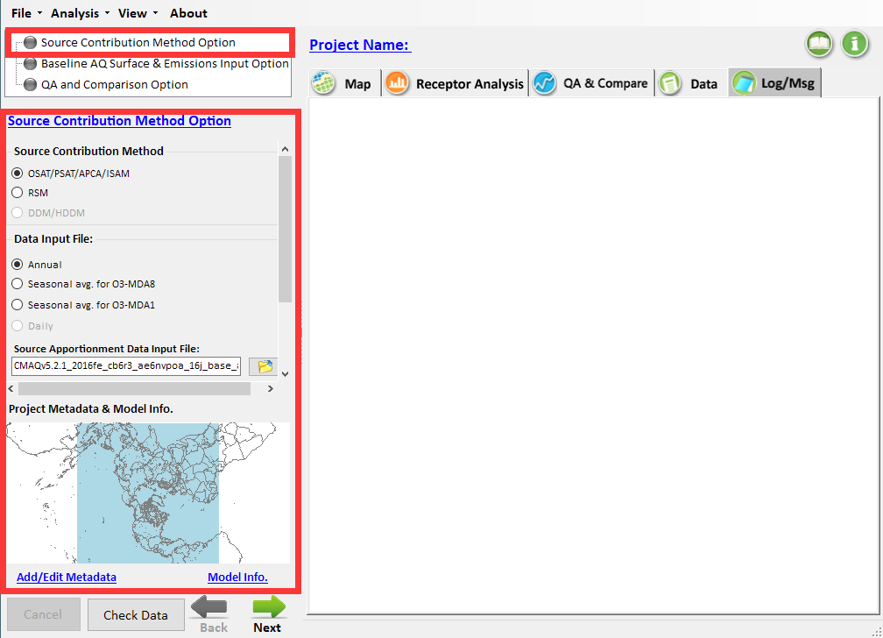
Figure 15. Source Contribution Input Option

Input option for OSAT/PSAT/APCA/ISAM method
For the OSAT/PSAT/APCA/ISAM methods, there are four necessary sub-options: Data Input File, Source Apportionment Data Input File, Source Apportionment Mapping File and Optional Receptor Region File.
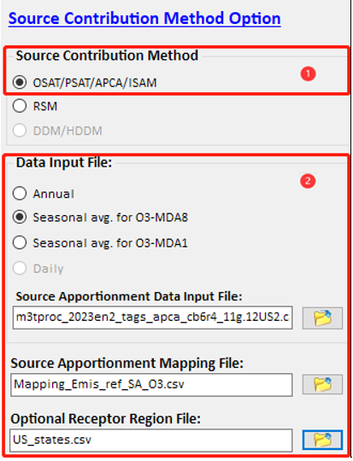
Figure 16. Input option for OSAT/PSAT/APCA/ISAM method

- Data Input Type: allows the user to specify the format of the input file (Daily, Seasonal Average for O₃-MDA8 (May-Sept.), Seasonal Average for O₃-MDA1 (April-Oct.).
- Source Apportionment Data Input File: allows the user to specify the file name and path of the input model data. The OSAT/PSAT method requires the Comprehensive Air Quality Model with Extensions (CAMx) model data. The ISAM method requires the Community Multiscale Air Quality (CMAQ) model data.
- Source Apportionment Mapping File: A *.csv file, which is used to link the tagged variables of CAMx model data with control factors (Region, Pollutant, Source) of FAST-CE.
- Optional Receptor Region File: A *.csv file which defines the grids of the analyzed receptors.

Input option for RSM method
For the RSM method, there are two necessary sub-options: Input RSM File and Optional Receptor Region File.

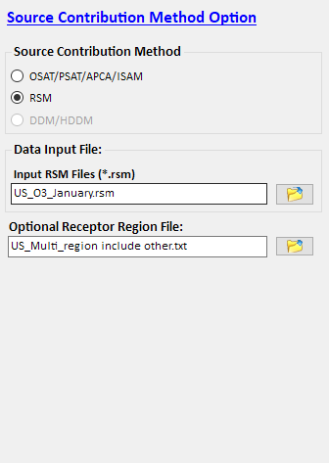
Figure 17. Input option for RSM method

- Input RSM File: Specify the path and name of a pre-run RSM file, created by RSM-VAT.
- Receptor Region File: Specify the path and name of a *.txt file which defines the grids of the analyzed receptors.

Emission & Spatial Field Input Option
In this option, users should set up one or more control cases and provide corresponding emission data files. Different source contribution methods require different kinds of input files.
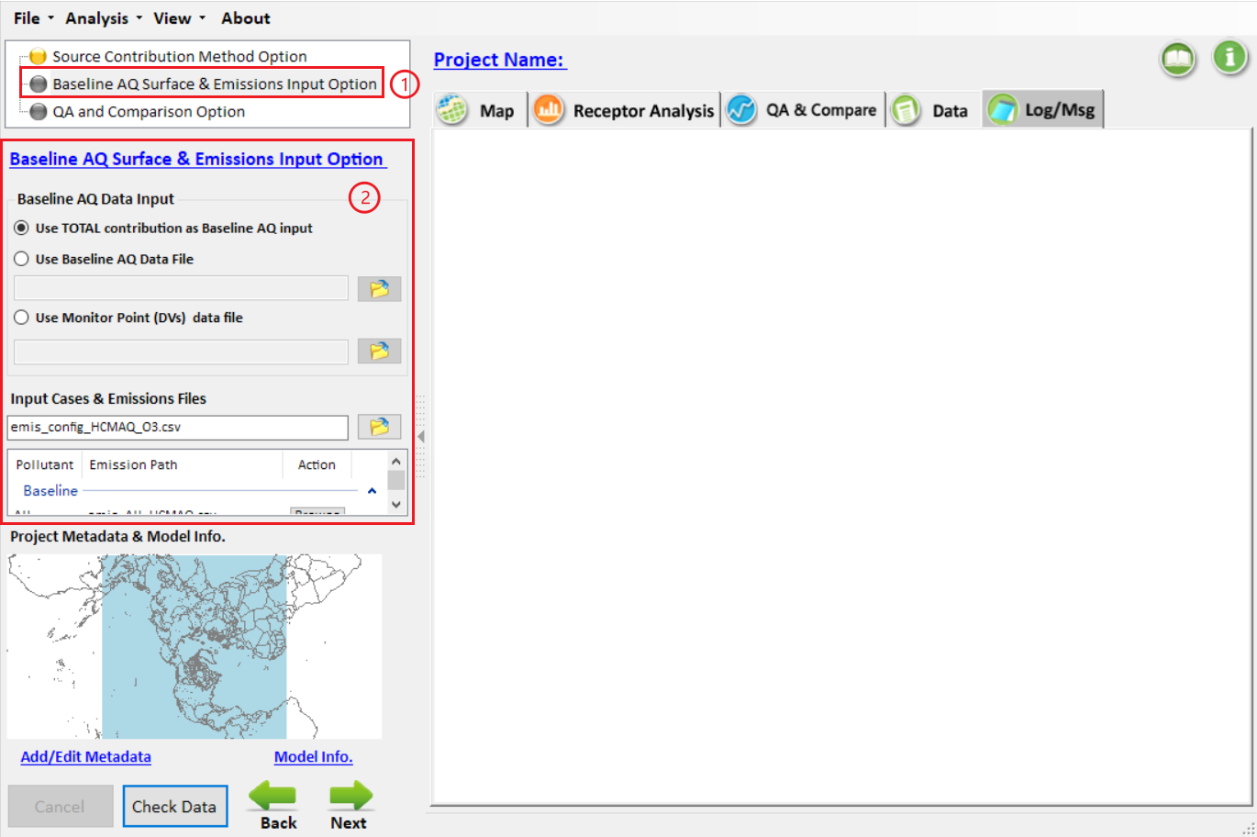
Figure 18. Emission & Spatial Field Input Option

Emission & Spatial Field Input option for OSAT/PSAT/APCA/ISAM method
For OSAT/PSAT/APCA/ISAM method, there are two necessary sub-options: Baseline AQ Data Input and Input Cases & Emission Files.
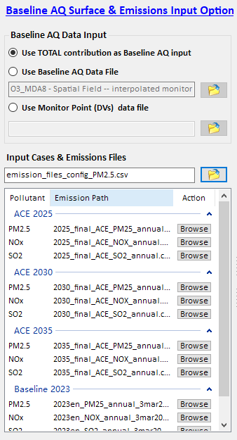
Figure 19. Baseline AQ Surface & Emissions Input Option for OSAT/PSAT/APCA/ISAM Method

- Baseline AQ Data Input: Allow the user to set up the baseline AQ data, including using TOTAL contribution as Baseline AQ input, using Baseline AQ data file and using monitor point (DVs) data file.
- Input Cases & Emission Files: A *.csv formatted file describes the configuration information of base & control cases and corresponding emission data.

Emission & Spatial Field Input option for RSM method
For the RSM method, users need to set up the Input Emission Matrix for RSM option.
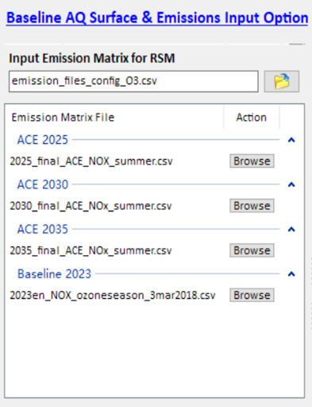
Figure 20. Baseline AQ Surface & Emissions Input Option for RSM Method

- Emission Matrix for RSM: A *.csv file which exhibits the emission matrix of the baseline case and control cases for RSM analysis.

QA/Validation Input Option
To validate the results of FAST-CE, the QA and Comparison Option module allows users setting up validation cases. In this option, users need to input a Validation Configuration File, *.csv formatted file that describes QA data files for each FAST-CE case.

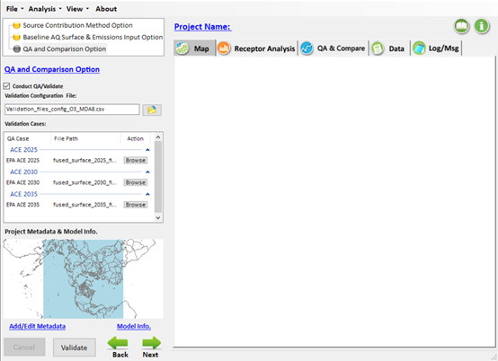
Figure 21. QA/Validation Input Option

After the input settings are completed, users click “Next” to start running FAST-CE. Users can view the running messages through “Log/Msg”, as shown in Figure 22.

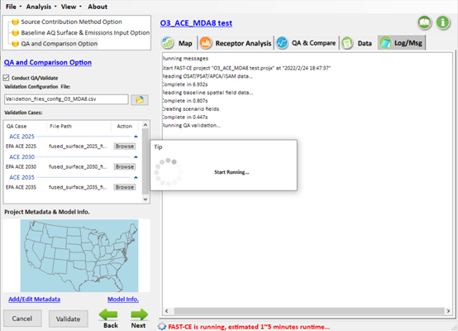
Figure 22. Running FAST-CE

Input File Validation Option
When click "Next" button or the "Check Data" button, FAST-CE can detect and validate the in-put data files.
There will be three different results:
(1) The input data is invalid, which means FAST-CE can’t run into next step until the invalid data file gets fixed. In this case, one or more pop-up message boxes/windows will display and the bottom icon will display like this .
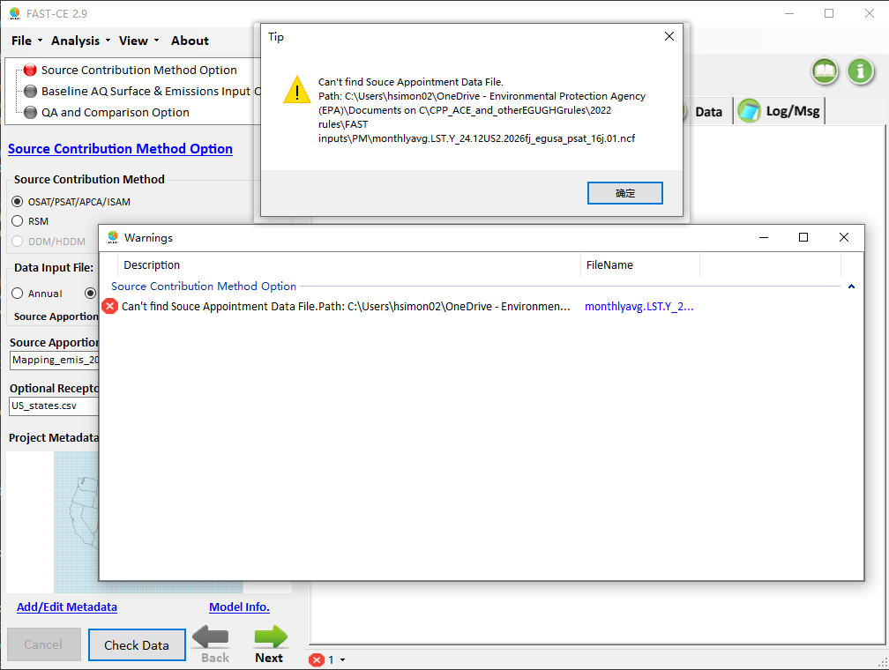
Figure 23. Data Invalid Warnings

(2) In some cases, the input data files are accepted, but the contents may not be reasonable. FAST-CE will provide some warnings. The bottom icon will turn to . In this case, the warning window will not display automatically. User need to click the bottom icon manually to display the window.
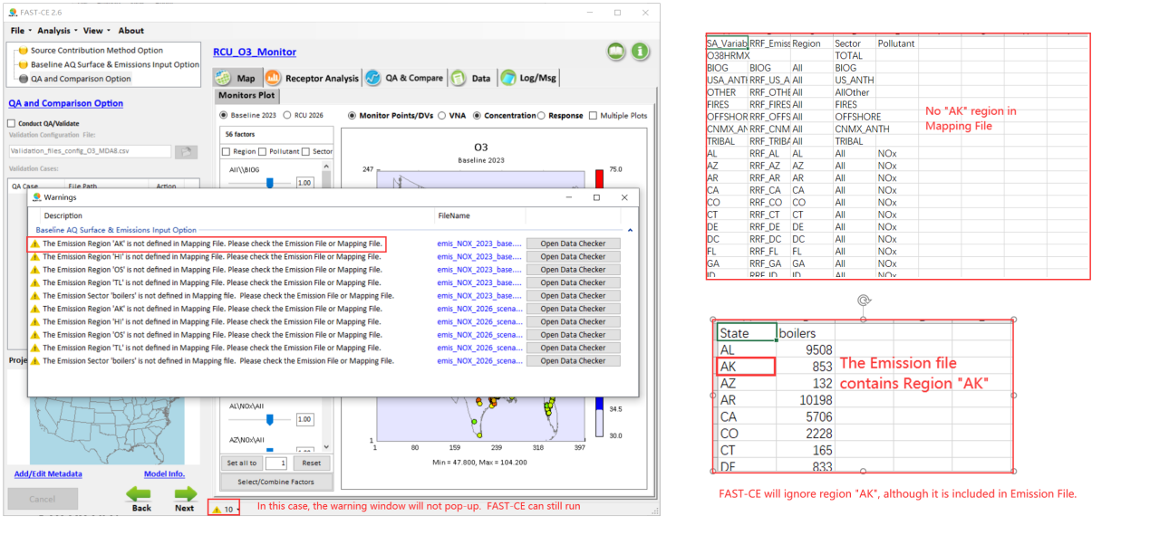
Figure 24. Data Unreasonable Warnings

(3) If the input data files are acceptable and reasonable, the bottom icon will disappear.
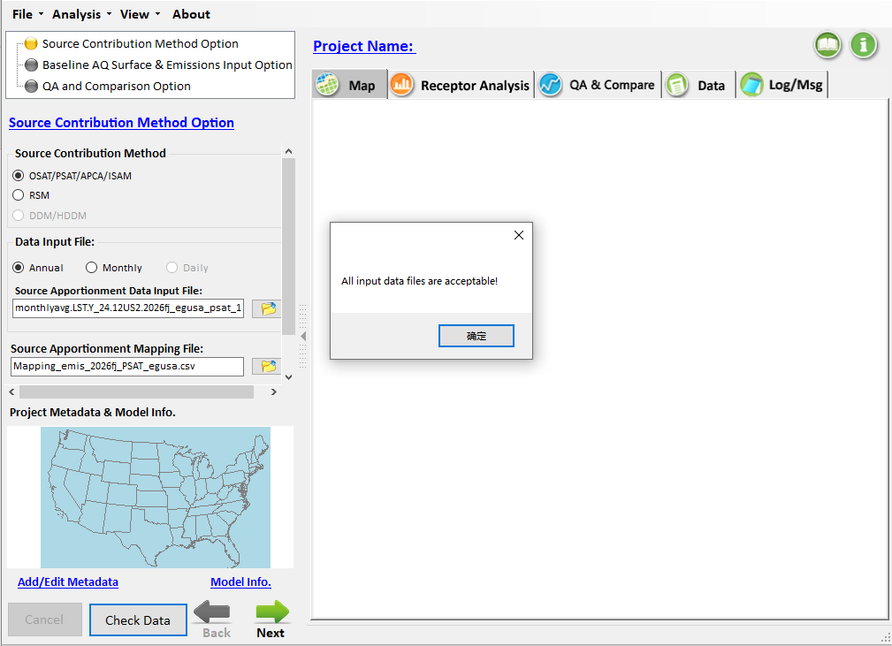
Figure 25. Acceptable data tips

Operation Results
When the FAST-CE running is finished, the system provides four kinds of ways to display the source contribution analysis results, including Map, Receptor Analysis, QA/Validate, and Data, as shown in Figure 26.

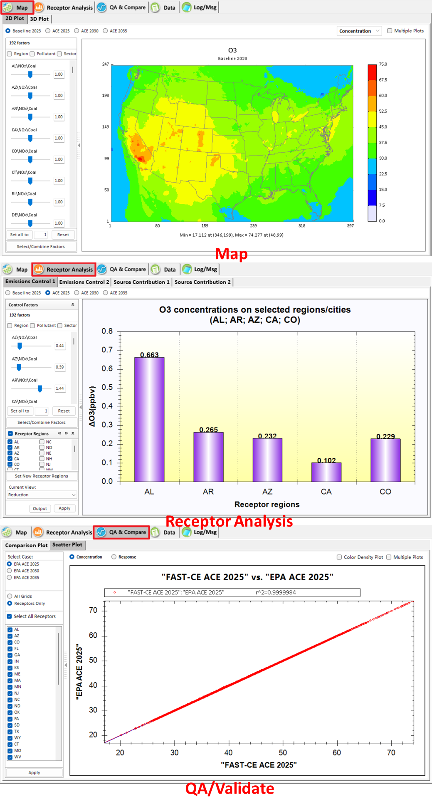
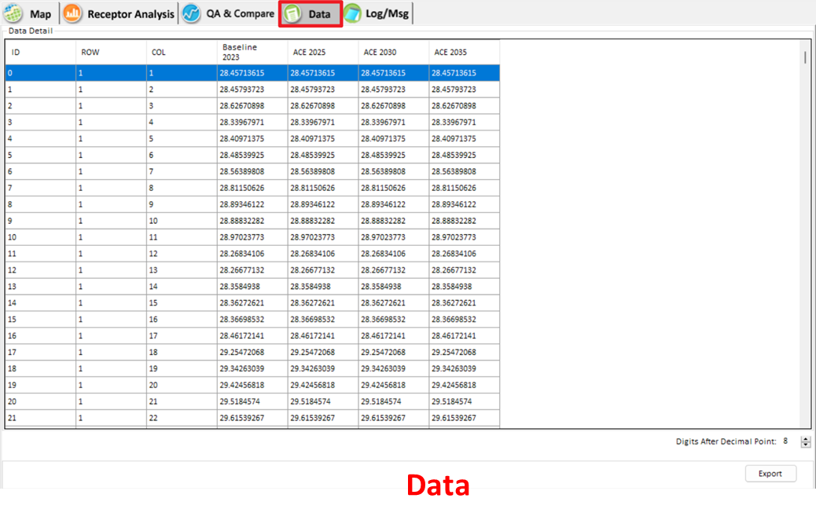
Figure 26. Data Viewer of the FAST-CE results

Map
Under the Map module, users may explore the concentration/response distribution of different control scenarios. Options include the display of 2D or 3D plot types, adjustment of emission factors grouped by region, pollutant, and sector for base and control cases were provided in this module, as shown in Figure 27.

To visualize the results, FAST-CE allows the user to:
- Select 2D/3D plot
- Configure color legend
- Show concentration or response value of base/control cases
- Customize the value of control factors to display the corresponding results
- Customize Model Domain
- Monitor Point/DVs & Projection module
- Display the PM Species Concentration/Response value
- Overlay the EJ/Demographics Data

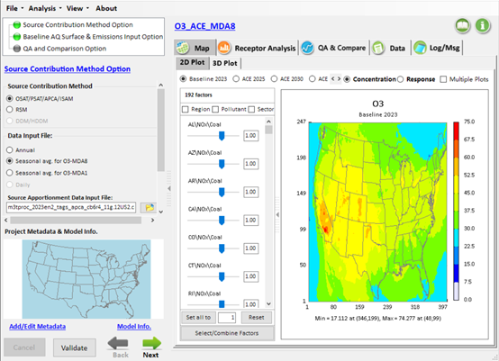
Figure 27. Map view of FAST-CE results

Select 2D/3D plot
Select “2D Plot” or “3D Plot” to show a specific plot type. In general, both 2D and 3D plots will display the distribution of Concentration/Response values and show the min/max value on the bottom, and the legend scale on the right.
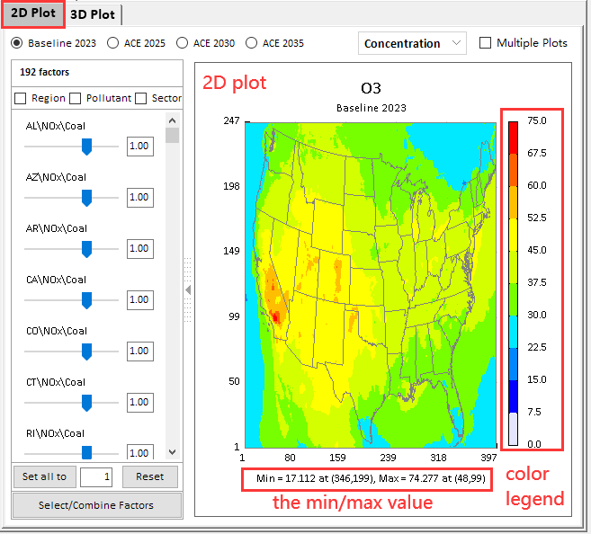
Figure 28. 2D plot

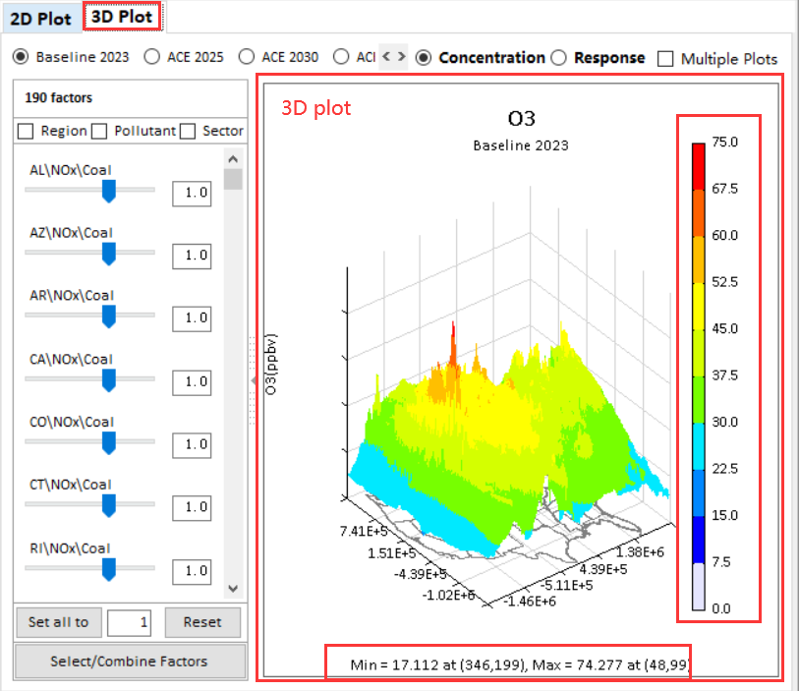
Figure 29. 3D plot

Configure color legend
Double-click on the color legend, to activate a pop-up configuration window as shown in Figure 30. Users can select a different color palette and new legend scale values.
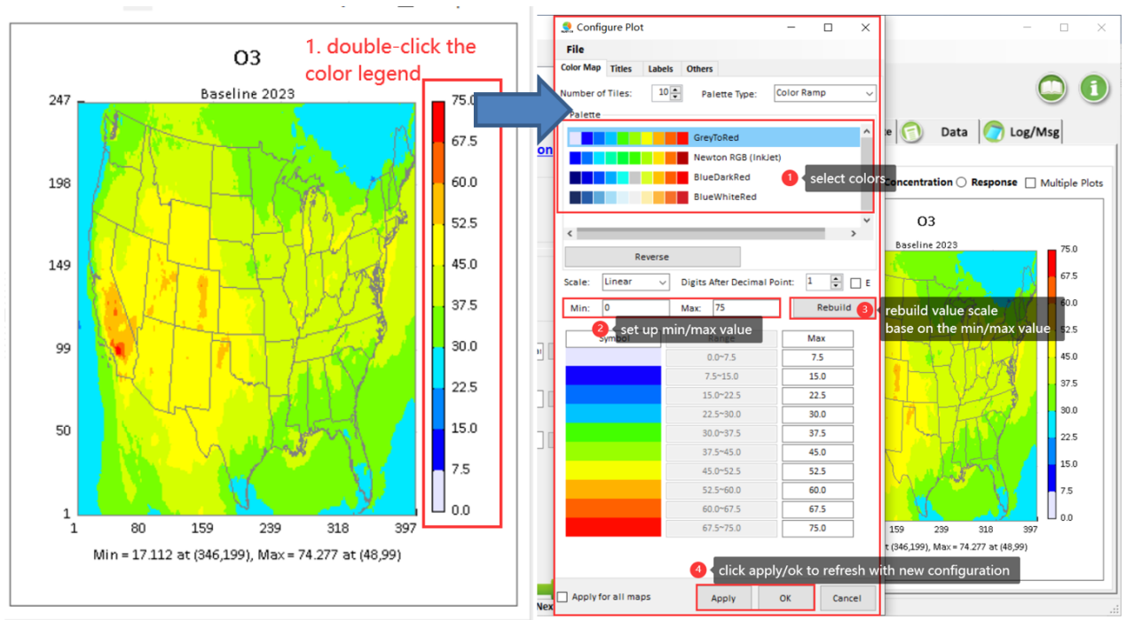
Figure 30. Configure color legend

Show concentration or response value of base/control cases
Users can select either the Concentration or the Response option on the top of the map to display the concentration or response results of different cases as shown in Figure 31.

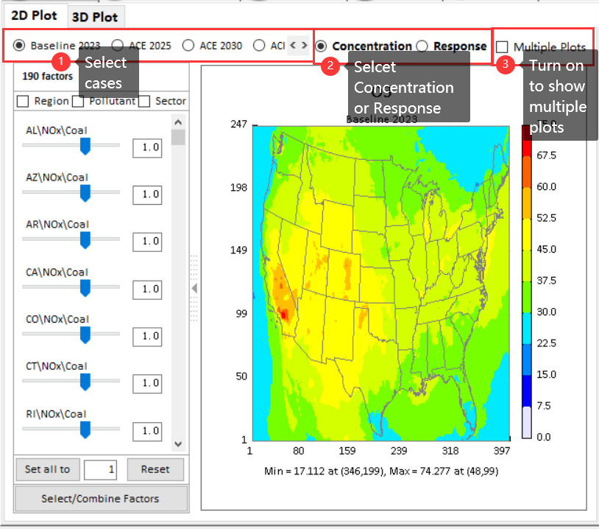
Figure 31. Show concentration value of base/control cases

If the user selects the Response button, FAST-CE will show the distribution of the difference between base case and control case as shown in Figure 32.

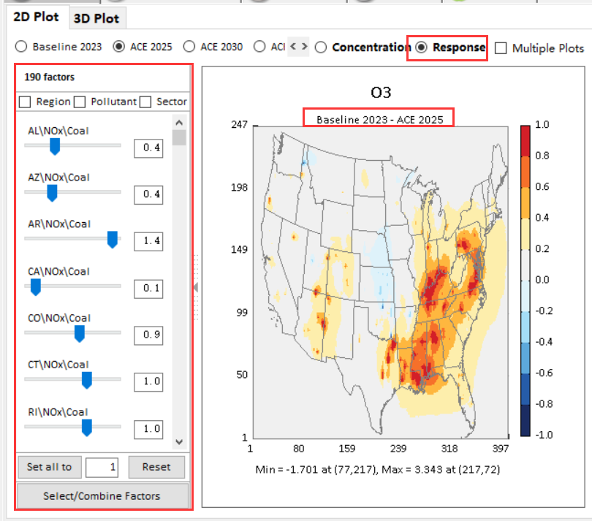
Figure 32. Show response value of base/control cases

Users can also check the “Multiple Plots” option to display multiple results at one time.

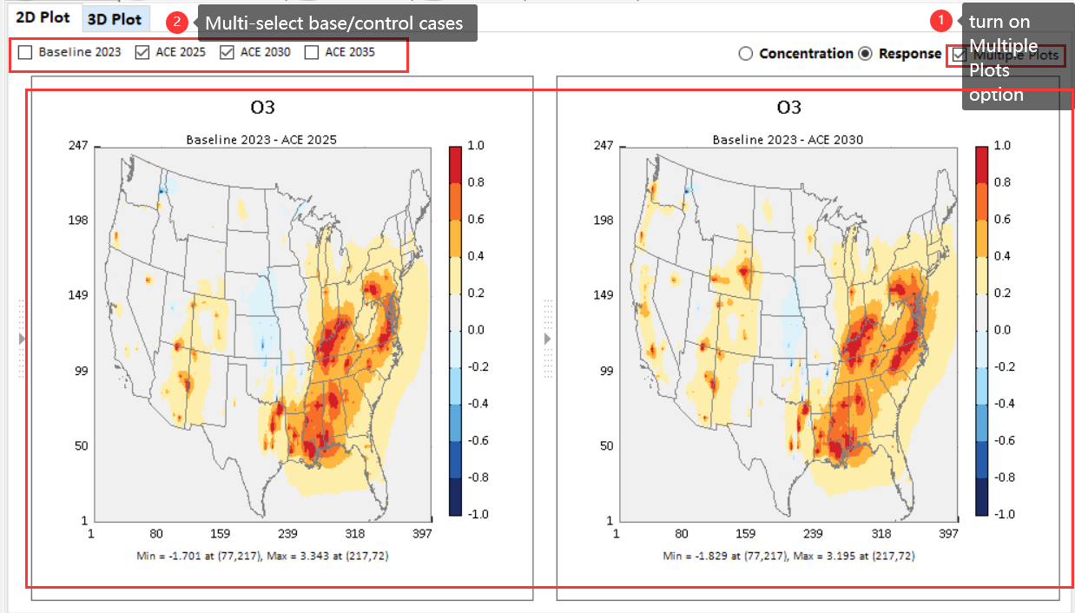
Figure 33. Show multiple plots

Customize control factors
FAST-CE allows the user to flexibly change the input control factor and show the corresponding response value of concentrations in real-time. The panel on the left lists all control factors. The sliders may be adjusted to change a single factor or multiple factors at the same time.

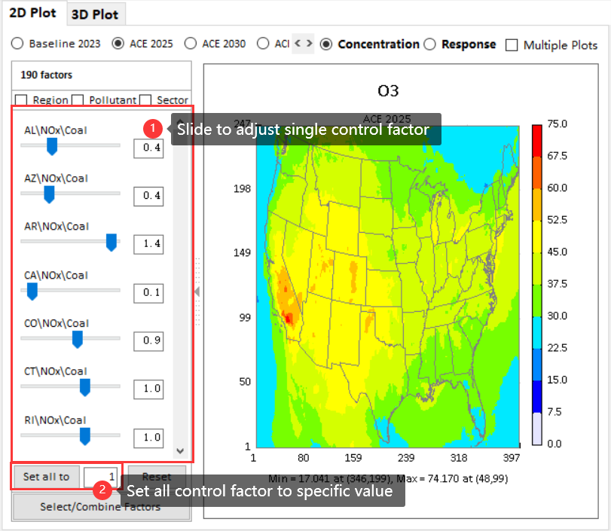
Figure 34. Customize control factors and displaying results

User can also set up the max “slider bar value” in the “FAST-CE.ini” file in …\My FAST-CE Files\FAST-CE.ini. So that user can change the ratio up to “10” or higher value.
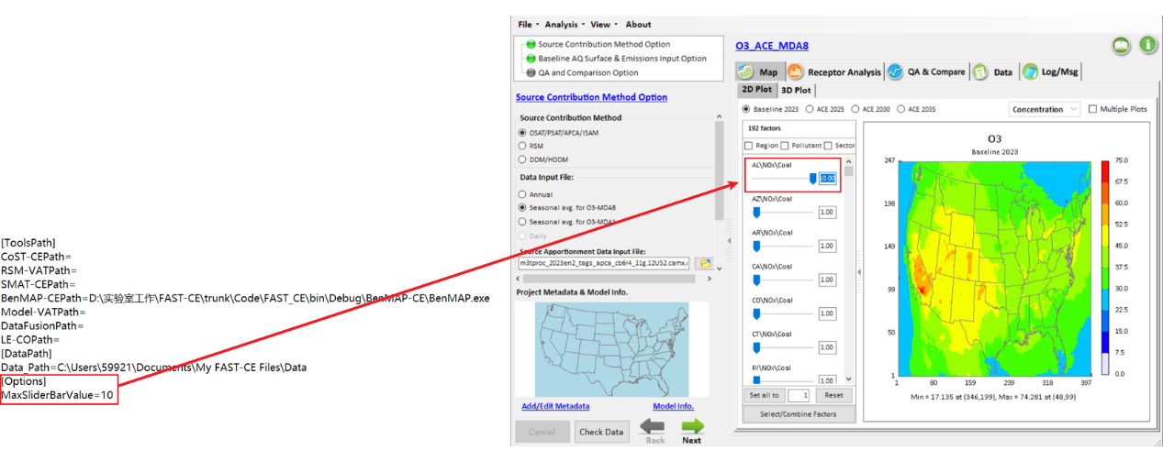
Figure 35. Set the Max Slider Bar Value.
Moreover, users can group/combine specific factors by region/pollutant/sector in the control factors panel to change the selected control factors to some extent.

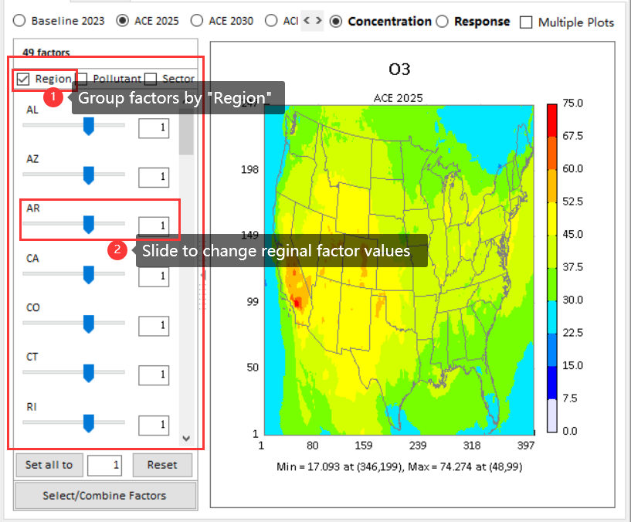
Figure 36. Group/combine specific factors

Users can also define control factors through the following two ways according to their needs.
- Pre-defined control filter: all existing control factors can be classified by pre-defined filters, including “Region”, “Pollutant” and “Sector”. Users can select interested filter to re-organized control factors and get the corresponding air quality surfaces by changing these new defined factors, as shown in Figure 37.

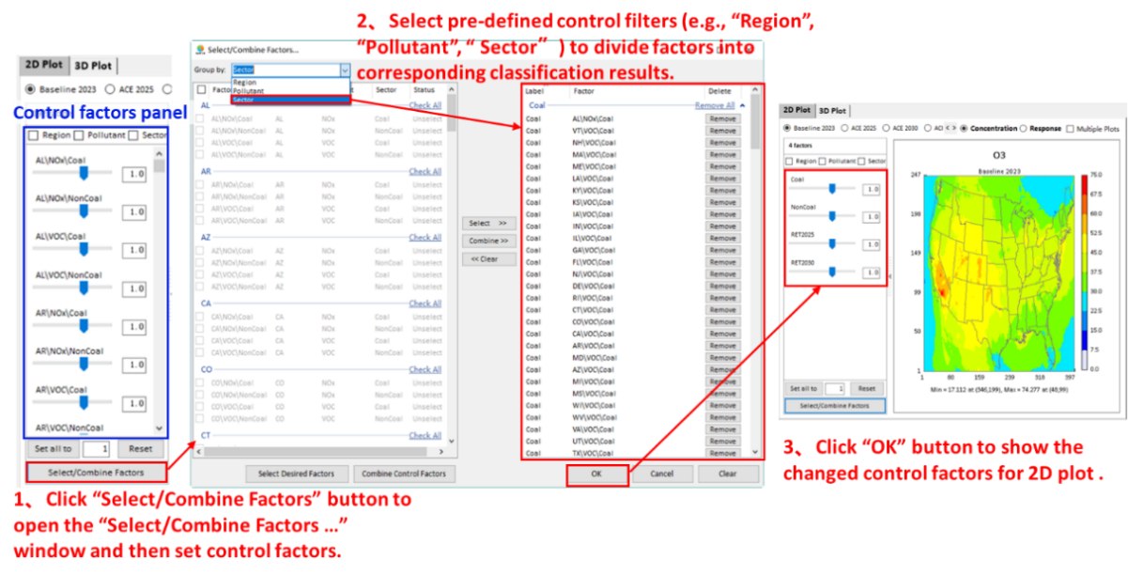
Figure 37. Pre-defined control filter
- User-defined control method: it provides two kinds of ways to define control factors as needed. a) Select interested factors only. This means that those factors you want to control will be selected and listed in control factors panel while those unselected factors will be kept as baseline (equal to 1). To do this, users just need to check the interested factors from the left panel of Figure 38(a), and then click “Select Desired Factors” to move these factors to right panel and finally click “OK” to return control factors panel. b) Select any combination of factors. This means that you can combine one or more factors to form a new factor by using “Combine Control Factors”, as shown in Figure 38(b).

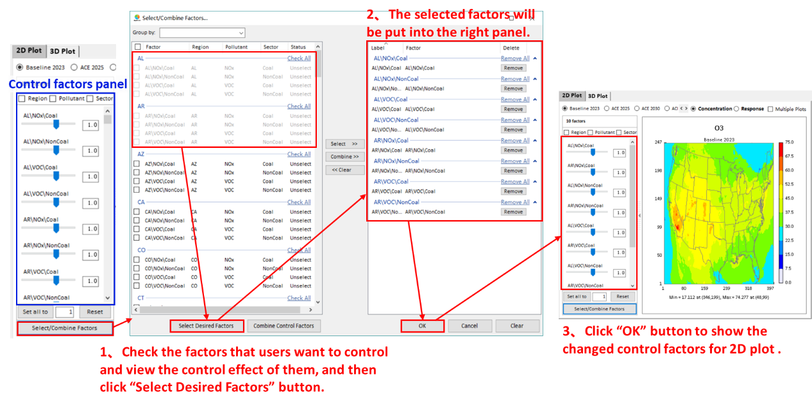
- Select interested factors only
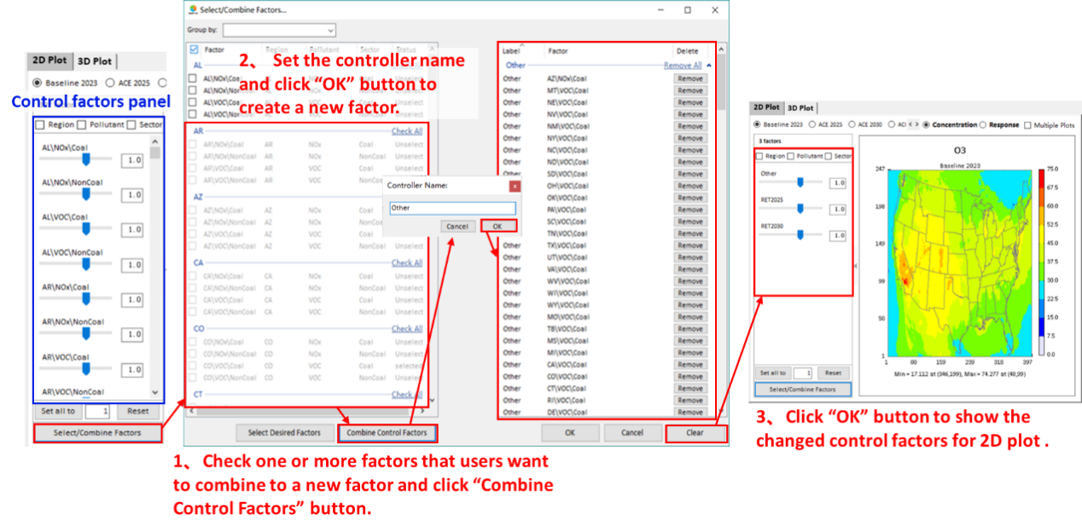
- Select any combination of factors
Figure 38. User-defined control method

Customize Model Domain
FAST-CE allows the user to flexibly change the model domain.
Click the mini-map in the lower left corner of the main interface, a new "Edit Domain" window will be displayed.
Under the "Edit Domain" window, users can select a sub-range area as new model domain and click "OK", then the modified domain will be applied to all 2D/3D plots
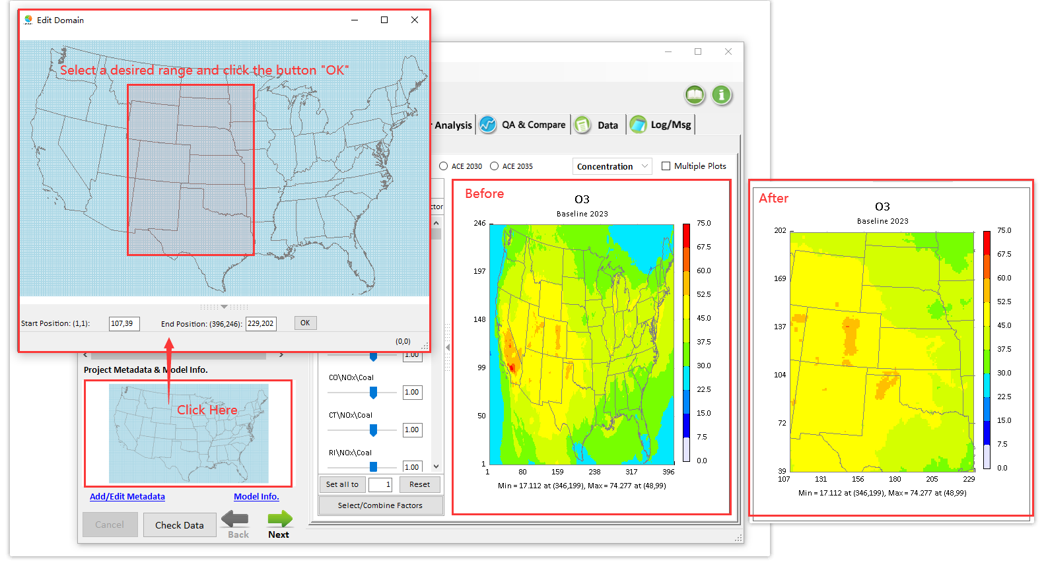
Figure 39. Edit the Model Domain

Monitor Point/DVs & Projection module
When user Input the monitor-based data by selecting the option “Use Monitor Points (DVs) data file” under the “Baseline AQ surface & Emissions Input Option” and finish Running/Loading a “Monitor Projection” scenario, the “Monitor Plot” module will display all monitors on the Map and provide following functions:
  - “Probe” function to show value when click monitor point
  - Allow to configure the “size” and “color” of monitor points
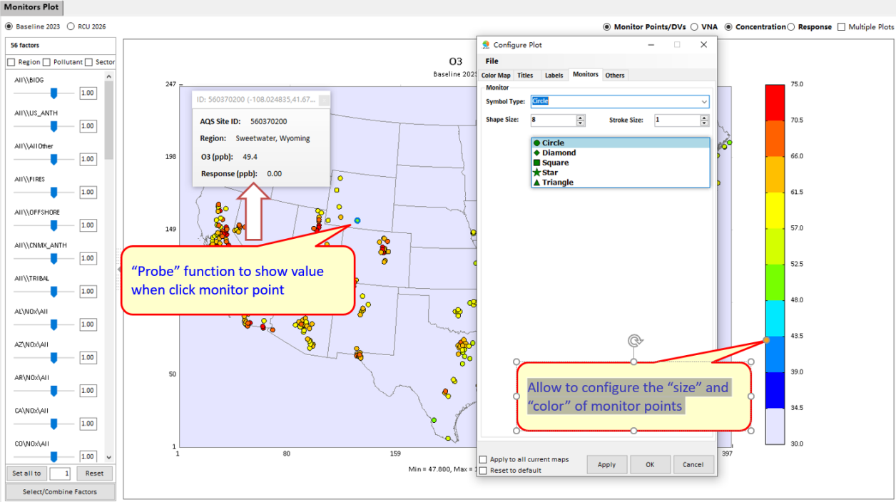
Figure 40. Configure Color and Size of Monitor Points
  - Allow to “zoom-in” “zoom-out” map
  - Allow to “Compare” the difference of two selected scenarios
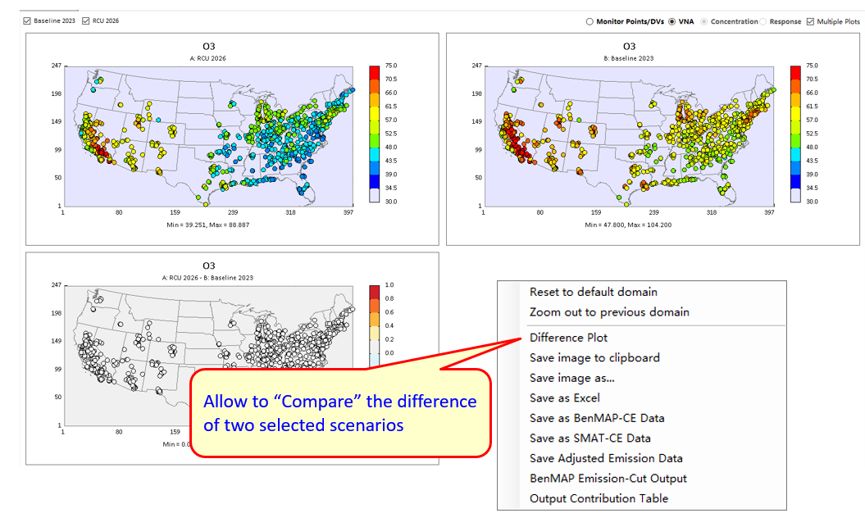
Figure 41. Compare the Selected Scenarios

  - Allow to display VNA results.
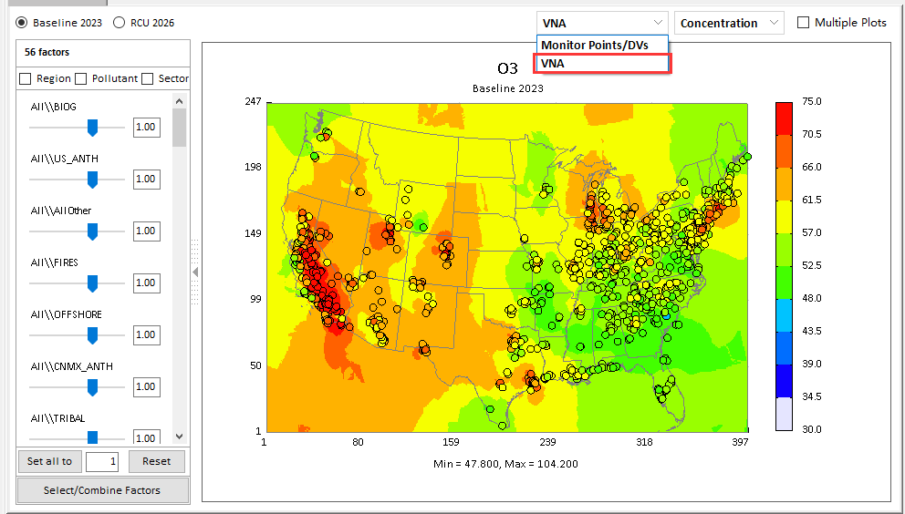
Figure 42. Display VNA Results
  - Output Contribution Table
FAST-CE can also calculate the contributions to all Monitor point/DVs and extract the summary table as *.csv file.
- Click the "Output Contribution Table" button and select the output file path:
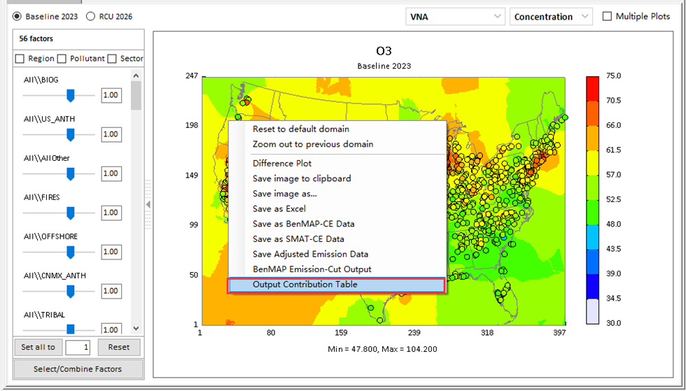
Figure 43. Output contribution table
- The summary table will be shown as below:
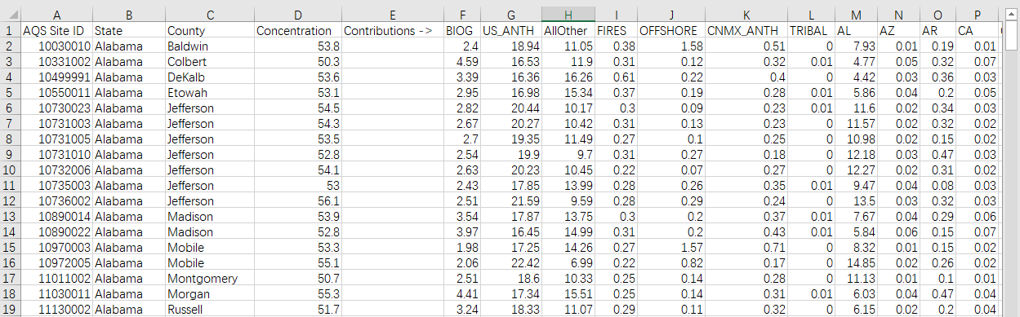
Figure 44. Output summary table of contributions to all O₃ monitors

Display PM Species value
For PM2.5 analysis, users can display the PM species concentration/response value under 2D/3D plot. This function is available only when the “Include PM Species” and “SMAT-CE adjustment” options are checked.
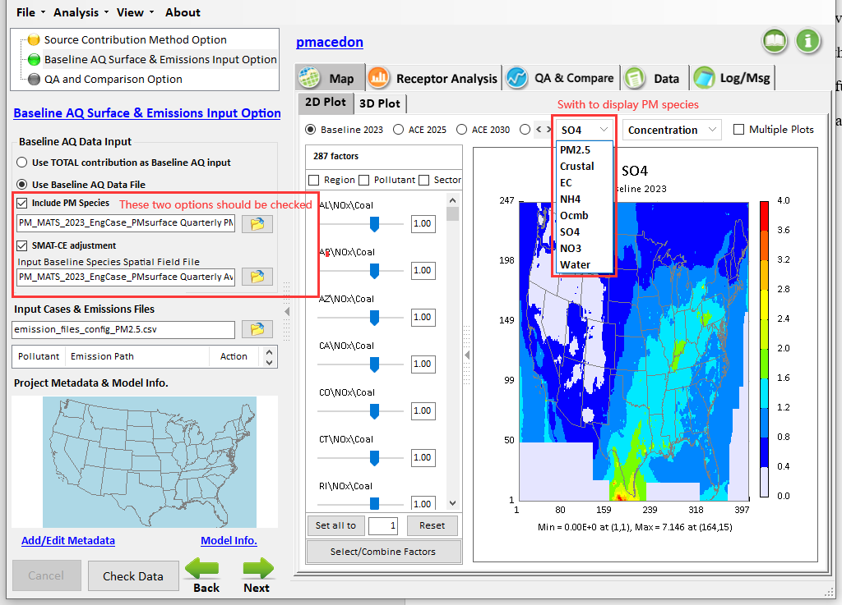
Figure 45. Display the PM Species Value

EJ/Demographics Data module
Users can choose whether to enable the EJ/Demographics Data module and navigate to the EJ/Demographics data files directory in "Startup Option" plot. Note that the EJ/Demographics function only available when the EJ/GCAM Data package is installed.
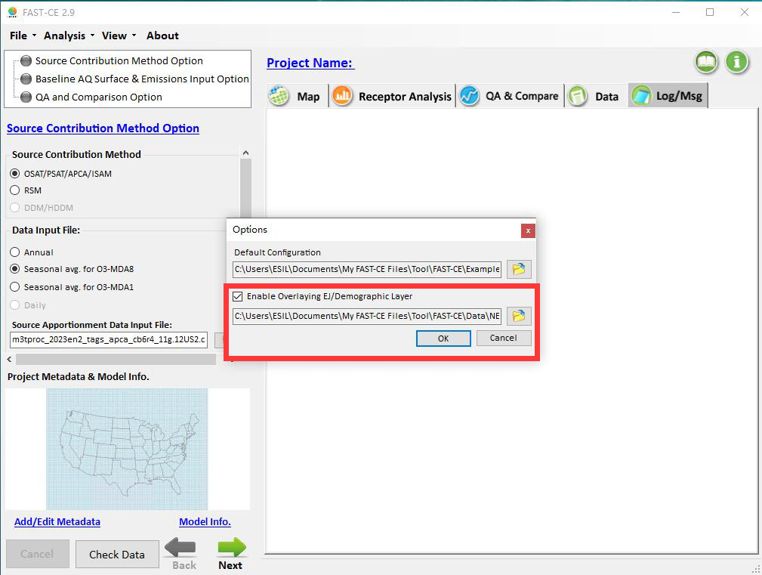
Figure 46. Enable EJ/Demographics Data Module
If user enable overlaying EJ/Demographic layer, the “EJ/Demographics Data” option will be added to the right-click menu under 2D plot.
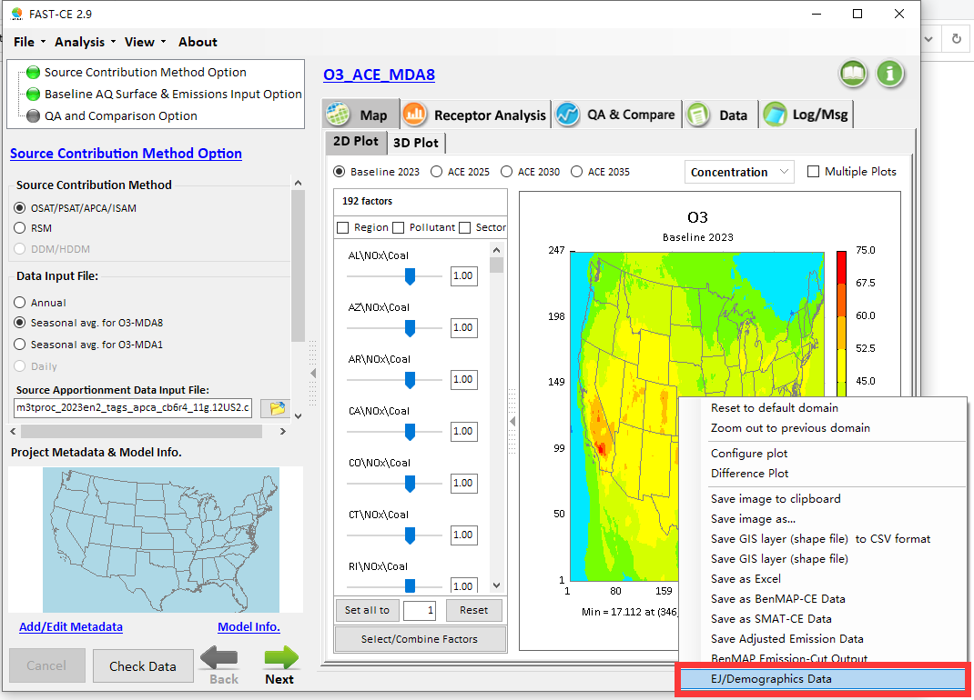
Figure 47. "EJ/Demographics Data" Option in Right-click Menu
When right-click the “EJ/Demographics Data”, user will be asked to set the EJ/Demographics Data. After clicking the "Confirm" button, the “EJ/Demographics Data” layer will be de displayed. FAST-CE also allows the user to flexibly change the EJ index and show the corresponding “EJ/Demographics Data” layer in real-time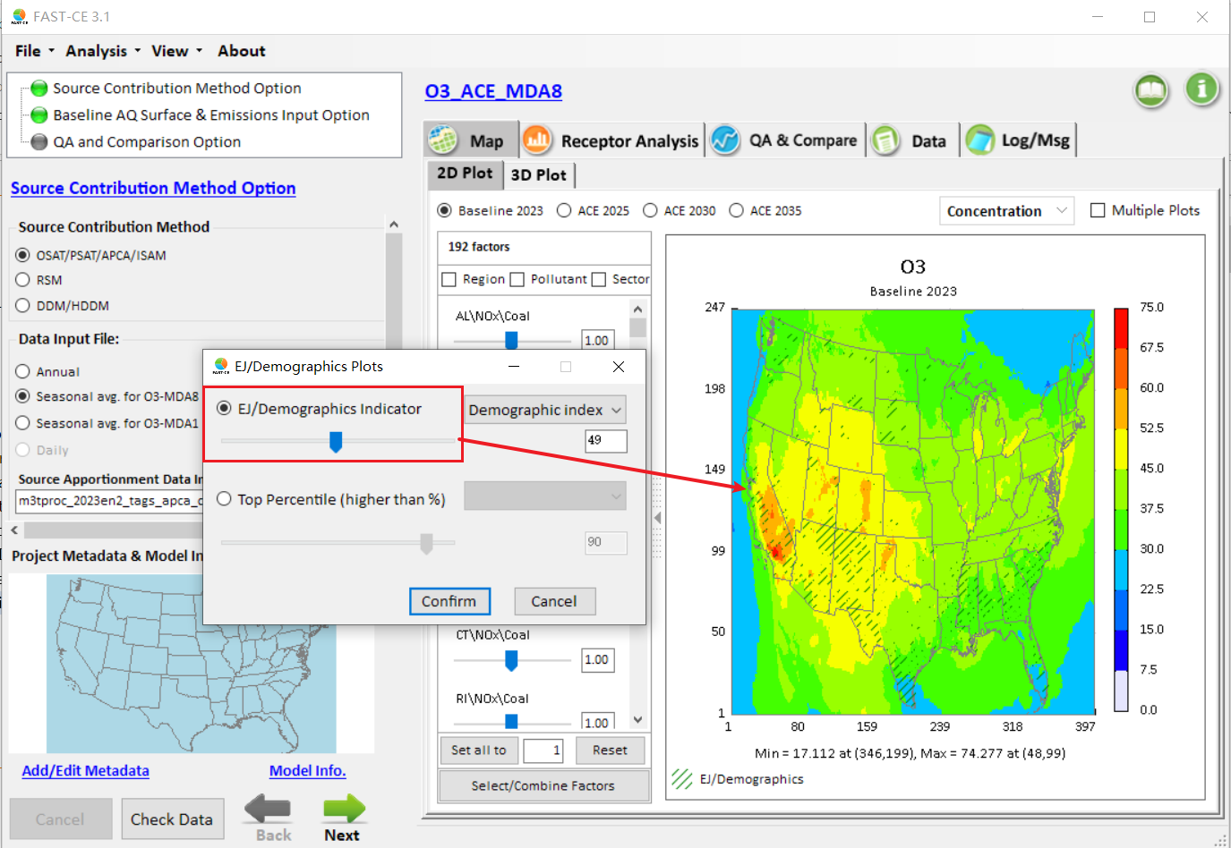
Figure 48. EJ/Demographics Setting Plot

Receptor Analysis
Under the Receptor Analysis module, users can also view the effects of emission reduction at different scales through the chart and configure the plotting according to their preferences.

There are four types of charts in this module:
- Emission Control 1
- Emission Control 2
- Source Contribution 1
- Source Contribution 2

Emission Control 1
Under the Emission Control 1 module, users can view the effects of different emission control scenarios on selected receptor regions through bar charts.

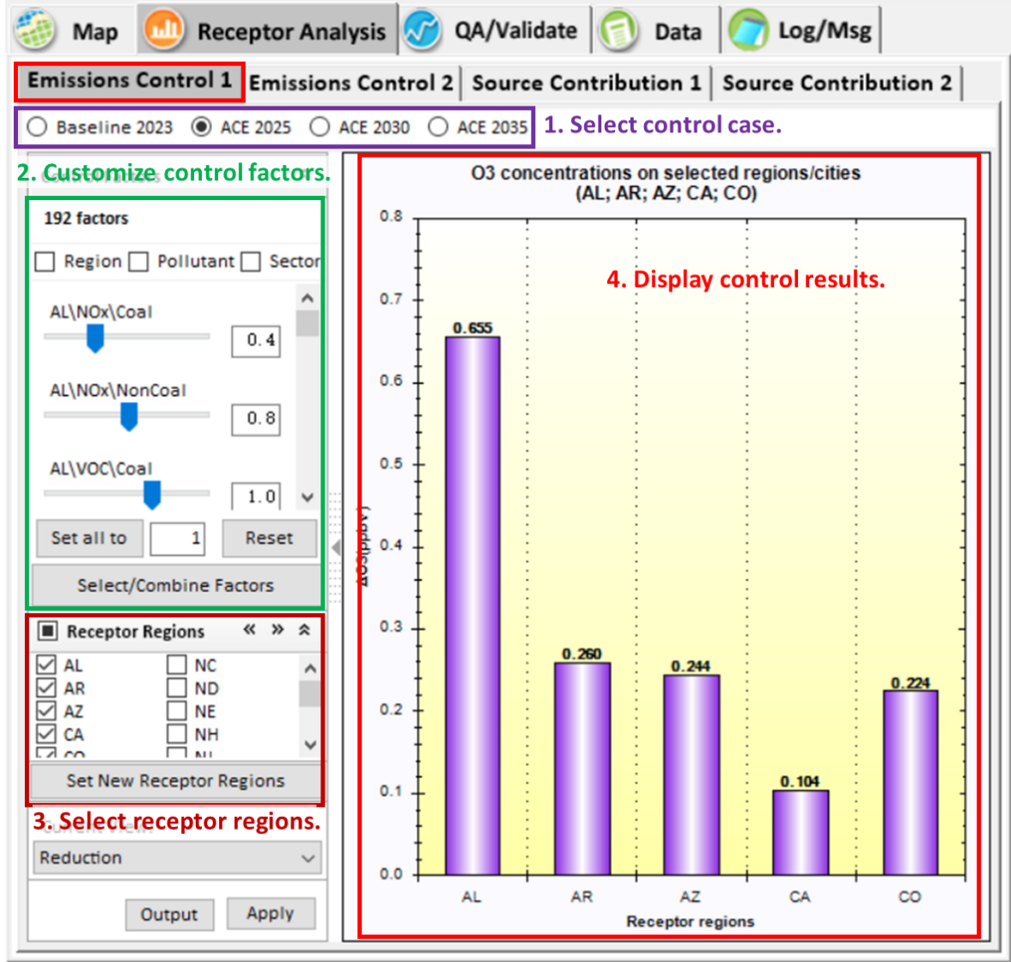
Figure 49. Emission Control 1

Emission Control 2
Under the Emission Control 2 module, users can view the effects of emission control scenarios at different levels in one bar chart.

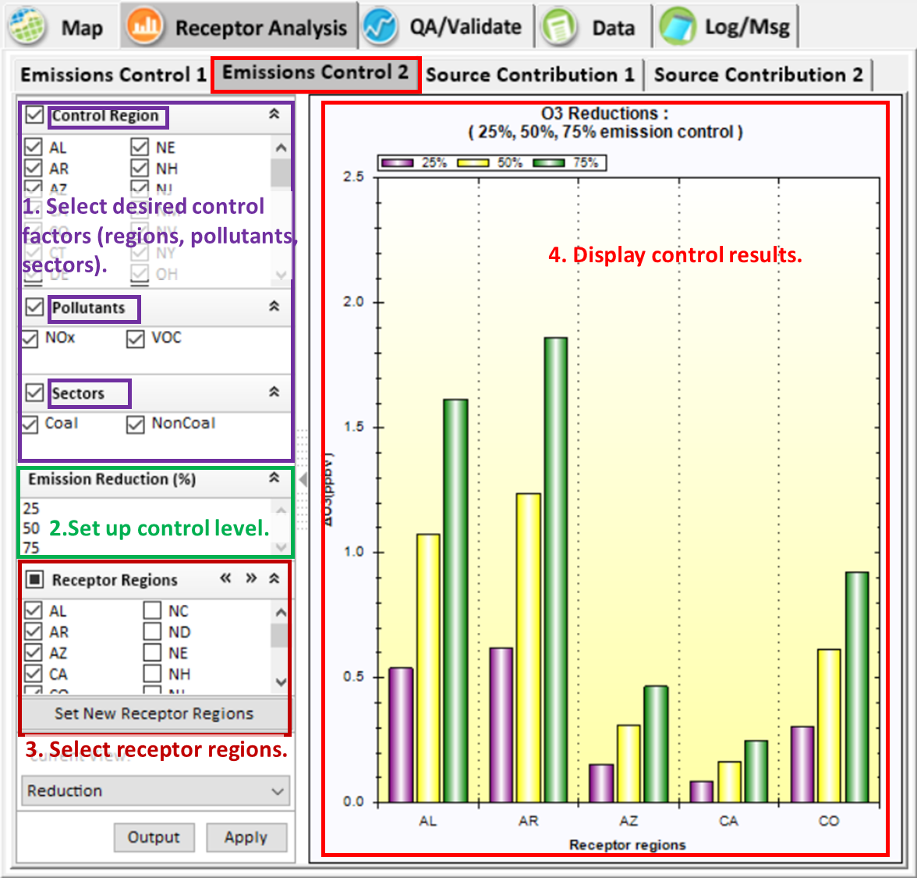
Figure 50. Emission Control 2

Source Contribution 1
The Source Contribution 1 module displays a bar chart of the total source contribution to receptors caused by all user-selected control factors.
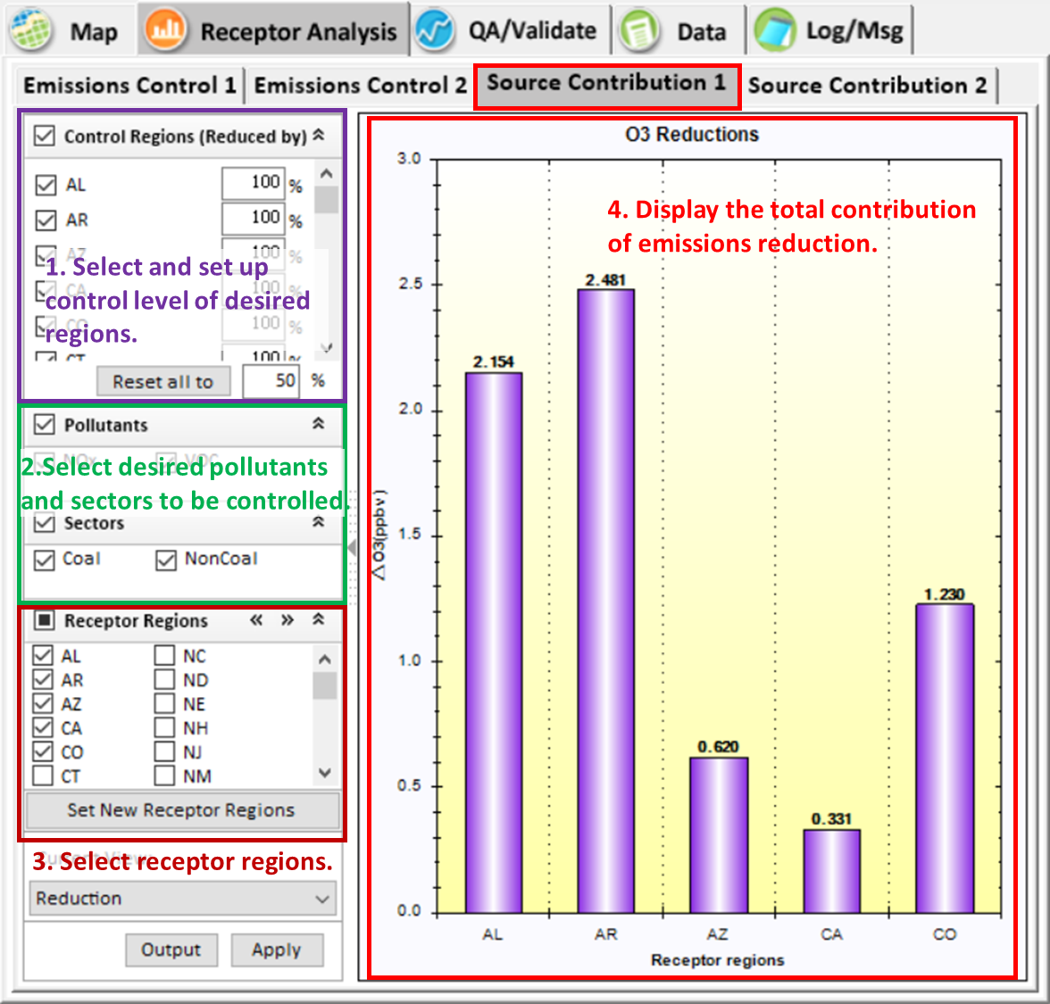
Figure 51. Source Contribution 1

Source Contribution 2
The Source Contribution 2 module displays a stacked bar chart of the source contribution to receptors caused by each user-selected control factor.
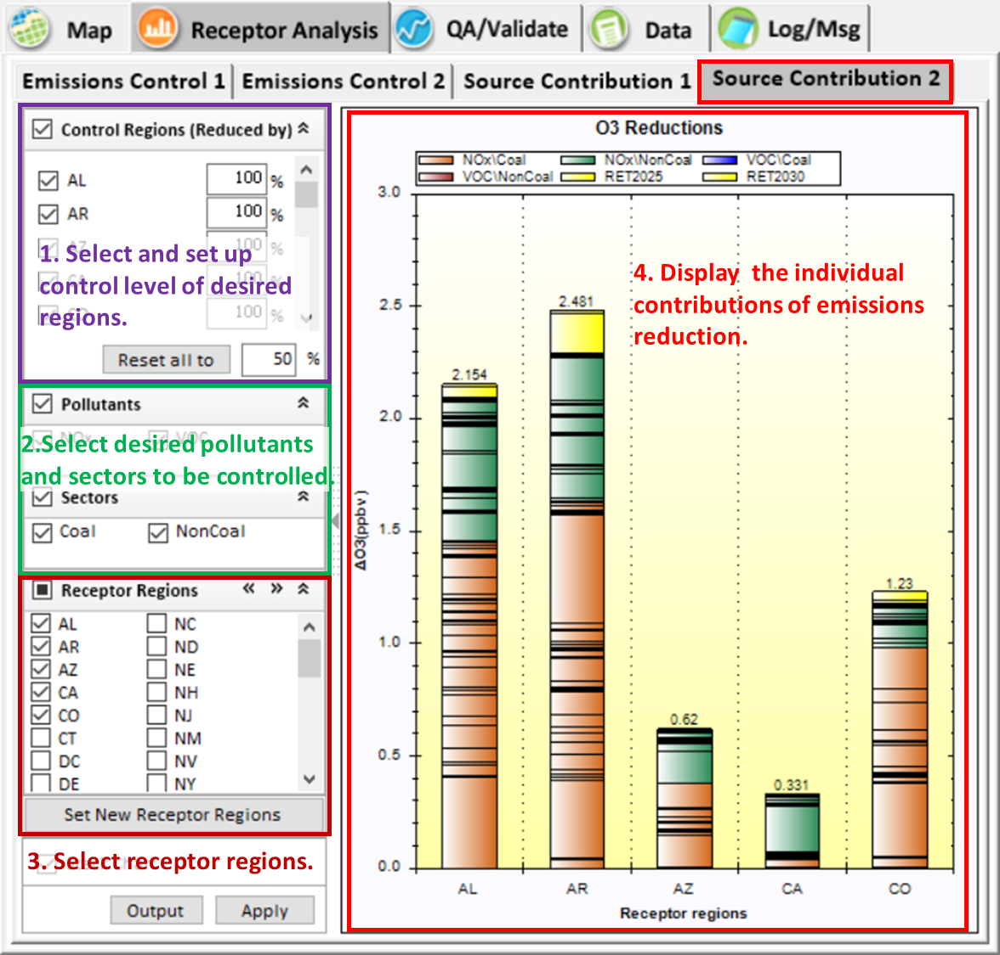
Figure 52. Source Contribution 2

Customize receptor regions
FAST-CE allows the user to flexibly customize the receptor regions and show the corresponding response results of new receptor regions in real-time. For example, users can select desired states or CBSA regions by selecting the default file “US_states.csv” or “US_cbsa.csv” or checking the regions of interest on the right panel, and then click “Apply” to display the corresponding response results of new receptor regions (Figure 53). Users can also add new receptor regions by importing receptor region files in the specified format according to their needs (Figure 54). Besides, users can extract the desired regions for further study.
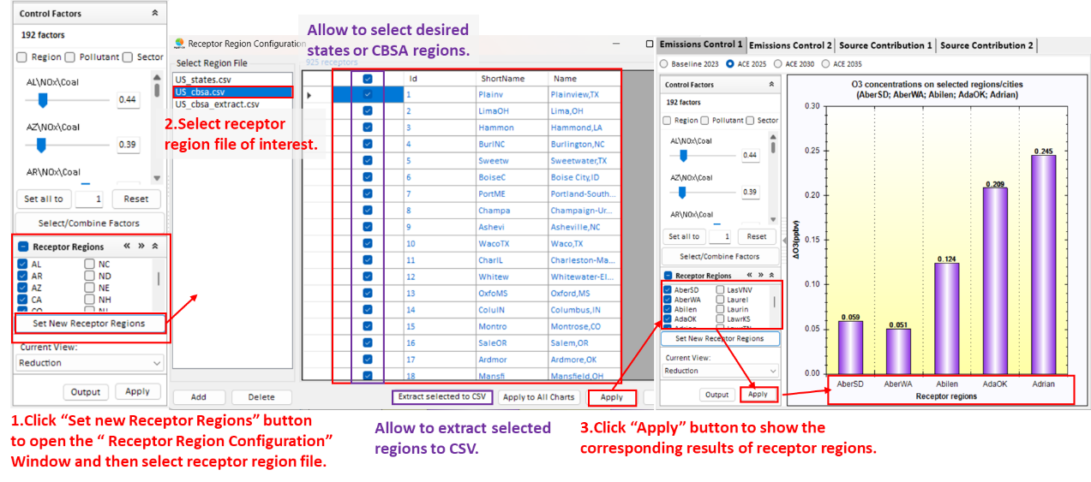
Figure 53. Select receptor regions of interest
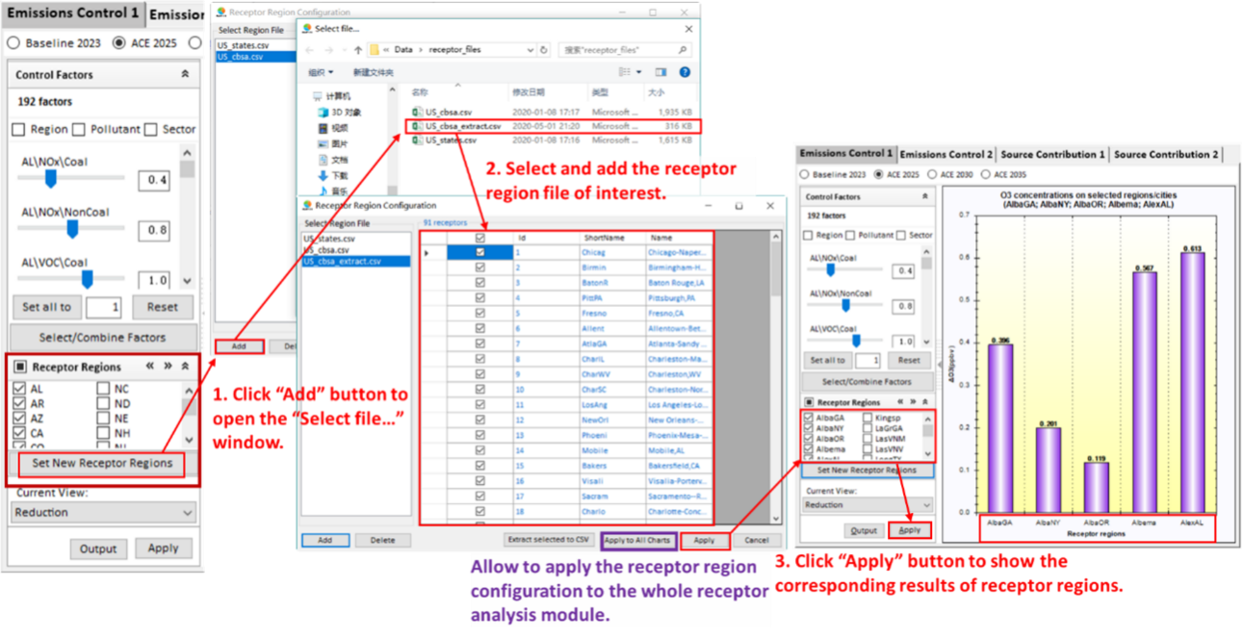
Figure 54. Add new receptor regions

QA/Validation
The QA/Validation module evaluates the performance of FAST-CE. Users can specific the receptors or grids to be included in the analysis for generating the scatter plots to compare the user-generated FAST-CE results with EPA validation data, as shown in Figure 55. This module not only supports to display the comparison results about concentration between FAST-CE predicted and EPA but their corresponding response comparison results. The default scatter plots displayed are normal scatter plots, but users can switch to the color density scatter plots by checking “Color Density Plot”. Besides, users can also compare the results of multiple control scenarios simultaneously by checking the “Multiple Plots”.

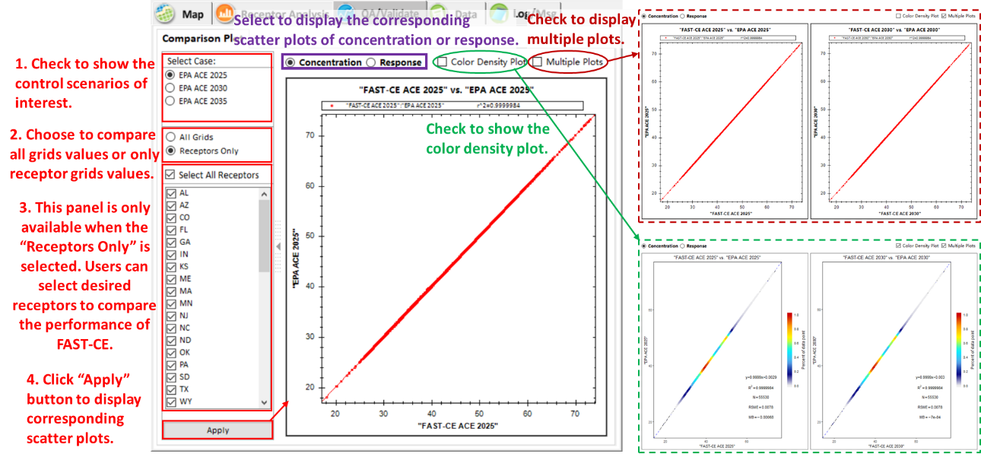
Figure 55. QA/Validate module

Data
The Data module provides more detailed information about the concentration of the target pollutant at each grid. Users can export the data for further study, as shown in Figure 56.

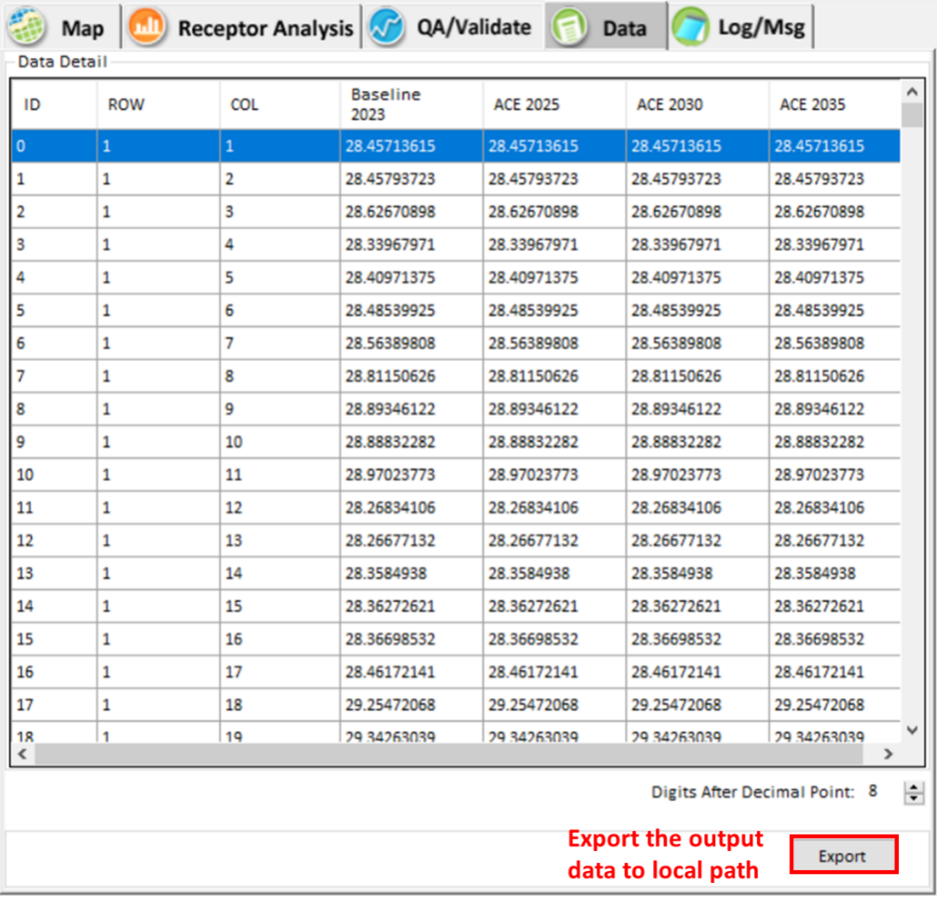
Figure 56. Detailed data results and configuration

GCAM Scenario Builder
The GCAM Scenario Builder module allows users to run GCAM in FAST-CE and output emissions files. This function is available only when the GCAM data package was installed. Users can set up GCAM configuration in “GCAM Scenario Builder” plot and click “Save & Run” to run GCAM model. After running the GCAM model, the output emissions plot will be presented to the user.
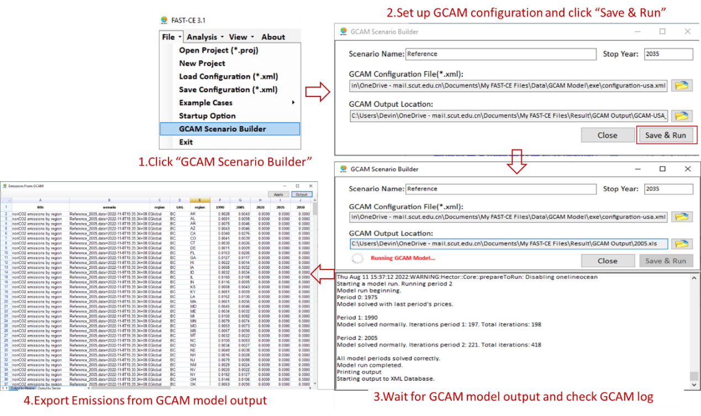
Figure 57. Steps for GCAM Scenario Builder
The output emissions from GCAM model as shown in Figure58. Users can switch the “Emissions from GCAM” table sheet by clicking the sheet name (“Output by Region” or “Output by Sector”) on the bottom of the worksheet. Also, user can click the "output" button to save the output to local path.
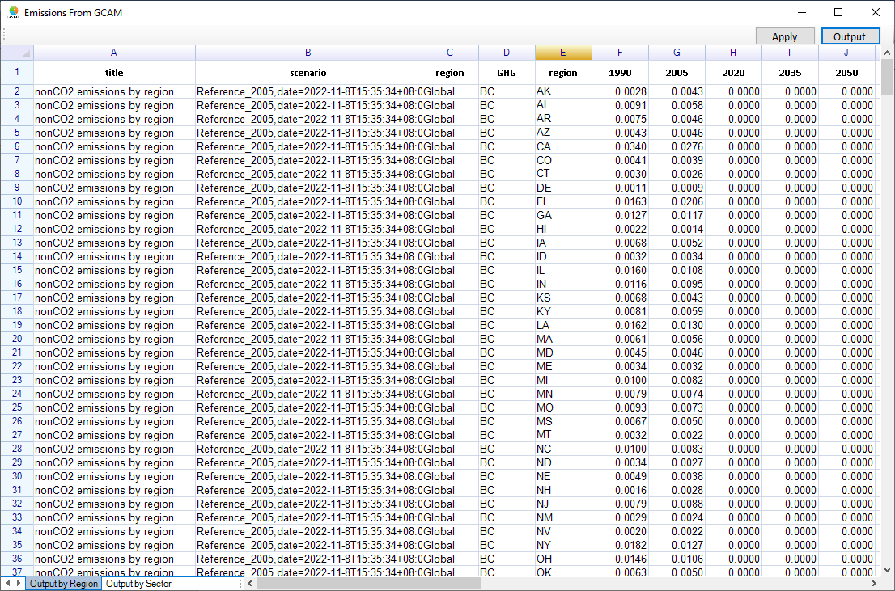
Figure 58. Emissions output from GCAM

Case Study
To illustrate how to run the FAST-CE, an example case study of the OSAT method in the U.S. is given as follows.

Ozone MDA8 Analysis – OSAT.

Create a new project
- Click the File button and choose the New Project option to create a new project.
- Click the Analysis button and choose the Ozone option to create a new O₃ project.
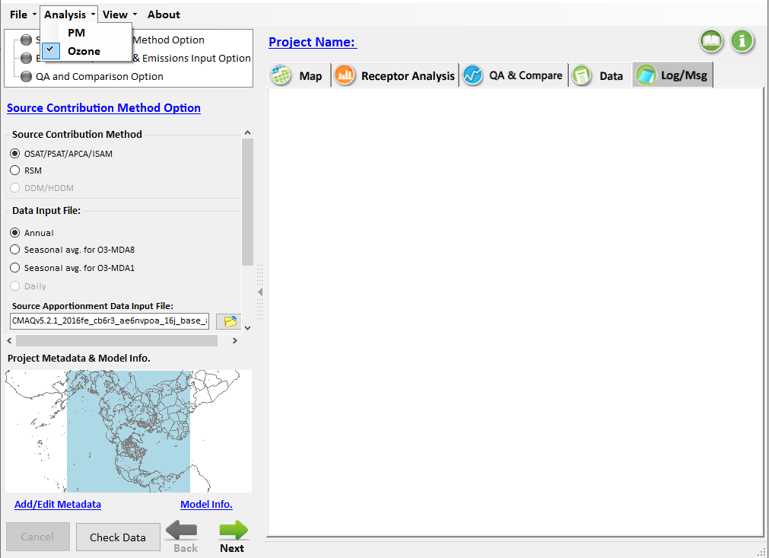
Figure 59. Create a new O3 project

Set up input parameters
- Double-click the Source Contribution Method Option, then select the OSAT/PSAT/APCA/ISAM method.
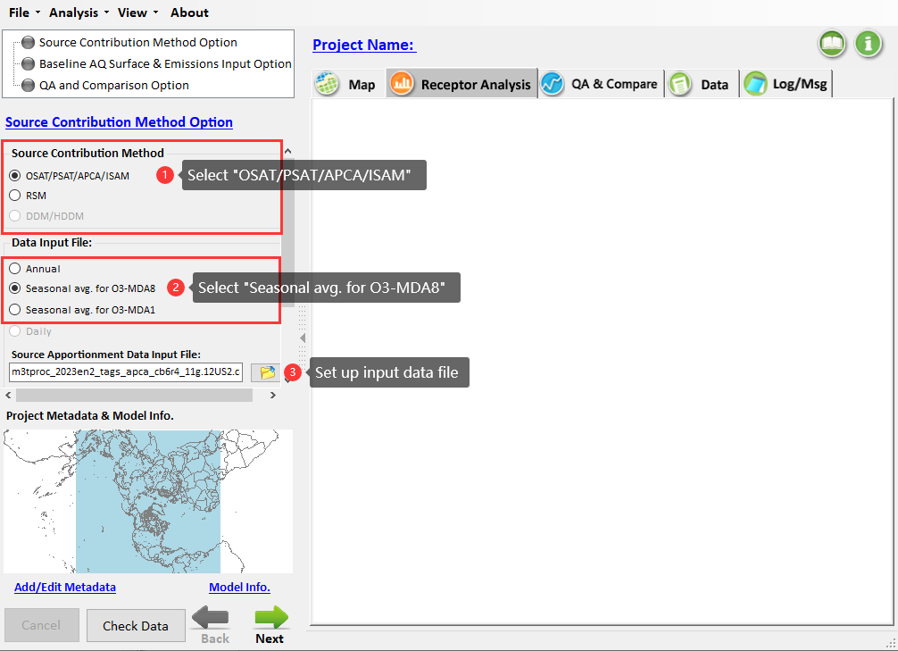
Figure 60. Source Contribution Method Option for O₃-MDA8 analysis
- Set the Data Input Type to Seasonal avg for O₃-MDA8 (May-Sept), which can be explained by the nonattainment of the National Ambient Air Quality Standards (NAAQS) over many areas in the U.S caused by the high summertime ozone concentrations (Hakami, Seinfeld et al. 2006, Liao, Hou et al. 2014, Couzo, Mccann et al. 2016).
- Click button and choose “m3tproc_2023en2_tags_apca_cb6r4_11g.12US2.camx.contrib8hrmax_LST.5-9.ioapi” as the Data Input File, “US_states.csv” as the Receptor Region File and “Mapping_Emis_ref_SA_O3.csv” as the Mapping File. The details of the Receptor Region File and Mapping File are shown in Figure 61 and Figure 62, respectively.
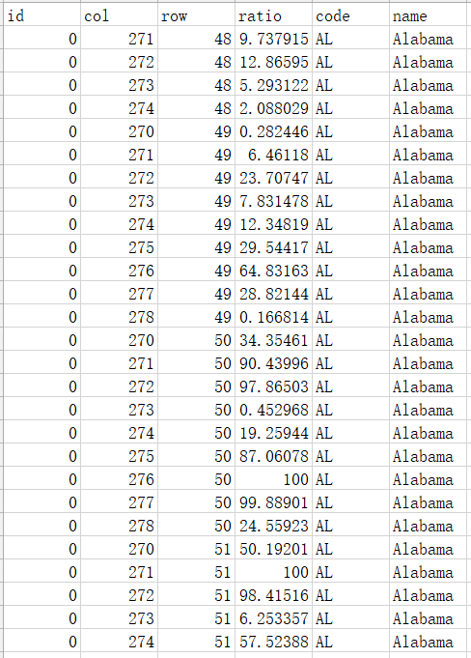
Figure 61. Receptor Region File

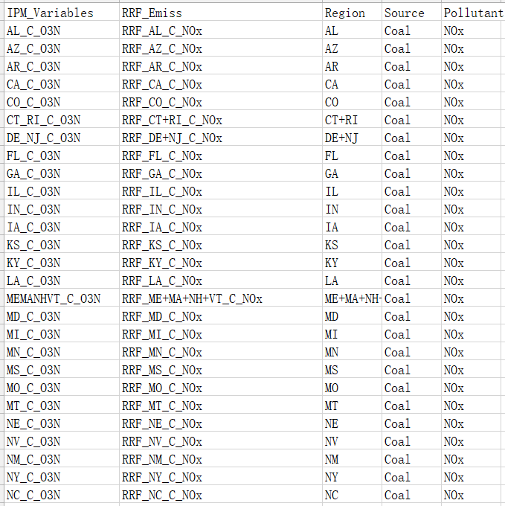
Figure 62. Mapping File
- Click and go to set up the Emission & Spatial Field Input Option.
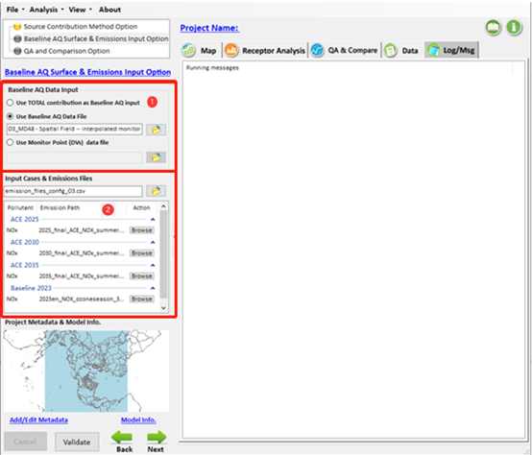
Figure 63. Emission & Spatial Field Input Option for O₃-MDA8 analysis

- Click button and select
“O3_MDA8 - Spatial Field -- interpolated monitor data, temporally adjusted; gradient-adjusted monitor data, 2023.csv” as the Input Baseline Spatial File. The details of the Baseline Spatial File are shown in Figure 64.

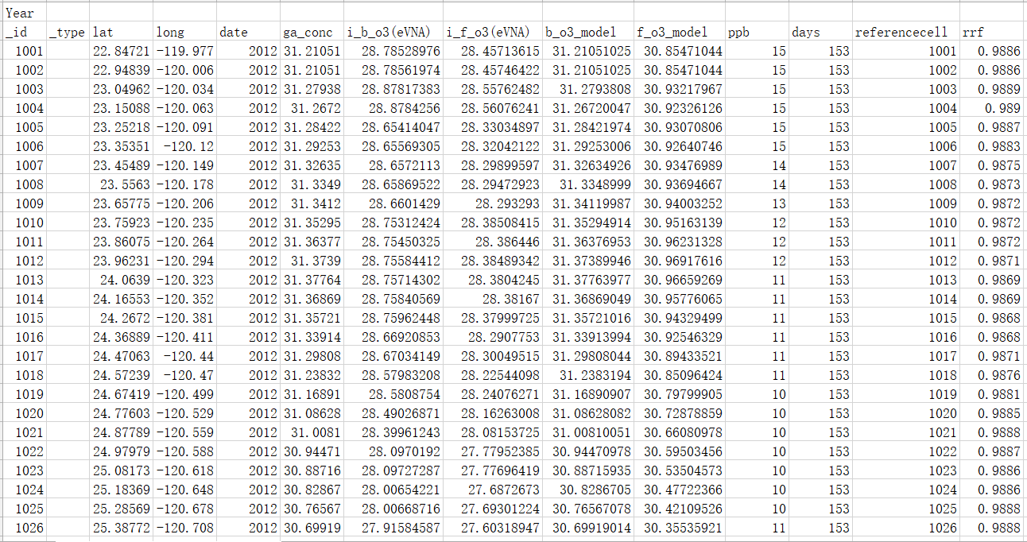
Figure 64. Baseline Spatial File

- Click the next button and select “emission_files_config_O3.csv” as the Input Cases & Emissions Files. The details of the Cases & Emission Files are displayed in Figure 65 and Figure 66.
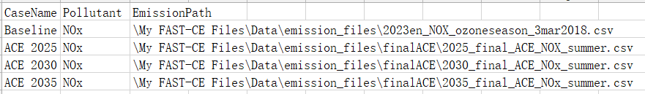
Figure 65. Cases & Emission Files

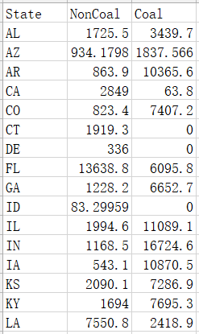
Figure 66. An example of “Emission File”
(“2025_final_ACE_NOX_summer.csv”)
- Click and go to set up the QA/Validation Input Option.
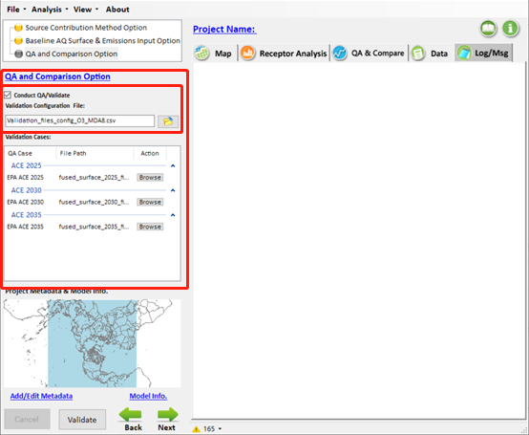
Figure 67. QA/Validation Input Option for O₃-MDA8 analysis
- Check “Conduct QA/Validation”, click button and select “Validation_files_config_O3_MDA8.csv” as the Validation Configuration File. The details of the Validation Configuration File and an example of “QA File” are shown in Figure 68 and Figure 69, respectively.

Figure 68. Validation Configuration File
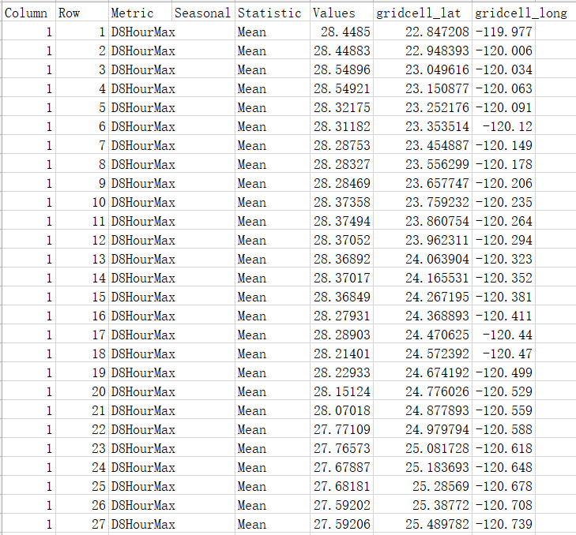
Figure 69. An example of “QA File”
(“fused_surface_2025_final_ACE_MDA8.BenMAP_ready.O3_Spatial_Field_Future_eVNA.csv”)
- Click button to run FAST-CE.

View results

Map results

The map results show the distribution of O₃-MDA8 concentration and the corresponding O₃-MDA8 response under selected control scenarios (i.e., ACE 2025, 2030, 2035), as displayed in Figure 70. With the strengthening of the control scenarios, O₃-MDA8 pollution has improved significantly throughout the U.S., especially in the southeastern U.S.
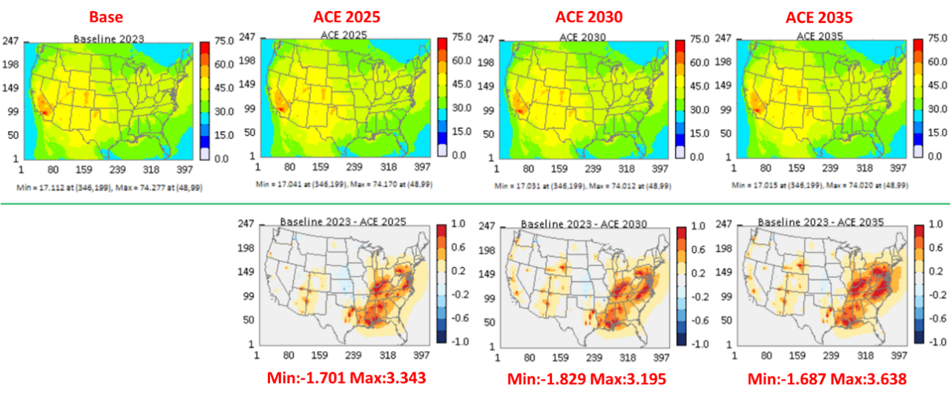
Figure 70. Map results

The results of Receptor Analysis

The effects of emission reduction on selected receptor regions are displayed in the Receptor Analysis module, as shown in Figure 71. For example, the top three contributors to the overall O₃-MDA8 reductions from control scenarios of ACE 2025 to 2035 are slightly different but all include DC, which indicates that more stringent control measures on DC can effectively alleviate the O₃-MDA8 pollution to a certain extent.

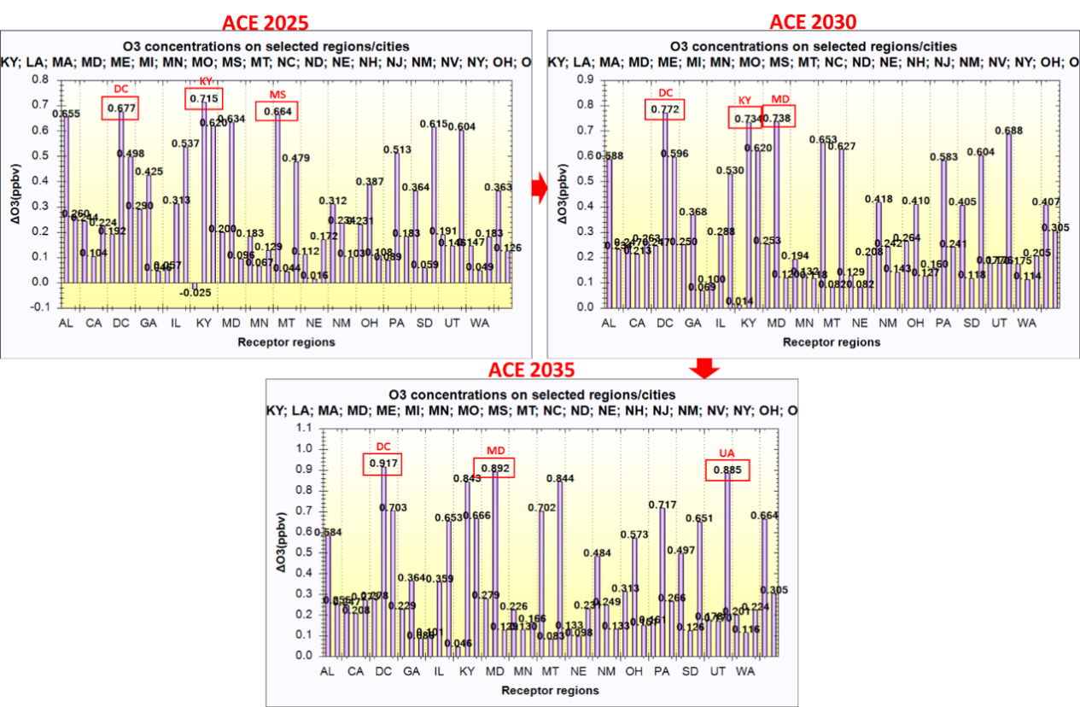
Figure 71. Results of “Emission Control 1”

The results of QA/Validation

In the OA/Validation module, it can be seen that the FAST-CE predictions of O₃-MDA8 show good performance with the EPA’s ACE results, with the R² of both concentration and response more than 0.99 (Figure 72).

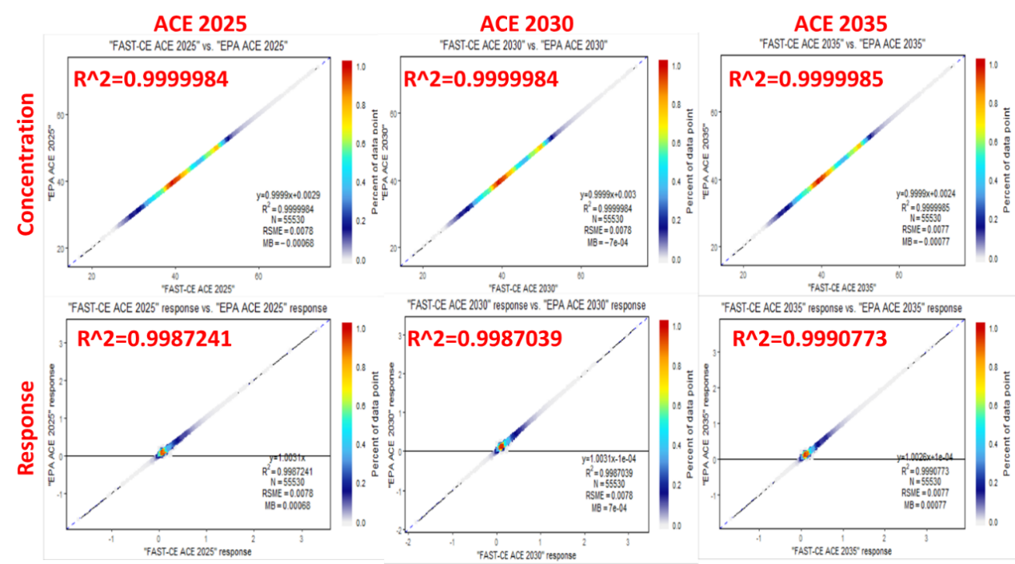
Figure 72. Results of QA/Validation

Data results
The more detailed information about the O₃-MDA8 concentration of each grid, including the baseline concentration and the concentration that responds to the control scenarios (i.e., ACE 2025, 2030, 2035), can be seen in the Data module (Figure 73).

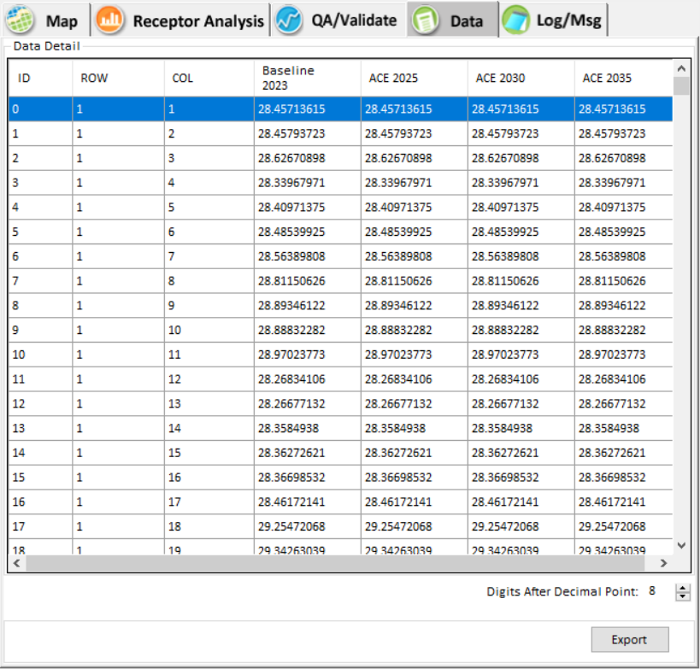
Figure 73. Data results

Reference
- Couzo, E., J. Mccann, W. Vizuete, S. Blumsack and J. J. West (2016). "Modeled response of ozone to electricity generation emissions in the northeastern United States using three sensitivity techniques." Journal of the Air & Waste Management Association 66(5): 456-469.
- Dunker, A. M., G. Yarwood, J. P. Ortmann and G. M. Wilson (2002). "Comparison of Source Apportionment and Source Sensitivity of Ozone in a Three-Dimensional Air Quality Model." Environmental Science & Technology 36(13): 2953-2964.
- Hakami, A., J. Seinfeld, T. Chai, Y. Tang, G. Carmichael and A. Sandu (2006). "Adjoint sensitivity analysis of ozone nonattainment over the continental United States." Environmental Science & Technology 40(12): p. 3855-3864.
- Li, L., J. Y. An, Y. Y. Shi, M. Zhou, R. S. Yan, C. Huang, H. L. Wang, S. R. Lou, Q. Wang and Q. Lu (2016). "Source apportionment of surface ozone in the Yangtze River Delta, China in the summer of 2013." Atmospheric Environment 144: 194-207.
- Liao, K. J., X. Hou and D. R. Baker (2014). "Impacts of interstate transport of pollutants on high ozone events over the Mid-Atlantic United States." Atmospheric Environment 84(feb.): 100-112.
- Mojtaba, M., A. C. L. and M. Ali (2018). "The importance of transport to ozone pollution in the U.S. Mid-Atlantic." Atmospheric environment 191(OCT.): 420-431.

