Main Improvements of SMAT-CE 2.3
25-January, 2024
Main Improvements:
- Develop a new check option named “Output Max Design Value” under the “Output Choices-Advanced” input option for Annual PM analysis.
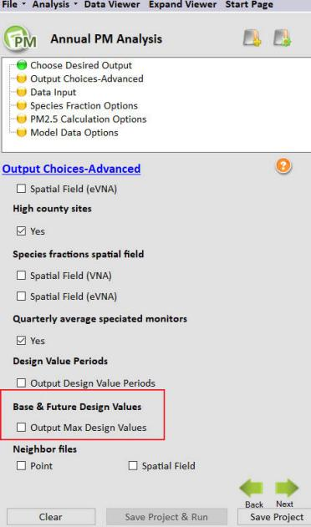
Fig. 1 The Output Choices-Advanced input option for Annual PM analysis
- Under this new option, three additional files named as “Annual PM25 Point Max.csv”, “Quarterly PM25 Point Max.csv” and “High County Sites Max.csv” with the same format like “Annual PM25 Point.csv”, “Quarterly PM25 Point.csv” and “High County Sites.csv” respectively will be output.
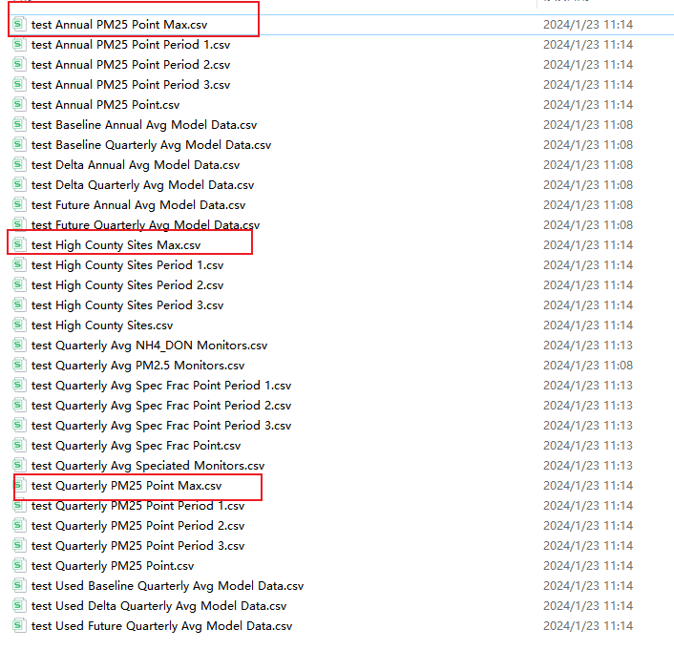
Fig. 2 The “Max” file for the default case
- The max DVs in these new output files are picked up from the design period files. For example, the “b_pm25_ann_DV_Max” and “f_pm25_ann_DV_Max” for each monitoring sites in “Annual PM25 Point Max.csv” are the maximum of “b_pm25_ann_DV” and “f_pm25_ann_DV” from “Annual PM25 Point Period x.csv” files, respectively.
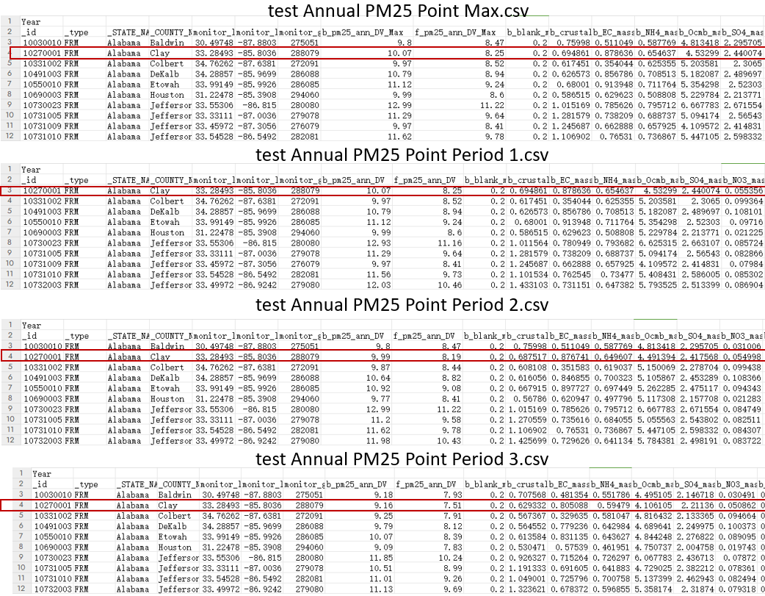
Fig. 3 The results in Annual PM25 Point Max and Annual PM25 Point Period x file
- “using_data” and “missing_data” columns are newly included to mark the max DV used and missing period data. For example, as shown in Fig. 4, the first-row data with a value of “2010-2012” in “using_data” means that the max DV are come from the “2010-2012” design period, while the value of “2009-2011” in “missing_data” indicates that there are no data in “2009-2011” design period in calculating the max DV.
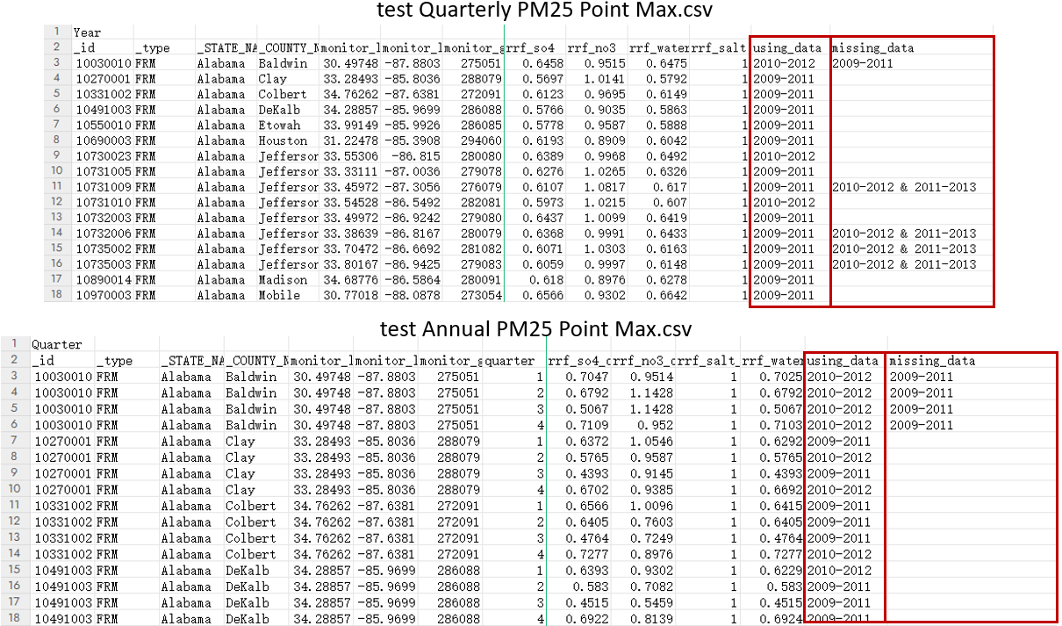
Fig. 4 The results in Quarterly PM25 Point Max and Annual PM25 Point Max file (the intermediate data is hidden)

