Supplementary Material for

A Comparison of Three Chromatographic Retention Time Prediction Models
Andrew D. McEachran*, Kamel Mansouri, Seth R. Newton, Brandy Beverly, Jon R. Sobus, Antony J. Williams*
mceachran.andrew@epa.gov
williams.antony@epa.gov

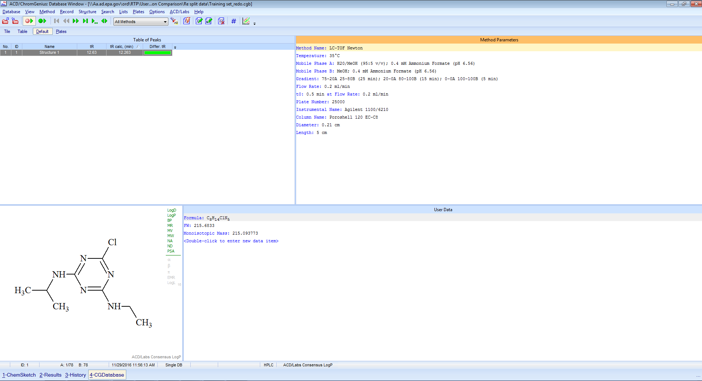
Figure S1. ACD/ChromGenius Database Window. Structures and retention times in the training set are added to the internal database for model generation.
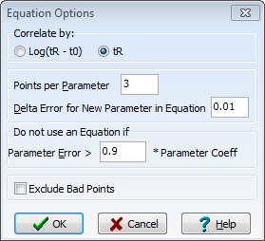
Figure S2. Equation options selected during model generation.

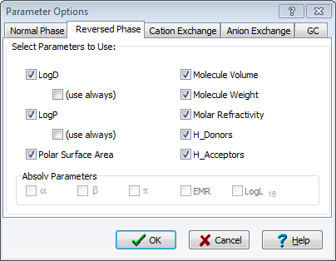
Figure S3. Parameter options selected during model generation.
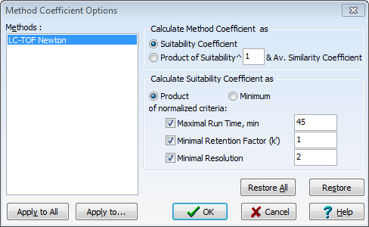
Figure S4. Method coefficient options selected during model generation.

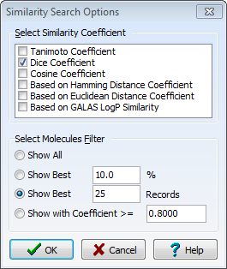
Figure S5. Similarity Search Options selected.

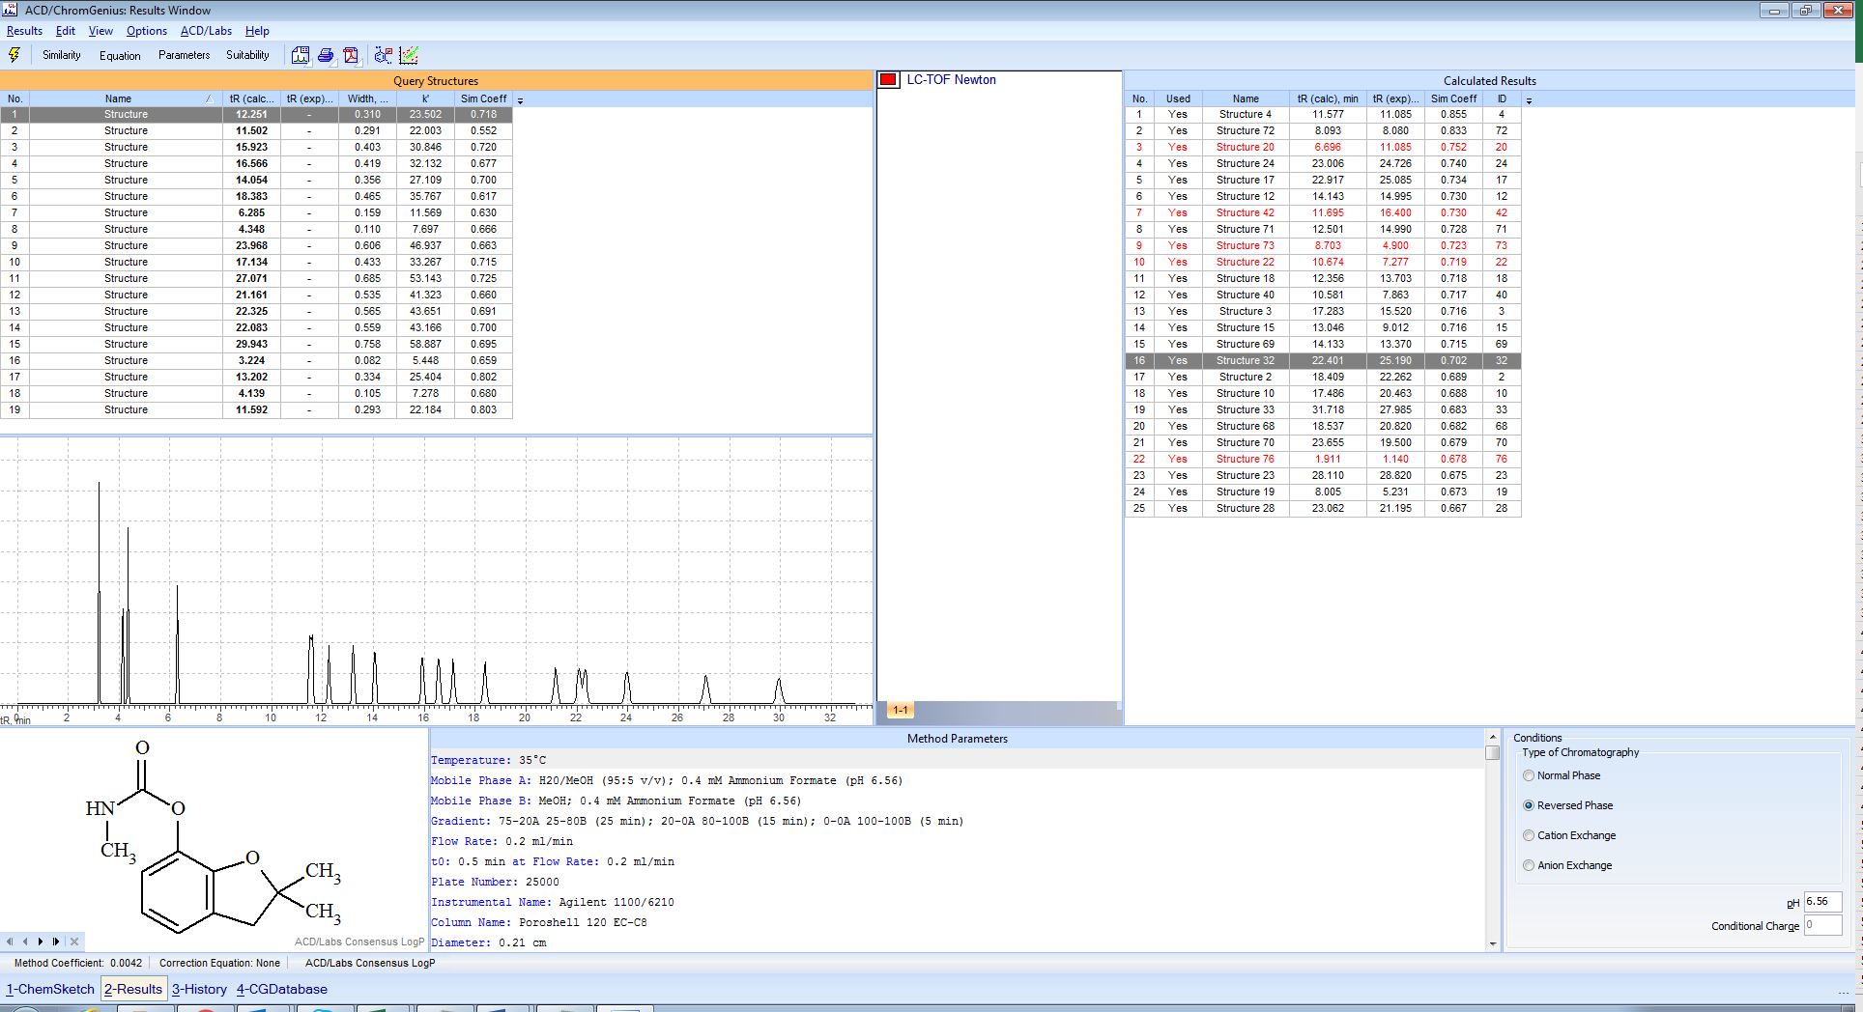
Figure S6. Model results screen with test set compounds.

