Supplemental File S1
Selecting a Minimal set of Androgen Receptor Assays for Screening Chemicals
Richard Judson [1], Keith Houck [1], Katie Paul Friedman [1], Jason Brown [1], Patience Browne [2], Paul A. Johnston[4], David A. Close[4], Nicole Kleinstreuer [3]
[1] U.S. Environmental Protection Agency, RTP NC
[2] OECD
[3] NTP Interagency Center for the Evaluation of Alternative Toxicological Methods, RTP, NC
[4] Department of Pharmaceutical Sciences, School of Pharmacy, University of Pittsburgh, Pittsburgh, Pennsylvania.

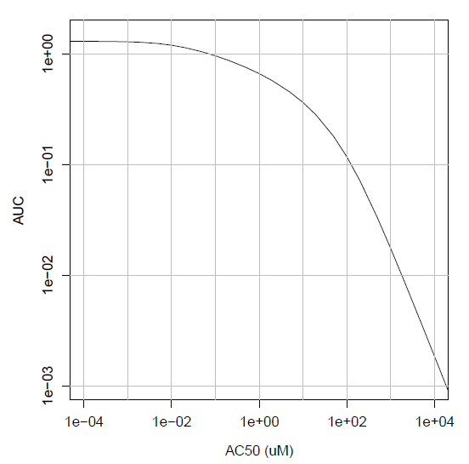
Supplemental Figure S1: Calibration curve showing the ideal relationship between assay potency and AUC values.

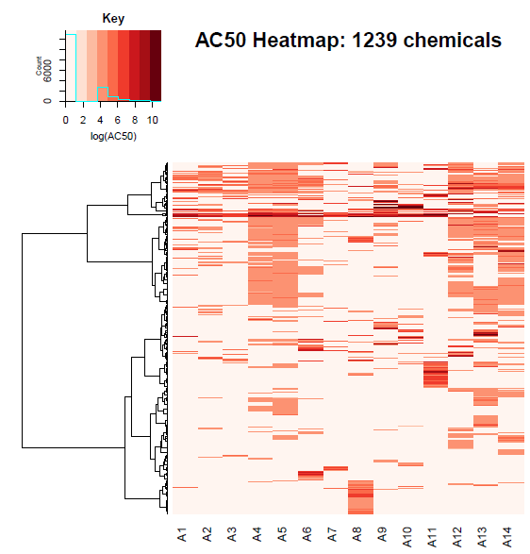
Supplemental Figure S2: Heatmap of AC50 values for all 14 assays, showing the set of chemicals active in at least one of these assays.

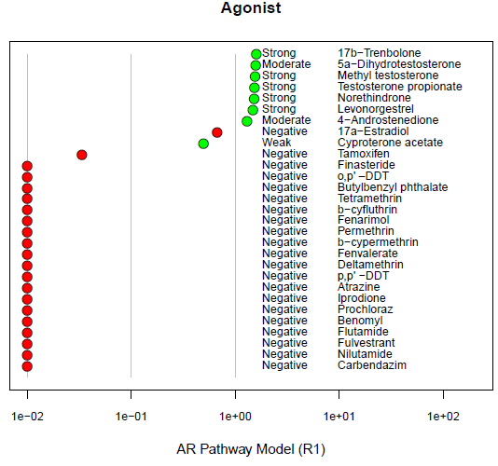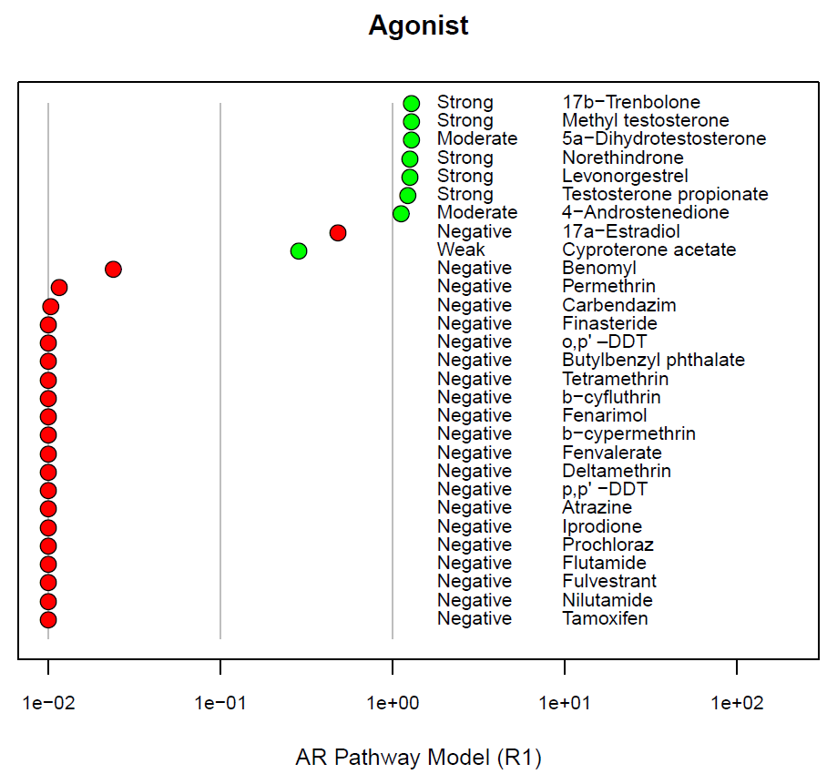
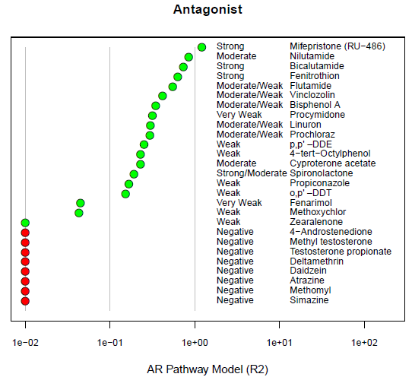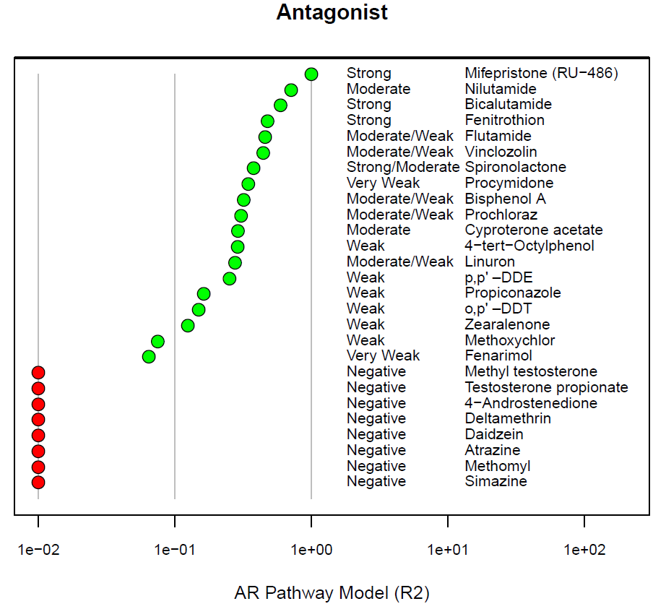
Supplemental Figure S3: In vitro reference chemical AUC values. The left-hand panels are from the original model and the right-hand panels are from the current model. From the original model figure legend: “AR pathway model results for reference chemicals. Reference chemicals and associated potency categories (from the literature search) are listed along the y-axes, and the AR pathway model AUC score for (a) agonism (R1) or (b) antagonism (R2) are listed along the x-axes. Green dots represent positive reference chemicals, and red dots represent negative reference chemicals. AR pathway model scores below 0.01 were truncated at 0.01 for plotting purposes. There was one false positive for agonism (17a-estradiol), and one negative agonist reference chemical with an inconclusive model score (tamoxifen). The initial false negative for antagonism (zearalenone) was confirmed as a potential true positive by the antagonist confirmation assay (Tox21_AR_LUC_MDAKB2_Antagonist-confirmation). Two antagonist reference chemicals had AUC scores in the inconclusive region.”

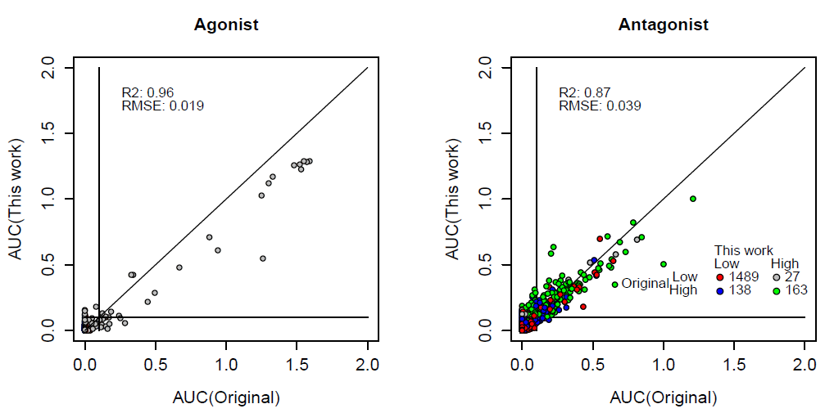
Supplemental Figure S4: Comparison of AUC(agonist) and AUC(antagonist) between the original model of Kleinstreuer et al. and the current work. In the antagonist figure, the colors indicate the confidence values for the original and new models. In the antagonist plot, the “low” and “high” categories correspond to chemicals with antagonist confidence scores below and above the cutoff of 2.

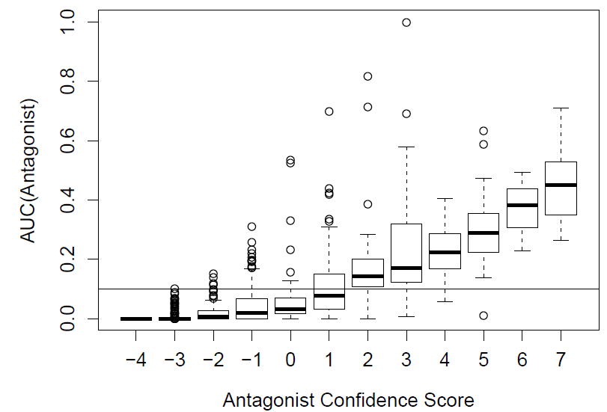
Supplemental Figure S5: Relationship between the AUC(Antagonist) and the Antagonist Confidence Score

