Integrated Model of Chemical Perturbations of a Biological Pathway
Using 18 In Vitro High Throughput Screening Assays for the Estrogen Receptor

Judson, et al.

Supplemental File S1

Appendix 1 – Experimental Methods

Data Availability: All data described in this manuscript is available as supplemental files. In addition, the full ToxCast data set is available from the ToxCast data download page: http://epa.gov/ncct/toxcast/data.html . Included here are data as csv files and as a MySQL database. Additional files on this site describe the data processing pipeline, assay annotation, the chemical library and chemical QC process, and results and summary statistics on assay quality.

Chemical Selection: The present study was conducted using data from three ToxCast chemical libraries that consisted of 1860 unique chemicals. This inventory includes 293 unique chemical structures from the Phase Iv2 ToxCast chemical library, (U.S. EPA 2008)(U.S. EPA 2008)(U.S. EPA 2008)(U.S. EPA 2008)(U.S. EPA 2008)[1] the majority of which are active ingredients of current or former food-use pesticides, with a smaller number of industrial chemicals of environmental relevance included (Kavlock, Chandler et al. 2012). An additional 667 unique chemical structures were added from the ToxCast Phase II chemical library, spanning a much larger diversity of environmental chemicals and use-group categories including antimicrobials, fragrances, green chemistry alternatives, food-additives, toxicity reference compounds, and pharmaceuticals (Kavlock, Chandler et al. 2012). The remaining 800 unique chemical structures were added from the ToxCast E1K chemical library; this chemical library was designated to be run on a subset of ToxCast endocrine related assays and included a relatively large subset of endocrine reference compounds. Individual chemical library information can be found at http://www.epa.gov/ncct/toxcast/chemicals.html, with a downloadable structure file for the entire ToxCast inventory available from the U.S. EPA DSSTox website (http://www.epa.gov/ncct/dsstox/sdf_toxcst.html). The majority of chemicals were shipped as 20mM stock solutions in DMSO, whereas relatively few compounds that were insoluble at 20mM were provided at lower concentrations, 2-15mM.

In Vitro Assays: The NovaScreen HTS competitive binding assays for human, bovine, and mouse estrogen receptor (hER, bER, mERa, respectively) were developed and run by Caliper Discovery Alliances and Services, A PerkinElmer company (Hanover, MD). A more complete description of the large set of HTS assays from which these are taken is provided in Knudsen et al. and Sipes et al. (Knudsen, Houck et al. 2011). The hER, bER, mERa receptor binding assays (Catalog Nos. 100-0127, 100-0126, 100-0897) were conducted on extracts of human breast cancer cells, bovine, and mouse uterine membranes, respectively. The ER radioligand assays measure displacement of [³H]-estradiol at final ligand concentrations of 0.1 nM (hER) and 0.7 nM (bER) with the positive reference 17β-estradiolReactions were carried out in 10 mM TRIS-HCI (pH 7.4 containing 1.5 mM EDTA, 1.0 mM dithiothreitol and 25 mM sodium molybdate at 0-4 ºC for 18 hr. The reaction is terminated with dextran-coated charcoal and incubated for 20 min at 0-4 ºC to adsorb unbound radioactivity. After centrifugation, the radioactivity remaining bound in the supernatant fraction is determined and compared to reference control values in order to ascertain any interactions of test compound with the ligand-binding site. The competitive binding assays were initially run in duplicate at a single concentration. Assay-chemical combinations meeting a pre-defined threshold of 30%, from the vehicle (DMSO) control signal or if the Z score was at least 2.0 median absolute deviations from the median (30% inhibition or MAD2) were then run in a follow-up screen in singleton concentration–response format with maximum concentration of 50µM (Knudsen et al. 2011)(Sipes, Martin et al. 2013). Concentration response curves in the follow-up screen constrained the upper and lower asymptotes of the curve between 0- and 20% activity and between 100- and 120% activity, respectively, to allow for consistent extrapolation of the concentration at 50% activity (AC50) across assay-chemical combinations. Extrapolated AC50s above the highest concentration tested were allowed if the Emax was greater than 25% activity. Emax is defined in this analysis as the maximal tested response minus the lower asymptote. In order for a response to report an AC50 and be established as a hit, an Emax of 25% and an R-squared filter of 0.5 must be obtained (Knudsen et al., 2011)(Sipes, Martin et al. 2013).

Protein-fragment complementation assay (PCA) technology developed by Odyssey Thera (San Ramon, CA) utilizes a reporter protein rationally dissected into two fragments which are fused to proteins known to interact within a signaling complex. The fusion proteins, all GFP or YFP variants, are constitutively expressed in HEK293T human embryonic kidney cells. Assembly of the reporter protein from its fragments occurs when brought within proximity through complex formation of the fusion partners. Chemical activity is measured via changes in signal intensity and localization (e.g. fluorescence). Assays were run at 8 and 24 h across three dimerization conditions (ERα-ERα, ERα-ERβ, ERβ- ERβ) and represent assays, OT_ERaERa_1440, OT_ERaERb_1440, OT_ERbERb_1440, respectively. Normalization of assay results was performed as percent of the 17β-estradiol, and the baseline for each plate-wise normalization was the median raw plate response including all DMSO wells. Concentration response data was fit to a Hill model with criteria for generating AC50 values including: Hill curves R²values ≥ 0.5, p-value ≤ 0.01 (from a test of significant difference between the top and bottom of the curve fit), and Emax (maximum activity) ≥ 30% baseline activity. The assay technology and specifics of the estrogen receptor assays are more fully described in the following reference: (Stossi, Bolt et al. 2014).

The Attagene assays describe a large collection of transcription factor assays, including two ER assays (ATG_ERa_TRANS, ATG_ERE_CIS). This collection of a multiplexed reporter gene assays and data on 309 environmental chemicals are described in Martin et al. (Martin, Dix et al. 2010). Attagene Inc. (RTP, NC), under contract to the U.S. EPA (Contract Number EP-W-07-049), provided multiplexed reporter transcription unit (RTU) assays consisting of 48 human transcription factor DNA binding sites transiently transfected into the HepG2 human liver hepatoma cell line (Romanov, Medvedev et al. 2008)(Romanov et al., 2008). In addition to the Cis-acting reporter genes (CIS), a modification of the approach was used to generate a trans-system (TRANS) with a mammalian one-hybrid assay consisting of an additional 25 RTU library reporting the activity of nuclear receptor (NR) superfamily members (Martin, Dix et al. 2010).The human ligand-binding domain of each nuclear receptor was expressed as a chimera with the yeast GAL4 DNA-binding domain that activated in trans a 5XUAS-TATA promoter, which regulated the transcription of a reporter sequence unique to each NR RTU. To ensure the specificity of detection, each individual trans-RTU system including both receptor and reporter gene was separately transfected into suspended cells followed by pooling and plating of the transfected cells prior to screening. A major difference between the CIS and TRANS system is that in CIS activities of endogenous transcription factors are measured, whereas the TRANS assay evaluates changes in activities of exogenous, chimeric NR-Gal4 proteins. A cytotoxicity assessment was performed at the higher concentrations, qualitatively, to remove confounding data from the downstream analysis process. Additional details on how the cytotoxicity assessment was performed are provided in Rotroff et al. (Rotroff, Dix et al. 2013).

The ACEA data (ACEA_T47D_80hr_Positive) was generated using the xCELLigence system Multi-E-Plate (MP) stations which measure the time-dependent growth response by real-time cell analysis. All screening was carried out by ACEA Biosciences, Inc. (San Diego, CA). T-47D cells purchased from ATCC were maintained in RPMI1640 media supplemented with 10% characterized fetal bovine serum (FBS). Before screening, T-47D cells were pre-conditioned in assay medium: Phenol Red-free RPMI1640 supplemented with 10% charcoal-stripped FBS. Cells were then detached and seeded in E-Plates 96 in assay medium. Cellular responses were then recorded once every 5 min for the first 5 hours, and once every hour for an additional 100 hours. Each chemical was tested in an eight-point, 1:4 serial dilution series starting at a maximum final concentration of 100 µM. A maximum starting concentration of 0.5% DMSO was present in the 100 µM chemical samples and was diluted along with the test article dilution series. The screen was performed in biological duplicate using two separate, 96-well, E-Plates 96TM for each dilution series (n=2). Positive control, 17β-estradiol, was tested in quadruplicate on each testing plate. 0.5% and 0.125% DMSO were tested in duplicates in each plate to serve as solvent controls for the 2 highest concentrations of testing compounds: 100 µM and 25 µM. Reference compounds were tested with 8 concentrations with 1:5 serial dilutions. Raw data were collected in the form of Cell Index (CI) for each of the time points before and after compound addition. All data was normalized to the CI value at the time of compound administration. Following background subtraction of the DMSO solvent control, the values were represented as % of 17β-estradiol based on the positive and negative controls on each plate. For the present study, only the 80 h time point was used for incorporation into the model. Cytotoxicity was ascribed to a particular chemical-concentration level when the response fell below 15% of the next lower test concentration. This concentration and all higher concentrations were flagged and excluded from the concentration response data prior to concentration response curve fitting. If the upper asymptote of the concentration response curve reached 25% of 17β-estradiol, then the chemical was assessed as ‘active’ for T-47D cell growth. Additional details of the ACEA data processing and analysis can be found in Rotroff et al. (Rotroff, Dix et al. 2013).

The Tox21 assays consist of two high-throughput ER reporter gene assays run in both agonist and antagonist mode. Two ERα reporter gene assays, HEK293 ER-bla and BG1 ER-luc, were run in both agonist and antagonist modes in a qHTS format. The GeneBLAzer® ERα-UAS-bla GripTite™ (HEK293 ERα-bla; Invitrogen, Carlsbad, CA, USA) cells comprise a mammalian one-hybrid system stably expressing a β-lactamase reporter gene under the control of the GAL4 DNA-binding site and a fusion protein consisting of the human ERα ligand-binding domain and the GAL4 DNA-binding domain. The BG1Luc4E2 (BG1 ER-luc) cell line was provided by Dr. Michael S. Denison (University of California at Davis, USA). BG1 (human ovarian carcinoma) cells were stably transfected with an estrogen-responsive luciferase reporter gene plasmid (pGudLuc7ere) containing the estrogen responsive element (ERE) and luciferase reporter gene9. To help differentiate true ER antagonists from cytotoxic compounds, cell viability was determined in the same well that ER antagonist activity was measured. A luminescence-based cell viability assay measuring intracellular ATP levels (Promega, Madison, WI, USA) was multiplexed with the HEK293 ER-bla assay and a fluorescence-based cell viability assay measuring conserved and constitutive protease activities within live cells (Promega) was multiplexed with the BG1 ER-luc assay. In the qHTS format, each compound was tested at 15 concentrations ranging from 1.1 nM to 92 μM. Theses assays and the data from them are described more fully elsewhere (Huang, Sakamuru et al. 2014).

Chemical Categories: All chemicals were assigned to a single category, and potentially to a single super-category. For chemicals with a single function group (e.g. alcohol, carboxylic acid, ketone, etc.), this functional group defined the category. Chemicals with two functional groups (e.g. chloro alcohols) were defined by both in a consistent manner. More complex chemicals were grouped using a combination of known structural classes (e.g. steroids, conazoles, pyrethroids) and cluster information from the hierarchical clustering. This latter approach was used most often with the complex pharmaceutical compounds in the library that did not have multiple close structural analogues in the chemical library. Certain categories were then grouped into super-categories. For instance, there are a variety of phenols (e.g. phenol, chloro-phenols, alkyl phenols). All of these are placed into the phenol super-category. There are a total of 616 categories and 75 super-categories.

Appendix 2: Sensitivity to the Penalty Term

The main manuscript has described the result of the ER model for a specific set of conditions, and this document describes sensitivity of the results to the penalty term, and the reason for selection of a particular value. The reason for using the penalty term is that the mapping from assay potency to receptor strength (and hence AUC) is underdetermined, i.e. there are more receptors than assays. (Note that in addition to the 9 receptors/pseudo-receptors noted in Figure 1, there is also an assay-specific pseudo-receptor for all assays except A16, which is identical to R8.) The penalty term is intended to select a solution that minimizes the error term of Equation 3 while minimizing the number of receptors/pseudo-receptors with significant activity. This is based on the physical assumption that chemicals are relatively specific in their activities and will typically not interact with many targets at the same concentration. Figure S1-A2-1 illustrates this effect. With a small value of alpha (in this case 0.001 with the THRESHOLD formula), several pseudo-receptors show activity, and actually have peaks well above 1.0. By using a stronger penalty value (0.1), most of this pseudo-receptor activity is suppressed and the known agonist activity dominates.

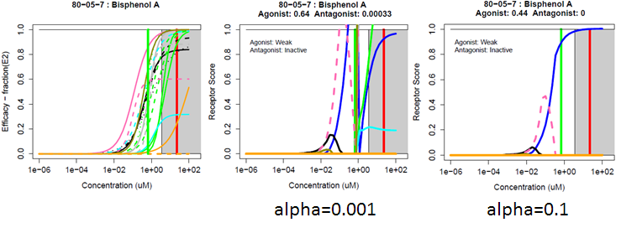
Figure S1-A2-1: Assay data for Bisphenol A (left) and receptor models for alpha=0.001 (middle) and 0.1 (right) using the THRESHOLD penalty.

Because the penalty term is a heuristic, we performed a broad sensitivity analysis examining both the functional form of the penalty and the parameter alpha. The metric we used was the stability of the quantitative prediction of AUC(agonist) and AUC (antagonist). Three penalty terms were investigated:
RIDGE:
LASSO:
THRESHOLD:

The RIDGE(Hoerl and Kennard 1970) and LASSO(Tibshirani 1996) terms are widely used to regularize underdetermined regression problems. The THRESHOLD function is more tailored to this specific problem, where we wish to largely limit activity to a single receptor, whose strength will tend towards a value of 1. For each penalty function, we performed a sweep of alpha, starting at very large values and going to values large enough that they caused activity in all receptors to be reduced to zero. The initial set of chemicals included in the sweep where those that are “pure” receptor or pseudo-receptor chemicals, i.e., those with activity in all assays associated with the receptor, but no others. The activity additionally need to be outside of the cytotoxicity range. For a “perfect” chemical (i.e. one where all of the concentration-response curves for the selected assays have the same potency and efficacy), the corresponding receptor curve with exactly match the assay curves. Therefore, we can then calculate the expected receptor curve and the expected AUC for these chemicals and the mean AUC for the active assays. The first phase of the sweep looked at the error for these chemicals, as the RMS (root-mean square) deviation between the expected and calculated AUC values. For the three penalty functions, these error plots are shown in Figure S1-A2-2.

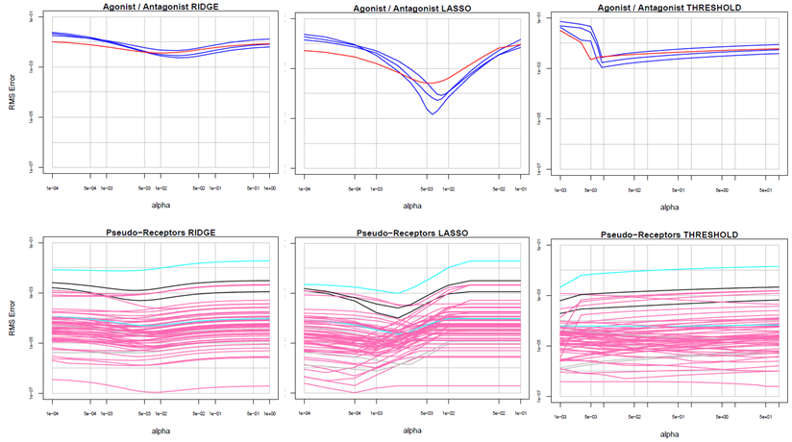
Figure S1-A2-2: RMS Error for the three penalty methods as a function of alpha

From this figure, we can see that there are preferred regions of alpha for specific assays, but that with the exception of LASSO, the trend is relatively flat. A second view of the trends is provided by heat maps of the activity in all receptors for each chemical as a function of alpha, examples of which are show in Figure S1-A2-3. In the top row of the figure, one can see that the RIDGE method has only limited ability to push activity into only the targeted receptor, and tends to push all activity to zero at about the same value of alpha for both the targeted receptor and the others. Both LASSO and THRESHOLD (middle and bottom rows) are able to push activity to the targeted receptor and away from the others well before all activity falls to zero. However, the amount of “clean space” (range of alpha between having single receptor activity and having activity go to zero), and the specific clean region differ from chemical to chemical within a penalty method.

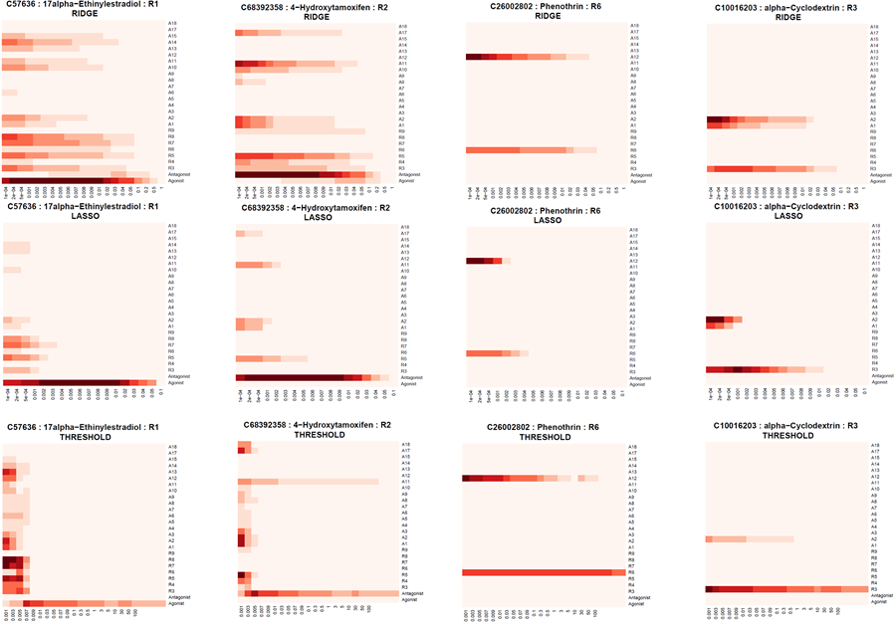
Figure S1-A2-3: Examples of activity in the different pseudo-receptors as a function of alpha for 3 example chemicals. Each panel shows data for one chemical and one penalty method. The x-axis is alpha, using the same range for all chemicals in that method, but the range differs between methods. The y-axis is receptors, with agonist and antagonist at the bottom, the multi-assay pseudo-receptors next and then the single assay pseudo-receptors at the top. Color in a cell is proportional to the AUC(chemical, receptor) with darker red being closer to 1.0.

Given the results in Figure SA-3, and similar results for all of the other chemicals tested here, there is clearly not a unique value of alpha that optimizes the collapse to the target receptors. Therefore, we need another approach to select a suitable alpha or range. To do this, we return to the original purpose of the model, which is to predict whether a chemical is an ER agonist, antagonist or pseud-receptor active. We then want to select the penalty method to which these predictions are least sensitive in terms of alpha. Additionally, we especially want to be sensitive to weak (potential) agonists / antagonists, and not have their predicted activity suppressed. To do this, we ran the model against the ER reference chemical set for each of the penalty methods and for a range of values of alpha. For each combination of penalty method and alpha, the normalization parameters were reset to give AUC(R1,17 alpha-Ethynylestradiol) ~1.0. Figure S1-A2-4 shows the variability of the values of AUC(R1/agonist) for the reference chemicals as a function of penalty method and alpha for alpha values giving even moderate agreement. We used as a comparator THRESHOLD with alpha=0.1.
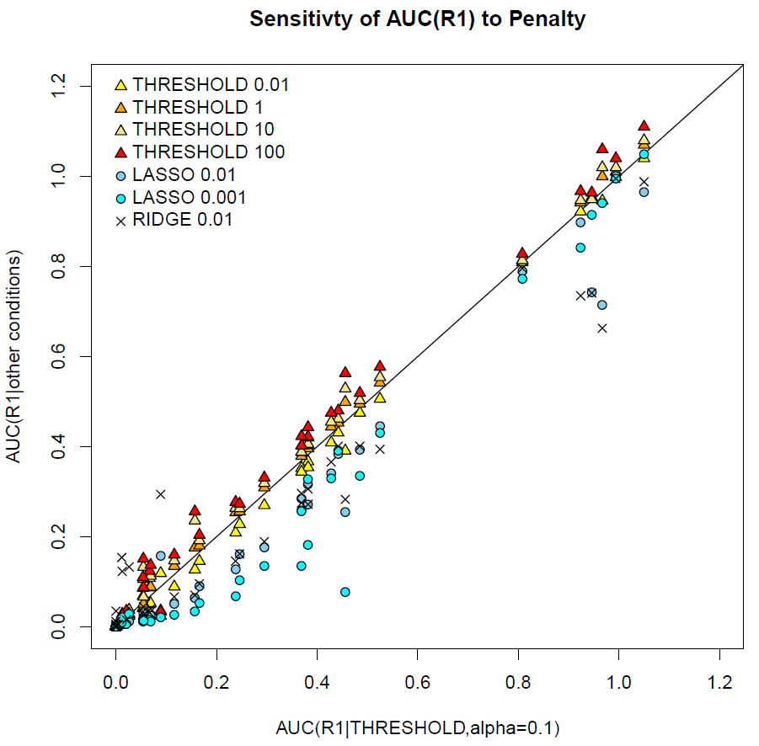
Figure S1-A2-4: Sensitivity of AUC(R1/agonist) to varying the penalty method and alpha. The y-value for each point indicates the AUC(R1) value for one chemical at the penalty method/alpha indicated by the legend symbol The x-axis gives the AUC(R1) value for THRESHOLD at alpha=0.1. Each vertical series of points (those with the same X-value) are all the same chemical.

One can see that the AUC(R1/agonist) values using the THRESHOLD method are very stable over 4 orders of magnitude, while LASSO varies significantly over 2 orders of magnitude, and the sensitivity to alpha varies from chemical to chemical (e.g., pairs of cyan and blue-gray points directly above and below one another). Additionally, the RIDGE and LASSO methods both tend to suppress AUC(R1/agonist) values, with greater suppression at the lower end. This will make it harder to distinguish weak actives from negatives. There is a trend that slightly increases the value of AUC(R1/agonist) as the penalty term increases from 0.01 to 100. The same trend is largely present for AUC(R2/antagonist), shown in Figure S1-A2-5.

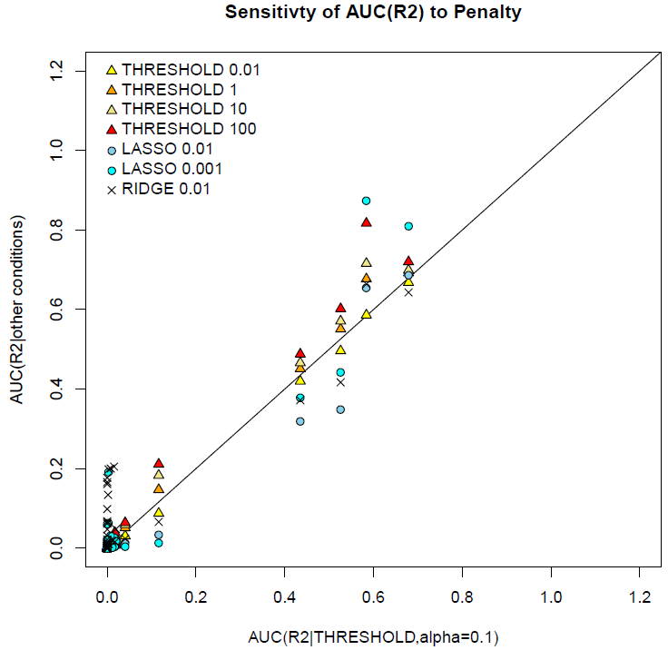
Figure S1-A2-5: Sensitivity of AUC(R2/antagonist) to varying the penalty method and alpha. Annotation is identical to Figure S1-A2-4.

Based on this analysis, the main model was run using the THRESHOLD method with alpha between 0.01 and 100. Based on Figures S1-A2-4 and S1-A2-5, the values of AUC(R1/R2) will be expected to vary by about ±0.05. Because the AUC(R1/agonist) values increase monotonically with alpha in the THRESHOLD method, we can run the model for all chemical at the extreme values of 0.01 and 100 to estimate the range of values.

Appendix 3 – Reference Chemicals

Table S1.A3.1: Reference chemicals used along with their expected potency class and the Agonist (R1) and Antagonist (R2) AUC values.

CASRN | Chemical Name | Agonist Potency | Antagonist Potency
57-63-6 | 17alpha-Ethinyl estradiol | Strong | Inactive
50-28-2 | 17beta-Estradiol | Strong | NA
56-53-1 | Diethylstilbestrol (DES) | Strong | Inactive
84-16-2 | meso-Hexestrol | Strong | NA
57-91-0 | 17alpha-Estradiol | Moderate | NA
140-66-9 | 4-tert-Octylphenol | Moderate | NA
53-16-7 | Estrone | Moderate | NA
599-64-4 | 4-Cumylphenol | Weak | NA
521-18-6 | 5alpha-Dihydrotestosterone | Weak | Inactive
80-05-7 | Bisphenol A | Weak | Inactive
77-40-7 | Bisphenol B | Weak | NA
486-66-8 | Daidzein | Weak | NA
446-72-0 | Genistein | Weak | Inactive
143-50-0 | Kepone | Weak | Inactive
789-02-6 | o,p'-DDT | Weak | NA
58-18-4 | 17alpha-Methyltestosterone | Very Weak | NA
520-36-5 | Apigenin | Very Weak | Inactive
85-68-7 | Butylbenzyl phthalate | Very Weak | Inactive
480-40-0 | Chrysin | Very Weak | Inactive
115-32-2 | Dicofol | Very Weak | Inactive
117-81-7 | Diethylhexyl phthalate | Very Weak | Inactive
84-74-2 | Di-n-butyl phthalate | Very Weak | Inactive
120-47-8 | Ethylparaben | Very Weak | NA
60168-88-9 | Fenarimol | Very Weak | NA
520-18-3 | Kaempferol | Very Weak | NA
72-43-5 | Methoxychlor | Very Weak | NA
72-55-9 | p,p’-DDE | Very Weak | Inactive
104-40-5 | p-n-Nonylphenol | Very Weak | NA
1912-24-9 | Atrazine | Inactive | NA
50-22-6 | Corticosterone | Inactive | NA
66-81-9 | Cycloheximide | Inactive | NA
13311-84-7 | Flutamide | Inactive | NA
52-86-8 | Haloperidol | Inactive | NA
52806-53-8 | Hydroxyflutamide | Inactive | NA
65277-42-1 | Ketoconazole | Inactive | NA
330-55-2 | Linuron | Inactive | NA
57-30-7 | Phenobarbital Sodium | Inactive | NA
32809-16-8 | Procymidone | Inactive | NA
50-55-5 | Reserpine | Inactive | NA
52-01-7 | Spironolactone | Inactive | NA
68392-35-8 | 4-Hydroxytamoxifen (E/Z) | NA | Active
82640-04-8 | Raloxifene | NA | Active
10540-29-1 | Tamoxifen | NA | Active
54965-24-1 | Tamoxifen citrate | NA | Active
57-83-0 | Progesterone | NA | Inactive

Appendix 4: Comparison with Rotroff et al.

Previously, our group published another model combining multiple ER assays (Rotroff, Martin et al. 2014), and here we summarize the differences between those models. We first state that this data set (many assays for the same pathway on a large and common set of chemicals) offers a good test case for developing a variety of different models and comparing strengths and weaknesses of different approaches. In particular, there are four main differences between the current model and that of Rotroff et al. First, and most trivially, we added additional assays. Second, the Rotroff et al. model was somewhat ad hoc in that it build four separate and somewhat different models, one for binding, one each for agonist and antagonist activity and one for ER-driven cell proliferation. Each of these sub-models used a subset of the assays. The current model treats all of the points in the pathway in a unified way, and is hence easier to generalize to other pathways. It was a straightforward exercise to modify the current model for the androgen receptor pathway, for instance. The third difference is how concentrations were dealt with. As one can see from any of the concentration-response plots (e.g. Figure 3A) the curves for the different assays / technologies can be shifted significantly from one another. We tested the hypothesis that there was a systematic technology-wise shift and attempted to correct for it. For instance, the cell-free assays would be assumed to be more sensitive because chemicals are not hindered from accessing the receptor. Such a technology-wise correction was performed in Rotroff et al. prior to building a consensus model. This facet of the model in retrospect was overly complex, and did not sufficiently correct for the technology-wise shifting, because the shifts (in both magnitude and direction) are strongly chemical dependent. So in the current model, this shifting was not applied. Finally, in Rotroff et al., no attempt was made to understand the sources of false-positive activity, which our pseudo-receptor approach begins to do. Figure A4.1 shows the quantitative comparison between the agonist and antagonist scores in the two models.

Figure A4.1 shows the quantitative comparison between the agonist and antagonist scores in the two models. The current model is somewhat more sensitive than the earlier model, as indicated by the points along the bottom axis, which were classified as inactive before, but are here classified as active with AUC>0.1. The chemicals on the vertical line at 1E-3 are active in Rotroff but inactive in the current model. Note that Rotroff et al predicts there to be many more relatively potent antagonists than does the current model, and vice versa for agonists. Ongoing comparison with a larger set of uterotrophic assay data may help determine the “truth” here.

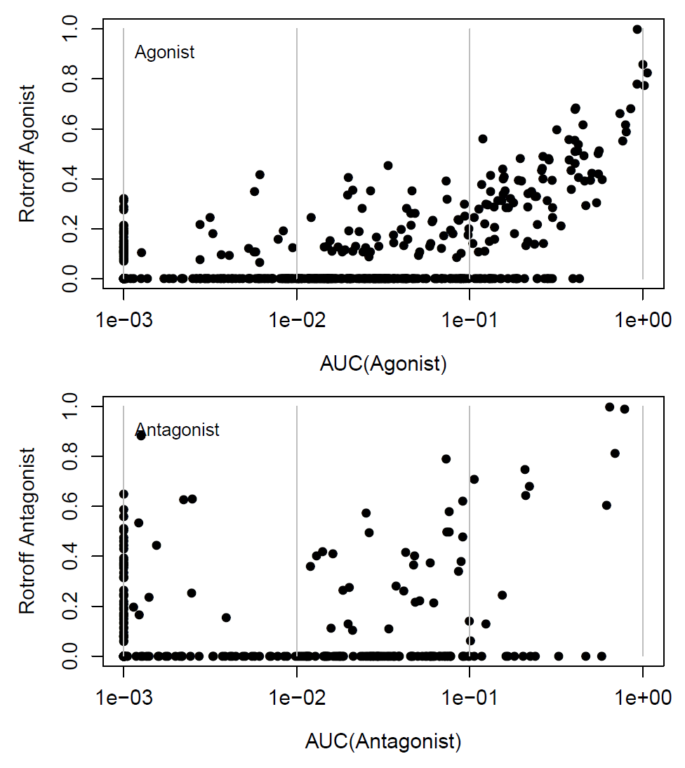

Figure S4.1: Comparison between the AUC values in the current manuscript and those developed by Rotroff eta al.

References for Appendices

Hoerl, A. E. and R. W. Kennard (1970). "Ridge Regression: Biased Estimation for Nonorthogonal Problems." Technometrics 12(1): 55-67.
Huang, R., S. Sakamuru, M. T. Martin, D. M. Reif, R. S. Judson, K. A. Houck, W. Casey, J. H. Hsieh, K. R. Shockley, P. Ceger, J. Fostel, K. L. Witt, W. Tong, D. M. Rotroff, T. Zhao, P. Shinn, A. Simeonov, D. J. Dix, C. P. Austin, R. J. Kavlock, R. R. Tice and M. Xia (2014). "Profiling of the Tox21 10K compound library for agonists and antagonists of the estrogen receptor alpha signaling pathway." Sci Rep 4: 5664.
Kavlock, R., K. Chandler, K. Houck, S. Hunter, R. Judson, N. Kleinstreuer, T. Knudsen, M. Martin, S. Padilla, D. Reif, A. Richard, D. Rotroff, N. Sipes and D. Dix (2012). "Update on EPA's ToxCast program: providing high throughput decision support tools for chemical risk management." Chem Res Toxicol 25(7): 1287-1302.
Knudsen, T. B., K. A. Houck, N. S. Sipes, A. V. Singh, R. S. Judson, M. T. Martin, A. Weissman, N. C. Kleinstreuer, H. M. Mortensen, D. M. Reif, J. R. Rabinowitz, R. W. Setzer, A. M. Richard, D. J. Dix and R. J. Kavlock (2011). "Activity profiles of 309 ToxCast chemicals evaluated across 292 biochemical targets." Toxicology 282(1-2): 1-15.
Martin, M. T., D. J. Dix, R. S. Judson, R. J. Kavlock, D. M. Reif, A. M. Richard, D. M. Rotroff, S. Romanov, A. Medvedev, N. Poltoratskaya, M. Gambarian, M. Moeser, S. S. Makarov and K. A. Houck (2010). "Impact of environmental chemicals on key transcription regulators and correlation to toxicity end points within EPA's ToxCast program." Chem Res Toxicol 23(3): 578-590.
Romanov, S., A. Medvedev, M. Gambarian, N. Poltoratskaya, M. Moeser, L. Medvedeva, L. Diatchenko and S. Makarov (2008). "Homogeneous reporter system enables quantitative functional assessment of multiple transcription factors." Nat Methods 5(3): 253-260.
Rotroff, D. M., D. J. Dix, K. A. Houck, R. J. Kavlock, T. B. Knudsen, M. T. Martin, D. M. Reif, A. M. Richard, N. S. Sipes, Y. A. Abassi, C. Jin, M. Stampfl and R. S. Judson (2013). "Real-Time Growth Kinetics Measuring Hormone Mimicry for ToxCast Chemicals in T-47D Human Ductal Carcinoma Cells." Chem Res Toxicol 26(7): 1097-1107.
Rotroff, D. M., D. J. Dix, K. A. Houck, R. J. Kavlock, T. B. Knudsen, M. T. Martin, D. M. Reif, A. M. Richard, N. S. Sipes, Y. A. Abassi, C. Jin, M. Stampfl and R. S. Judson (2013). "Real-Time Growth Kinetics Measuring Hormone Mimicry for ToxCast Chemicals in T-47D Human Ductal Carcinoma Cells." Chem Res Toxicol.
Rotroff, D. M., M. T. Martin, D. J. Dix, D. L. Filer, K. A. Houck, T. B. Knudsen, N. S. Sipes, D. M. Reif, M. Xia, R. Huang and R. S. Judson (2014). "Predictive endocrine testing in the 21st century using in vitro assays of estrogen receptor signaling responses." Environ Sci Technol 48(15): 8706-8716.
Sipes, N. S., M. T. Martin, P. Kothiya, D. M. Reif, R. S. Judson, A. M. Richard, K. A. Houck, D. J. Dix, R. J. Kavlock and T. B. Knudsen (2013). "Profiling 976 ToxCast chemicals across 331 enzymatic and receptor signaling assays." Chem Res Toxicol 26(6): 878-895.
Stossi, F., M. J. Bolt, F. J. Ashcroft, J. E. Lamerdin, J. S. Melnick, R. T. Powell, R. D. Dandekar, M. G. Mancini, C. L. Walker, J. K. Westwick and M. A. Mancini (2014). "Defining estrogenic mechanisms of bisphenol A analogs through high throughput microscopy-based contextual assays." Chem Biol 21(6): 743-753.
Tibshirani, R. (1996). "Regression shrinkage and selection via the Lasso." Journal of the Royal Statistical Society Series B-Methodological 58(1): 267-288.
U.S. EPA. (2008). "TOXCST: Research Chemical Inventory for EPA's ToxCastTM Program: Structure-Index File " Retrieved 8 August, 2008, from http://www.epa.gov/ncct/dsstox/sdf_toxcst.html.

