Supplemental Figure 3
Literature Review for AR Binding Data on Potential Reference Chemicals:
(a) Assay Types and (b) Receptor Types
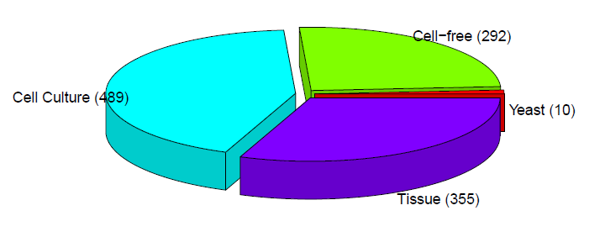
(a)
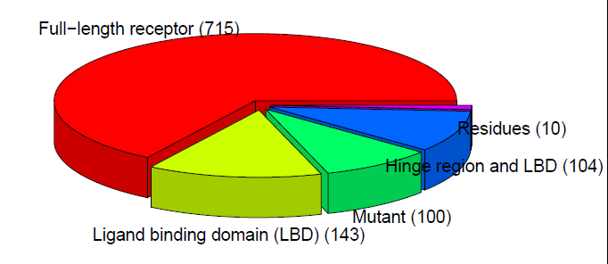
(b)
Abbreviation: AR = androgen receptor. The number of experiments conducted using each assay type is shown in parentheses.

Supplemental Figure 4
Literature Review for AR Transactivation Data on Potential Reference Chemicals:
(a) Assay Types and (b) Receptor Types
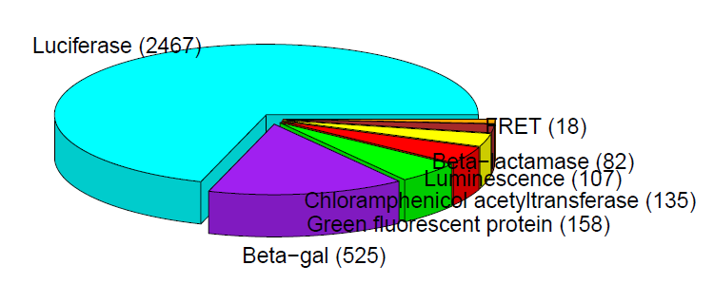
(a)
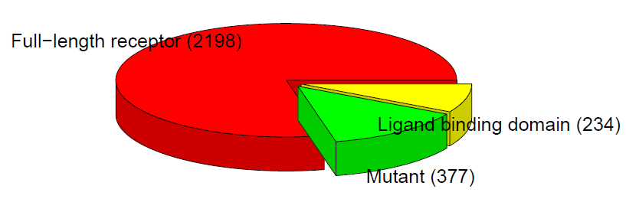
(b)
Abbreviation: AR = androgen receptor, FRET = fluorescence resonance energy transfer. The number of experiments conducted using each assay type is shown in parentheses.

Supplemental Figure 5
Calibration curve using the AR Tier 1 binding data from U.S. EPA EDSP List 1 chemicals, allowing the estimation of IC50 values from RBAs
