Homework – Doing your Part
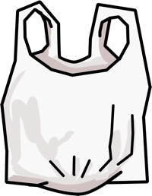
Intro: Have you ever seen trash that isn’t in trash cans? Where? Trash can accidentally flow into our streams, rivers, and oceans, which upsets our animal friends. Some times, trash can leak nasty chemicals into the soil? Ask you parents to help you find 3 pieces of trash in you home, on your street, or at your local park, and throw it in the trash!

Instructions: Survey your home, neighborhood, or community park for trash that hasn’t made it into the trash can. For every piece of trash collected, write down what it was, and draw a checkmark in the checkbox. Bring this back to school and give it to your teacher! If its yucky wear gloves!

1. _____________

2. _____________

3. _____________
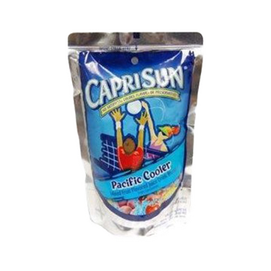
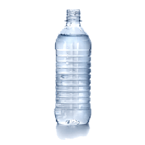
Here are some types of trash to look for:
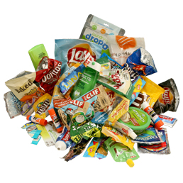

Top 9 Items Collected:

- Cigarette Butts
- Food Wrappers
- Plastic Bottles
- Plastic Bottle Caps
- Plastic Grocery Bags
- Straws, stirrers
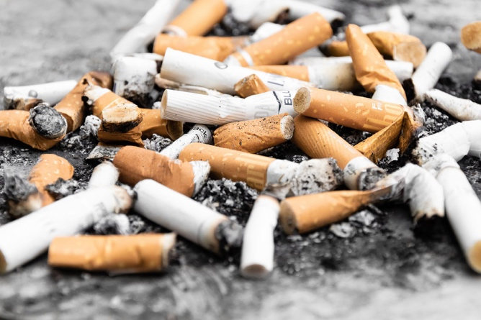
- Plastic take-out containers
- Plastic Lids
- Foam take-out containers

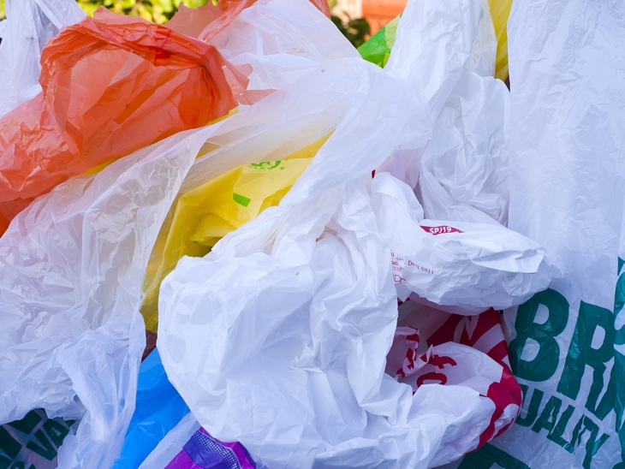
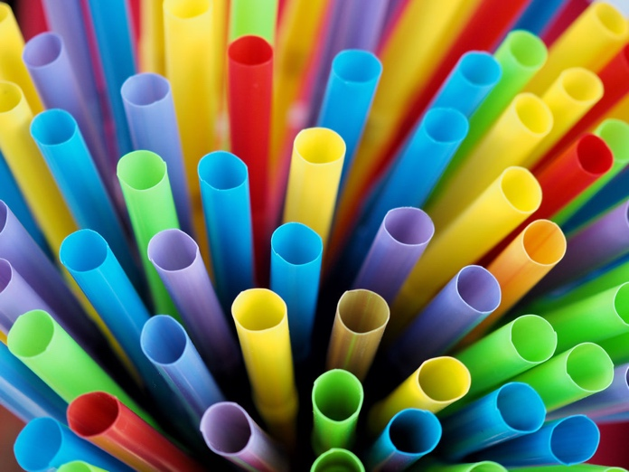

Sources: http://osof.org/problem-plastic-bag/
https://www.5gyres.org/plastic-straws
https://www.como.gov/utilities/solidwaste/multi-family/attachment/food-wrappers/
https://www.plasticpollutioncoalition.org/pft/2018/8/6/cigarette-butts-are-plastic-and-compound-the-nicotine-health-risk-from-smoking

