What Belongs in the Ocean?
(Preschool-Kindergarten)

Activity: What lives in the ocean? What doesn’t live in the ocean? Can you find 4 things that don’t belong in this picture?

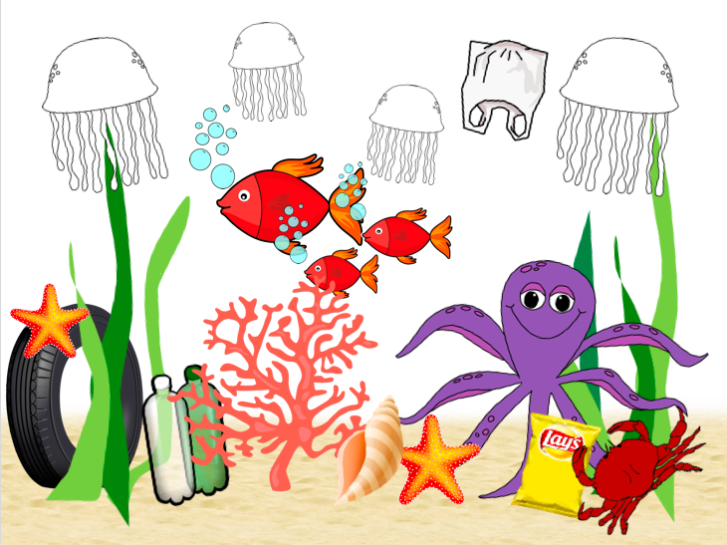
Instructions: Find the 4 things that don’t belong in the ocean and color them in.
Plastic Bottle: https://www.kisscc0.com/clipart/plastic-bag-fizzy-drinks-plastic-bottle-water-bott-3v81ct/
Plastic Bag: https://openclipart.org/detail/303136/plastic-shopping-bag
Tire: https://www.kisscc0.com/clipart/car-a-rubber-tire-download-duesi-tire-12zmst/
Fishing Net: https://clipart.wpblink.com/wallpaper-4864769
Jellyfish: https://www.pinterest.com/pin/119626933828969334/
Sand: http://clipart-library.com/beach-sand-cliparts.html

Source:
Fish: https://requestreduce.org/categories/images-of-fish-clipart.html
Octopus: https://www.mycutegraphics.com/graphics/letter/octopus.html
Starfish: https://clipartpng.com/?1439,starfish-png-clip-art
Shell: https://gallery.yopriceville.com/Free-Clipart-Pictures/Summer-Vacation-PNG/Sea_Shell_PNG_Clip_Art_Image
Crab: http://www.clipartpanda.com/categories/crab-clip-art-cartoon
Coral: http://worldartsme.com/coral-free-clipart.html#gal_post_52417_coral-free-clipart-1.jpg
Seaweed: http://clipart-library.com/seaweed-cliparts.html

