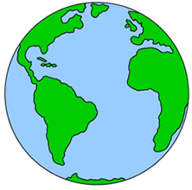
NAME:
Earth: My home
“Keeping my earth clean!”
Just like your room, it is important to do your part and help keep the earth clean!
Cut and paste the pictures below into the correct column based on whether or not you think the action prevents air pollution or makes it worse. Work as a group or individually and compare.
What prevents air pollution? | What makes air pollution worse?

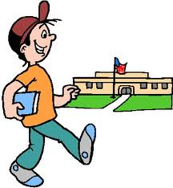 |  | 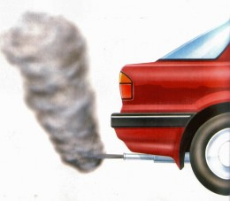
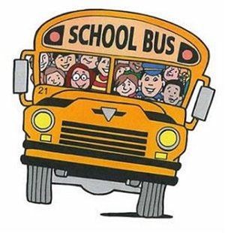 | 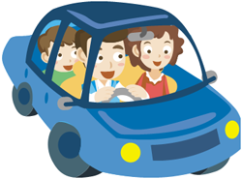 | 