Background - What does the teacher need to know before teaching this lesson?
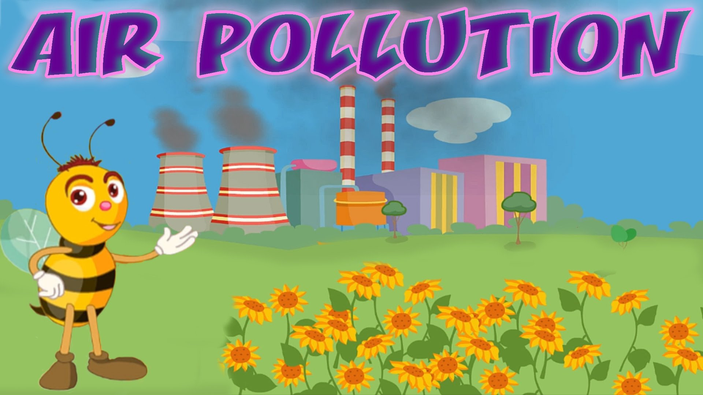
What is air?
Air is a mixture of different gases that covers the Earth in a layer over 400 miles high. This layer is called the atmosphere. It contains roughly 78% nitrogen, 21% oxygen, and smaller amounts of argon, hydrogen, carbon dioxide, and others.

Why is air important?
Air is needed by almost all the living things living on Earth. Most plants and animals take in air, use the oxygen in it and give out another gas, carbon dioxide. This process is called respiration. Air also protects life on Earth by absorbing harmful ultraviolet solar radiation and reducing temperature extremes between day and night

What is air pollution?
Air pollution is caused by the accumulation of one or more chemicals or substances in the air in high enough concentrations to harm humans, other animals, vegetation, or materials. Air pollution consists of chemicals or particles in the air that can harm the health of humans, animals, and plants. It also damages buildings. Pollutants in the air take many forms. They can be gases, solid particles, or liquid droplets. (National Geographic)

What causes air pollution?
Air pollution can result from both human and natural actions. Natural events that pollute the air include forest fires, volcanic eruptions, wind erosion, pollen dispersal, evaporation of organic compounds and natural radioactivity. Pollution from natural occurrences is not very often. Human activities that result in air pollution include emissions from industries and manufacturing activities, burning fossil fuels, and household and farming chemicals. For instance, common causes of air pollution are emissions from industrial facilities and electric utilities, motor vehicle exhaust, gasoline vapors, chemical solvents, roadway dust, and smoke.

What are pollutants and emissions?
Pollutants are unwanted chemicals or other materials found in the air, at high enough concentrations to endanger the environment and people’s health. Emissions are discharges of a pollutant from a particular source (e.g., a factory) or group of sources (e.g., vehicles) into the air.

What is smog?
Smoke and fog together create smog. The term smog was first coined during the 1950s when it was used to describe a mixture of smoke and fog experienced in London. Major cities along the west coast of America were also experiencing a different type of air pollution. Smog occurs when emissions from industry, motor vehicles, incinerators, open burning and other sources accumulate under certain climatic conditions.

Why is air pollution such a serious problem?
Air pollution can cause many health problems such as burning eyes, cancer, birth defects, brain damage, or even death. Air pollution can also damage the environment and property such as food crops, trees, lakes and buildings.

What Can I Do to Help Reduce Air Pollution?
Every time we drive to school, use our heater or air conditioner, clean our windows, or even style our hair, we make choices that affect air pollution. These steps, as well as many others, are things we all can do to help reduce air pollution.
- Conserve energy – remember to turn off lights, computers, and electric appliances when not in use.
- Use energy efficient light bulbs and appliances.
- Participate in your local utility’s energy conservation programs.
- Limit driving by carpooling, using public transportation, biking and walking.
- Combine errands for fewer trips, etc.
- Turn off your ignition if you’re waiting more than 10 seconds. Do not idle.
Further readings
Air pollution: https://www3.epa.gov/airnow/aquikids/games/aqi/Games.htm
Ways to reduce air pollution: http://www.vcapcd.org/pubs/Factsheets/50WaysfactSheet.pdf

Standards - What standards are being met by teaching this lesson?
- K-12 Integrated Environmental and Sustainability Learning Standards (See Appendix Table 1)
- California Education and the Environment Initiative (See Appendix Table 2)
- Next Generation Science Standards (See Appendix Table 3)
- Common Core State Standards (See Appendix Table 4)

Necessary supplies - What supplies will you need to teach the class?
- Paperback book: “The Magic School Bus Gets Cleaned Up” (provided): http://www.epa.gov/cleanschoolbus/msb-book.htm
- A copy of ““My Environmental Assessment: Keep My Earth Clean!” worksheet for each student (provided in the appendix)
- Tape or glue
- An image of air pollution that can be projected or displayed (provided as document or .jpeg in the appendix)
- A copy of the New York State Department of Environmental Conservation’s “Clean Air Activity Booklet” for each student (provided in the appendix)

Do Now - (Written on board/projector) What quick independent activity will students engage in as soon as they arrive in class that will review past learning or preview the day’s learning? (5-10 min)
Start class by displaying the provided image of air pollution. Ask the kids to write down their thoughts about this picture. What does it make them think of? Have they ever seen this before? What do they think is going on in this picture?

Objective for the Day – (Written on board/projector) What skill are you going to teach and what should the students be able to do by the end of the class to demonstrate what they have learned?
Today, you will learn what air pollution is and how you can play your part in reducing it.

Keywords:
Air
Emissions
Air pollution
Smog
Ash

Purpose – Why is it important for students to learn this skill? Explain why today’s lesson matters.
With the knowledge gained from this lesson, students will be able to determine how they can reduce air pollution and why it matters to do so.

Teaching the Skill – How will you teach this skill to students? What will the examples and the modeling look like? How will you ensure that all students are actively participating in the lesson?
Step 1: | Open Discussion (10 – 15 minutes)  Begin a discussion with students about air and pollution. Start with a review:  What do we know about air? Can we see air? Can we feel it, taste it, hear it, or smell it?  What about pollution? What does it mean for something to become polluted?  Pollution is something that is bad or harmful for our environment. Air pollution is the introduction of chemicals and other pollutants into our air, making it dirty and harder for humans and animals to breathe.  What causes pollution in the air? Natural sources of air pollution include wildfires and volcanic eruptions, which create smoke and ash. However, the biggest form of air pollution and the one we will be focusing on today is a kind of air pollution called emissions. Emissions are put in the air when we burn fossil fuels like coal, oil, and gas to create energy. Emissions come from cars, trucks, factories, and power plants. Emissions contribute to a kind of air pollution known as smog, which is a combination of the words smoke and fog. You can see smog close to the ground in places where there is a lot of air pollution.  Riding your bike and walking are great ways to reduce air pollution because they do not burn fossil fuels. They are also good ways to get exercise! If you ride in a carpool or take a bus or train instead of driving, there are fewer cars on the road, which also creates less air pollution!
Step 3: | Reading Activity (15 minutes)  Read “The Magic School Bus Gets Cleaned Up” to the students.

Practice - What will it look like when you give the students the chance to practice on their own? What activity will students complete? Remember, you are gradually releasing responsibility to the students over the course of the lesson. Students should ultimately be practicing the day’s objective independently. They might start by working in pairs or groups or with some helpful resources before working on their own. (15 min)
5-10 minutes individually/in groups and 5-10 minutes as a class:

Pass out the “My Environmental Assessment: Keep My Earth Clean!” worksheet. Ask students to complete it in groups or individually before reviewing it as a class. It might be helpful for the students to see a compiled list of what they wrote on their papers. While they are providing answers during review, consider writing each point on the board.

Talk with students about what they wrote down and why.

Closure - What will you do to wrap up the class and check one more time for student understanding of the objective?
(5 min)
Ask students to take out a piece of paper and write a pledge:

“I will reduce air pollution by _______ because _______.”

Example: “I will reduce air pollution by riding my bike because it’s good for me and the environment.”

Pledges can be posted on the wall or taken home.

Take Home/Homework – An activity for the students to take home and perform. Optional: Have the students return the next day with proof of completion of the activity.
Send each student home with the Clean Air Activity Booklet from the New York State Department of Environmental Conservation. The teacher can decide whether or not these should come back for review/proof of completion.

Appendix of Tables

Appendix Table 1: K-12 Integrated Environmental and Sustainability Learning Standards

Standard 2: The Natural and Build Environment
- Students engage in inquiry and systems thinking and use information gained through learning experiences in, about, and for the environment to understand the structure, components, and processes of natural and human-built environments.
Standard 3: Sustainability and Civic Responsibility
- Students develop and apply the knowledge, perspective, vision, skills, and habits of mind necessary to make personal and collective decisions and take actions that promote sustainability.

Appendix Table 2: California Education and the Environment Initiative

Principle I: People Depend on Natural Systems
- The continuation and health of individual human lives and of human communities and societies depend on the health of the natural systems that provide essential goods and ecosystem services.
Concept C: Students need to know that the quality, quantity, and reliability of the goods and ecosystem services provided by natural systems are directly affected by the health of those systems.
Principle II: People Influence Natural Systems
- The long-term functioning and health of terrestrial, freshwater, coastal, and marine ecosystems are influenced by their relationships with human societies.
Concept B: Students need to know that methods used to extract, harvest, transport, and consume natural resources influence the geographic extent, composition, biological diversity, and viability of natural systems.
Principle IV: There are no Permanent or Impermeable Boundaries that Prevent Matter from Flowing Between Systems
- The exchange of matter between natural systems and human societies affects the long-term functioning of both.
Concept A: Students need to know that the effects of human activities on natural systems are directly related to the quantities of resources consumed and to the quantity and characteristics of the resulting byproducts. | Concept B: Students need to know that the byproducts of human activity are not readily prevented from entering natural systems and may be beneficial, neutral, or detrimental in their effect.

Appendix Table 3: Next Generation Science Standards

Engineering Design
- K-2-ETS1-1: Ask questions, make observations, and gather information about a situation people want to change to define a simple problem that can be solved through the development of a new or improved object or tool.
Science and Engineering Practices | Disciplinary Core Ideas | Crosscutting Concepts
Asking Questions and Defining Problems: Asking questions and defining problems in K–2 builds on prior experiences and progresses to simple descriptive questions.  Ask questions based on observations to find more information about the natural and/or designed world(s).  Define a simple problem that can be solved through the development of a new or improved object or tool. | ETS1.A: Defining and Delimiting Engineering Problems: A situation that people want to change or create can be approached as a problem to be solved through engineering.  Asking questions, making observations, and gathering information are helpful in thinking about problems.  Before beginning to design a solution, it is important to clearly understand the problem. | n/a

Appendix Table 4: Common Core State Standards

Mathematics
Mathematical Practices
Reason abstractly and quantitatively
- CCSS.Math.Practice.MP2: Mathematically proficient students make sense of quantities and their relationships in problem situations.
Model with mathematics
- CCSS.Math.Practice.MP4: Mathematically proficient students can apply the mathematics they know to solve problems arising in everyday life, society, and the workplace.
English Language Arts
Reading: Informational Text
Key Ideas and Details
- CCSS.ELA-Literacy.RI.1.3: Describe the connection between two individuals, events, ideas, or pieces of information in a text.
Writing
Production and Distribution of Writing
- CCSS.ELA-Literacy.W.1.5: With guidance and support from adults, focus on a topic, respond to questions and suggestions from peers, and add details to strengthen writing as needed.
Speaking and Listening
Comprehension and Collaboration
- CCSS.ELA-Literacy.SL.1.3: Ask and answer questions about what a speaker says in order to gather additional information or clarify something that is not understood.
Presentation of Knowledge and Ideas
- CCSS.ELA-Literacy.SL.1.4: Describe people, places, things, and events with relevant details, expressing ideas and feelings clearly.
- CCSS.ELA-Literacy.SL.1.5: Add drawings or other visual displays to descriptions when appropriate to clarify ideas, thoughts, and feelings.

http://eo.ucar.edu/kids/sky/air1.htm
http://eschooltoday.com/pollution/air-pollution/what-is-air-pollution.html
https://www3.epa.gov/airquality/emissns.html
http://www.epa.vic.gov.au/air/aq4kids/smog.asp
http://des.nh.gov/organization/divisions/air/tsb/ams/aqmdp/share.htm

