Energy Savers Questionnaire
Be an Energy Star saver! Are you doing the following?
1. Are you turning off lights when no one’s using them? 2. Is your family using energy saving light bulbs, such as fluorescent or LED bulbs?
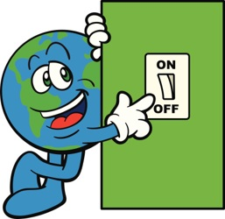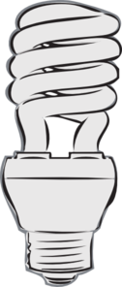

YES NO YES NO

3. Are you turning off electronics when not in use? 4. Are you using sunlight when possible instead of turning on lights?

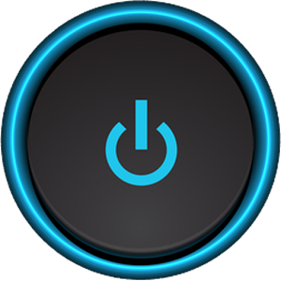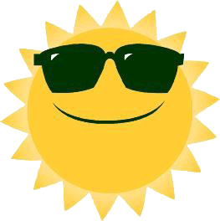

YES NO YES NO

5. Is your family unplugging electronics when not in use? 6. How many energy star appliances does your house have?
TIP: Look on electronic appliances like your refrigerator or stove.
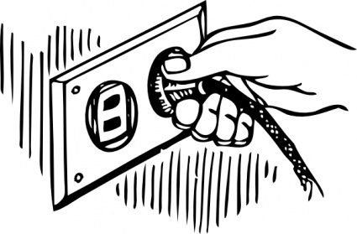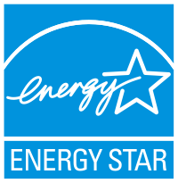

YES NO How many? _______

7. Does you family use power strips? 8. Are windows open when the AC/ Heater is on?
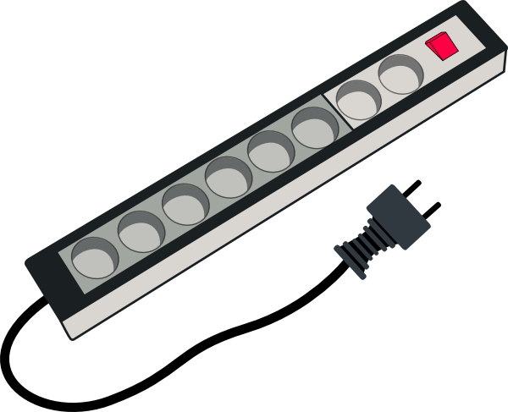

YES NO YES NO

Adapted from the Department of Energy

