Where Does Energy Come From?
Energy is all around us. It is in the light we see, it is in the food we eat, and it is in the ground we walk on. In fact, energy is everywhere! The Problem is, we can’t always use energy. If we want to use energy we have to first make some changes.

1. Our bodies can change the food we eat into energy!

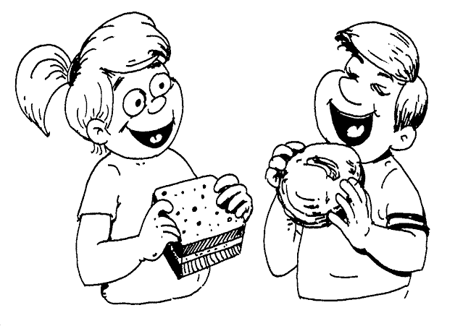
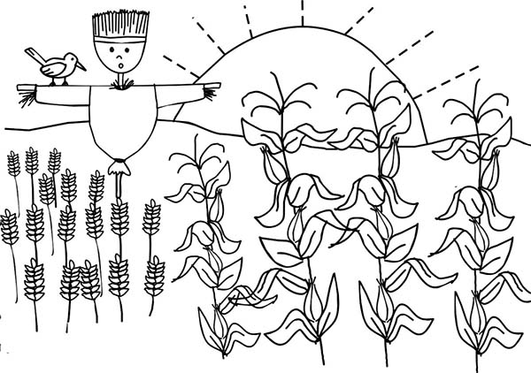
2. Plants can change sunlight into useful energy, which makes them grow!

3. Things like cars, airplanes and buildings use a kind of food which we call fuel. Gasoline, cola and wood are all types of fuel, but there are many more. Think of fuel as stuff that has energy inside, just waiting to get out to do something.
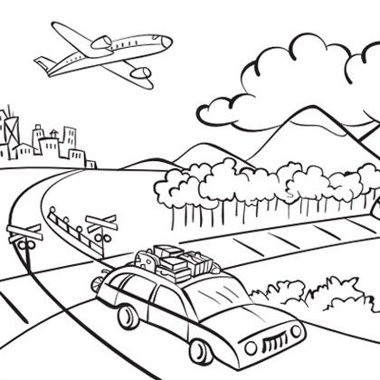

4. The electricity in your house comes from different types of fuels. This energy is often produced far away and is sent along wires into your home.
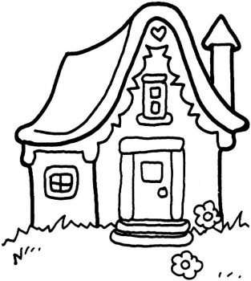
(Written from energystar.gov This lesson can be taught through the original interactive webpage at http://www.energystar.gov/index.cfm?c=kids.kids_index)

