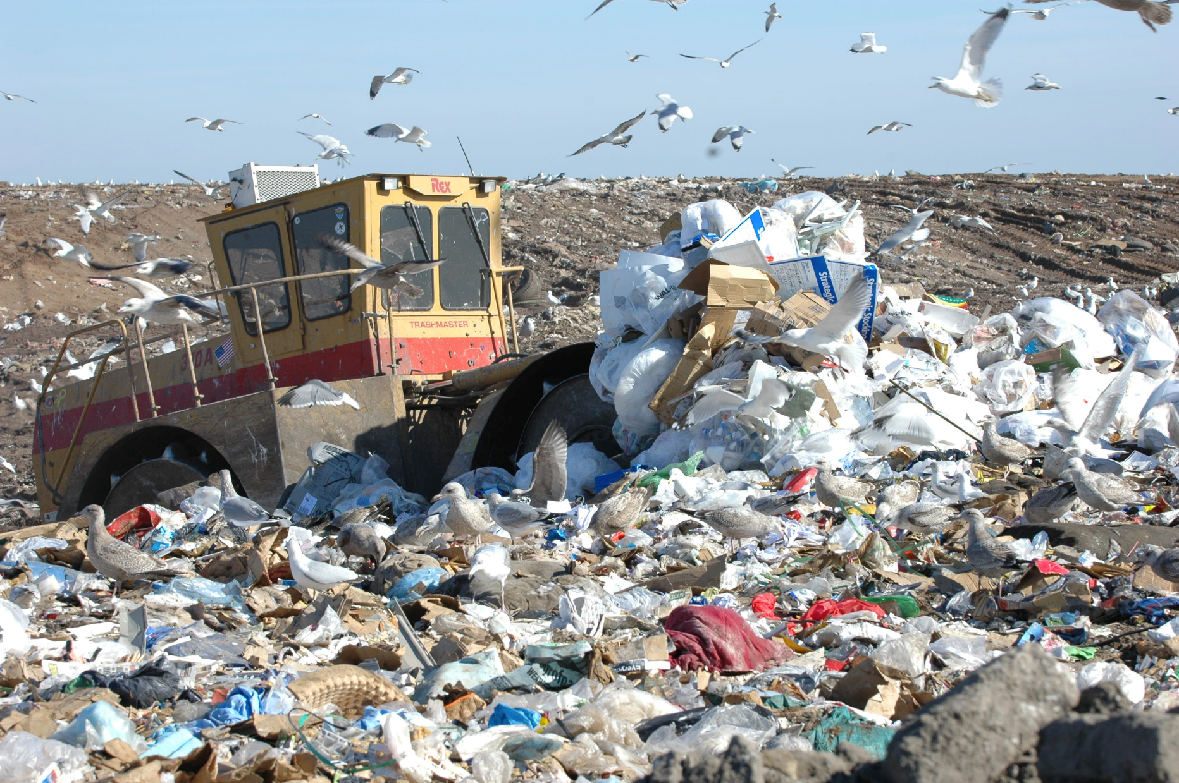
Source: Onslow County of North Carolina: http://www.onslowcountync.gov/assets/20557.jpg?langType=1033

