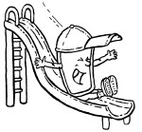
Water Cycle Adventure
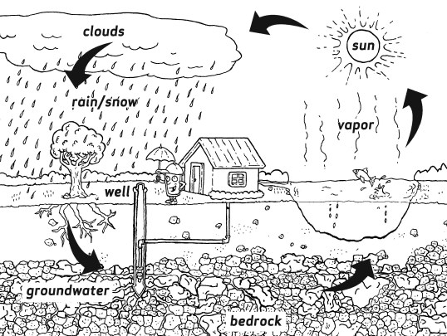
Office of Water (4606M) • EPA 816-F-04-018 • 06/2004 • www.epa.gov/safewater

