Background- What does the teacher need to know before teaching this lesson?
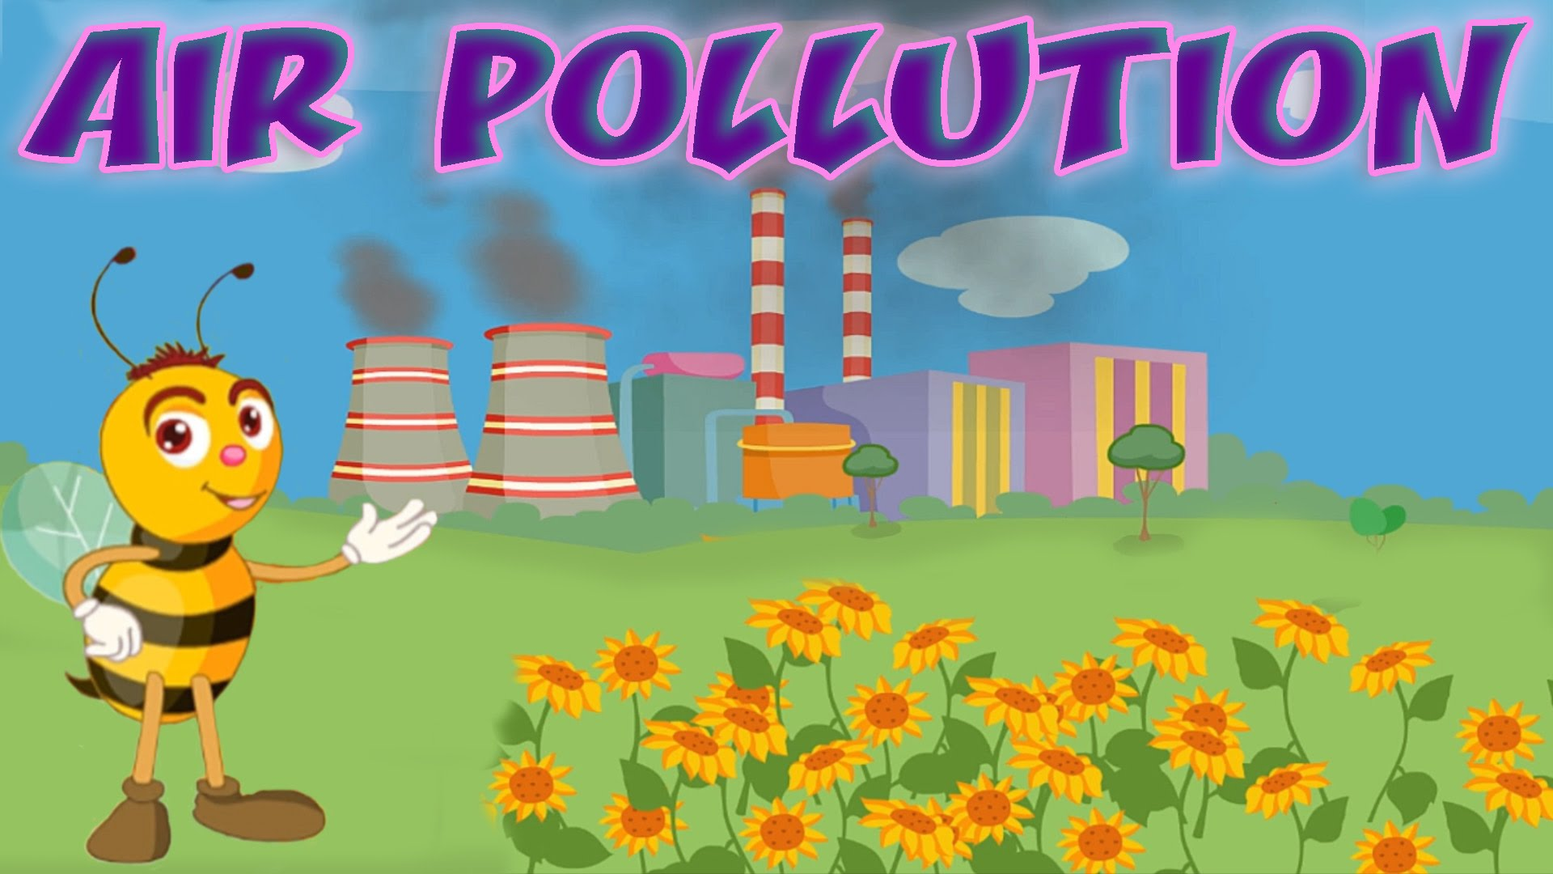
What is air?
Air is a mixture of different gases that covers the Earth in a layer over 400 miles high. This layer is called the atmosphere. It contains roughly 78% nitrogen, 21% oxygen, and smaller amounts of argon, hydrogen, carbon dioxide, and others.

Why is air important?
Air is needed by almost all the living things living on Earth. Most plants and animals take in air, use the oxygen in it and give out another gas, carbon dioxide. This process is called respiration. Air also protects life on Earth by absorbing harmful ultraviolet solar radiation and reducing temperature extremes between day and night

What is air pollution?
Air pollution is caused by the accumulation of one or more chemicals or substances in the air in high enough concentrations to harm humans, other animals, vegetation, or materials. Air pollution consists of chemicals or particles in the air that can harm the health of humans, animals, and plants. It also damages buildings. Pollutants in the air take many forms. They can be gases, solid particles, or liquid droplets. (National Geographic)

What causes air pollution?
Air pollution can result from both human and natural actions. Natural events that pollute the air include forest fires, volcanic eruptions, wind erosion, pollen dispersal, evaporation of organic compounds and natural radioactivity. Pollution from natural occurrences is not very often. Human activities that result in air pollution include emissions from industries and manufacturing activities, burning fossil fuels, and household and farming chemicals. For instance, common causes of air pollution are emissions from industrial facilities and electric utilities, motor vehicle exhaust, gasoline vapors, chemical solvents, roadway dust, and smoke.

What are pollutants and emissions?
Pollutants are unwanted chemicals or other materials found in the air, at high enough concentrations to endanger the environment and people’s health. Emissions are discharges of a pollutant from a particular source (e.g., a factory) or group of sources (e.g., vehicles) into the air. Processes such as fossil fuel burning in industry, motor vehicles and buildings emit pollutants that cause local and regional pollution. These pollutants include particulate matter (PM), ground-level ozone (O3), nitrogen oxides (NOx), Sulphur oxides (SOx), volatile organic compounds (VOCs) and carbon monoxide (CO).

What is smog?
Smoke and fog together create smog. The term smog was first coined during the 1950s when it was used to describe a mixture of smoke and fog experienced in London. Major cities along the west coast of America were also experiencing a different type of air pollution. Smog occurs when emissions from industry, motor vehicles, incinerators, open burning and other sources accumulate under certain climatic conditions.

Why is air pollution such a serious problem?
Air pollution can cause many health problems such as burning eyes, cancer, birth defects, brain damage, or even death. Air pollution can also damage the environment and property such as food crops, trees, lakes and buildings.

What is acid rain?
"Acid rain" is a broad term referring to a mixture of wet and dry materials deposited from the atmosphere that contain higher than normal amounts of nitric and sulfuric acids. Man-made sources are primarily emissions of sulfur dioxide (SO₂) and nitrogen oxides (NO_{x}) resulting from fossil fuel combustion. In the United States, roughly 2/3 of all SO₂ and 1/4 of all NO_{x} come from electric power generation that relies on burning fossil fuels, like coal. Acid rain occurs when these gases react in the atmosphere with water, oxygen, and other chemicals to form various acidic compounds. The result is a mild solution of sulfuric acid and nitric acid. When sulfur dioxide and nitrogen oxides are released from power plants and other sources, prevailing winds blow these compounds across state and national borders, sometimes over hundreds of miles.

What are the impacts of acid rains?
Acid rain causes acidification of lakes and streams and contributes to the damage of trees at high elevations and many sensitive forest soils. In addition, acid rain accelerates the decay of building materials and paints, including buildings, statues, and sculptures. Prior to falling to the earth, sulfur dioxide (SO₂) and nitrogen oxide (NO_{x}) gases and their particulate matter derivatives—sulfates and nitrates—contribute to visibility degradation and harm public health.

What Can I Do to Help Reduce Air Pollution?
Every time we drive to school, use our heater or air conditioner, clean our windows, or even style our hair, we make choices that affect air pollution. These steps, as well as many others, are things we all can do to help reduce air pollution.
- Conserve energy – remember to turn off lights, computers, and electric appliances when not in use.
- Use energy efficient light bulbs and appliances.
- Participate in your local utility’s energy conservation programs.
- Limit driving by carpooling, using public transportation, biking and walking.
- Combine errands for fewer trips, etc.
- Turn off your ignition if you’re waiting more than 10 seconds. Do not idle.

Further readings
Air pollution: http://www.nrdc.org/air/
Ways to reduce air pollution: http://www.vcapcd.org/pubs/Factsheets/50WaysfactSheet.pdf
Acid rain: https://www3.epa.gov/acidrain/index.html

Standards - What standards are being met by teaching this lesson?
- K-12 Integrated Environmental and Sustainability Learning Standards (See Appendix Table 1)
- California Education and the Environment Initiative (See Appendix Table 2)
- Next Generation Science Standards (See Appendix Table 3)
- Common Core State Standards (See Appendix Table 4)

Necessary supplies - What supplies will you need to teach the class?
- Water
- Chalk
- Vinegar
- Plate or bowl
- Projector
- Internet access

Do It Now - (Written on board/projector) What quick independent activity will students engage in as soon as they arrive in class that will review past learning or preview the day’s learning? (5 min)
Watch EPA’s “Acid Rain” animation http://www3.epa.gov/acidrain/education/site_students/acid_anim.html

Objective for the Day - (Written on board/projector) What skill are you going to teach and what should the students be able to do by the end of the class to demonstrate what they have learned?
Today you will learn
- About acid rain and how it affects the environment
- What we can do to reduce the pollution that leads to acid rain
Keywords:
Acid
Acid rain
Air pollution
Base
pH
Erosion

Purpose- Why is it important for students to learn this skill? Explain why today’s lesson matters.
- To see how pollution affects the environment around us, and learn what we can do to help.

Teaching the Skill – How will you teach this skill to students? What will the examples and the modeling look like? How will you ensure that all students are actively participating in the lesson?
Step 1 | What are acids and bases? (5 min)  The pH scale measures how acidic an object is. Objects that are not very acidic are called basic. The scale has values ranging from zero (the most acidic) to 14 (the most basic). As you can see from the pH scale above, pure water has a pH value of 7. This value is considered neutral—neither acidic nor basic. Normal, clean rain has a pH value of between 5.0 and 5.5, which is slightly acidic. However, when rain combines with sulfur dioxide or nitrogen oxides—produced from power plants and automobiles—the rain becomes much more acidic. Typical acid rain has a pH value of 4.0. A decrease in pH values from 5.0 to 4.0 means that the acidity is 10 times greater.  Display and discuss the pH scale:  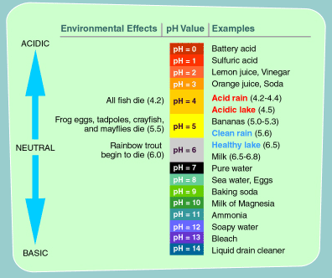
Step 2 | What is acid rain? (5 min)  Acid rain is rainwater that is more acidic than our regular water. Acid rain forms when air pollution, especially pollution including sulfur molecules, mixes with rain water in clouds. The pollutants get trapped in the water, making the water more acidic. Then the acidic, polluted water moves around the world in clouds. Eventually, the water rains out of the clouds. Acid rain can damage plants and animals and even erode away stone buildings, monuments, and statues.
Step 3 | How do you think acid might affect things made of stone? (10-15 min)  Review 4th Grade “Air Pollution” PowerPoint.  Let's see how acid rain causes erosion of buildings, statues, and monuments:  - Put chalk in a bowl or on a plate. Make sure students can still see the chalk. Explain that the chalk represents stone buildings, monuments, and statues.  - Drip some tap water on the chalk. Discuss what happens (nothing or maybe a little chalk dissolves). Explain that this is what it is like when unpolluted rain falls on stone buildings, monuments, and statues. Normal rainwater is slightly acidic, so it will dissolve the stone a bit, but not much. This is a normal process, and it happens over a very long time.  - Drip some vinegar on the chalk. Going back to the Ph chart, show that vinegar is an acid and is similar in strength to acid rain. It will cause the chalk to fizz and disintegrate. Explain that this is what happens when acid rain falls on buildings, monuments, and statues. The strong acidity dissolves the stone much faster.
Step 4 | What has been done to stop acid rain: The success story (10-15 min)  We have many big environmental problems in this country, but we have also made a lot of progress. Acid rain is a success story:  - In 1990, Congress passed amendments to the Clean Air Act that gave the U.S. Environmental Protection Agency (EPA) the authority to regulate the pollution from power plants. In 1995, EPA also established the Acid Rain Program.  - Power plants that burn coal (which creates a lot of pollution) now clean the air they emit using a device called a scrubber before the pollution leaves. This has helped reduce acid rain in the United States dramatically.  - Today, we are using more renewable sources of energy, such as hydropower, wind power, and solar power. These all produce less pollution than coal and other fossil fuels.  - Cars have also become more fuel-efficient, which helps decrease the amount of pollution in the air.  - Together, all these factors have helped to drastically cut the amount of acid rain in the United States.  Although we've made good progress, we still have work to do. How can you help?  - Conserve energy: By conserving energy you can help reduce pollution. What are some ways we can conserve energy? (Answers could include turning off the light when you leave the room, turning off your computer when you aren't using it, turning down the heat or the air conditioning when you leave the house.)  - Carpool, walk, or bike when you can! Driving a car only when you need it can make a big difference.

Practice - What will it look like when you give the students the chance to practice on their own? What activity will students complete? Remember, you are gradually releasing responsibility to the students over the course of the lesson. Students should ultimately be practicing the day’s objective independently. They might start by working in pairs or groups or with some helpful resources before working on their own. (15 min)
Ask students to draw a picture showing how acid rain is formed, including the sources, and how it travels, or this as a group activity and ask the students to explain it as you draw it on the board.

Closure - What will you do to wrap up the class and check one more time for student understanding of the objective? (5 min)
Review the key points of the lesson.

Homework – An activity for the students to take home and perform. Optional: Have the students return the next day with proof of completion of the activity
Ask the students to research the effects of acid rain on forests and streams and then, have the students write a news article about the solution to the acid rain problem. Make sure they include “interviews” with plants, animals, or statues. A good site to refer the students to is National Geographic's “Acid Rain: Effects Felt Through the Food Chain” http://environment.nationalgeographic.com/environment/global-warming/acid-rain-overview/

Additional Resources
http://www.epa.gov/acidrain/education/site_students/whatisacid.html
http://www.nrdc.org/air/energy/fappl.asp (take home)

Appendix of Tables

Appendix Table 1: K-12 Integrated Environmental and Sustainability Learning Standards

Standard 1: Ecological, Social, and Economic Systems
- Students develop knowledge of the interconnections and interdependency of ecological, social and economic systems. They demonstrate understanding of how the health of these systems determines the sustainability of natural and human communities at local, regional, national, and global levels.
Standard 2: The Natural and Build Environment
- Students engage in inquiry and systems thinking and use information gained through learning experiences in, about, and for the environment to understand the structure, components, and processes of natural and human-built environments.
Standard 3: Sustainability and Civic Responsibility
- Students develop and apply the knowledge, perspective, vision, skills, and habits of mind necessary to make personal and collective decisions and take actions that promote sustainability.

Appendix Table 2: California Education and the Environment Initiative

Principle I: People Depend on Natural Systems
- The continuation and health of individual human lives and of human communities and societies depend on the health of the natural systems that provide essential goods and ecosystem services.
Concept C: Students need to know that the quality, quantity, and reliability of the goods and ecosystem services provided by natural systems are directly affected by the health of those systems.
Principle II: People Influence Natural Systems
- The long-term functioning and health of terrestrial, freshwater, coastal, and marine ecosystems are influenced by their relationships with human societies.
Concept B: Students need to know that methods used to extract, harvest, transport, and consume natural resources influence the geographic extent, composition, biological diversity, and viability of natural systems.
Principle IV: There are no Permanent or Impermeable Boundaries that Prevent Matter from Flowing Between Systems
- The exchange of matter between natural systems and human societies affects the long-term functioning of both.
Concept B: Students need to know that the byproducts of human activity are not readily prevented from entering natural systems and may be beneficial, neutral, or detrimental in their effect.

Appendix Table 3: Next Generation Science Standards

Biological Evolution: Unity and Diversity
- 3-LS4-4: Make a claim about the merit of a solution to a problem caused when the environment changes and the types of plants and animals that live there may change.
Science and Engineering Practices | Disciplinary Core Ideas | Crosscutting Concepts
Engaging in Argument from Evidence: Engaging in argument from evidence in 3–5 builds on K–2 experiences and progresses to critiquing the scientific explanations or solutions proposed by peers by citing relevant evidence about the natural and designed world(s).  Make a claim about the merit of a solution to a problem by citing relevant evidence about how it meets the criteria and constraints of the problem. | LS2.C: Ecosystem Dynamics, Functioning, and Resilience: When the environment changes in ways that affect a place’s physical characteristics, temperature, or availability of resources, some organisms survive and reproduce, others move to new locations, yet others move into the transformed environment, and some die. (secondary)  LS4.D: Biodiversity and Humans: Populations live in a variety of habitats, and change in those habitats affects the organisms living there. | Cause and Effect: Cause and effect relationships are routinely identified and used to explain change.
Earth and Human Activity
- 4-ESS3-1: Obtain and combine information to describe that energy and fuels are derived from natural resources and their uses affect the environment.
Science and Engineering Practices | Disciplinary Core Ideas | Crosscutting Concepts
Obtaining, Evaluating, and Communicating Information:  Obtaining, evaluating, and communicating information in 3–5 builds on K–2 experiences and progresses to evaluate the merit and accuracy of ideas and methods. Obtain and combine information from books and other reliable media to explain phenomena. | ESS3.A: Natural Resources: Energy and fuels that humans use are derived from natural sources, and their use affects the environment in multiple ways. Some resources are renewable over time, and others are not. | Cause and Effect: Cause and effect relationships are routinely identified and used to explain change.  Interdependence of Science, Engineering, and Technology: Knowledge of relevant scientific concepts and research findings is important in engineering.  Influence of Engineering, Technology, and Science on Society and the Natural World: Over time, people’s needs and wants change, as do their demands for new and improved technologies.
- 5-ESS3-1: Obtain and combine information about ways individual communities use science ideas to protect the Earth’s resources and environment.
Science and Engineering Practices | Disciplinary Core Ideas | Crosscutting Concepts
Obtaining, Evaluating, and Communicating Information: Obtain and combine information from books and other reliable media to explain phenomena. | ESS3.C: Human Impacts on Earth Systems: Human activities in agriculture, industry, and everyday life have had major effects on the land, vegetation, streams, ocean, air, and even outer space. But individuals and communities are doing things to help protect Earth’s resources and environments. | Systems and System Models: A system can be described in terms of its components and their interactions.  Connections to Nature of Science: Science findings are limited to questions that can be answered with empirical evidence.

Appendix Table 4: Common Core State Standards

Mathematics
Mathematical Practices
Reason abstractly and quantitatively
- CCSS.Math.Practice.MP2: Mathematically proficient students make sense of quantities and their relationships in problem situations.
Model with mathematics
- CCSS.Math.Practice.MP4: Mathematically proficient students can apply the mathematics they know to solve problems arising in everyday life, society, and the workplace.
English Language Arts
Reading: Informational Text
Integration of Knowledge and Ideas
- CCSS.ELA-Literacy.RI.4.7: Interpret information presented visually, orally, or quantitatively (e.g., in charts, graphs, diagrams, time lines, animations, or interactive elements on Web pages) and explain how the information contributes to an understanding of the text in which it appears.
Writing
Text Types and Purposes
- CCSS.ELA-Literacy.W.4.2: Write informative/explanatory texts to examine a topic and convey ideas and information clearly.
Research to Build and Present Knowledge
- CCSS.ELA-Literacy.W.4.7: Conduct short research projects that build knowledge through investigation of different aspects of a topic.
- CCSS.ELA-Literacy.W.4.8: Recall relevant information from experiences or gather relevant information from print and digital sources; take notes and categorize information, and provide a list of sources.
Speaking and Listening
Comprehension and Collaboration
- CCSS.ELA-Literacy.SL.4.3: Identify the reasons and evidence a speaker provides to support particular points.
Presentation of Knowledge and Ideas
- CCSS.ELA-Literacy.SL.4.4: Report on a topic or text, tell a story, or recount an experience in an organized manner, using appropriate facts and relevant, descriptive details to support main ideas or themes; speak clearly at an understandable pace.

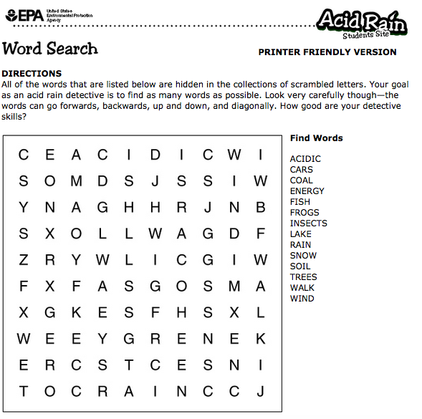

http://eo.ucar.edu/kids/sky/air1.htm
http://eschooltoday.com/pollution/air-pollution/what-is-air-pollution.html
https://www3.epa.gov/airquality/emissns.html
http://www.epa.vic.gov.au/air/aq4kids/smog.asp
http://www3.epa.gov/acidrain/what/
http://www3.epa.gov/acidrain/effects/
http://des.nh.gov/organization/divisions/air/tsb/ams/aqmdp/share.htm
http://www3.epa.gov/acidrain/education/site_students/phscale.html
Activities adapted from EPA’s “Learning about Acid rain” http://www3.epa.gov/acidrain/education/teachersguide.pdf

