Background - What does the teacher need to know before teaching this lesson?
What is water?
Water is a chemical compound consisting of two hydrogen atoms and one oxygen atom. The name water typically refers to the liquid state of the compound. The solid phase is known as ice and gas phase is called steam.

What are the three physical states of water?
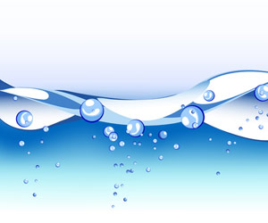
Pure water is tasteless, odorless, and colorless. Water can occur in three states: solid (ice), liquid, or gas (vapor). Solid water—ice is frozen water. When water freezes, its molecules move farther apart, making ice less dense than water. This means that ice will be lighter than the same volume of water, and so ice will float in water. Water freezes at 0° Celsius, 32° Fahrenheit. Liquid water is wet and fluid. This is the form of water with which we are most familiar. We use liquid water in many ways, including washing and drinking. Water as a gas—vapor is always present in the air around us. You cannot see it. When you boil water, the water changes from a liquid to a gas or water vapor. As some of the water vapor cools, we see it as a small cloud called steam. This cloud of steam is a mini-version of the clouds we see in the sky. At sea level, steam is formed at 100° Celsius, 212° Fahrenheit. The water vapor attaches to small bits of dust in the air. It forms raindrops in warm temperatures. In cold temperatures, it freezes and forms snow or hail.

Why is water important for life?
Several chemical properties of water make water indispensable for living creatures. Not only can water dissolve nearly anything, but it is also one of only a few materials that can exist as solid, liquid and gas within a relatively narrow range of temperatures. In some organisms, up to 90% of their body weight comes from water; up to 60% of the human adult body is water.

Where does the Earth's water come from?

Primordial Earth was an incandescent globe made of magma, but all magmas contain water. Water set free by magma began to cool down the Earth's atmosphere, and eventually the environment became cool enough so water could stay on the surface as a liquid. Volcanic activity kept and still keeps introducing water into the atmosphere, thus increasing the surface-water and groundwater volume of the Earth.

What are the different sources of water?
Rainwater, oceans, rivers, lakes, streams, ponds and springs are natural sources of water. Dams, wells, tube wells, hand-pumps, and canals are man-made sources of water. Rain water collects on the earth in the form of surface water and underground water. Water present on the surface of the earth in the form of oceans, rivers, lakes, ponds and streams is called surface water. The water in rivers and lakes comes from rain and melting of snow on mountains. Rivers flow into the sea. Some of the rainwater seeps through the soil on to the non-porous rocks below. This is underground water. Sometimes due to high pressure, this water sprouts out in the form of springs. It can be obtained by digging wells, sinking tube wells, etc.

How much of the Earth is covered with water?
About 70 % of the earth’s surface is covered with water. 97 % of the water on the earth is salt water. Salt water is filled with salt and other minerals, and humans cannot drink this water. Although the salt can be removed, it is a difficult and expensive process. 2 % of the water on earth is glacier ice at the North and South Poles. This ice is fresh water and could be melted; however, it is too far away from where people live to be usable. Less than 1% of all the water on earth is fresh water that we can actually use. We use this small amount of water for drinking, transportation, heating and cooling, industry, and many other purposes.

What is the water cycle?
The water cycle describes the existence and movement of water on, in, and above the Earth. Earth's water is always in movement and is always changing states, from liquid to vapor to ice and back again. The water cycle has been working for billions of years and all life on Earth depends on it continuing to work; the Earth would be a pretty stale place without it.

Where does drinking water come from?
Drinking water comes from natural sources that are either groundwater or surface water. Water is pumped, both from groundwater or surface water sources, into pipes or tanks. The pipes eventually lead to our homes, schools, businesses, and any place where you can turn on the tap and drink water. Most people in the U.S. who live in large cities and towns get their water from a public water supply. If you have a public water supply, a local government agency or private industry delivers water to your home. It comes through a network of underground pipes from a large source of water that you share with your neighbors and community. Your household will receive a bill from your public water supplier based on how much water you use.

How is water polluted?
Water pollution is any chemical, biological, or physical change in water quality that harms living organisms or makes water unsuitable for desired uses. Water pollution can come from single (point) sources, or from larger and dispersed (nonpoint) sources. Point sources discharge pollutants at specific locations through drain pipes , ditches, or sewer lines into bodies of surface water. Examples include factories, sewage treatment plants (which remove some, but not all, pollutants), underground mines, and oil tankers. Because point sources are located at specific places, they are fairly easy to identify, monitor, and regulate. Most developed countries have laws that help to control point-source discharges of harmful chemicals into aquatic systems. In most developing countries, there is little control of such discharges. Nonpoint sources are broad, and diffuse areas, rather than points, from which pollutants enter bodies of surface water or air. Examples include runoff of chemicals and sediments from cropland , livestock feedlots, logged forests, urban streets, parking lots, lawns, and golf courses. We have made little progress in controlling water pollution from nonpoint sources because of the difficulty and expense of identifying and controlling discharges from so many diffuse sources.

How drinking water is treated?
Drinking water sources are subject to contamination and require appropriate treatment to remove disease-causing agents. Public drinking water systems use various methods of water treatment to provide safe drinking water for their communities. Today, the most common steps in water treatment used by community water systems (mainly surface water treatment) include:
- Coagulation and flocculation: Coagulation and flocculation are often the first steps in water treatment. Chemicals with a positive charge are added to the water. The positive charge of these chemicals neutralizes the negative charge of dirt and other dissolved particles in the water. When this occurs, the particles bind with the chemicals and form larger particles, called floc.
- Sedimentation: During sedimentation, floc settles to the bottom of the water supply, due to its weight. This settling process is called sedimentation.
- Filtration: Once the floc has settled to the bottom of the water supply, the clear water on top will pass through filters of varying compositions (sand, gravel, and charcoal) and pore sizes, in order to remove dissolved particles, such as dust, parasites, bacteria, viruses, and chemicals.
- Disinfection: After the water has been filtered, a disinfectant (for example, chlorine, chloramine) may be added in order to kill any remaining parasites, bacteria, and viruses, and to protect the water from germs when it is piped to homes and businesses.

What can we do to protect our water?3
Generally speaking, contaminated groundwater is very difficult and expensive to clean up. Solutions can be found after groundwater has been contaminated but this isn't always easy. The best thing to do is adopt pollution prevention and conservation practices in order to protect important groundwater supplies from being contaminated or depleted in the first place. Top 10 ways to protect and conserve groundwater include:
- Dispose of chemicals properly.
- Take used motor oil to a recycling center.
- Limit the amount of fertilizer used on plants.
- Take short showers.
- Shut water off while brushing teeth.
- Run full loads of dishes and laundry.
- Check for leaky faucets and have them fixed.
- Abandon all wells that are not needed.
- Keep a pitcher of drinking water in the refrigerator.
- Get involved in water education.

Further readings
Why is Water Important for Life?: https://epa.gov/watersense/watersense-kids
Water Resources: http://www.greenfacts.org/en/water-resources/index.htm#2
Sources and Causes of Water Pollution: http://www.conserve-energy-future.com/sources-and-causes-of-water-pollution.php
Protect Sources of Drinking Water: https://www.epa.gov/sourcewaterprotection

Standards - What standards are being met by teaching this lesson?
- K-12 Integrated Environmental and Sustainability Learning Standards (See Appendix Table 1)
- California Education and the Environment Initiative (See Appendix Table 2)
- Next Generation Science Standards (See Appendix Table 3)
- Common Core State Standards (See Appendix Table 4)

Necessary supplies - What supplies will you need to teach the class?
Do it now!
- Handout for filling in the water cycle (or transparency/“Water Module” PowerPoint
Step 2:
- Aquarium (or clear container that can hold 5 gallons of water)
- 5 gallons of water
- Blue food coloring
- Ice cube tray
- Measuring cup (one with ounces is best)
Other steps:
- Handouts (at end of the lesson plan)
Closure:
- Poster board
- Markers

Do Now - (Written on board/projector) What quick independent activity will students engage in as soon as they arrive in class that will review past learning or preview the day’s learning?
The Water Cycle discussion (5-10 minutes)

Show the first slide in the PowerPoint entitled “Water Module” and discuss. Switch to the second slide and test the student's understanding.

Alternatively, show and discuss this interactive diagram:

Review the basics of the water cycle:
- Heat warms water on the Earth's surface, creating water vapor.
- Clouds form from the water vapor and condense.
- Once the water vapor droplets become heavy enough, it starts to rain or snow.
- Rain/snow lands on the Earth’s surface, running into rivers and oceans.
- The water eventually evaporates, starting the cycle over again.

Objective for the Day – (Written on board/projector) What skill are you going to teach and what should the students be able to do by the end of the class to demonstrate what they have learned?
Today you will learn
- Why water is important
- How water is used throughout the world
- Why water conservation is important

Key Words:
Evaporation
Condensation
Water vapor
Water consumption
Water cycle
Water scarcity

Purpose – Why is it important for students to learn this skill? Explain why today’s lesson matters.
Water is important for every living thing on Earth, and a finite amount of water is available. It is important to learn to conserve water to meet society’s needs today while providing for the future.

Teaching the Skill – How will you teach this skill to students? What will the examples and the modeling look like? How will you ensure that all students are actively participating in the lesson?
Step 1: | “How do you use water every day” discussion (5 minutes)  Divide students into groups and ask each group to discuss how they use water every day, or discuss as a class and write the answers on the board.  - What activities do you use water for?  - How many glasses of water do you drink every day?  - How much do you pay for a glass of water at a restaurant?
Step 2: | How much drinking water? (15-20 minutes)  How much water is there on Earth? And where does that water come from?  Demonstration:  - Put 5 gallons of water in an aquarium or a clear container that can hold 5 gallons. Tell students that this represents all of the water on Earth.  - Remove 2 1/4 cups of water (18 oz) and put it in a small clear container.  - Use blue food coloring to dye the water left in the aquarium or container. Tell the students this represents the oceans. The water in the small container is all of the freshwater on Earth.  - Pour 1 and 7/8 cups (15 oz) of the water from the small container into an ice cube tray. This represents all of the water on Earth that is frozen in glaciers and ice caps.  - The remaining 3/8 cup (3 oz) of water in the small container is the amount of drinkable water on Earth.  - Remind the students that the water we have on Earth today is the same water that has always been. No new water is ever made!  Have each student make a pie chart of the water in the oceans (97%), in ice (2%), and in lakes and rivers (drinkable, 1%). and color in the part of the pie chart that represents drinkable water. Or do this activity as a class on the board as follows:  - Explain how the whole "pie" is 100% of the total. For our example, the whole pie is all of the water on Earth.  - Draw out a large slice that is 97% of the circle, label as the oceans. With the 3% that is left, split into thirds and make 2/3 the ice (2%) and the rest the drinkable water. Color in the drinkable water.
Step 3: | Water Scarcity (15 minutes)  Water scarcity means that water is scarce, or rare. Areas that have low rainfall and/or economic problems can have water scarcity.  Watch a video from the New York Times on the drought in California at http://www.nytimes.com/video/us/100000002980095/californias-extreme-drought-explained.html (3:35). Allow a few minutes to discuss.  Show the map of water use by state: http://water.usgs.gov/watuse/wuto.html  Which states use more water? Which states use less?  Scroll down the page and show the list of the largest water users. Note that California leads the nation in water withdrawals.  Scroll down further and show the pie chart of withdrawals by category. Calculate the percentages for each slice of the pie and discuss. Note that thermoelectric power is the largest water consumer by far. (Thermoelectric power is power generated from a heat source, such as fossil fuels, through devices like steam turbines. Production of electrical power results in one of the largest uses of water in the United States and worldwide. http://water.usgs.gov/edu/wupt.html)
Step 4: | Water Conservation brainstorm (15 minutes)  As a class or in groups, brainstorm ideas of how to conserve water.  After the brainstorming session, review “Simple ways to Save water”  http://www3.epa.gov/watersense/kids/simpleways.html  and  “Why Save Water”  https://www3.epa.gov/watersense/kids/whysave.html

Closure – Discuss the day’s activity and lesson plan with the class. ( 5 minutes)
We use a lot of water in our everyday lives and the amount of water we are using is increasing as our population grows. Because water is a limited resource, we must use it wisely. Introduce the worksheet “How Much Water Do You Use” for homework. (See below.)

Take Home/Homework – An activity for the students to take home and perform. Optional: Have the students return the next day with proof of completion of the activity.
Hand out the “How Much Water Do You Use” worksheet at the end of this lesson plan so students can understand how much water they really use day to day.

Optional: Hand out the “Traveling for Water” worksheet at the end of the lesson plan as a math exercise. Preface this homework with a discussion about water access. In the United States, almost everyone has access to running water in their homes. In some countries, however, many people do not, and they must travel to rivers and streams to haul their water home.

Additional Materials - Handouts, supplements, etc
Graphic of the water cycle: http://earthguide.ucsd.edu/earthguide/diagrams/watercycle/
National Science Foundation video on the water cycle: https://www.youtube.com/watch?v=al-do-HGuIk (6:47)

Appendix of Tables

Appendix Table 1: K-12 Integrated Environmental and Sustainability Learning Standards

Standard 1: Ecological, Social, and Economic Systems
- Students develop knowledge of the interconnections and interdependency of ecological, social and economic systems. They demonstrate understanding of how the health of these systems determines the sustainability of natural and human communities at local, regional, national, and global levels.
Standard 2: The Natural and Build Environment
- Students engage in inquiry and systems thinking and use information gained through learning experiences in, about, and for the environment to understand the structure, components, and processes of natural and human-built environments.
Standard 3: Sustainability and Civic Responsibility
- Students develop and apply the knowledge, perspective, vision, skills, and habits of mind necessary to make personal and collective decisions and take actions that promote sustainability.

Appendix Table 2: California Education and the Environment Initiative

Principle III: Natural Systems Change in Ways that People Benefit from and can Influence
- Natural systems proceed through cycles that humans depend upon, benefit from, and can alter.
Concept A: Students need to know that natural systems proceed through cycles and processes that are required for their functioning. | Concept C: Students need to know that human practices can alter the cycles and processes that operate within natural systems.
Principle IV: There are no Permanent or Impermeable Boundaries that Prevent Matter from Flowing Between Systems
- The exchange of matter between natural systems and human societies affects the long-term functioning of both.
Concept A: Students need to know that the effects of human activities on natural systems are directly related to the quantities of resources consumed and to the quantity and characteristics of the resulting byproducts.

Appendix Table 3: Next Generation Science Standards

Earth's Systems
- 4-ESS2-2: Analyze and interpret data from maps to describe patterns of Earth’s features.
Science and Engineering Practices | Disciplinary Core Ideas |  | Crosscutting Concepts
Analyzing and Interpreting Data: Analyzing data in 3–5 builds on K–2 experiences and progresses to introducing quantitative approaches to collecting data and conducting multiple trials of qualitative observations. When possible and feasible, digital tools should be used.  Analyze and interpret data to make sense of phenomena using logical reasoning. | ESS2.B: Plate Tectonics and Large-Scale System Interactions: The locations of mountain ranges, deep ocean trenches, ocean floor structures, Earthquakes, and volcanoes occur in patterns. Most Earthquakes and volcanoes occur in bands that are often along the boundaries between continents and oceans. Major mountain chains form inside continents or near their edges. Maps can help locate the different land and water features areas of Earth. |  | Patterns: Patterns can be used as evidence to support an explanation.
- 5-ESS2-2: Describe and graph the amounts and percentages of water and fresh water in various reservoirs to provide evidence about the distribution of water on Earth.
Science and Engineering Practices | Disciplinary Core Ideas |  | Crosscutting Concepts
Using Mathematics and Computational Thinking: Mathematical and computational thinking in 3–5 builds on K–2 experiences and progresses to extending quantitative measurements to a variety of physical properties and using computation and mathematics to analyze data and compare alternative design solutions.  Describe and graph quantities such as area and volume to address scientific questions. | ESS2.C: The Roles of Water in Earth’s Surface Processes: Nearly all of Earth’s available water is in the ocean. Most fresh water is in glaciers or underground; only a tiny fraction is in streams, lakes, wetlands, and the atmosphere. |  | Scale, Proportion, and Quantity: Standard units are used to measure and describe physical quantities such as weight and volume.
Earth and Human Activity
- 4-ESS3-1: Obtain and combine information to describe that energy and fuels are derived from natural resources and their uses affect the environment.
Science and Engineering Practices | Disciplinary Core Ideas |  | Crosscutting Concepts
Obtaining, Evaluating, and Communicating Information:  Obtaining, evaluating, and communicating information in 3–5 builds on K–2 experiences and progresses to evaluate the merit and accuracy of ideas and methods. Obtain and combine information from books and other reliable media to explain phenomena. | ESS3.A: Natural Resources: Energy and fuels that humans use are derived from natural sources, and their use affects the environment in multiple ways. Some resources are renewable over time, and others are not. |  | Cause and Effect: Cause and effect relationships are routinely identified and used to explain change.  Interdependence of Science, Engineering, and Technology: Knowledge of relevant scientific concepts and research findings is important in engineering.  Influence of Engineering, Technology, and Science on Society and the Natural World: Over time, people’s needs and wants change, as do their demands for new and improved technologies.
- 5-ESS3-1: Obtain and combine information about ways individual communities use science ideas to protect the Earth’s resources and environment.
Science and Engineering Practices |  | Disciplinary Core Ideas |  | Crosscutting Concepts
Obtaining, Evaluating, and Communicating Information: Obtain and combine information from books and other reliable media to explain phenomena. |  | ESS3.C: Human Impacts on Earth Systems: Human activities in agriculture, industry, and everyday life have had major effects on the land, vegetation, streams, ocean, air, and even outer space. But individuals and communities are doing things to help protect Earth’s resources and environments. |  | Systems and System Models: A system can be described in terms of its components and their interactions.  Connections to Nature of Science: Science findings are limited to questions that can be answered with empirical evidence.
Matter and Its Interactions
- 5-PS1-1: Develop a model to describe that matter is made of particles too small to be seen.
Science and Engineering Practices | Disciplinary Core Ideas |  | Crosscutting Concepts
Developing and Using Models: Use models to describe phenomena. | PS1.A: Structure and Properties of Matter: Matter of any type can be subdivided into particles that are too small to see, but even then the matter still exists and can be detected by other means. |  | Scale, Proportion, and Quantity: Natural objects exist from the very small to the immensely large.

Appendix Table 4: Common Core State Standards

Mathematics
Mathematical Practices
Reason abstractly and quantitatively
- CCSS.Math.Practice.MP2: Mathematically proficient students make sense of quantities and their relationships in problem situations.
Model with mathematics
- CCSS.Math.Practice.MP4: Mathematically proficient students can apply the mathematics they know to solve problems arising in everyday life, society, and the workplace.
English Language Arts
Reading: Informational Text
Key Ideas and Details
- CCSS.ELA-Literacy.RI.4.3: Explain events, procedures, ideas, or concepts in a historical, scientific, or technical text, including what happened and why, based on specific information in the text.
Integration of Knowledge and Ideas
- CCSS.ELA-Literacy.RI.4.7: Interpret information presented visually, orally, or quantitatively (e.g., in charts, graphs, diagrams, time lines, animations, or interactive elements on Web pages) and explain how the information contributes to an understanding of the text in which it appears.
Writing
Text Types and Purposes
- CCSS.ELA-Literacy.W.4.2: Write informative/explanatory texts to examine a topic and convey ideas and information clearly.
Research to Build and Present Knowledge
- CCSS.ELA-Literacy.W.4.7: Conduct short research projects that build knowledge through investigation of different aspects of a topic.
Speaking and Listening
Comprehension and Collaboration
- CCSS.ELA-Literacy.SL.4.3: Identify the reasons and evidence a speaker provides to support particular points.
Presentation of Knowledge and Ideas
- CCSS.ELA-Literacy.SL.4.4: Report on a topic or text, tell a story, or recount an experience in an organized manner, using appropriate facts and relevant, descriptive details to support main ideas or themes; speak clearly at an understandable pace.
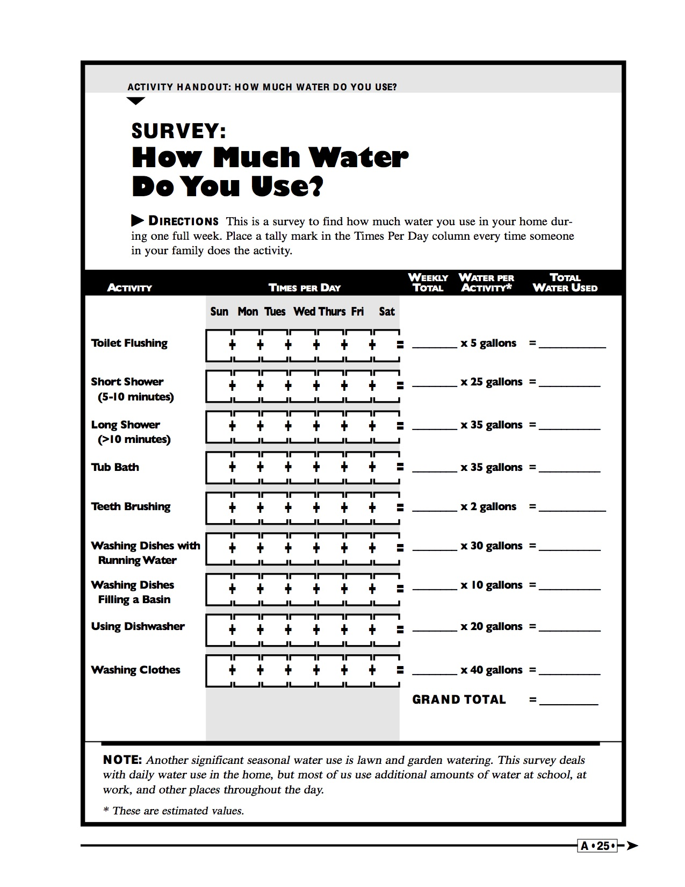
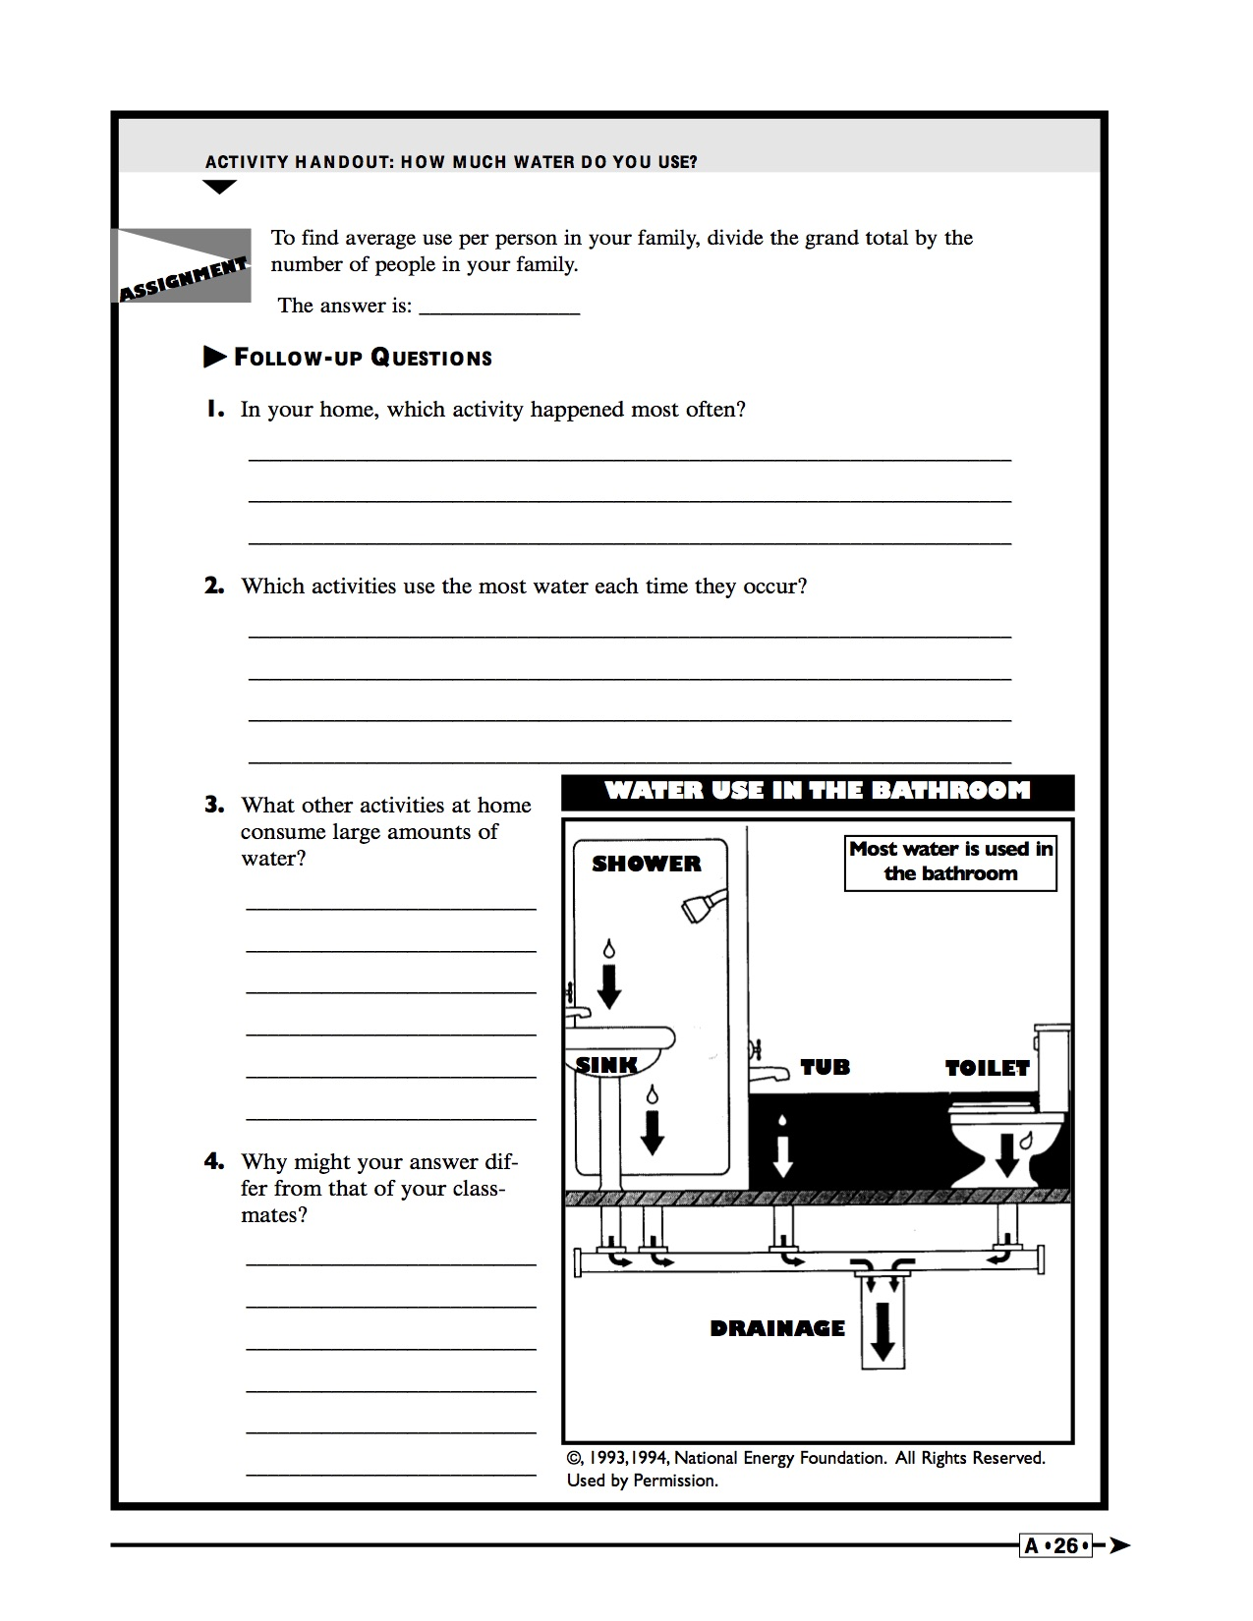
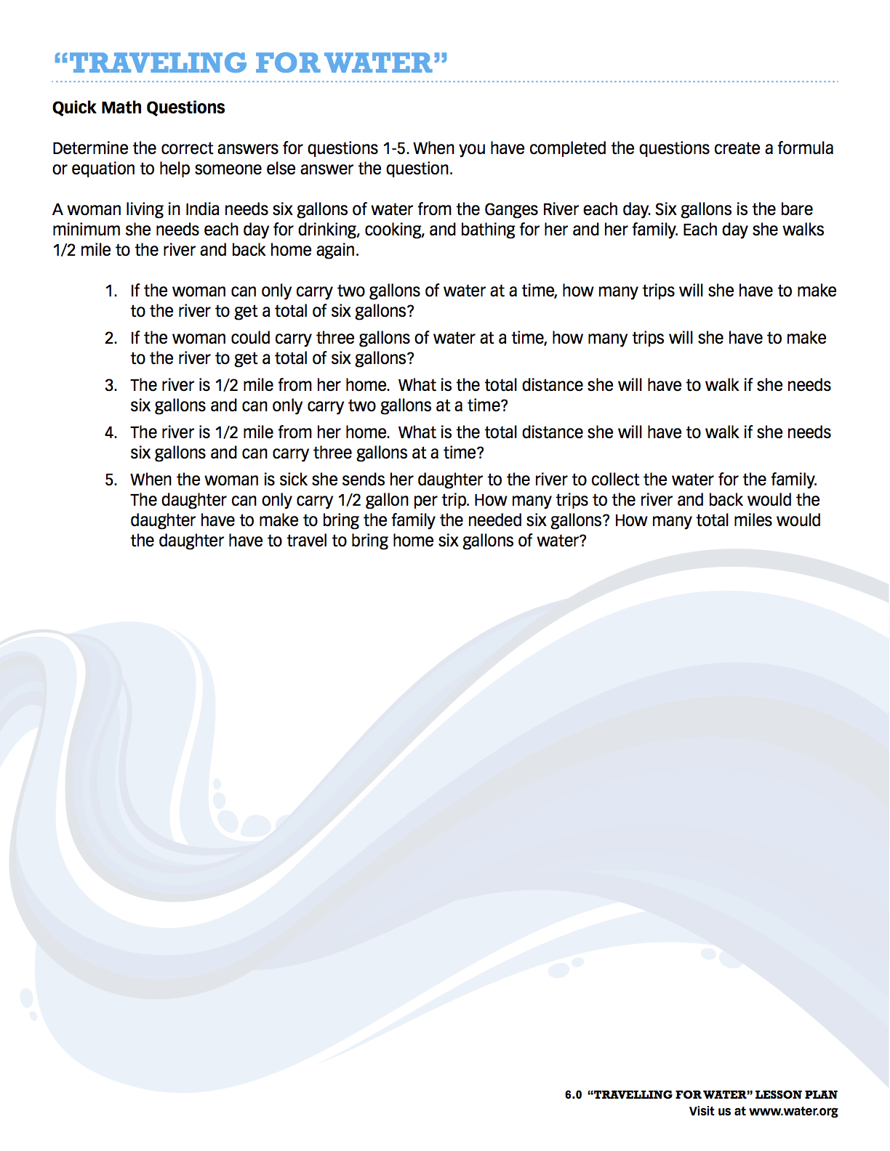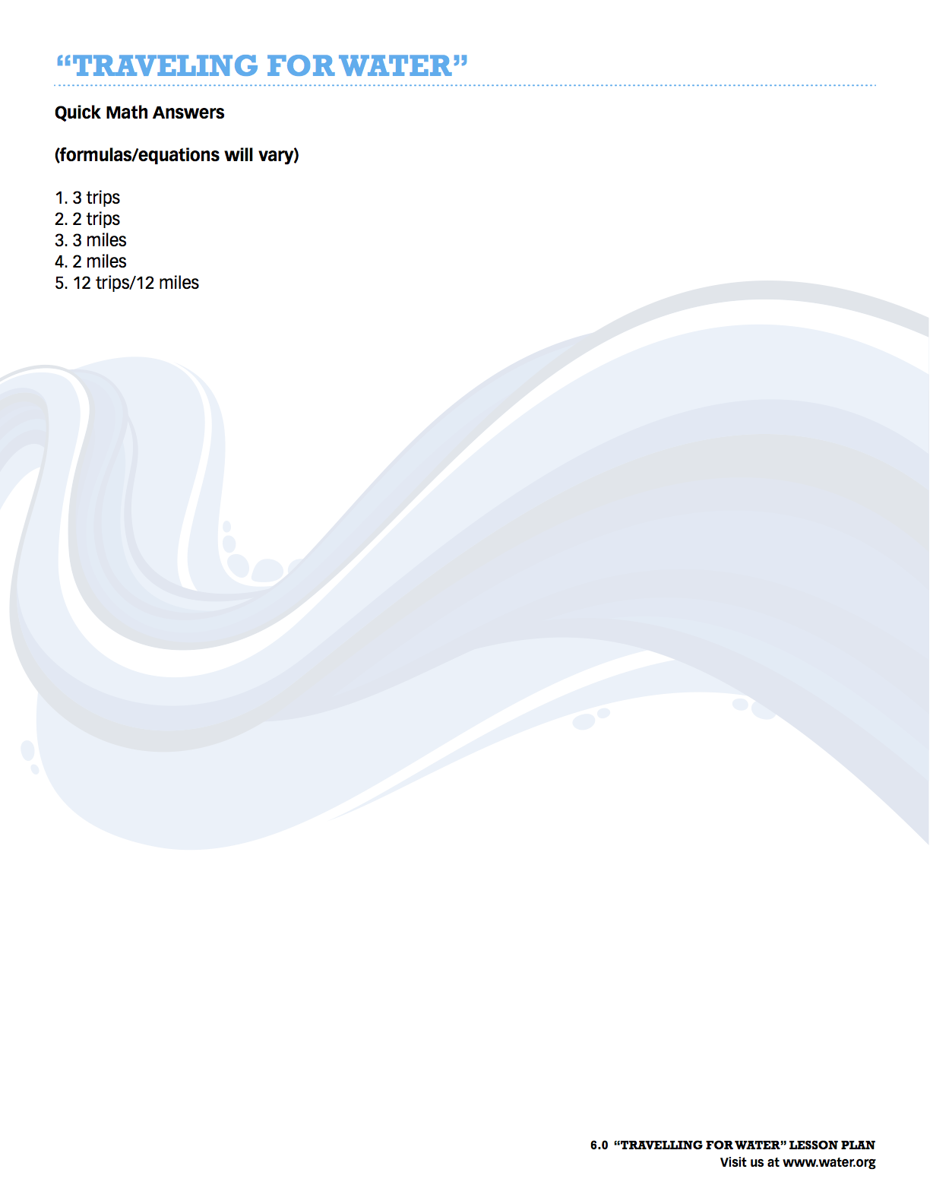

http://water.usgs.gov/edu/watercyclesummary.html
http://extension.psu.edu/natural-resources/water/youth/drinking-water/the-water-we-drink
https://www.epa.gov/environmental-topics/water-topics
http://www.cdc.gov/healthywater/drinking/public/water_treatment.html
The Meadows Center's “How much drinking water?” activity http://www.miseagrant.umich.edu/lessons/lessons/by-broad-concept/earth-science/water-quantity/324-2/
EPA, https://www.epa.gov/sites/production/files/2015-08/documents/mgwc-gwa21.pdf

