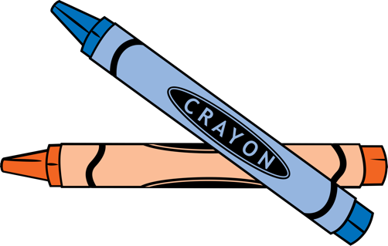

ECOLEARN

ENVIRONMENTAL ENRICHMENT COURSES

PRESCHOOL – 5TH GRADE
A FREE Environmental Education Curriculum that satisfies Common Core & Next Generation Science educational standards. Comes with 9 grade-appropriate lessons that include Air, Animals, Energy, Ecosystems, Waste, Water, Climate Change, Marine Debris & Food.

EcoLearn

Environmental Enrichment Lessons

To interested educators,

We thank you for your interest in EcoLearn - the Environmental Protection Agency's free environmental enrichment lessons. Environmental education makes a difference, and the EPA is ready to bring EcoLearn to your classroom.

The EcoLearn curriculum consists of 9, age-friendly lessons for preschool through fifth grade, all meeting Common Core and Next Generation Science educational standards. The 9 different topic areas are: Air, Animals, Energy, Ecosystems, Climate Change, Marine Debris, Food, Waste, and Water. These lessons are meant to be complementary to classroom instruction, so they are designed to be cherry picked and taught independent of one another.

The lessons and optional student intern are FREE for participating classrooms. Educators can access all the lesson plans, presentations, and activities via a public sharepoint site OR the EPA can delegate the instruction to a student intern in your area.

Through the EcoLearn program, students will not only increase their environmental knowledge, but they will be empowered to use their skills outside of the classroom. If you have any questions, please contact me using the email below. Thank you for your interest!

Best,

Sally Hanft
EPA Environmental Education
hanft.sally@epa.gov
Environmental Protection Agency Region 10 - Serving Alaska, Idaho, Oregon, Washington, and 271 tribal nations
Environmental Protection Agency Region 10 - Serving Alaska, Idaho, Oregon, Washington, and 271 tribal nations

