Detection Limits Best Practices Guide

How to submit censored data to WQP (Water Quality Portal) using the WQX (Water Quality eXchange) schema

Contents
Introduction
WQX Relevant Elements
Guidance Steps
Examples
Additional Resources
Appendix

Introduction
The Detection Limits Best Practices Guide provides guidance for organizations to clearly and consistently document censored data (commonly referred to as non-detects or over-detects) in WQX (Water Quality eXchange). Censored data are measurements that are either too high or too low to be accurately quantified due to analytical methods or instrumentation limitations but still contain partial information about the sample. In water quality sampling, censored data should be recorded because they provide information on the magnitude and direction of results (e.g., above or below the limit) and aid in data interpretation and analysis. We use the term ‘censored’ to characterize samples with measurements that lie within a restricted range of values such that they can be counted but otherwise not measured with accuracy (Cohen 1991)¹. This guidance document is not appropriate for data from samples with known quality control issues (e.g., contaminated sample or exceeded holding time).
Common types of censored data limits are Detection Limits, Quantitation Limits, and Reporting Limits. These terms sound similar, but they have distinct meanings and implications for data interpretation. Detection limits are defined as the lowest analyte concentration that can reliably be detected and distinguished from zero. Quantitation limits are the concentrations at which the analyte can be reliably detected and quantified with acceptable precision and accuracy. Reporting limits are the lowest analyte concentration that a laboratory can reliably report. Figure 1 shows hypothetical sample measurements in relation to limit types.
¹ Cohen, A.C., Truncated and Censored Samples, Marcel Dekker, New York 1991
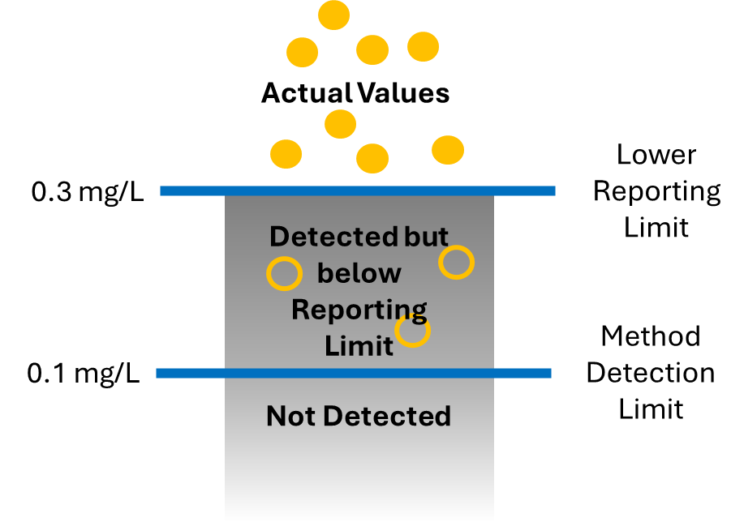
Figure 1. Conceptual diagram of analytic results and common censored data limit types. Observations above the Lower Reporting Limit (solid yellow dots) are actual values (non-censored) that are reliably measured and recorded. Observations between the Reporting Limit and the Detection Limit are censored measures that would be considered “Estimated” (yellow rings) and reported as “Below Reporting Limit”. Observations below the Method Detection Limit are censored measures and reported as “Not Detected” (figure credit Jason Jones ADEQ).

WQX provides a standardized format to document and submit censored data to the Water Quality Portal (WQP). For simplicity, we will refer to this information as detection limits. Detection limits are documented in WQX Results and returned in WQP Sample Results Profiles (Physical/Chemical, Biological, Habitat) and WQP Result Detection Quantitation Limit Profile. In WQX, data submitters can supply an unlimited number of detection limits. However, the WQP will only return six detection limits in the Detection Limit Profile and only two detection limits in the Result Profile that are determined by a ranked hierarchy (Table 3).
This guidance document describes how to properly document detection limits in WQX. We reference both WQX field names (bold & italicized) and their corresponding XML schema element (italicized in parentheses) where they are first introduced and after will simply refer to the WQX field names e.g., Result Value (ResultMeasureValue).
Understanding WQX Elements Relevant to Censored Data Submissions
Detection limits are documented with the following WQX elements: Result Detection Condition (ResultDetectionConditionText), Detection Limit Type (DetectionQuantitationLimitTypeName), Detection Limit Value (DetectionQuantitationLimitMeasure), and Detection Limit Unit (MeasureUnitCode). Definitions of WQX elements relevant to censored data are provided in the Appendix Table A1.
Table 1. Examples of censored data in WQX. Underlined column names are fields that reference WQX domain values (or pick lists of approved names) for users to adopt consistent nomenclature when describing detection limits. Cells colored orange denote which fields (columns) need to be populated to properly document censored data in WQX.
Characteristic Name | Result Detection Condition | Result Value | Result Unit | Result Qualifier | Result Sample Fraction | Result Status ID | Detection Limit Type | Detection Limit Value | Detection Limit Unit
Kjeldahl Nitrogen | Not Detected |  |  |  | Filtered, lab | Final | Method Detection Level | 0.10 | mg/l
Fecal Coliform | Not Detected |  |  |  |  | Final | Lower Reporting Limit | 100 | MPN/100ml
pH |  | 7.1 | None |  |  | Final
Conductivity |  | 4.3 | mg/l |  |  | Final

Censored observations in WQX are reported in the Result Detection Condition using WQX-approved domain names, such as “Not Detected” or “Below Method Detection Limit”. Result Detection Condition is a principal field in WQX for data users to identify censored observations. A WQX validation rule ensures that the data submitter populates a value for either the Result Detection Condition or the Result Value, i.e., there must be a value in at least one of the fields, both fields cannot be blank. See Appendix Table A2 for WQX validation rules.
Censored observations also need to include Detection Limit Type, Detection Limit Value, and Detection Limit Unit. Data-submitting organizations may use different criteria to censor data based on their data quality standards and objectives, which is reflected in the Detection Limit Type. Common Detection Limit Types include “Method Detection Level”, “Lower Quantitation Limit”, and “Lower Reporting Limit”. Detection limit metadata are recorded at the individual result level because detection limits can vary even for a specific analyte due to different analytical methods, field/lab instruments, sample sizes, environmental and laboratory conditions, and other factors that can change over time.

In Table 1, the first two rows (Kjeldahl Nitrogen and Fecal Coliform) are censored data. Note, the Result Value field is left blank, and descriptions of the detection condition are provided in Result Detection Condition – both are “Not Detected’ observations. The Detection Limit Type describes the methodology used to censor the data – “Method Detection Level” for Kjeldahl Nitrogen and “Lower Reporting Limit” for Fecal Coliform. And the specific Detection Limit Values and Units are provided. In contrast, pH and Conductivity are non-censored data, and measures are reported in the Result Value field and Result Detection Condition is left blank. Non-censored data do not need to include detection limit metadata.
KEY Tips
- The Result Detection Condition should always be populated if an observation is censored.
- We recommend censored observations leave the Result Value field blank to prevent WQP data users from misanalysing censored data.
- Always populate both the associated Result Detection Condition and Detection Limit Type for censored results.
- If organizations choose to estimate censored data values in the Result Value field, they should fill out the Result Detection Condition and Detection Limit Type that most accurately agrees with the accompanying result.

In the following sections, we provide more detailed information and guidance with regard to each of the WQX detection limit elements.

Result Detection Condition
The Result Detection Condition field indicates whether an observation is censored or not. It includes a pick list of approved WQX domain names, such as “Not Detected”, “Below Reporting Limit”. When Result Detection Condition is “Not Detected”, “Present Above Quantitation Limit”, or “Present Below Quantitation Limit”, then WQX requires that a Detection Limit Type, Detection Limit Value, and Detection Limit Unit be reported (see Appendix Table A2).

Detection Limit Type
Censored data must include at least one Detection Limit Type. The Detection Limit Type describes the reason or criteria for why data are censored. Common Detection Limit Types include “Method Detection Level”, “Lower Quantitation Limit”, “Lower Reporting Limit”, “Upper Quantitation Limit”, “Upper Reporting Limit”. In most cases, a single Detection Limit Type is sufficient to describe the censored data. But two or more Detection Limit Types might be needed if for example, the censored data value falls between two Detection Limit Types – e.g., between a “Lower Quantitation Limit” and a “Method Detection Level”. WQX allows for users to supply multiple Detection Limit Types per observation (see Table 2).

Table 2. Example data with multiple detection limits recorded for an observation.
Characteristic Name | Result Detection Condition | Result Value | Result Value Type | Detection Limit Type 1 | Detection Limit Value 1 | Detection Limit Unit 1 | Detection Limit Type 2 | Detection Limit Value 2 | Detection Limit Unit 2
Lead | Not Detected |  |  | Lower Quantitation Limit | 0.3 | ug/l | Method Detection Level | 0.06 | ug/l
Mercury | Present Below Quantification limit | 0.013 | Estimated | Lower Quantitation Limit | 0.023 | mg/kg | Method Detection Level | 0.009 | mg/kg

Example: In Table 2, the example organization reports more than one detection limit type (“Method Detection Level” and “Lower Quantitation Limit”) for several analytes to aid in data interpretation and analysis. In this example, observations that were below the Method Detection Limit are left blank and marked as “Not Detected”. Observations that fall between limits (greater than the Method Detection Limit but below the Lower Quantitation Limit) report a Result Value and include a qualifier indicating that they are “Estimated”.

Detection limit types may be defined in different ways across organizations. For example, Reporting Limits may be interchangeable with Quantitation Limits for some organizations. Please refer to the Detection Limit Type WQX domain names and definitions to ensure your organization is defining its censored data values as accurately as possible. Additionally, check your organization’s internal hierarchy for detection types and the use-cases for reporting each (or multiple) type(s).

Detection Limit Type Hierarchy
In cases where multiple detection limit types are associated with a single censored result, the data submitter must recognize that WQX uses a hierarchy to prioritize which Detection Limit Type(s) are returned in WQP queries (Table 3). In the WQP legacy version, only one detection limit type per observation will be returned in the FullPhysicalChemical results data profile even if three or more “limits” are provided to WQX by the data submitter. In the WQP beta version, this will increase to two detection limit types per observation. The rest of the detection limits are only available in WQX Web or as a URL in the WQP Results Profile (ResultDetectionQuantitationLimitUrl) field or in the WQP Result Detection Limit Data Profile. [Note: The WQP beta version will return two detection limit types per observation based on a hierarchy shown below.] A user can join detection limits to their main result measures using the (ResultIdentifier) field if desired.
Table 3: Ranked hierarchy of detection limit types used to determine which detection limits are returned in WQP. It was developed with input from censored data subject matter experts many years ago.

Hierarchy | Result Detection Limit Type | Upper (+), lower (-), or other (0) limit
1 | Practical Quantitation Limit | -
2 | Lower Quantitation Limit | -
3 | Sample-Specific Quantitation Limit | -
4 | Estimated Quantitation Limit | -
5 | Contract Quantitation Limit | -
6 | Minimum Reporting Level | -
7 | Reporting limit | -
8 | Sample-specific min detect conc | -
9 | Laboratory Reporting Level | -
10 | Lower Reporting Limit | -
11 | Sample Detection Limit | -
12 | Lower limit of detection | -
13 | Instrument Detection Level | -
14 | Estimated Detection Level | -
15 | Method Detection Level | -
16 | Measurement Uncertainty | 0
17 | Long Term Method Detection Level | -
18 | Interim Reporting Level | -
19 | Daily detection limit | -
20 | Blank-adjusted method detect limit | -
21 | Contract Detection Limit | -
22 | Upper Quantitation Limit | +
23 | Upper Reporting Limit | +
24 | Upper Calibration Limit | +
25 | Field Holding Time Limit | 0
26 | Laboratory Holding Time Limit | 0
27 | Drinking Water Maximum | 0
28 | Systematic Uncertainty | 0
29 | Statistical Uncertainty | 0
30 | Water Quality Standard or Criteria | 0
31 | Specified in workplan | 0
32 | Taxonomic Loss Threshold | 0

Interpreting the detection limit type hierarchy, if a WQX data submitter supplied a “Lower Quantitation Limit” (rank: 2), “Lower Reporting Limit” (rank: 10), and a “Method Detection Level” (rank: 15), with a single censored data value, ONLY the “Lower Quantitation Limit” will be provided with that observation in a WQP results profile (2.0 legacy version). Both the “Lower Quantitation Limit” and “Lower Reporting Limit” metadata would be provided in the beta WQP results profile (3.0) version.
Note: Lower detection limits typically rank as higher priority than upper detection limits. This means that if your censored data are over-detections, we do NOT recommend you supply both a lower and upper detection/quantitation limit; in most cases, only the lower detection/quantitation limit will be served in a WQP query. Including multiple detection limit types could mislead the data user on the nature of the censored data. For example, data users may associate the Result Detection Condition with wrong Detection Limit Type.

The Result Detection Condition should agree as closely as possible with the Detection Limit Type. Data submitters should double check that the selected limit(s) accurately describe an upper limit versus a lower limit. For example, a result with Result Detection Condition “Below Reporting Limit” should not be described in the Detection Limit Type field as an ‘Upper’ limit. WQX does not have validation checks for this. It is the responsibility of the data submitter to ensure results are properly documented across these related elements. However, mismatches do commonly occur, and the EPATADA R package can be leveraged by data users to check for this (see TADA_IDCensoredData). Table 4 presents examples of logical pairings between Result Detection Condition and Result Detection Limit Type.

Table 4: Examples of suggested Detection Condition and Detection Limit Type pairings.

Result Detection Condition | Detection Limit Type
Below Detection Limit | Method Detection Level
Below Reporting Limit | Lower Reporting Limit or Reporting limit
Between Inst Detect and Quant Limit | Practical Quantitation Limit
Detected Not Quantified | Practical Quantitation Limit

Result Qualifier Code
WQX schema includes Result Qualifier (MeasureQualifierCode) to document quality assurance/quality control issues associated with result values. Result Qualifier field is optional and references WQX domain codes (e.g., J = Estimated value; U = Not Detected). It is not sufficient to only populate the Result Qualifier to document censored results. Please ensure if populating the Result Qualifier, it agrees with the information supplied in Result Value, Result Detection Condition, and Result Detection Limit Type elements.

Guidance for Populating Result Detection Condition and Result Detection Limit Type Elements

Option 1 (Preferred): Report Measured Values and Censored Values Separately in their Respective Fields

The simplest and recommended approach for reporting censored data is to keep the Result Value blank and populate both the associated Result Detection Condition and Result Detection Limit Type. This approach is preferred to better communicate that data are censored (i.e., not quantified with enough precision and accuracy to be treated as actual measures), and it is up to the data user how they would like to handle the censored information. Data users may want to estimate a result value using the provided Result Detection Limit Type and associated Detection Limit Value and Unit for analyses, but others may analyze censored data differently.

Option 2 (Valid but not recommended): Include Estimated Result Values for Censored Data as the Result Value

A valid option but NOT recommended for handling censored data is to estimate a value in the Result Value field and indicate in the Result Value Type that the result is “Estimated”. This option is valid in WQX, but not recommended because data analyzers may not recognize that the supplied Result Values are CENSORED data without referencing other fields (e.g., Result Detection Condition) and this can lead to misinterpretation.
If your organization estimates censored data values prior to uploading to WQX, please populate the Result Value and Result Unit with these values and use Result Value Type to indicate to users that the result is “Estimated”. Fill out the Result Detection Limit Comment (free text) with the method used to estimate the result (e.g., “half of the detection limit”). Data submitters should also populate the associated Result Detection Condition and Result Detection Limit Type. Make sure that each estimated Result Value is representative of the Result Detection Condition and Result Detection Limit Type. For example, if the Result Detection Condition reads “Below Reporting Limit” and the Reporting Limit is 0.05 mg/L, an estimated Result Value should be at or below 0.05 mg/L.

Note: Analytic labs reporting data results often include ‘<’ when values are below detection limits. These special characters can be problematic in datasets, and it is generally recommended NOT to use special characters (<, >, ~, *, ^, etc.) or non-numeric data in WQX Results fields. However, WQX Web can handle these issues by enabling the option “Generate Detection Condition and Limits from Result Value” (see below) or creating a translation in an import configuration.

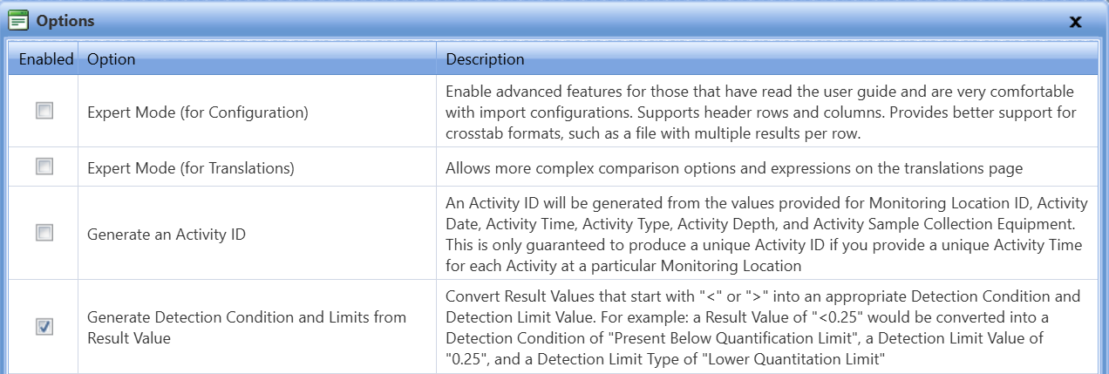
Figure 2. WQX Web Import Configuration Option to generate detection condition limits from special characters in results field of the dataset.
When a result field contains a “<” or “>” followed by values, WQX will populate an appropriate Detection Condition and Detection Limit Value. The user would need to specify the Detection Limit Type. For example, a Result Value of “<0.25” with a Detection Limit Type of “Lower Quantification Limit”, would be converted into a Detection Condition of “Present Below Quantification Limit” and a Detection Limit Value of “0.25”.

Examples: Valid and Invalid Submissions
Table 5: Three examples of VALID Result Detection Condition and Result Detection Limit Type submissions.
In the Result Qualifier column, DL = Not Detected: The analyte was not detected at a level ≥ to the Method Detection Limit for the analysis; LTGTE = Result is less than the MQL but greater than or equal to the MDL.
 | Result Detection Condition | Result Value | Result Unit | Result Value Type | Result Qualifier | Result Detection Limit Type | Result Detection Limit Value | Result Detection Limit Unit | Result Detection Limit Comment
Example #1  Valid (Preferred) | Not Detected |  |  | Actual | DL | Method Detection Level | 0.05 | mg/L
Example #2  Valid  (NOT Preferred) | Not Detected | 0.025 | mg/L | Estimated |  | Method Detection Level | 0.05 | mg/L | Half the detection limit
Example #3 Valid  (NOT Preferred) | Present Below Quantification Limit | 0.07 | mg/L | Estimated | LTGTE | Practical Quantitation Limit | 0.1 | mg/L | Estimated using regression on order statistics

Explanation of Table 5
Example 1 is a data submission where the WQX user reported in the Result Detection Condition that the analyte was “Not Detected”, which agrees with the Result Qualifier code provided (‘DL’). They then provided the Result Detection Limit Type, Result Detection Limit Value, and Result Detection Limit Unit, that corresponds to the “Method Detection Level”. A data user could then decide how they wanted to use the detection limit information in their analyses.
In Example 2 the WQX user provided their own estimate for the censored data record. This example is valid in WQX but not preferred because it may lead to inappropriate analysis of the censored data. The user estimated a Result Value, provided a Result Unit, and made sure to populate “Estimated” in the Result Value Type to indicate the result is not an “Actual” value, but an estimate based on the detection limit. They provided the Result Detection Limit Type, Result Detection Limit Value, and Result Detection Limit Unit, which is required when the Result Detection Condition is populated, and additionally filled out the Result Detection Limit Comment with their method for estimating the Result Value.
Example 3 mirrors Example 2, but the user provided a Result Qualifier (LTGTE = Result is less than quantitation limit but ≥ to detection limit), which matches the situation presented by the Result Detection Condition (‘Present Below Quantitation Limit’) and Result Detection Limit Type (‘Practical Quantitation Limit’). This user utilized a regression approach to estimate the Result Value, and this information is provided in the Result Detection Limit Comment.
Table 7 Two examples of INVALID Result Detection Condition and Result Detection Limit Type data submissions.
In the Result Qualifier column, AR = Counts outside acceptable range.
 | Result Detection Condition | Result Value | Result Unit | Result Value Type | Result Qualifier | Result Detection Limit Type | Result Detection Limit Value | Result Detection Limit Unit | Result Detection Limit Comment
Example #1 | Below Reporting Limit | 0.04 | mg/L | Actual |  | Method Detection Level | 0.05 | mg/L
Example #2 | Below Detection Limit |  |  |  | AR | Lower Reporting Limit | 0.1 | mg/L

Explanation of Table 7:
In Example 1, the user did not heed several best practices. The Result Detection Condition does not agree with the Result Detection Limit Type (reporting limit versus detection level, where reporting limit values are generally greater than the detection level values). Furthermore, the user populated a Result Value and Result Unit that are LESS than the Result Detection Limit Value and Result Detection Limit Unit provided, which adds more confusion in the disagreement between the Result Detection Condition and the Result Detection Limit Type. Lastly, the user failed to switch the Result Value Type from “Actual” to “Estimated” and did not provide any context for the estimation method in the Result Detection Limit Comment element. WQX does not check for these inconsistencies, and it is on the data submitter to make sure information is accurately reported. To fix this, the user might change the Result Detection Condition to “Not Detected”, change the Result Value Type to “Estimated”, and provide the nondetect estimation method in the Result Detection Limit Comment.
Example 2 shows another situation where the Result Detection Condition and Result Detection Limit Type do not agree. Generally, a reporting limit is ABOVE a detection limit, so the detection condition suggests a value that would be LOWER than the lower reporting limit of 0.1 mg/L. If the user had the ‘Method Detection Level’ in addition to the’ Lower Report Limit’, they could reduce confusion by providing the information associated with that limit type instead, which would improve clarity of the meaning of the data record. Finally, the Result Qualifier of “AR” means “Counts outside acceptable range”, which adds confusion to the detection limit, which is in concentration units.

Additional Resources
- Method Detection Limit – Frequent Questions
- Procedures for Detection and Quantitation – Documents
- Regional Guidance on Handling Chemical Concentration Data Near the Detection Limit in Risk Assessments
- Water Quality Exchange Web Template Files
- Data Exchange Template (xls) includes the entire WQX data schema and element definitions

Appendix
Appendix Table A1: WQX schema elements relevant to censored data. Please reference the Water Quality eXchange Domain Services and Downloads for the allowable values for each element (or field); and the WQX Data Elements Types (DET) File for the full WQX 3.0 data schema and all element definitions. Please note that this guidance document references the WQX 3.0 element (column 2) and is applicable to all WQX templates and WQP profiles.
WQX Web Element Name | WQX 3.0 Schema XML names | WQX Element Definition
Result Value | ResultMeasureValue | Measured value of characteristic. Required if Result Detection Condition is blank. Usually a numeric value.
Result Unit | MeasureUnitCode | Units for characteristic Result Measure Value, required if a non-text result is reported.
Result Detection Condition | ResultDetectionConditionText | Result Detection Condition is used to document censored values – that is, if the result falls above (over-detects) or below (non-detects) the detection limit.
Detection Limit Type | DetectionQuantitationLimitTypeName | Text describing the type of censored data limit. Both Detection Quantitation Limit Type and Result Detection Condition should be reviewed and populated (paired) when using data for analyses.  Required if Result Detection Condition is "Not Detected", "Present Above Quantification Limit", or "Present Below Quantification Limit".
Detection Limit Value | MeasureValue | The reportable measure of the result for the chemical, microbiological or other characteristic being analyzed.  Required if Result Detection Condition is "Not Detected", "Present Above Quantification Limit", or "Present Below Quantification Limit".
Detection Limit Unit | MeasureUnitCode | The code that represents the unit for measuring the chemical substance, microbiological substance or other characteristic.  Required if Result Detection Condition is "Not Detected", "Present Above Quantification Limit", or "Present Below Quantification Limit". Also Required if Detection Quantitation Limit Type is reported.
Detection Limit Comment | DetectionQuantitationLimitCommentText | Text providing further description and comment on the detection limits.  * Note: this is an added element in WQX v3.0
Result Value Type | ResultValueTypeName | Defines process used in the determination of result value (e.g. Actual, Estimated, Calculated). Required if result is non-text. Default is Actual.
Result Qualifier | MeasureQualifierCode | A code used to identify any quality assurance and quality control (QAQC) issues that affect the results.
Result Comment | ResultCommentText | Provided to allow for comments about the result.  * Note: this was used in 2.0 for detection limit comments but now 3.0 supports a specific element for detection limit comments
Appendix Table A2: WQX validation rules associated with detection limit attributes.
Rule #32 | Either Result Measure Value and/or Result Detection Condition Text must be reported
Rule #12 | When Result Detection Condition is 'Not Detected', 'Present Above Quantification Limit' or 'Present Below Quantification Limit', then Detection Limit Type and Detection Limit Value must be reported.
Rule #45 | If Result Detection Limit is reported, then Detection Limit Type and Detection Limit Value are required
Rule #14 | When Detection Limit Value is reported, Detection Limit Unit must be reported.

