Background Info:
https://en.wikipedia.org/wiki/Interquartile_range
https://www.statisticshowto.com/probability-and-statistics/interquartile-range/
Interquartile Range Outlier detection
One rule based method that works well and is easy to implement in SQL is to use the interquartile range. The IQR is defined as the difference between the 75% 95% percentile and the 25% 5% percentile of your dataset.
If a data point is above the 75th percentile by 1.5x the IQR or more or below the 25th percentile by 1.5x the IQR or less, they can be considered outliers.
- Upper Outlier = 75th Percentile + 1.5 * (75th percentile - 25th percentile)
- Lower Outlier = 25th Percentile - 1.5 * (75th percentile - 25th percentile)
Why 1.5x and not 2x or 3x? 1.5x is pretty similar to 3 standard deviations above the mean (see the diagram below). You can certainly change it to 1.75x or 2.25x etc. depending on how ‘sensitive’ you want the outlier detection to be, which is another great thing about using the IQR.
Since the IQR uses the median instead of the average it’s considered a robust measure of scale and less likely to be influenced by a few outliers compared to measures that use the average such as standard deviation. This will make it easier to identify actual outliers.
If you’ve ever seen a boxplot, that’s just the IQR method of outlier detection visualized. The ‘box’ is the IQR, the ‘whiskers’ are at the 25th and 75th percentile and any data points above those (called ‘fliers’) are the outliers as you can see from the below diagram:
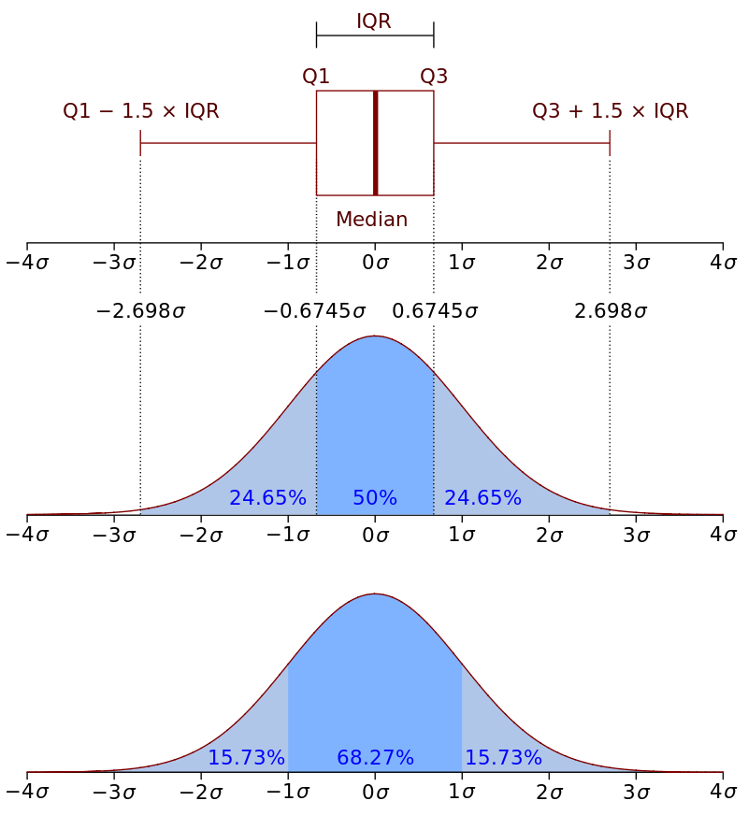
Source: Wikipedia
However, you may not have access to a box and whiskers chart. And even if you do, some boxplots may not show outliers. For example, this chart has whiskers that reach out to include outliers: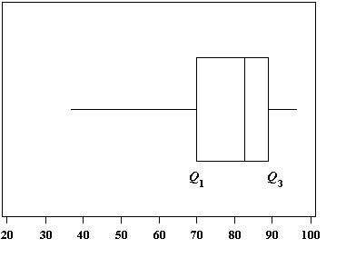
Therefore, don’t rely on finding outliers from a box and whiskers chart. That said, box and whiskers charts can be a useful tool to display them after you have calculated what your outliers actually are. The most effective way to find all of your outliers is by using the interquartile range (IQR). The IQR contains the middle bulk of your data, so outliers can be easily found once you know the IQR.
Back to Top

How to Find Outliers Using the Interquartile Range(IQR)
Need help with a homework question? Check out our tutoring page!
An outlier is defined as being any point of data that lies over 1.5 IQRs below the first quartile (Q₁) or above the third quartile (Q₃)in a data set.
High = (Q₃) + 1.5 IQR
Low = (Q₁) – 1.5 IQR
Watch this video on How To Find Outliers, or read the steps below:
Sample Question: Find the outliers for the following data set: 3, 10, 14, 22, 19, 29, 70, 49, 36, 32.
Step 1: Find the IQR, Q₁(25th percentile) and Q₃(75th percentile). Use our online interquartile range calculator to find the IQR or if you want to calculate it by hand, follow the steps in this article: Interquartile Range in Statistics: How to find it.
IQR = 22
Q₁ = 14
Q₃ = 36
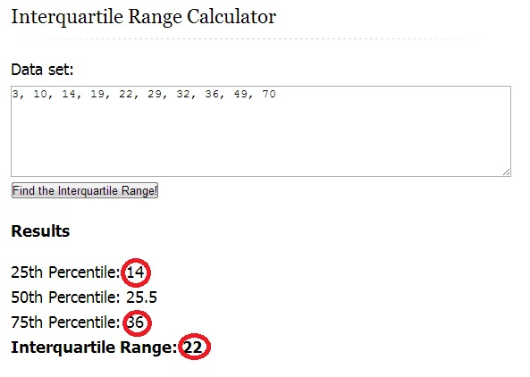
IQR, Q1 and Q3 found using the online calculator (see link in this step).
Step 2: Multiply the IQR you found in Step 1 by 1.5:
IQR * 1.5 = 22 * 1.5 = 33.
Step 3: Add the amount you found in Step 2 to Q₃ from Step 1:
33 + 36 = 69.
This is your upper limit. Set this number aside for a moment.
Step 3: Subtract the amount you found in Step 2 from Q₁ from Step 1:
14 – 33 = -19.
This is your lower limit. Set this number aside for a moment.
Step 5: Put the numbers from your data set in order:
3, 10, 14, 19, 22, 29, 32, 36, 49, 70
Step 6: Insert your low and high values into your data set, in order:
-19, 3, 10, 14, 19, 22, 29, 32, 36, 49, 69, 70
Step 6: Highlight any number below or above the numbers you inserted in Step 6:
-19, 3, 10, 14, 19, 22, 29, 32, 36, 49, 69, 70
That’s it!
Back to Top

How to Find Outliers with The Tukey Method
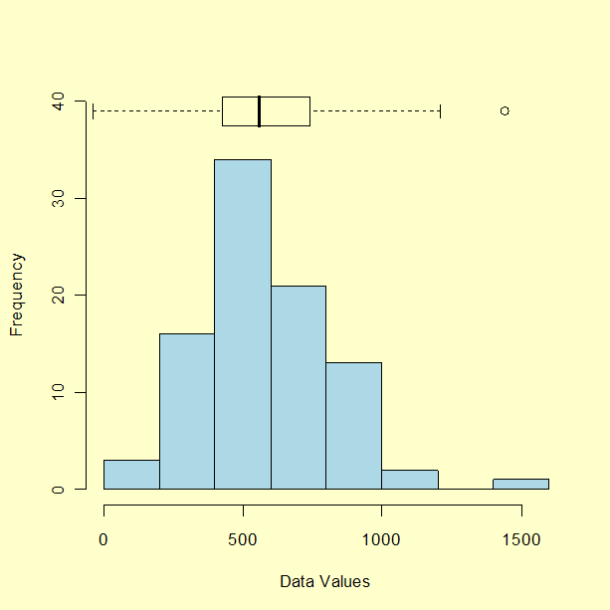
Frequency chart with boxplot at the top. The outliers are shown as dots outside the range of the whiskers.
The Tukey method for finding outliers uses the interquartile range to filter out very large or very small numbers. It’s practically the same as the procedure above, but you might see the formulas written slightly differently and the terminology is a little different as well. For example, the Tukey method uses the concept of “fences”.
The formulas are:
Low outliers = Q1 – 1.5(Q3 – Q1) = Q1 – 1.5(IQR)
High outliers = Q3 + 1.5(Q3 – Q1) = Q3 + 1.5(IQR)
Where:
Q1 = first quartile
Q3 = third quartile
IQR = Interquartile range
These equations give you two values, or “fences“. You can think of them as a fence that cordons off the outliers from all of the values that are contained in the bulk of the data.
Sample question: Use Tukey’s method to find outliers for the following set of data: 1,2,5,6,7,9,12,15,18,19,38.
Step 1: Find the Interquartile range:
- Find the median: 1,2,5,6,7,9,12,15,18,19,38.
- Place parentheses around the numbers above and below the median — it makes Q1 and Q3 easier to find.
(1,2,5,6,7),9,(12,15,18,19,38)
- Find Q1 and Q3. Q1 can be thought of as a median in the lower half of the data. Q3 can be thought of as a median for the upper half of data.
(1,2,5,6,7), 9, ( 12,15,18,19,38). Q1=5 and Q3=18.
- Subtract Q1 from Q3. 18-5=13.
Step 2: Calculate 1.5 * IQR:
1.5 * IQR = 1.5 * 13 = 19.5
Step 3: Subtract from Q1 to get your lower fence:
5 – 19.5 = -14.5
Step 4: Add to Q3 to get your upper fence:
18 + 19.5 = 37.5.
Step 5:Add your fences to your data to identify outliers:
(-14.5) 1,2,5,6,7,9,12,15,18,19,(37.5),38.
Anything outside of the fences is an outlier. For this data set, 38 is the only outlier.

To do this, the below Oracle query can be adjusted as follows:

with orderedList AS (
SELECT
full_name,
age,
ROW_NUMBER() OVER (ORDER BY age) AS row_n
FROM friends
),

quartile_breaks AS (
SELECT
age,
full_name,
(
SELECT age AS quartile_break
FROM orderedList
WHERE row_n = FLOOR((SELECT COUNT(*) FROM friends)*0.75)
) AS q_three_lower,
(
SELECT age AS quartile_break
FROM orderedList
WHERE row_n = FLOOR((SELECT COUNT(*) FROM friends)*0.75) + 1
) AS q_three_upper,
(
SELECT age AS quartile_break
FROM orderedList
WHERE row_n = FLOOR((SELECT COUNT(*) FROM friends)*0.25)
) AS q_one_lower,
(
SELECT age AS quartile_break
FROM orderedList
WHERE row_n = FLOOR((SELECT COUNT(*) FROM friends)*0.25) + 1
) AS q_one_upper
FROM orderedList
),

iqr AS (
SELECT
age,
full_name,
(
(SELECT MAX(q_three_lower)
FROM quartile_breaks) +
(SELECT MAX(q_three_upper)
FROM quartile_breaks)
)/2 AS q_three,
(
(SELECT MAX(q_one_lower)
FROM quartile_breaks) +
(SELECT MAX(q_one_upper)
FROM quartile_breaks)
)/2 AS q_one,
1.5 * ((
(SELECT MAX(q_three_lower)
FROM quartile_breaks) +
(SELECT MAX(q_three_upper)
FROM quartile_breaks)
)/2 - (
(SELECT MAX(q_one_lower)
FROM quartile_breaks) +
(SELECT MAX(q_one_upper)
FROM quartile_breaks)
)/2) AS outlier_range
FROM quartile_breaks
)

SELECT
full_name,
age
FROM iqr
WHERE age >=
((SELECT MAX(q_three)
FROM iqr) +
(SELECT MAX(outlier_range)
FROM iqr))
OR age <=
((SELECT MAX(q_one)
FROM iqr) -
(SELECT MAX(outlier_range)
FROM iqr))
Written by: Rebecca Barnes

URL: https://dataschool.com/how-to-teach-people-sql/how-to-find-outliers-with-sql/

Reference Tables:
- Locations Spatial Table: Country and State
  - Generate Country: For incorrect or inaccurate lat/long
  - Generate State: For incorrect or inaccurate lat/long
  - RESPONSE - Dataowner will resubmit with more accurate lat/long based on the above metadata ? WRONG country or WRONG state (NO?)
  - PRECISION: requires 3 digit decimals (padded zeros? If applicable.)
  - DUPLICATES matching truncated 3 digit decimals
- Results Table
  - Range: Characteristic, Unit, Lower and Upper Range, State, Activity Type, Activity Medium
  - Characteristic and Sample Fraction
  - Characteristic and Method Speciation
  - Characteristic and Analytical Method
  - Characteristic and Unit
  - Characteristic and Limit
  - QAPP Approved via Project services and table

TEST Case Locations applying criteria for Precision and Duplicates Flag based on 3 digit decimal precision
- Question: Must the dataowner submit padded zeros for satisfying the 3 decimal precision requirement?
- Question: Duplicates Flag based on matching latitude and longitude (of truncated 3 digit decimal precision)
agency_cd | site_no | station_nm | site_tp_cd | dec_lat_va | dec_long_va | coord_acy_cd | dec_lat_long_datum_cd | agency_use_cd
USGS | 1021050 | St. Croix River at Milltown, Maine | ST | 45.17000000 | -67.29666670 | 5 | NAD83 | A
USGS | 1388000 | Ramapo River at Pompton Lakes NJ | ST | 40.99194444 | -74.28000000 | 1 | NAD83 | M
USGS | 1396800 | Spruce Run at Clinton NJ | ST | 40.64000000 | -74.91555560 | S | NAD83 | M
USGS | 1401750 | Millstone River at Griggstown NJ | ST | 40.44000000 | -74.61750000 | S | NAD83 | M
USGS | 1409124 | Barnegat Bay near Waretown NJ | ES | 39.77000000 | -74.18833330 | S | NAD83 | I
USGS | 1410510 | Absecon Creek at Absecon, NJ | ES | 39.42305556 | -74.50000000 | S | NAD83 | M
USGS | 1415000 | TREMPER KILL NEAR ANDES NY | ST | 42.12000000 | -74.81861110 | S | NAD83 | A
USGS | 1432495 | Shohola Creek near Walker Lake, PA | ST | 41.45000000 | -74.92166670 | S | NAD83 | A
USGS | 1435000 | NEVERSINK RIVER NEAR CLARYVILLE NY | ST | 41.89000000 | -74.59000000 | S | NAD83 | A
USGS | 1436000 | NEVERSINK RIVER AT NEVERSINK NY | ST | 41.82000000 | -74.63555560 | S | NAD83 | A
USGS | 1464500 | Crosswicks Creek at Extonville NJ | ST | 40.13722220 | -74.60000000 | S | NAD83 | A
USGS | 1465850 | South Branch Rancocas Creek at Vincentown NJ | ST | 39.94000000 | -74.76305560 | S | NAD83 | A
USGS | 1467000 | North Branch Rancocas Creek at Pemberton NJ | ST | 39.97000000 | -74.68444440 | S | NAD83 | A
USGS | 21989792 | LITTLE BACK RIVER AT GA 25 AT PORT WENTWORTH, GA | ST-TS | 32.16583333 | -81.13000000 | S | NAD83 | M
USGS | 2245290 | ST JOHNS RIVER AT RACY PT NEAR HASTINGS FL | ST | 29.80000000 | -81.55000000 | S | NAD83 | L
USGS | 2246518 | POTTSBURG CRK AT US90 NR S. JACKSONVILLE, FL | ST | 30.28696944 | -81.57000000 | 5 | NAD83 | A
USGS | 229070854 | BLACK CREEK CANAL EAST OF US1 NR GOULDS, FL | ST-CA | 25.57000000 | -80.37477780 | S | NAD83 | A
USGS | 2334480 | RICHLAND CREEK AT SUWANEE DAM ROAD, NEAR BUFORD,GA | ST | 34.13250000 | -84.07000000 | S | NAD83 | M
USGS | 2335405 | CHATTAHOOCHEE R 0.47 MI DS GA140, ALPHARETTA, GA | ST | 33.97333330 | -84.27000000 | S | NAD83 | A
USGS | 23432415 | CHATTAHOOCHEE R .36 MI DS WFG DAM NR FT GAINES, GA | ST | 31.62138889 | -85.06000000 | S | NAD83 | M
USGS | 2385800 | HOLLY CREEK NEAR CHATSWORTH, GA | ST | 34.71666667 | -84.77000000 | S | NAD83 | M
USGS | 4026561 | TYLER FORKS RIVER AT STRICKER ROAD NEAR MELLEN, WI | ST | 46.39472220 | -90.59000000 | S | NAD83 | A
USGS | 4071000 | OCONTO RIVER NEAR GILLETT, WI | ST | 44.86500000 | -88.30000000 | S | NAD83 | A
USGS | 40851385 | FOX RIVER AT OIL TANK DEPOT AT GREEN BAY, WI | ST | 44.52861110 | -88.01000000 | S | NAD83 | A
USGS | 5538020 | DES PLAINES RIVER IN LOCK CHANNEL AT ROCKDALE, IL | ST | 41.50000000 | -88.10694440 | S | NAD83 | M
USGS | 6101630 | Marias River at Highway 223 bridge near Chester,MT | ST | 48.26000000 | -110.89166670 | S | NAD83 | A
USGS | 6178500 | East Poplar River at international boundary | ST | 49.00000000 | -105.40958610 | 1 | NAD83 | A
USGS | 6796500 | Platte River near Leshara, Nebr. | ST | 41.32000000 | -96.40388890 | S | NAD83 | A
USGS | 7340300 | Cossatot River near Vandervoort, AR | ST | 34.38000000 | -94.23638890 | T | NAD83 | M
USGS | 11153000 | PACHECO C NR DUNNEVILLE CA | ST | 36.98000000 | -121.38027780 | S | NAD83 | A
USGS | 11169750 | ALVISO SLOUGH NR ALVISO CA | ES | 37.44000000 | -121.99833330 | 1 | NAD83 | I
USGS | 13266000 | WEISER RIVER NR WEISER ID | ST | 44.27000000 | -116.77222220 | 1 | NAD83 | L
USGS | 13307000 | SALMON RIVER NR SHOUP ID | ST | 45.32250000 | -114.44000000 | S | NAD83 | L
USGS | 15580095 | NIUKLUK R AB MELSING C AT COUNCIL AK | ST | 64.89194440 | -163.67000000 | S | NAD83 | A
USGS | 265906080093500 | LOXAHATCHEE RIVER AT MILE 9.1 NEAR JUPITER, FL | ST | 26.98528333 | -80.16000000 | S | NAD83 | A
USGS | 292800090060000 | Little Lake near Bay Dosgris E of Galliano, LA | LK | 29.46666667 | -90.10000000 | S | NAD83 | M
USGS | 293559098284801 | AY-68-29-112 (Donella) | GW | 29.59972220 | -98.48000000 | F | NAD83 | A
USGS | 301324090382400 | CRMS0061-H01-RT | WE | 30.22333333 | -90.64000000 | R | NAD83 | A
USGS | 422848088191001 | 46N8E-08.2e1 (4-RCH-S) | GW | 42.48000000 | -88.31944440 | S | NAD83 | A

URL:
https://waterdata.usgs.gov/usa/nwis/current?type=quality&group_key=state_cd&format=sitefile_output&sitefile_output_format=xml&column_name=agency_cd&column_name=site_no&column_name=station_nm&column_name=site_tp_cd&column_name=dec_lat_va&column_name=dec_long_va&column_name=agency_use_cd

select CHR_MSUNT_ACMED
,case when is_number(SUBSTR(RES_MEASURE,1,INSTR (UPPER (RES_MEASURE), '.'))) = 1 then to_number(LTRIM(SUBSTR(TRANSLATE(SUBSTR(RES_MEASURE,1,INSTR (UPPER (RES_MEASURE), '.')) , '+-0123456789. ', '+-0123456789'),1,INSTR (UPPER (RES_MEASURE), '.')),'0'))*conversion_factor else null end as RES_VALUE
,RES_MEASURE
,ST_CD
,ACTYP_CD
,row_number() over (partition by CHR_MSUNT_ACMED order by null) as row_num
,count(*) over (partition by CHR_MSUNT_ACMED) as group_count
,case when row_number() over (partition by CHR_MSUNT_ACMED order by null) = 1 then 'Y' else null end as first_row
,case when row_number() over (partition by CHR_MSUNT_ACMED order by null) = count(*) over (partition by CHR_MSUNT_ACMED) then 'Y' else null end as last_row
,case when row_number() over (partition by CHR_MSUNT_ACMED order by null) = TRUNC(count(*) over (partition by CHR_MSUNT_ACMED)*0.05) then '5L' else null end as q_one_lower
,case when row_number() over (partition by CHR_MSUNT_ACMED order by null) = TRUNC(count(*) over (partition by CHR_MSUNT_ACMED)*0.95)+1 then '95U' else null end as q_three_upper
,case when row_number() over (partition by CHR_MSUNT_ACMED order by null) = TRUNC(count(*) over (partition by CHR_MSUNT_ACMED)*0.05)+1 then '5U' else null end as q_one_upper
,case when row_number() over (partition by CHR_MSUNT_ACMED order by null) = TRUNC(count(*) over (partition by CHR_MSUNT_ACMED)*0.95) then '95L' else null end as q_three_lower
from (SELECT DISTINCT
CHR_NAME||RESULT.CHR_UID||','||MSUNT_TARGET_CD||','||ACTIVITY.ACMED_UID||ACMED_NAME as CHR_MSUNT_ACMED,
SUBSTR(RES_MEASURE,1,INSTR (UPPER (RES_MEASURE), '.')) as RES_MEASURE, CONVERSION_FACTOR, ST_CD, ACTYP_CD
FROM ((WQX.ORGANIZATION RIGHT JOIN ((WQX.STATE RIGHT JOIN WQX.MONITORING_LOCATION ON STATE.ST_UID = MONITORING_LOCATION.ST_UID) RIGHT JOIN (WQX.ACTIVITY_TYPE RIGHT JOIN WQX.ACTIVITY ON ACTIVITY_TYPE.ACTYP_UID = ACTIVITY.ACTYP_UID) ON MONITORING_LOCATION.MLOC_UID = ACTIVITY.MLOC_UID) ON ORGANIZATION.ORG_UID = ACTIVITY.ORG_UID) RIGHT JOIN (WQX.MEASUREMENT_UNIT RIGHT JOIN (WQX.CHARACTERISTIC RIGHT JOIN WQX.RESULT ON CHARACTERISTIC.CHR_UID = RESULT.CHR_UID) ON MEASUREMENT_UNIT.MSUNT_UID = RESULT.MSUNT_UID_MEASURE) ON ACTIVITY.ACT_UID = RESULT.ACT_UID) LEFT JOIN WQX.ACTIVITY_MEDIA ON WQX.ACTIVITY.ACMED_UID = WQX.ACTIVITY_MEDIA.ACMED_UID
WHERE TRIM(RES_MEASURE) IS NOT NULL AND LENGTH(TRIM(TRANSLATE(RES_MEASURE, ' +-.0123456789', ' '))) IS NULL AND RESULT.CHR_UID=985)
--AND ACT_UID IN (SELECT ACT_UID FROM WQX.ACTIVITY WHERE ACT_TRANS_ID = '_27553289-bc34-4251-ac70-7e983bfcb956')
order by 1,2

