Water Quality Framework
Handout for August 2013 ACWA Meeting

What is the Water Quality Framework?
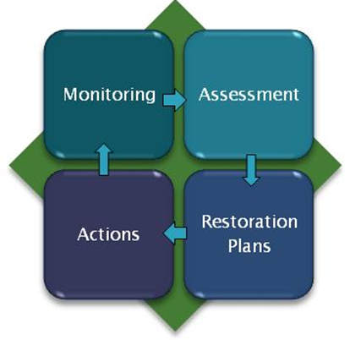
The Water Quality Framework is a new way of thinking about how EPA’s data and information systems can be better integrated to more effectively support water quality managers. Ultimately, the Framework will streamline water quality assessment and reporting while providing a more complete picture of the nation’s water quality. The Framework is in line with EPA’s E-Enterprise Initiative, which seeks to assess and reformulate EPA’s business process to reduce burden through the improved use of technology.
Background
EPA and the states recently completed a retrospective review of the Clean Water Act Section 305(b) and 303(d) reporting process. The workgroup found that the elements of this process that demand the greatest investment of state resources include: compiling and reviewing available water monitoring data, analysis and interpretation of that data to make assessment determinations, and preparing and submitting electronic Integrated Reporting (IR) data to EPA.
The review recommended a number of improvements to the process, including:
- Identifying tools to automate processing and interpreting ambient water quality data;
- Transitioning to complete electronic 305(b) and 303(d) reporting and electronic signatures for 303(d) approvals; and
- Aligning data systems with programmatic processes to track water quality improvement.

These findings have led EPA to begin implementing the Water Quality Framework.

Benefits of this approach
Integrating data systems through the implementation of the Water Quality Framework provides many key benefits:
  - Reduces state burden by streamlining the assessment and reporting process;
  - Provides the means to tell the ‘whole’ story from monitoring to assessment to restoration;
  - Provides better measurement and reporting of water quality improvement;
  - Provides better transparency on water quality decisions making;
  - Allows for tools that can be used to identify relevant monitoring data for water quality assessments; and
  - Supports state development of tools to automate screening monitoring data against water quality standards.
  - Connects data, decision and actions geospatially.
Implementing the Framework
EPA’s first step in implementing the Framework is to evaluate the Assessment TMDL Tracking and ImplementatioN System (ATTAINS), which displays state IR information reported to EPA under Sections 305(b) and 303(d). As part of this evaluation, EPA will assess how ATTAINS can be better integrated with water quality monitoring data in STORET and with EPA’s geospatial surface water mapping tool, the National Hydrography Dataset Plus (NHDPlus).
Building on the success of the 305(b)/303(d) retrospective review, EPA is seeking state participation in four workgroups starting in September 2013. Over the next year, these workgroups will hold monthly meetings via teleconference; their input will aid in determining
the future direction of the ATTAINS system and the Framework. A final report on their findings is planned for September 2014.
These four workgroups are:
- Data Elements and Schema: This workgroup will define the data elements and draft schema for exchanging IR information between the states and EPA.
- Data Exchange Methodology: This workgroup will make recommendations on data exchange approaches and system design.
- Performance Measures Evaluation: This workgroup will evaluate the existing performance measures that can be reported using IR data and will make recommendations on how the new ATTAINS design can be used to report on these measures.
- Improved Assessment Methods: This workgroup will evaluate tools and methods that can be used to discover monitoring data and automate comparisons to water quality criteria.

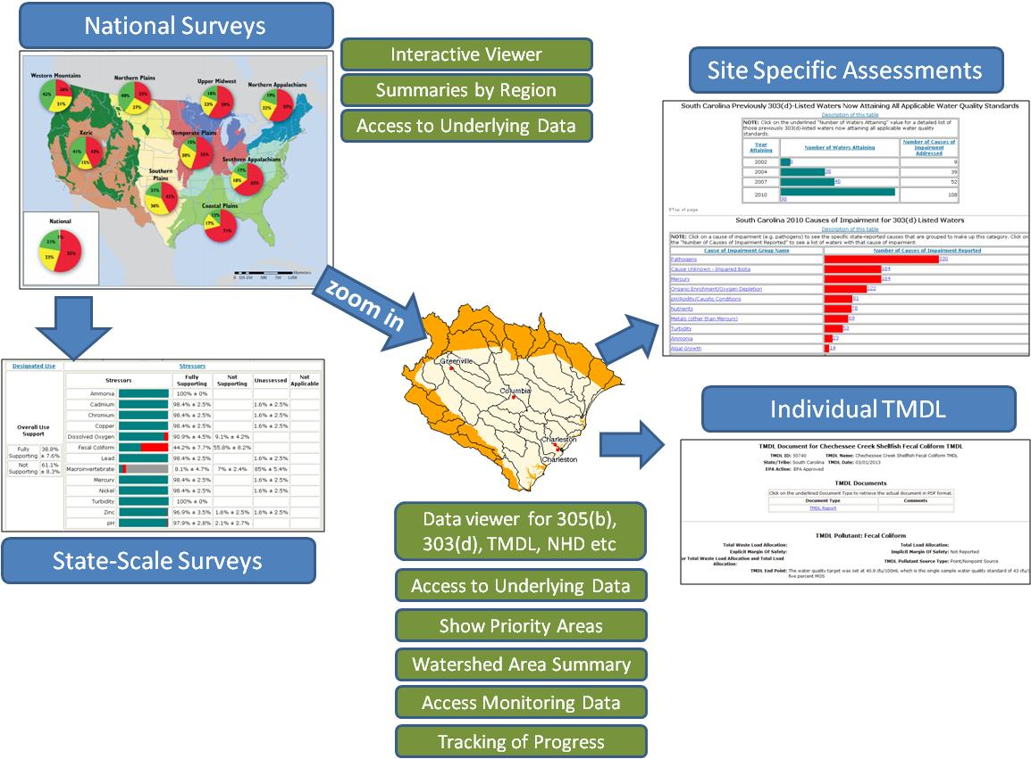
This graphic represents how the Water Quality Framework could integrate assessment information on EPA’s public web site. The user could start at the national scale, interacting with data and summary information from EPA’s National Aquatic Resource Surveys. From there, the user would be able to navigate to a state-scale survey, and then be able to zoom into state priority areas and evaluate site-specific assessments and restoration activities.

