WQX Resources and Step-by-Step Guide for 319 Grant
Useful Resources
See end of document for additional resources

WQX Web
Access to WQX Web through Central Data Exchange requires a login.gov account.
https://cdx.epa.gov/

WQX Web Templates
Excel spreadsheets to be used to assist with data tracking and entry.
https://www.epa.gov/waterdata/water-quality-exchange-web-template-files

WQX Web Template User Guide
Detailed Step-by-Step guide to using WQX Web Template to prepare data for import into WQX Web
https://www.epa.gov/waterdata/water-quality-exchange-web-template-user-guide

WQX 101 Webinars YouTube
Webinar series providing training and guidance on submitting water quality monitoring data to the Water Quality Portal (WQP) using the Water Quality eXchange (WQX) data sharing standard. https://www.youtube.com/playlist?list=PL7F4YD5AdOGKZBD6MnNRwOnuJlZlzhwLS

Step-by-Step Guide (using Excel templates)

Step 1. Identify the path your program will take to submit data to WQX
This guide will focus on submitting data through WQX Web using an excel template. But there are other pathways to submit data to WQX that are suited to advance users (i.e., node-to-node exchange of xml formatted data to the Central Data Exchange (CDX)). In addition, there are proprietary third-party software products available that will support WQX-style exports as part of their data management solution. For information or training on using these systems, please contact the software vendors directly.
WQX Web is an online EPA web application that assists users in preparing, mapping, submitting, and reviewing water quality datasets to WQX. There are two primary WQX Web tools: web data templates that help users harmonize and structure their data to WQX data standards, and an import configurations module that allows users to map their existing dataset to the WQX standard for importing.

Step 2. Register an account and gain access to WQX and CDX

WQX Web registration: https://www.epa.gov/waterdata/wqx-web-account-registration
Please follow the instruction on the page above. This page includes a training video on completing this step.
- ORG ID (may be up to 30 characters long)
- Organization Name
- Contact Name
- Contact Email – needs to be registered to a login.gov account for multi-factor authentication
- Address
- Phone

Step 3. Prepare your data

We will focus on using the WQX Web path and using the already-developed Excel Template to upload data.

A.
Identify and describe your Projects
Data in WQX can be associated with multiple projects. In general, a project should describe WHY a sample is being collected. A project must contain a unique ID, a name, and description information. Adding other Projects to a dataset is a way to label data and make them discoverable under different contexts in WQX and WQP.
To make data collected under 319 discoverable in the WQP, we recommend giving the following Project ID CWA319.
- Open the WQX Excel Template and click on the Projects – config#7039 tab. Note the import configuration number referenced in the tab name. Multiple projects can be listed and uploaded to WQX at a time, and once registered in WQX, it will stay there unless needing to update information.
- For data collected under CWA 319 funding,
  - Create a 319 Project Enter a
    - Project ID = CWA319
    - Project Name = free text no longer than 512 characters.
    - Project Description= free text no longer than 4000 characters
    - Indicate whether a Quality Assurance Project Plan is associated with the data
    - Attach the QAPP (optional but highly recommended)
  - If data are associated with other projects, enter the respective project information in the spreadsheet in the next rows.

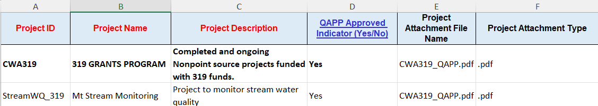

B.
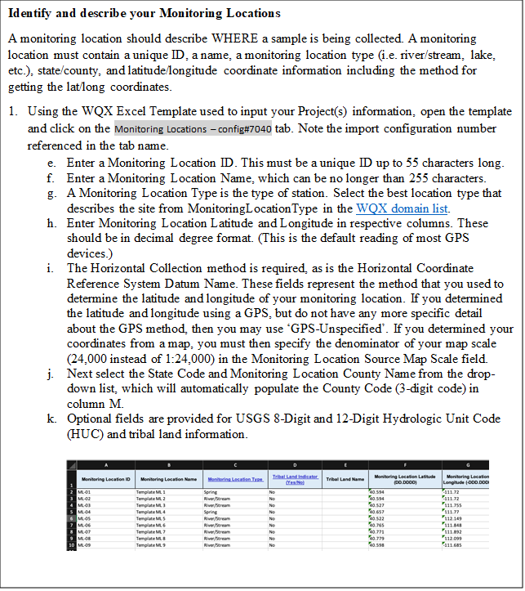

C.
Identify the Activities in your dataset

Physical Chemical Results
The results define WHAT, WHEN, and HOW the sample is being collected.
- Open the template in Excel and click on the Results – config#9419 tab to enter in your information. Note: Your Project ID and Monitoring Location ID must already exist.

+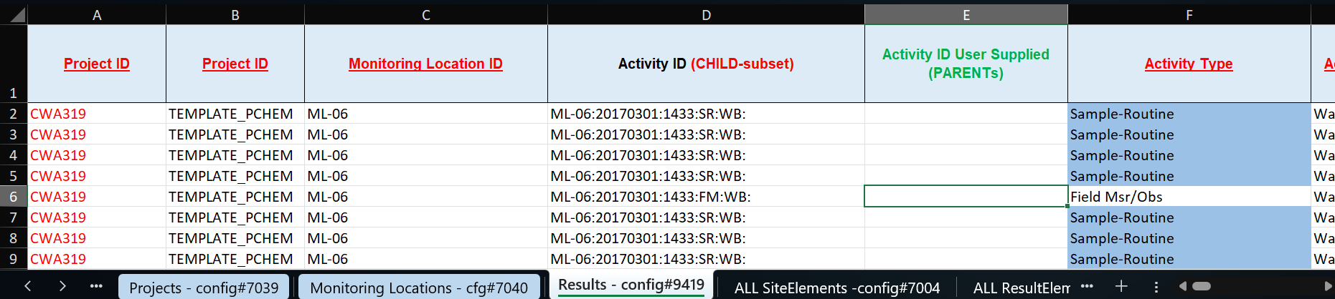
- Enter in the following information:
- Project IDs: In separate columns, list CWA319 and a second project that is specific to your organization’s project (if appropriate).
- Monitoring Location ID: The unique ID of the site sampled
- Activity ID: This is a required field in WQX and is how data are organized. It identifies any individual action you are performing at a location to collect data.
  - WQX Excel template will generate a unique Activity by concatenating Monitoring Location ID, Activity Start Date, Activity Time (if provided), Activity Type, Activity Depth (if provided), and Activity Sample Collection Equipment (if provided). Activity IDs are limited to 55 characters.
  - Anytime there is a change in Activity Type, Activity Medium, Monitoring Location, Activity Start Date, or Activity Depth, a new Activity ID must be created.
  - An Activity ID cannot be reused for multiple activities, but the same Activity ID can be associated with multiple Results (e.g., Phosphate and Total Nitrogen were analyzed from the same grab sample).

- Activity Type: This is required and describes the type of sampling or quality control activity.
  - In most cases the following defaults can be used:
    - Sample-Routine (for samples taken and sent to a lab)
    - Field Msr/Obs (for measurements taken at a site such as with a probe or other onsite instrument)
Continue on next page

Identify the Activities in your dataset (cont.)
- Enter in the following information:

- Activity Media: This is required and describes the environmental medium where the sample was collected.
  - In most cases the following defaults can be used:
    - Medium – Water

- Activity Start Date: Refers to the date the sample was collected.
- Activity Start Time: This is optional, but if entered, use the format in the example.
  - If time is entered, the three-character Time Zone becomes required, for example: CST.
- Activity Depth and Depth Units: These are optional, but if Depth is entered the units must also be entered. Choices are ft (feet) and m (meters).
- Sample Collection Method ID and Sample Collection Equipment Name: These are required for samples that are collected and sent to the lab, but not for field measurements. If uncertain about the Sample Collection Method, you may refer to your QAPP.

Identify the Results in your dataset
Physical Chemical Results
- Characteristic Name: These are required and represent the substance, object, or property which is evaluated or enumerated by either field measures, observations, or laboratory analyses of materials collected in the field. The Characteristic Name MUST match the approved WQX domain Characteristic Names (or the name must match characteristic alias name using context: “WQX Synonym Registry (validation)”). These are available by either using the drop-down list in the Characteristic Name column, or by searching the WQX Domain Values List for Characteristic.
- Method Speciation: This field may be required depending on the substance. It identifies the chemical speciation in which the measured result is expressed. E.g., The characteristic ‘Phosphate-phosphorus’ may be expressed ‘as P’ or ‘as PO4’.
- Result Detection Condition: Indicates if result values are censored due to detection/quantitation limits. Required if the Result Value is blank.
- Result Value: Measurement value of a characteristic.
  - The Result Value field or the Result Detection Condition field must contain a value. If the result is censored, we recommend leaving the Result Value field blank. The Result Detection Condition field must be populated with why the data are censored.
  - If you report a value as ‘Not Detected’, ‘Present Above Quantitation Limit’, or ‘Present and Below Quantitation Limit’:
  - You must provide the Detection Limit Type, Detection Limit Measure, and units.
  - The Result Detection/Quantitation Limit Type describes why the analyte was censored. Options are available in the drop-down list.

- Result Unit: This is required for non-text result values unless the Result Detection Condition field contains a value. For pH it will always be None.
- Result Measure Qualifier: Code that identifies any issues that affect the results. Reference WQX Domain Values List for ResultMeasureQualifiers
- Sample Fraction: This is a description of the portion of the characteristic being analyzed. Sample Fraction will usually be Total or Dissolved. Which value you use is driven by the method used for the analysis.
- Result Status ID: This is required if you reported a result. Results labeled ‘Preliminary’ will not be transferred to the Water Quality Portal.

Continue on next page

Identify the different types of monitoring Activities in your dataset (cont.)
Physical Chemical Results
- Result Value Type: This is required if a result is non-text. It must be either Actual, Estimated, Calculated, or Control Adjusted. The default entry is Actual. If you use Calculated, you may wish to specify the method used to calculate the results in the optional Statistical Base Code field. Examples of valid Statistical Base Codes are Mean, Maximum, or Standard Deviation.
- Result Analytical Method ID and Context: These are the analytical procedures used by the lab for analyzing samples. For example, if you’re using the APHA method “Total Coliform- Chromogenic Substrate Test” for analyzing Total Coliform (method number 9223-B), you would enter APHA as the Context, and 9223-B as the Analytical Method ID. WQX references methods documented in NEMI.
- Analysis Start Date: Optional field which is the date the lab started analyzing samples.
- Result Comment: Optional field that may be entered if desired.

Save workbook.

Step 4. Upload data to WQX Web using filled out data template
Log into CDX to access WQX Web

Upload Projects
- Go to the ‘Import and Submit’ option on the WQX Home Page and select ‘Import Projects (into the staging area)’.

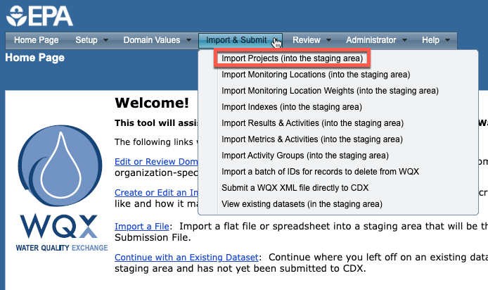

- Select the Project Template Import Configuration. In this example, the import configuration is ‘7039’. This references the Physical Chemical Template Excel workbook and automatically fills in Type of File (Microsoft Excel) and Worksheet to Import (3rd worksheet in Excel Workbook).

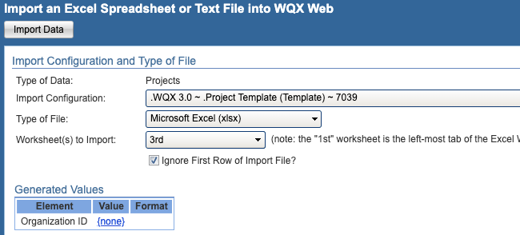

- Indicate whether the file contains new data, existing data, or both new and existing data in WQX.
- Select whether you want to review the data import in the staging area before submitting (preferred) or to automatically submit the data to WQX.
- Navigate to the WQX Template that you saved your Project data in and select Import Data.

Upload Monitoring Locations
- In WQX Web, go to the ‘Import and Submit’ option on the WQX Home Page and select the “Import Monitoring Locations (into the staging area)”

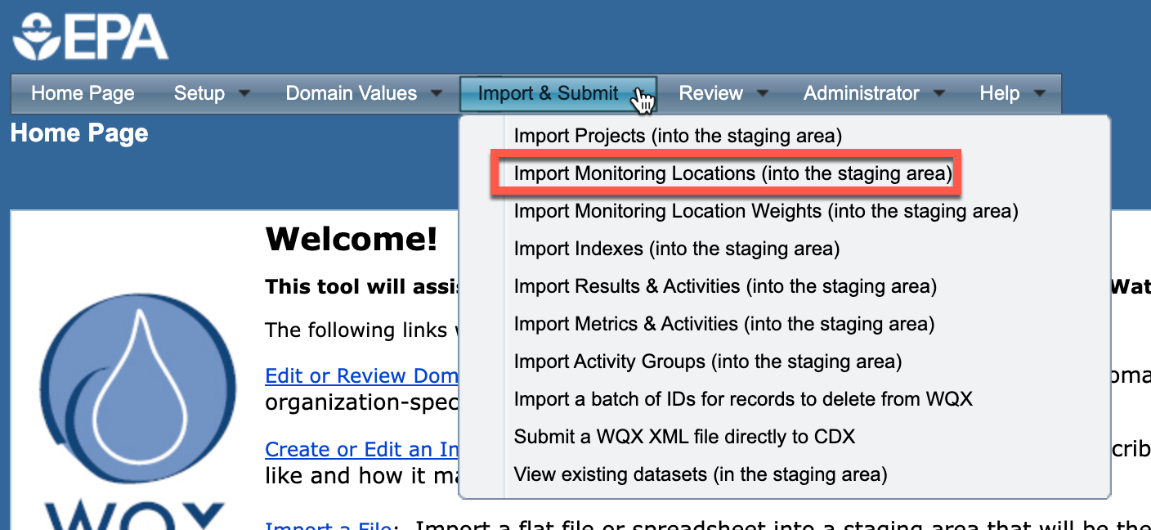

- Select the Template Monitoring Location Configuration
- Select the Monitoring Location Template Import Configuration. In this example, the import configuration is ‘7040’. This references the Physical Chemical Template Excel workbook and automatically fills in the Type of File (Microsoft Excel) and Worksheet to Import (4th in Excel Workbook).

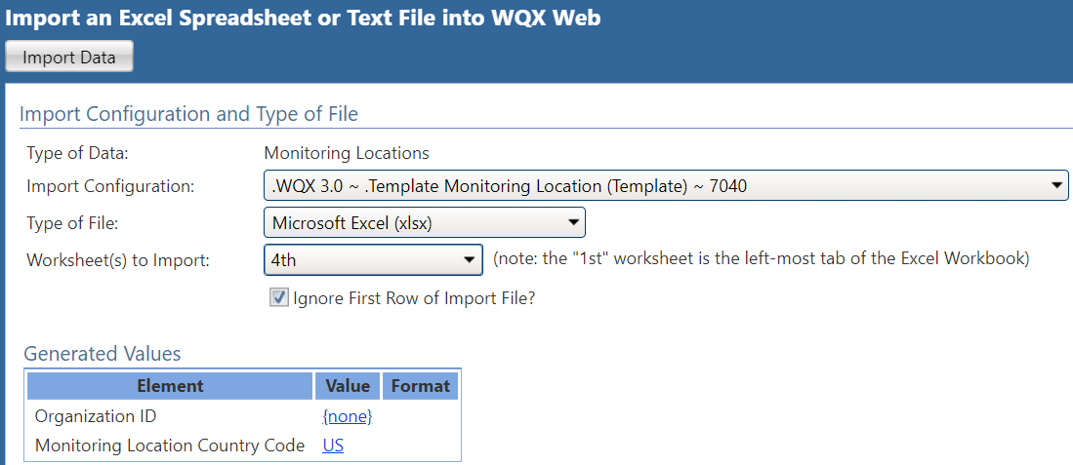

- Indicate whether the file contains new data, existing data, or both new and existing data in WQX.
- Select whether you want to review the data import in the staging area before submitting or to automatically submit the data to WQX.
- Navigate to the WQX Template that you saved your Monitoring Location data in and select Import Data.

Upload Results (Physical Chemical)
- In WQX Web, go to the ‘Import and Submit’ option on the WQX Home Page and select ‘Import Results and Activities’ option.
- Select your import configuration that describes your import file format. In this example, the import configuration is ‘9419’ referencing the Physical Chemical Template Excel workbook. This automatically fills the Type of File (Microsoft Excel) and Worksheet to Import (5th in Workbook).

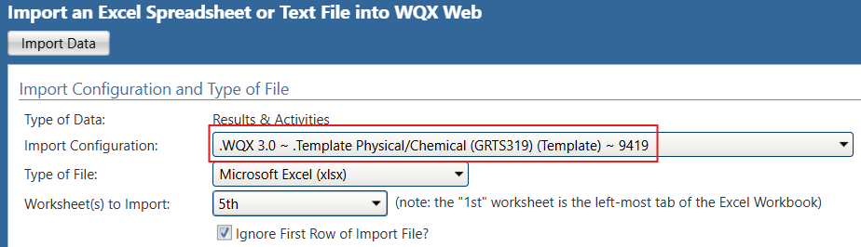

- Indicate whether the file contains new data, existing data, or both new and existing data in WQX.
- Select whether you want to review the data import in the staging area before submitting or to automatically submit the data to WQX.

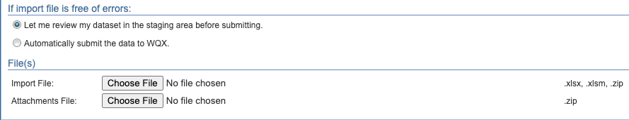
- Navigate to the WQX Template that you saved your Results and Activities data and select Import Data.

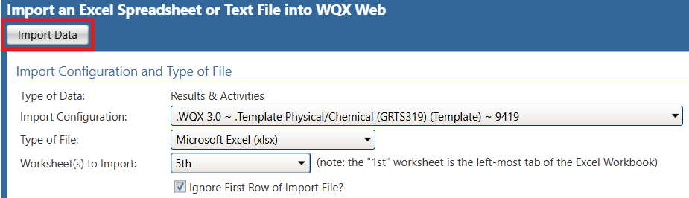
- Once your file has been imported, you will get a ‘Dataset Summary Page’ that displays:
  - The number of valid and invalid errors.
  - The number of each type of validation error, and in some cases, a link to the page where that type of error can be corrected online.
  - A link to the Event log where you can review all errors and warnings encountered while importing the file.
- Once all errors are resolved, you can now export and submit your data file to CDX to make the data final.

If you have questions or have trouble with an error, please see Common Import Error Resolutions for common error resolutions, or contact the WQX help desk for assistance WQX@epa.gov

Add Project ID(s) to existing Activities Results (Physical Chemical)
- In WQX Web, go to the ‘Import and Submit’ option on the WQX Home Page and select ‘Import Results and Activities’ option.
- Select ‘System ~ Add Project ID(s) to existing Activities (Template) ~ 9’. The import configuration is ‘9’ and references a two-column workbook. This automatically fills the Type of File (Microsoft Excel) and Worksheet to Import (1st in Workbook).

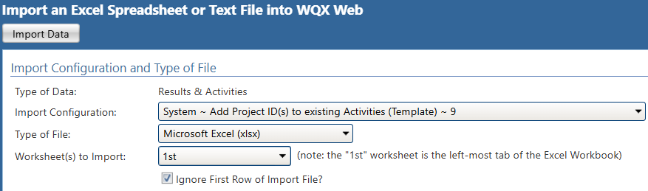
- Accept the default(s) This file contains existing data only (i.e. already in WQX).
- Select you want to review the data import in the staging area before submitting.

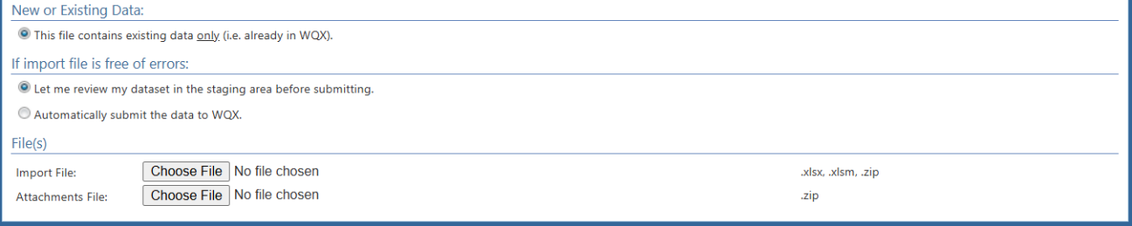
- For Import File, Choose File by Navigating to the spreadsheet that you saved your two columns (1st column: Activity IDs and 2nd column: Project IDs) data and select Import Data.

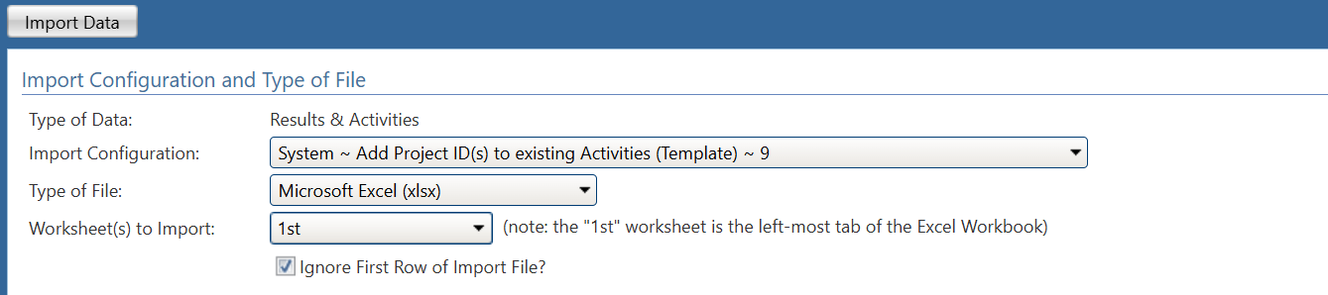
- Once your file has been imported, you will get a ‘Dataset Summary Page’ that displays:
  - The number of valid and invalid errors.

- You can now submit your data file via Update WQX to make the data final.

Additional WQX/WQP Resources

Topic Area | Resource Links
Open Water Data Resources / Links | Water Quality Exchange (WQX) [Data In]  The Water Quality Portal (WQP) [Data Out]  How’s My Waterway (HMW) [Info Out]  Central Data Exchange (CDX) [Data Held]  Exchange Network (Node Submissions)  WQX 101 Overview of EPA Water Data Integration Systems (YouTube)
WQX Nuts and Bolts | Upload Resources Page  Glossary of Terms  Business Rules  Data Exchange Template (List of Available Elements)  Domain Service (Acceptable Values)
Using WQX – Getting Started | Introduction to WQX, WQX Web, and WQP (5 min video)  Quick WQX Web User Guide (PDF Guide)  User Guide Version 3.0 for Water Quality Exchange Web  Getting Started with WQX Web: How to Gain Access (5 min video)  WQX Web Basics – Two-part session--Day 1  WQX Web Basics – Two-part session--Day 2  WQX 101 Introduction to WQX (YouTube)  WQX 101 Preparing Datasets for Submission (YouTube)
Using WQX – Templates | Water Quality Exchange Web Template User Guide | US EPA  Link to Web Templates  Web Templates Overview Video  WQX 101 Web Templates: Project & Location (YouTube)  WQX 101 Web Templates: Physical & Chemical (YouTube)  WQX 101 Web Templates: Biological, Metric, & Continuous Time-Series Data (YouTube)
Using WQX – Import Configurations | WQX Web Import Configuration Options  Translations via Expert Mode  WQX 101 Import Configurations (YouTube)
Using WQX – Best Practices | Best Practices for sharing Nutrients Data  Best Practices for sharing Benthics Data  Best Practices for sharing Metals Data  Best Practices for Detection Limits
Using WQX – Water Quality Portal | WQX 101 Finding Data on Water Quality Portal (YouTube)
Using WQX - Other | Water Quality eXchange Factsheet  Common Errors Resolution  WQX Program Information

