How to join Results to Limits using the Water Quality Portal download reports?

Defining the “Join Type” in MS Access as follows
- RESULT DETECTION QUANTICATION LIMIT AND RESULT (narrow)
  - ResultIdentifier <=====> ResultIdentifier
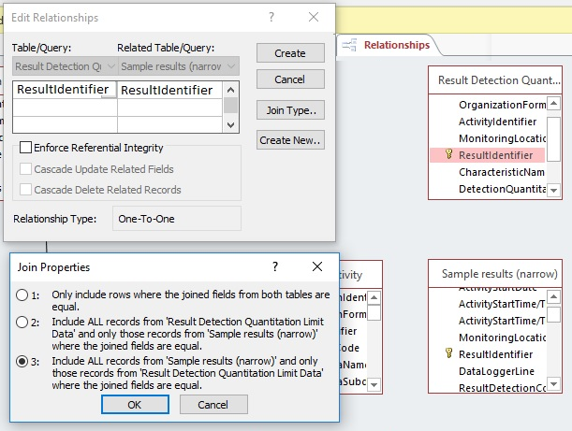

Defining the “Join Type” in MS Access as follows
- ACTIVITY AND RESULT (narrow)
  - ActivityIdentifier <=====> ActivityIdentifier
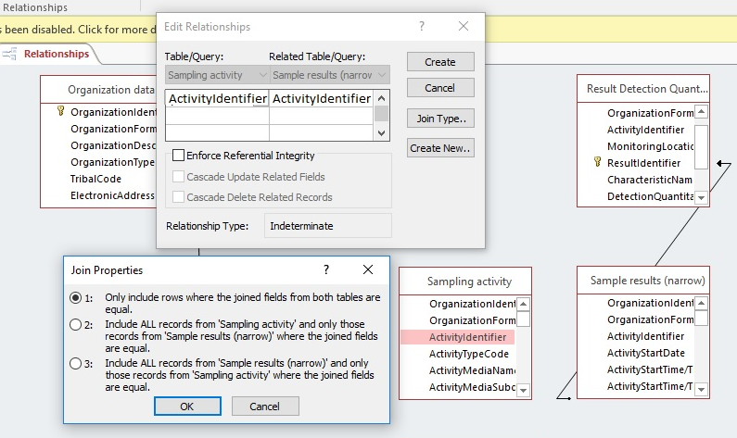
Defining the “Join Type” in MS Access as follows
- MONITORING LOCATION AND RESULT (narrow)
  - MonitoringLocationIdentifier <=====> MonitoringLocationIdentifier
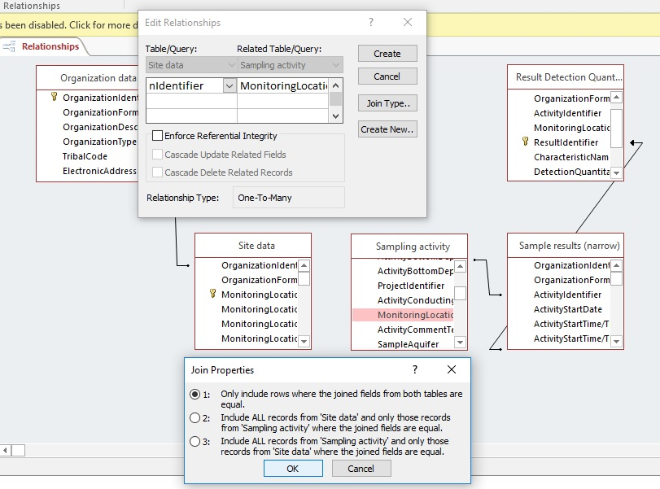

Water Quality Portal User Guide URL: https://www.waterqualitydata.us/portal_userguide/
RESULTS (narrow)
Table 7. Sample result retrieval elements and definitions for the "narrow" data profile

This data profile contains minimal data from parts of the WQX data model that are not in the "Result" section of WQX. Activity data can be linked to the activityID through ActivityID, and ResultIdentifier can be used to link to ResultDetectionQuantitationLimit data.
Narrow data profile Result Retrieval Element | Description
OrganizationIdentifier | A designator used to uniquely identify a unique business establishment within a context.
OrganizationFormalName | The legal designator (i.e. formal name) of an organization.
ActivityIdentifier | A designator used to uniquely identify a data collection project within a context of an organization.
ActivityStartDate | The calendar date on which the field activity is started.
ActivityStartTime/Time | The time of day that is reported when the field activity began, based on a 24-hour timescale.
ActivityStartTime/TimeZoneCode | The time zone for which the time of day is reported. Any of the longitudinal divisions of the earth's surface in which a standard time is kept.
MonitoringLocationIdentifier | A designator used to describe the unique name, number, or code assigned to identify the monitoring location.
ResultIdentifier | An Identifier that uniquly identifies this result in the Water Quality Portal output. This identifier is unique within an output, but not nessarily over time.
DataLoggerLine | The unique line identifier from a data logger result text file, normally a date/time format but could be any user defined name, e.g. "surface", "mD68:D86idwinter", and or "bottom".)The unique line identifier from a data logger result text file, normally a date/time format but could be any user defined name, e.g. "surface", "midwinter", and or "bottom".)
….. | …...
Etc… | …..
ProviderName | The name of the database that provided the data to the Water Qaulity portal (E.G. STORET, NWIS, STEWARDS)

RESULT DETECTION QUANTITATION LIMIT (ResultIdentifier)
Table 8. Result Detection Quantitation Limit elements and definitions.
Constituent concentration that, when processed through the complete method, produces a signal that is statistically different from a blank. There can be multiple Result Detection Quantitation limits per result, and they can be linked to results retrieved using the "narrow" result profile using ResultIdentifier.
Result Detection Quantitation Limit Element | Description
DetectionQuantitationLimitTypeName | Text describing the type of detection or quantitation limit used in the analysis of a characteristic.
DetectionQuantitationLimitMeasure/MeasureValue | The reportable measure of the result for the chemical, microbiological or other characteristic being analyzed.
DetectionQuantitationLimitMeasure/MeasureUnitCode | The code that represents the unit for measuring the chemical substance, microbiological substance or other characteristic.
ResultIdentifier | The Identifier that links a result record to a Result Detection Quantitation Limit record

ACTIVITY (ActivityIdentifier)
Table 9. Sampling Activity retrieval elements and definitions
Activity Retrieval Element | Description
OrganizationIdentifier | A designator used to uniquely identify a unique business establishment within a context.
OrganizationFormalName | The legal designator (i.e. formal name) of an organization.
MonitoringLocationIdentifier | A designator used to describe the unique name, number, or code assigned to identify the monitoring location.
ProjectIdentifier | A designator used to uniquely identify a data collection project within a context of an organization. Multiple projects may be concatenated together.
ActivityIdentifier | Designator that uniquely identifies an activity within an organization.
ActivityTypeCode | The text describing the type of activity.
Etc… | etc…
MethodSpecificationName | Identifies the chemical speciation in which the measured result is expressed.

