WQX User Call
September 23, 2021

There were approximately ## participants.
The next WQX User call is October 28, 2021.
Agenda:
- new QAQC Service
  - monitoring Locations: QAQCLocations.zip (QAQCLocations.CSV)
    - detailed report (ⱱ)
    - summary report
  - activity Results report: QAQCResults.zip (QAQCResults.CSV)
    - detailed report (ⱱ)
    - summary report
  - QAQC_CHARACTERISTIC_VALIDATION domain values
    - Characteristic and Unit
    - Characteristic and Analytical Method
    - Characteristic and Fraction
    - Characteristic and Speciation
    - Characteristic and Min/Max Measure Range w converted unit
  - QAQC_LATLONG_VALIDATION reference table via FTP Site (Copy Link)
  - FY22 - Develop URL download report by parameter transaction_id
  - FY23 - Develop CSV file Import configuration
  - FY23/24 – Develop Water Quality Portal cached QAQC data profiles
- WQX Project Status Report
  - Frequent Questions about WQX ?
  - Updated WQX Business Rule #50 (Click Here)
    - When AssemblageSampledName is reported then ActivityMediaName must be 'Biological' or 'Tissue'.
    - WQX Data Flow – Exchange network (published)
  - Updated STORET to Water Quality Portal
  - Updated support email address: wqx@epa.gov
  - Domain Values w tab character for string values: MethodIdentifier (Analytical,SampleCollection,SamplePreparation,LabSamplePreparation), Tribe (BIA Code), County (FIPS), State (FIPS), CharacteristicWithPickList
  - Rename schema example file via FTP Site (Copy Link)
- Water Quality Portal Project Status Report
  - WQP download profiles workgroup meetings, become a participant by emailing: wqx@epa.gov
  - The portal is up and running. It was last refreshed on Wednesday, August 25th. The WQP Team is addressing a number of help desk issues via FTP Site (Copy Link)
  - Check and Verify Last Successful Water Quality Portal ETL service (Click Here)
    - WQP UI URL: https://www.waterqualitydata.us/data/lastETL
  - The main priority is to address consistency on refreshes and investigating an issue with the project parameter - it has an inconsistency in querying some Beaches program data.
  - Report WQP Tool issues using URL: “Copy To Clipboard”
  - Show Web Services Call appended with a new parameter option (counts=no) may resolve certain WQP timeouts / 504 Errors
- Open Discussion

Water Quality Exchange Best Practices

WQX’s Update Identifiers schema (renaming / changing) primary identifiers.
Documentation is referenced on page 24 of the Flow Configuration Document
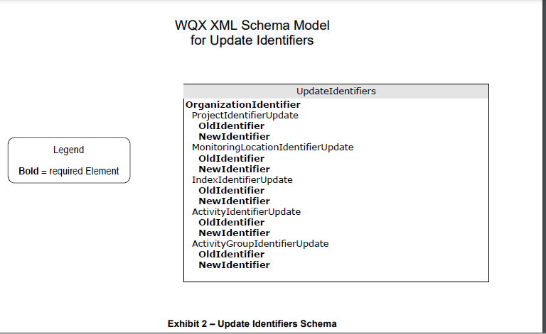

Visit ftp site for further examples:
ftp://newftp.epa.gov/storet/wqx/test_submission/

Here is the file content for example: Rename of MyMonitoringLocationIdentifiers.xml

<?xml version="1.0"?>
<Document Id="UI1" xmlns="http://www.exchangenetwork.net/schema/v1.0/ExchangeNetworkDocument.xsd" xmlns:xsi="http://www.w3.org/2001/XMLSchema-instance">
<Header>
<Author>Kevin Christian</Author>
<Organization>EPA</Organization>
<Title>WQX</Title>
<CreationTime>2004-04-05T09:30:47-05:00</CreationTime>
<Comment>This is a test file</Comment>
<ContactInfo>1200 Pennsylvania Ave, Mailcode 4503-T Washington, DC 20460 800-424-9067, storet@epa.gov</ContactInfo>
<Notification>wqx@epa.gov</Notification>
</Header>
<Payload Operation="Update-Insert">
<WQXUpdateIdentifiers xmlns="http://www.exchangenetwork.net/schema/wqx/3"
xmlns:xsi="http://www.w3.org/2001/XMLSchema-instance"
xsi:schemaLocation="http://www.exchangenetwork.net/schema/wqx/3 http://www.exchangenetwork.net/schema/wqx/3/index.xsd">
<UpdateIdentifiers>
<OrganizationIdentifier>WQXTEST</OrganizationIdentifier>
<MonitoringLocationIdentifierUpdate>
<OldIdentifier>125-0503</OldIdentifier>
<NewIdentifier>125-0503zz</NewIdentifier>
</MonitoringLocationIdentifierUpdate>
<MonitoringLocationIdentifierUpdate>
<OldIdentifier>126-0503</OldIdentifier>
<NewIdentifier>126-0503zz</NewIdentifier>
</MonitoringLocationIdentifierUpdate>
</UpdateIdentifiers>
</WQXUpdateIdentifiers>
</Payload>
</Document>

